Population Aging and Fiscal Sustainability in Thailand:

The National Transfer Accounts (NTA) Approach

Suphannada Lowhachai[1] , Sang-Hyop Lee[2] , Tanisa Tawichsri1

1. **Introduction**

Population aging has important implications for the public finances in large part because the beneficiaries of public programs in many countries are primarily children and the elderly. As the share of the children declines and the share of the elderly increases during the demographic transition, public spending on education becomes lower but public spending on health and pensions will begin to rise relative to other changes in public spending. These problems are most acute in high income countries, while lower income countries in general have low spending on public sector programs. But as countries develop, they develop new programs and hence public spending on education, health care, and pensions all tend to increase. Thus, the key issue for developing economies is whether public programs can be expanded at the same time that their populations are aging. For wealthier countries with well-developed public sectors the key issue might be whether those programs can be sustained as their population ages.

The purpose of the paper is to examine the linkages between population and the public sector using the model developed by Mason, Lee et al (2015). The 2012 Thai National Transfer Account (NTA) data set is used to quantify the linkages. This paper emphasizes the experience of Thailand although it compares the results with other countries. Thailand is an interesting case study as the country has experienced very rapid changes in economy, population structure as well as public budget structure during the past three decades. Between 1987 and 1996, the economy grew so rapidly that the country was regarded as one of the Asian Economic Miracles (World Bank, 1993). As a consequence, Thailand has moved from low income country status to upper-middle income country status within four decades. As the country has become richer, government policy has been geared more toward social development. Since the implementation of the Eight Economic and Social Development Plan in 1997, the focus of development shifted from economic growth to human development through social policy. Compulsory education was extended from 6 to 9 years in 1999 together with the government’s commitment to provide 12 years of education free of charge (Kirtikara, 2001). Universal health care coverage has also been implemented beginning in 2001. In 2009, the mean-tested old-age allowance was made universal to all elderly Thais who are not covered by other pension schemes. Implementation of these policies has changed the government budget structure substantially.

In addition to rapid economic and social development, Thailand has also experienced rapid demographic transition over these past few decades. With successful contraceptive and family-planning measures, the fertility rate in Thailand has fallen markedly to a level now below the replacement rate. Another important demographic trend is that cohorts born during the baby boom period are reaching entering have increasingly entered the retirement age. This means a smaller share of working-age population to take care of the increasing share of elderly in the future. The demographic trends will certainly affect the economic and social context of the country for decades to come.

The outline of this paper is as follows: Section 2 provides an overview of the population structure and government budgeting system in Thailand. The section also describes how recent public policy shifts has affected the government’s budget structure. Section 3 presents National Transfer Account data used in the analysis of public sector effects of demographic change. Section 4 summarizes the model briefly and presents the results. The final section provides concluding remarks.

1. **Overview of Thailand’s Demography and its Public Sector**

*Population and Demographic Change in Thailand*

Over the past few decades, Thailand has seen rapid demographic change. Because high population growth in 1970s was considered an obstacle to economic growth, intensive population growth-reduction policies were continuously implemented between 1977 and 1996. As a result of policy and socio-economic change, the total fertility rate declined remarkably. In fact, Thailand is one of the countries with the most rapid fertility reduction and the shortest period of fertility transition in Southeast Asia. The total fertility rate fell from 6.30 during 1964-1965 to 1.82 in 2000-2005, below replacement level. The rate continued to fall to 1.62 in 2005-2010 and is expected to continue to decline in the near future. Concerns about high fertility and its development effects have been replaced with concerns over low and perhaps further declines in the fertility rate. According to the NESDB’s population projection (NESDB, 2013), the total population will continue to increase until reaching its peak at 66.4 million people in 2026. Afterwards, the population will gradually decline to 63.9 million people in 2040. While Thailand had long been praised as a success case for reproductive health (UNFPA and NESDB, 2011), now such success seems to become a challenge for the country’s future development.

Not only is Thailand facing population decline in the near future, its demographic structure is changing considerably, moving the country inexorably toward an ageing society (Figure 1). The child- and working-age populations have already begun to decline, and the proportion of older population has constantly increased. The child population decreased from 15.5 million or 45.1 percent of total population in 1970 to 12.6 million or 19.8 percent in 2010 and is expected to decrease further to 8.2 million or 12.8 percent in 2040. The working-age population attained its high point at 42.9 million or 66.9 percent in 2011. It is projected to fall to 35.2 million or 55.1 percent of total population in 2040. In contrast, the older population increased from 1.7 million or 4.9 percent of total population in 1970 to 8.4 million or 13.2 percent in 2010. It is projected to increase to 20.5 million or 32.1 percent of the total population in 2040.

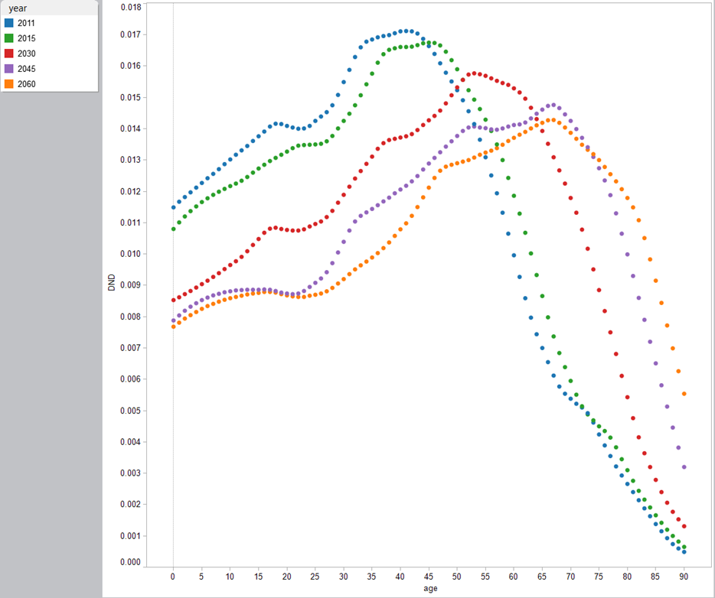

Figure 1. Population age distribution, Thailand, selected years.

Source: UN Population Division, World Population Prospects (2014 revision)

Such changes in population growth and demographic structure bring about challenges to sustainable economic and social development of Thailand. If accurate and in absence of other compensating changes, the population will begin to decline in 2026 leading to decline in the number of consumers and further decline in the number of workers. Accordingly, the size of domestic market may not grow as rapidly as in the past. Maintaining economic growth will become more difficult. Moreover, the increasing share of older population, coupled with declining share of working-age population will lead to a higher old-age dependency ratio. This means that, on average, there will be fewer working-age persons to support the older population—with important implications for the sustainability of pensions and other social security schemes. Together with declining number and share of children, the country will inevitably and urgently need to prepare for sustainable approaches to social welfare.

*The Public Sector in Thailand*

Government revenue in Thailand, on average, accounted for 17.5 percent of GDP between fiscal year (FY) 1990 and FY2014. Along with economic growth, the revenues steadily increased from 404,939 million Baht in FY1990 to 2,171,412 million Baht in FY2014. For the sources of revenues, in FY2014, 88.9 percent of government revenues came from tax collection while 11.1 percent was from non-tax revenue. Of tax revenues, indirect taxes made up the largest share (50.7 percent of government revenues), mostly value-added tax (VAT)—accounting for 28.5 percent of government revenues. As for direct taxes, corporate income tax made up the largest share (22.9 percent of government revenues) while personal income tax accounted for 11.3 percent of government revenues. Although direct taxes still has relatively smaller share of tax revenues, government has become increasingly relied direct taxes over time. Over the period FY1990-FY2014, the share of direct tax to total government revenues rose from 24.7 percent to 38.2 percent.

|  |  |
| --- | --- |
|  |  |

Figure 2. Government Budget Structure, 1989-2014.

Source: Fiscal Policy Office. 2015. Ministry of Finance and several editions of *Budget in Brief* by Bureau of Budget

On the expenditure side, the government budget in Thailand has increased from 285,500 Million Baht in FY1989 to 2,525,000 Million Baht in FY2014. Considering the budget as a share of GDP, it ranged between 15.9 percent of GDP and 22.4 percent during the FY1989-2014 period—an average of 18.1 percent of GDP. Along with an increasing share of GDP, the structure of the budget itself has changed considerably over the period. The budget structure in figure 2 shows that the share of expenditure on social services has increased at the cost of expenditure on economic affairs. This is consistent with the government policy shift toward social aspects of development since the implementation of the Eighth Plan (1997-2002). From 1997, Thailand has seen many changes in social policy, particularly the provision of education, public health and protection for elderly and the disabled. The government debt is 45.7 percent GDP in FY2014. The government debt to GDP in Thailand averaged 45.4 percent from 1996 until 2013, reaching an all-time high of 57.8 percent in 2000 and a record low of 15.2 percent in 1996. More detail of thee government policy changes are as follows.

Public Health

Prior to 1991, two-thirds of the Thai population was not covered by any health insurance program (see Figure 3). At the time, there were only two conditional health care schemes-- the Civil Servants’ Medical Benefit Scheme (CSMBS) and the Medical Welfare Scheme for Low-income Persons. The introduction of the Social Security Scheme (SSS) under the Social Security Act B.E.2533 (1990) extended coverage of health care insurance to those employed in firms with 20 employees or more. Then, the social security scheme was extended to cover firms with at least 10 employees. At the same time, the government also introduced the Health Card—a voluntary health insurance program partially subsidized by the government. In 1994, the Medical Welfare Scheme for Low-income Persons was expanded to include elderly, children, disabled, monks and veterans. Accordingly, in 1996, 28 percent of population was covered by the Health Card and the Medical Welfare Scheme for low-income persons. Despite these attempts to expand the coverage of health benefit, in 2001, there were still 18 million persons—one-third of the population—not covered by any health benefit scheme.

|  |
| --- |
|  |
| Figure 3 Shares of Population with Health Benefit Schemes in Thailand, 1991-2009  Source: NHSO (2012: 29) |

In April 2001, the government implemented the Universal Health Coverage Scheme (UC), providing health care coverage for all people who were not covered by CSMBS and SSS. It was afterwards expanded to full coverage in April 2002 with the objectives to provide “universal coverage”, using a “single standard” and a “sustainable system.” At the same time, the Social Security also extended its coverage to include firms with at least 1 employee. From that point forward, there were three major health benefit schemes in Thailand—the Civil Servants’ Medical Benefit Scheme (CSMBS), the Social Security Health Insurance Scheme (SSS) and the Universal Health Coverage Scheme (UC). In 2002, the UC covered 45 million people with capitation of 1,202 Baht per person.

Along with expanding provision of health care benefits by the government, total health expenditure in Thailand has increased gradually, but at a rate faster than that of the GDP. Per capita total health expenditure increased almost three-fold from 2,106 Baht in 1994 to 6,142 Baht in 2010. The total government expenditure on health also increased markedly from 56,885 million Baht in 1994 to 293,378 million Baht in 2010. In 2007, total health expenditure was 3.5 percent of the GDP, with 64.4 percent contribution from the public sector and 35.6 percent from the private sector. Public contribution to the country’s health expenditure is also on an increasing trend. Government expenditure on health as a percent of total expenditure on health increased from 44.6 percent in 1994 to 56.1 percent in 2000. It then increased further, after the implementation of the UC, to 61.6 percent in 2003 (WHO, 2006). In 2010, government expenditure on health stood at 74.8 percent of total health expenditure. In contrast, the proportion of private expenditure on health decreased, from 55.4 percent in 1994 to 25.2 percent in 2010 (IHPP, 2012). Moreover, government expenditure on health as a percent of total government expenditure also rose after the introduction of UC, from 10.8 percent in 2000 to 13.6 percent in 2003.

Education transfers

Education policy has been important in Thailand since it shifted from an absolute to a constitutional monarchy in 1932. The National Education Development Schemes (NEDS) have been implemented since 1960. The first two NEDS (1960-1968 and 1969-1976) emphasized an expansion of primary education. The third NEDS (1977-1991) changed the education structure from 4:3:3:2 to 6:3:3 where the 6-year primary education was compulsory.

In the 1980s, the government further intensified its efforts to achieve universal primary education, while at the same time promoting tertiary education. This included allowing the establishment of private universities and setting up provincial colleges around the country. As a result, the government budget for education was 19.3 percent of the total budget in 1980. However, it accounted for 3.4 percent of the Gross National Product (GNP), low compared to developed countries (6.7 percent for US and 5.6 percent for UK) and even Malaysia (6.0 percent).

In 1990, the cabinet approved in principle the extension of compulsory education from six to nine years. Accordingly, since 1991 there were increasing numbers of primary schools opening lower secondary classes on a free-of-charge basis (Jones, 2003, p. 11). As for the budget, during 1990-1997, the education budget has increased by 15 percent per year with the highest in 1997 at 202,864 million Baht or 4.3 percent of GNP (UNESCO, 2000). In 1999, under the enactment of the National Education Act 1999, the government was obligated to provide twelve years of education free of charge (Kirtikara, 2001, p. 6). As a result, the budget for education jumped to 220,031 million Baht, accounting for 25.8 percent of the total government expenditure. Between 2000-2009, value of the budget for education has increased continually (see figure 4). The share of education budget to total government budget was averaged at 22.9 percent over the same period.

|  |
| --- |
|  |
| Figure 4 Government Budget for Education and its Share of Total Budget, 2000-2009.  Source: Comptroller-General’s Department, Ministry of Finance, compiled by NESDB |

Pension and other Social Provisions

Aside from public health and education, the Thai government also has increased its provisions of financial assistance to vulnerable population—namely elderly, the disabled, and HIV/AIDS patients. The latter two groups receive cash transfers of 500 Baht per month. Persons at least 60 years old not covered by other schemes receive a universal pension of 600-1,000 Baht per month. The universal pension scheme in Thailand started as the means-tested old-age allowance system in 1993. The system provided 200 Baht per month to persons at least 60 years of age with inadequate income, no supporter, and unable to work. The system has increased both the coverage and the amount of the allowance over time. The allowance amount was increased to 300 Baht per month in 2000. In 2005, there were significant reforms of the allowance system. Under the decentralization process, the tasks of identifying the recipient and defining the allowance amount was devolved to local authorities. Under this reformed system, the local authorities can use their own funds to increase the allowance amount or increase the number of recipients (Sakunphanit and Suwanrada, 2011). In 2006, the allowance amount allocated from central government budget was increased again to 500 Baht per month.

In 2009, the government changed the old-age allowance system to the 500-Baht Universal Pension Scheme. Under this scheme, all elderly who do not receive pension from other pension schemes are eligible for the 500-Baht per month pension. Like health insurance, there are 3 broad types of pension schemes in Thailand. Employees in private sector receive old-age benefits from the contributory Social Security System. Public sector personnel have long been provided with pensions under several pension schemes—Government Pension Schemes for central and regional government officers, Local Government Officers Pension Scheme for those in local authorities and Public Enterprise Employee Pension Scheme. The rest of the elderly population is now covered by the Universal Pension Scheme. In 2012, the flat-rate allowance of the Universal Pension Scheme was replaced by a multiple-rate system. Under this system, eligible elderly receive 600-1,000 Baht, depending on their age —600 Baht per month for those aged 60-69 years, 700 Baht per month for 70-79 years, 800 Baht per month for 80-89 years and 1,000 Baht per month for 90 years and above.

Given such increase in both coverage and amount of the old-age allowance system in Thailand, the government budget for the program has increased considerably (see Figure 5). The number of recipients has increased from 20,000 elderly persons when the system was first established in 1993 to 529,977 persons in 2005. The number then almost doubled to 1,086,484 persons in 2006 as a result of the system reform. As the Old-age Allowance System was replaced by the Universal Pension Scheme in 2009, the number again jumped from 1,772,666 persons in 2008 to 5,448,940 persons in 2009. In 2012, the Scheme covered 7,045,894 elderly persons in the country. Similar, the government budget gradually increased from 32.0 million Baht in 1993 to 1,906.2 million Baht in 2005. In 2006, the budget more than doubled to 3,920.8 million Baht, possibly due to both an increase in allowance and the reforms of the system. After the introduction of the Universal Pension Scheme, the budget jumped from 10,620.1 million Baht in 2008 to 21,963.7 million Baht in 2009. In 2012, the government budget allocated to the Scheme was 53,608.4 million Baht.

|  |
| --- |
|  |
| Figure 5. Coverage and Budget for Old-age Allowance/Universal Pension Scheme, 1993-2012  Source: Department of Local Administration, Ministry of Interior |

From all policies above, it is apparent that government policies have shifted toward social policy over the past decade or so. As a consequence, the share of government budget for social policies has increased noticeably. It would be interesting to see how much this policy shift affect both the well-being and consumption patterns of the Thai people at different ages. In addition, given the rapid demographic transition Thailand is now facing, it is also important that the impact of such the demographic change be investigated. This includes examining how the benefits from the current schemes are distributed across population ages, how family members support one another to cover their consumption needs, and how much demographic change affect the financing of these social security schemes. In order to measure these effects, we compile and analyze the national transfer accounts (NTA) of Thailand. Details of the compilation of NTA and the results will be discussed in the following section.

1. **Public Sector Accounting for Thailand**

Construction of Thailand NTA

National Transfer Accounts (NTA) is accounting system which shows financial sources and uses across age. It is accounting system that incorporates the age aspect into the national income account—the macroeconomic picture of production, income and uses for an entire economy. National Transfer Accounts show the distributions of labor income, consumption and transfers across population ages. It is a crucial tool for analyzing the effects of demographic change, impacts of public policies, as well as, the sustainability of support system across generations. Detailed information about NTA and methodology for calculating it are available in Lee and Mason (2012) or United Nations (2013).

Main data sources for Thailand NTA include (1) national account, which are used as the control for the macroeconomic picture of the country; (2) household’s socio-economic survey, which provides details on sources of income and consumption expenditures, along with assets and transfers by ages and (3) population data by ages. For current NTA compilation, the year 2011 was selected as it was the year with most recent data availability for main data sources of Thailand’s NTA.

At the time of compilation, the annually published National Income of Thailand for 2011—the main part of the national account system—was the latest series available. As for Socio-Economic Survey (SES) of Thailand, the National Statistical Office (NSO) only collects income data every 2 year while collecting expenditure data every year. The year 2011 was the latest year that both income and expenditure data were collected. Moreover, it is also the year with the most recent Health and Welfare Survey—providing detailed data for beneficiaries of the public health service schemes at individual level. For population projection, we use the UN Population Division’s population projection (2014 revision).

Compilation of NTA normally involves 2 major steps. The first step is the construction of aggregate controls. This step is performed such that the aggregate values of the NTA are consistent with total values of economic activities appeared in the national accounts. Then, the second step involves breaking down each of the NTA aggregate values by ages. This is usually done through construction of age profile. Details of each step for the case of Thailand are described below.

Following universal practice, construction of Thailand’s NTA 2011 also began with the construction of aggregate controls. For all variables in the NTA flow identity, aggregate NTA values were drawn from the national account data. By doing this, the aggregate values of NTA are consistent with the national accounts, which represents total income, expenditure and saving of the country. While some of the items of NTA can be taken directly from the national accounts, some items required adjustments to conform with concepts and definitions employed in NTA. For items in which definitions of NTA and the system of national accounts (SNA) differ, the adjustments were made following the NTA Manual.

The methodology in the United Nation’s (2013) NTA Manual is based on the latest concept of SNA, namely SNA1993 and SNA2008. SNA 1993 is considered a major overhaul—both conceptually and methodologically from its predecessor, SNA 1968. The concepts and methods employed in the national accounts of Thailand have been mostly updated to the SNA 1993, with some items meeting SNA 2008 standard. However, there are still some areas in which the national accounts of Thailand have not yet reached the SNA 1993 standard. In particular, the disaggregation of the total economy into institutional sectors has not been completed for the full sequence of the national accounts. This means that there exist some items in which the disaggregated values into institutional sectors were required for NTA but data from national accounts of Thailand that were not available. Accordingly, some further adjustments were made in the process of constructing the aggregate Thailand’s NTA 2011 on these items.

Once the aggregate NTA was constructed, the next step is to break down each variable of NTA by ages. This step was compiled using the SES data. The estimation methods followed mostly from the NTA Manual, with a few exceptions. One of the exceptions is the estimation of public health consumption. In Thailand, the National Health Accounts (NHA) has been compiled for the year 1994-2001. Accordingly, the structure of public expenditure for the 3 healthcare schemes from the NHA, together with the data from Health and Welfare Survey 2011 were employed to construct the age profile of public health consumption. Another exception involves the construction of private asset income. The national accounts of Thailand only provide net property income data. Accordingly, the age profile for private asset income was estimated at the net property income level instead of constructing the outflows and inflows separately. The smoothing (where applicable) and adjusting to aggregate control for all variables also followed the NTA Manual.

Per Capita Age Profiles and Aggregate Features

Figure 6 presents the lifecycle profile of per capita labor income and consumption in Thailand. The numbers are normalized by per capita labor income of 30-49 (YoLY hereafter). The figure indicates that the lifecycle surplus extends for a period of 31 years, from age 29 to age 59. In Thailand, consumption peaks in the late teens and decreases until the 40s. Such a decline in consumption was also found in other countries such as South Korea as a result of decreasing expenditure on education. However, unlike South Korea, this result is related to the high level of *public* education spending in Thailand. The wage profile shows a peak in the mid-50s, whereas self-employment income reaches a peak in the mid-40s. Self-employment income is substantial for those in their mid-40s:

Figure 6. Economic lifecycle, normalized by labor income of 30-49 (YoLY). Thailand 2011.

Source: www.ntaccounts.org. Accessed October 1, 2015.

The direct impact of changes in population age structure in Thailand can be described as the change in the number of consumers per worker. Figure 7 shows how Thai consumption would have changed in the past and the future in relation to labor income due purely to changes in age structure over the demographic transition. Thailand’s demographic transition has been very rapid, and its changing patterns in Figure 7 illustrate the various stages of that demographic transition. The consumption and labor income are measured by effective consumers and effective workers by weighting the population at each age to reflect age differences in per capita consumption and labor income. One effective worker is defined as a person earning the average labor income of person in the prime age group at age 30-49. The effective consumer is defined similarly.

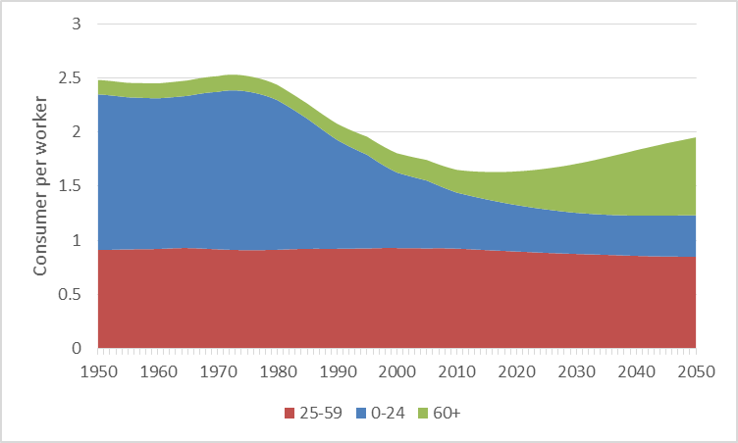

Figure7. Effective consumer per effective worker by age group. 1950-2050 Thailand.

Source: [www.ntaccounts.org](http://www.ntaccounts.org). Accessed October 1, 2015.

The population of young consumers began decreasing along with declining fertility in the mid-1970s. As a result, the effective number of consumers per effective producer dropped substantially. This has an important implication for Thailand’s future. For at least four decades, Thailand has experienced a favorable period in terms of population age structure, somewhere between the current situation in India and Japan. This has contributed to outstanding economic growth, producing the first demographic dividend. The decrease in the ratio is a transitory phenomenon though. The number of elderly, as a proportion of the whole population is growing rapidly and hence the ratio is projected to increase again beginning 2016. Current estimates indicate that in 2050 Thailand will have the equivalent of 1.95 consumers for each worker in the population.

The public transfer profiles are most important for the model in this paper (Figure 8). Public transfer outflows flow mostly from prime age adults to children and elderly. Net transfers relative to YoLY are positive for children ages 0-23 (ranging from 0.11 to 0.41) and elderly ages 65 and older (ranging from 0 to 0.11), and low for people ages 24-64 (ranging from -0.2 to 0). Public transfer inflows benefit children most in Thailand, but net public transfers to the elderly are relatively modest in Thailand. Net public transfers are essentially zero at age 65 and only about 0.05 YoLY at age 75 in year 2015. Thus, in the absence of public policy reform, population aging will not create pressure on the public sector, but will place a great deal of pressure on the private sector.

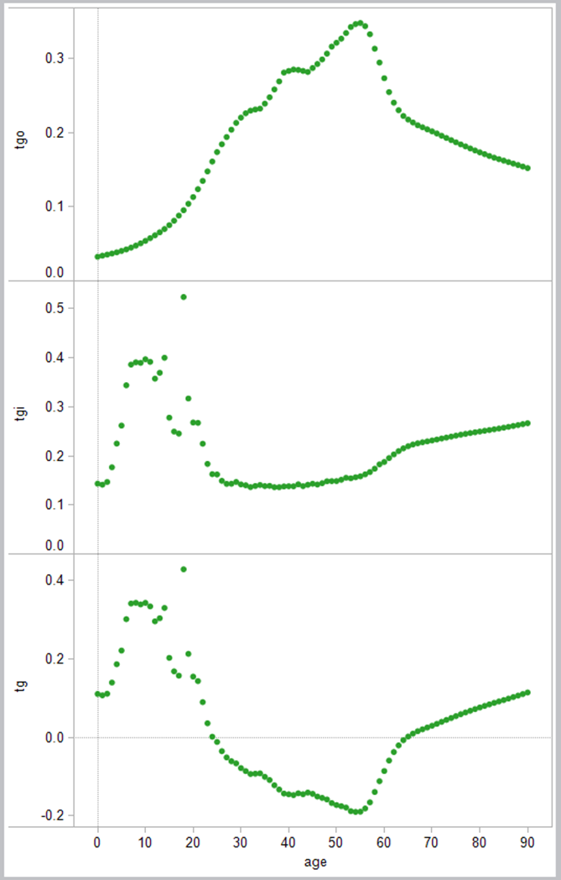

Figure 8. Normalized public transfers outflow, inflow, and net public transfers, 2011.

Source: www.ntaccounts.org. Accessed October 1, 2015.

1. **Results**

Model in brief

The simulation model is described in detail in Mason, Lee et al (2015). The purpose of the model is to assess how changes in population age structure will influence the public sector given exogenously specified policies that govern taxes and spending. Population is incorporated into the model by relying on annual population projections by single year of age. Aggregate economic growth depends on growth in the population at each age and changes in the nominal labor income. The growth rate in the nominal labor income is introduced using an exogenous, time varying rate of productivity growth that leads to increases in counties per capita labor income. Aggregate labor income is then determined by the population at each age and labor income at each age. Aggregate asset income is assumed to grow at the same rate as aggregate labor income maintaining a constant share of total primary income (asset income plus labor income).

Per capita taxes paid at each age are determined by the tax profile and productivity growth. Aggregate taxes are determined, in turn, by the population at each age and per capita taxes paid at each. Thus, all public spending and public transfer flows are determined by three factors: productivity growth, the relevant public transfer age profile, and population at each age. The gap between tax revenues and public transfer inflows is equal to the public transfer deficit. Public asset reallocations equal public asset income less saving the public transfer deficit by definition. Public asset income is determined by the exogenously given public interest rate and public assets (or debt). Public assets at the end of the year equal public assets at the end of the preceding year plus public saving, equal in turn to public tax revenues less public transfer outflows.

The private sector model tracks how changes in population age structure and public policy reform influence the resources available to members of each age and the responses in private consumption, private saving, and private inter- and intra-household transfers. In our model, inflows consist of labor income, transfer inflows, and asset income while outflows consist of consumption, transfer outflows, and saving and inflows and outflows are jointly or simultaneously determined. That is, as inflows must equal outflows for each age group and for the economy as a whole, any change in private transfer outflows produces an equal change in private transfer inflows. For example, if taxes are increased for a particular age group, this will influence the transfers they make to those with whom they are linked. The change in inflows to these age groups will, in turn, influence the transfers those age groups make to others. The iterative simulation model and a household transfer matrix projects private flows and stocks including private assets and private transfer wealth.[3]

We consider two policy scenarios and two constraints. The policy scenarios consist of the status quo scenarios and target scenarios. The status quo scenario holds normalized public sector age profiles fixed at their base year values. This scenario is useful, for example, for accessing the implications of changes in population age structure in the absence of changes in public policy. The target scenario is designed to allow for a transition from the age profiles in the base year to exogenously specified alternative age profiles. The year at which the transition begins and is completed are exogenously specified (or triggered by per capita GDP). The transition path is linear. The two constraints are the size of government constraint and the national debt constraints. The size of government constraint imposes an upper limit on taxes and/or public transfer inflows as a share of GDP. The constraint is incorporated by rescaling the tax and/or public transfer inflow age profiles. In other words the value at each age is reduced by the same percentage. The public debt constraint also imposes an upper limit on public debt as a percentage of GDP. If the debt to GDP ratio is projected to exceed the cap at the end of an exogenously specified planning horizon, taxes are scaled upward by an amount sufficient to satisfy the constraint at the end of the planning horizon. In combination with these constraints, we consider four cases for Thailand, i) the status quo with no constraints, ii) low net public transfers (capitalist) with constraints, iii) high net public transfers (social welfare) with no constraints, and iv) the high net public transfers with constraints.

Status quo results

This section presents results under the status quo assumptions. Three inflows to age groups in Thailand are shown in Figure 9. Labor income and public cash transfer inflows are fixed by assumption. As public transfers profiles are fixed by assumption, per capita private asset income drops sharply as the number of elderly surviving increases.

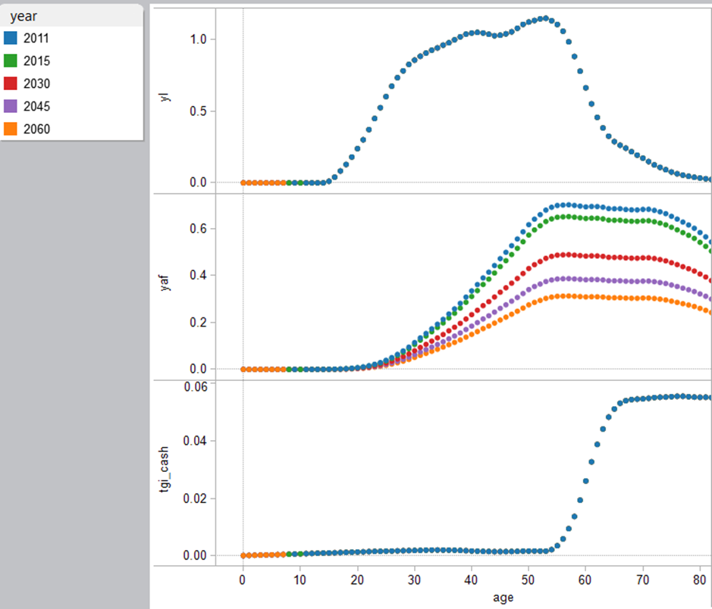

Figure 9. Normalized labor income (yl), private asset income (yaf), and public cash transfer inflows (tgi_cash). Thailand, selected years. status quo scenario.

The combined impact of the decline in per capita asset income for the elderly and population aging on private transfers is very dramatic as shown in Figure 10. Note that inflows must equal outflows for each age group and for the economy as a whole. In Thailand, private transfer outflows from the middle-aged and the elderly decline very substantially while those from younger adults (under 40) change very little. Private transfer inflows decline at all ages this leads to a redistribution of private resources from children to the elderly.

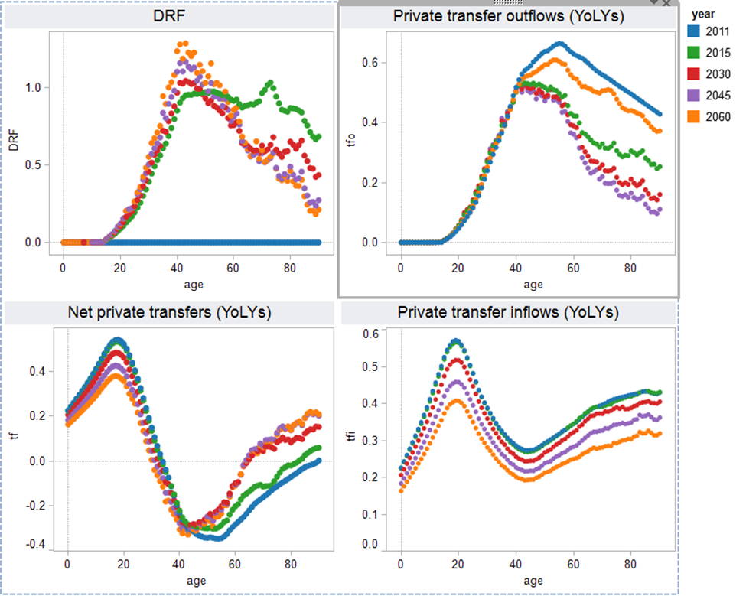

Figure 10. Private dependency ratio (DRF) and private transfer outflows, inflows, and net for Thailand, selected years, status quo scenario.

The impact on consumption is shown in Figure 11. Public consumption is fixed at the 2011 level while private consumption declines at all ages except among the very old. Private consumption remains somewhat elevated for those in their late 20s and mid-50s and lowest among those who are in their mid-40s and 70s. Those at the older ages appear to have lower private consumption. This is offset to some extent by public consumption. Population aging does not lead to deficits under the status quo scenario. Public saving would be positive and rising steadily as a share of GDP eventually reaching an unrealistic 15 percent of GDP. Public assets would as a consequence exceed 3.5 times GDP at the end of the century. This is not a realistic outcome and it seems likely that as Thailand continues to develop and age, public spending on the elderly will increase.

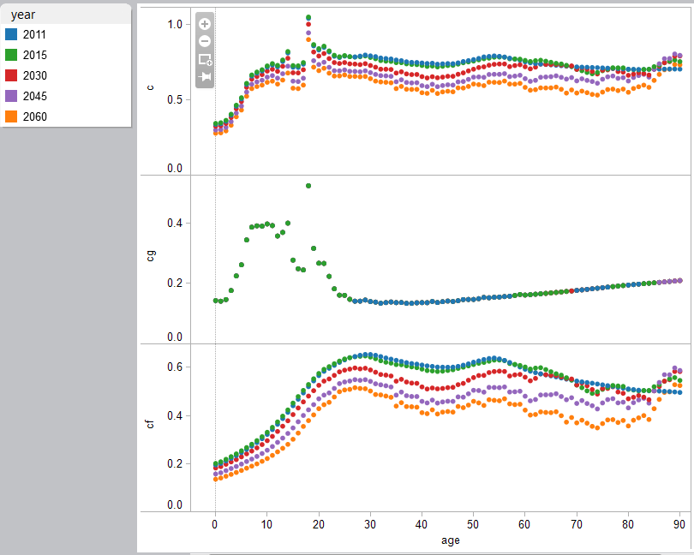

Figure 11. Consumption by age, combined, public, and private, Thailand, status quo scenarios.

Capitalist transformation scenarios

The capital scenario for Thailand would begin in 2020 and be completed by the time it reach high income status in 2063. Under the capitalist scenario, as compared with current spending normalized per capita public spending on children would decline and public transfers to the elderly would rise sharply. The shifts in public transfer inflows and outflows are shown in Figure 12. The public transfer outflows increase mostly sharply for young and middle aged adults. Net public transfers decline the most for those in their late thirties and forties. The impact of public sector spending is to increase consumption of the elderly relative to labor income and to reduce consumption by adults and children. Both private and public consumption at older ages rise sharply.

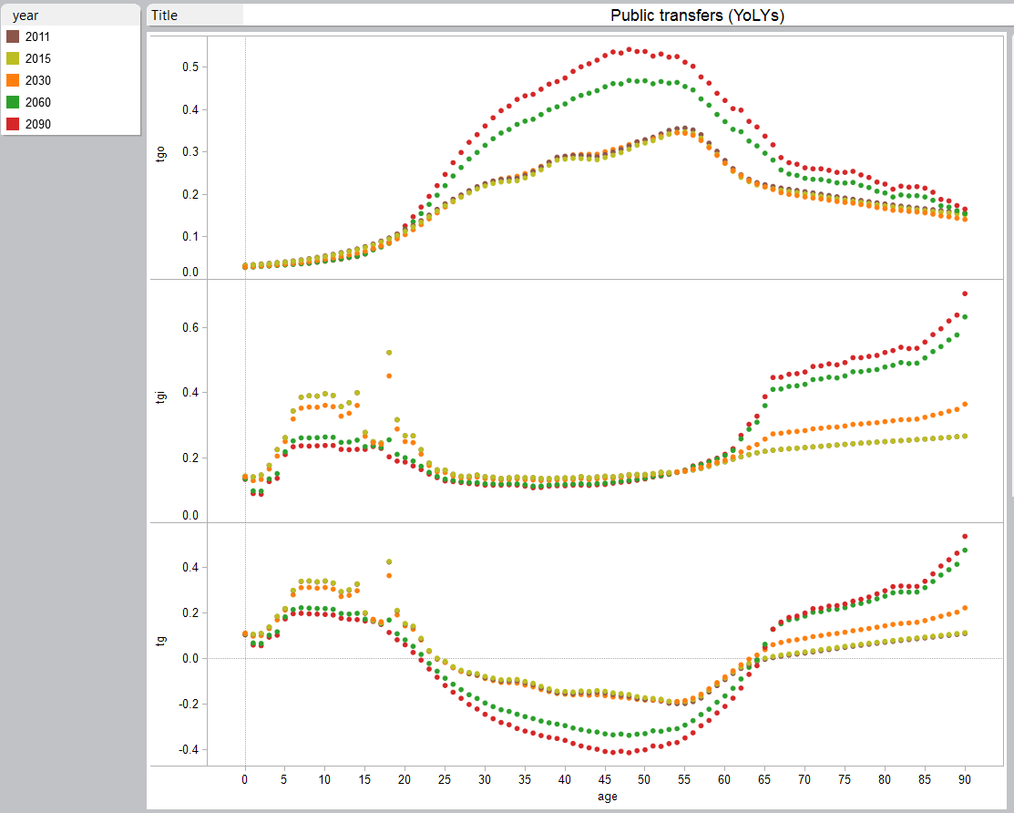

Figure 12. Public transfers by age, Thailand, selected years, capitalist scenario. Constraints are imposed to insure that public transfer inflows do not exceed 35 percent and public debt does not exceed 90 percent of GDP.

The impact of public sector spending is to increase consumption of the elderly relative to labor income and to reduce consumption by adults and children. Both private and public consumption at older ages rise sharply (Figure 13).

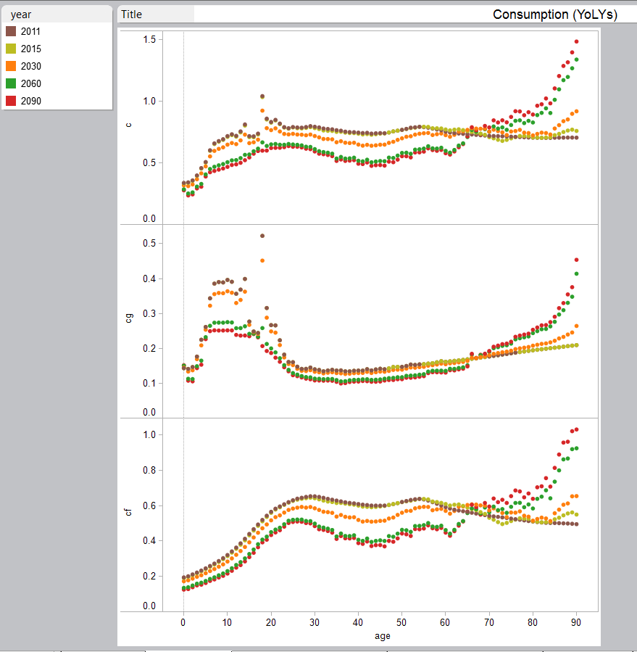

Figure 13. Normalized consumption by age, Thailand, capitalist scenario

Comparison with social welfare scenarios

The social welfare scenario is similar to the capitalist scenario as per capita public spending and consumption on children would decline and public transfers and consumption to the elderly would rise sharply. The major difference between the capitalist approach and the social welfare approach is that the transfers to the elderly increases even more sharply. The public transfer inflows reaches 35 percent in 2050 under the social welfare approach (Figures 14 and 15)



Figure 14. Public transfers by age, Thailand, selected years, social welfare scenario. Constraints are imposed to insure that public transfer inflows do not exceed 35 percent and public debt does not exceed 90 percent of GDP.



Figure 15. Normalized consumption by age, Thailand, social welfare scenario

Figure 16 shows the results for the public transfer inflows as a share of GDP for all different scenarios. The size of the Thai government is about 17 percent of GDP in 2011. The government size constraints binds in 2050 in case of social welfare transformation assumption. Without constraints, the government size reaches 44 percent and 27 percent in 2060 in case of social welfare transformation and capital transformation, respectively.

Figure 16. Government transfers as a share of GDP. Thailand, all scenarios.

Components for public asset based reallocations are presented in Figure 17. All components are expressed as a share of GDP for all different scenarios. The impact on public finances under the social welfare transformation become quite noticeable in 2025 when public saving begins to decline and public assets grow more slowly. As the government size binds in 2050, the public saving starts to rise again slowly, and hence the public asset based reallocation starts to decrease. Due to the constraint, the public saving increases beginning 2050.

Figure 17. Public assets (AG), public asset-based reallocations (RAG), public asset income (YAG), and public saving (SG).

1. **Concluding remarks**

Thailand has experienced very rapid changes in economy, population structure, and public budget structure during the past three decades. As the country becomes richer, the government policy has been geared more toward social development. As the simulation results suggest, the government debt will rise very rapidly if this trend continues in the future.

It seems that the Thai government has focused on expanding the social development to their broad citizens. So far, Thailand has had some advantage since the cost per person has been kept low. Thus, even with rapid population aging, currently, the cost of social policy expansion does not appear to be large. However, healthcare for the elderly is a large and increasing cost that is often heavily subsidized by the public sector, hence this advantage may not be sustainable. People may live longer, but they may not live healthier for the extended life. The huge long-term care cost observed in many developed countries might be inevitable. Thus, rapid aging in Thailand can eventually lead to large implicit debts that are shared by taxpayers and the adult children of the elderly.

In particular, if labor income and familial transfers play a limited role in the future, Thai will have to rely on accumulating assets or public transfers. Undoubtedly, in the future, there will a growing demand for more public transfers. Thus it will be critical for Thai government to effectively and efficiently design public support over the lifecycle. Population aging implies a pronounced increase of dependent elderly as compared with dependent young people and at the same time an aging and shrinking of the productive age group. Since public transfers cover most of the lifecycle deficit of the elderly, the sustainability of the current welfare state is in question. Pension reforms are called for that encourage higher participation rates of older workers. The sheer speed of Thailand demographic transition adds a sense of urgency to policymakers’ tasks.

One alternative strategy for supporting the elderly and achieving strong, sustained growth is to promote investment in physical capital. The other strategy is to promote investment in human capital to make workers more productive, which is a strategy very much in line with Thai government’s high spending on education and health. Human capital investments again require taxes and public transfers. However, unlike the old-age support, public investment in child might be a more attractive policy option for Thai government to promote growth and maintain fiscal sustainability in the future.

**References**

International Health Policy Program. 2013. *National Health Accounts of Thailand.* Bangkok: International Health Policy Program. Accessed October 1, 2015 <http://ihpp.thaigov.net/index.php?option=com_content&view=article&id=215>

Kirtikara, K. 2001, *Higher Education in Thailand and the National Reform Roadmap*. Paper presented at the Thai-US Education Roundtable, Bangkok. Accessed October 1, 2015 <http://www.kmutt.ac.th/pi/backup/fileKK/Higher%20Edu%20Reform%20Roadmap.pdf>

Lee, R. and A. Mason (eds). 2012. *Population Aging and the Generational Economy*. Cheltenham, UK and Northampton, MA, USA, Edward Elgar.

Mason, A., R. Lee, D. Stojanovic, and M. Abrigo. 2015. “The Impact of Population Aging on Public and Private Economic Flows”, National Transfer Accounts Working Paper 15-04.

National Economic and Social Development Board (2012).*National Income of Thailand 2011Chain Volume Measures* (Annual Report, 2011 edition). Bangkok: Office of the National Economic and Social Development Board. Accessed October 1, 2015 <http://www.nesdb.go.th/Default.aspx?tabid=94>

_______________________. 2013. *Population Projections for Thailand 2010-2040.*Bangkok: Office of the National Economic and Social Development Board.

National Health Security Office. 2012. *The Thai Health Security System* (in Thai)*.* Bangkok: National Health Security Office. Accessed October 1, 2015 <http://www.nhso.go.th/frontend/NewsInformationDetail.aspx?newsid=NjI3>

National Statistical Office (several editions). *Population and Housing Census.* Bangkok: National Statistical Office.

National Statistical Office. 2012. *The 2011 Household Socio-Economic Survey: Whole Kingdom.* Bangkok: National Statistical Office.

_______________________ 2012. *The 2011 Health and Welfare Survey: Whole Kingdom.* Bangkok: National Statistical Office.

Pananiramai, M. 2007. *Effects of Change in the Method to Close the Deficit and Implications for Welfare State* (in Thai).Paper presented at the TDRI Year-end Conference 2007 in Pattaya, Thailand. Accessed October 1, 2015 [http://tdri.or.th/wp-content/uploads/2013/02/g3_mattana. pdf](http://tdri.or.th/wp-content/uploads/2013/02/g3_mattana.%20pdf%20)

Sakunphanit, T and W. Suwanrada 2011. 500 Baht Universal Pension Scheme. In ILO-SU/SSC (Eds.), *Sharing Innovative Experiences: Successful Social Protection Floors Experiences,* Vol.18 (pp. 385-399). Accessed October 1, 2015 <http://www.socialsecurityextension.org/gimi/gess/ShowRessource.action?ressource.ressourceId=24378>

United Nations. 2013. *National Transfer Accounts Manual: Measuring and Analysing the Generational Economy.* Population Division of the Department of Economic and Social Affairs of the United Nations Secretariat. New York: United Nations Publication.

United Nations Education, Scientific and Cultural Organization (UNESCO) (2000). *The EFA 2000 Assessment Thailand Country Report.* Paris: UNESCO. Accessed October 1, 2015 <http://www.unesco.org/education/wef/countryreports/thailand/contents.html>

United Nations Population Fund (UNFPA) and National Economic and Social Development Board. 2011. *Impact of Demographic Change in Thailand.* Bangkok: UNFPA.

World Bank. 1993. *The East Asian Miracle: Economic Growth and Public Policy*. New York: Oxford University Press.

1. The Office of the National Economic and Social Development Board, Thailand
2. Corresponding author. University of Hawaii at Manoa and East West Center. 2424 Maile Way, Honolulu, HI 96822, USA. [Leesang@hawaii.edu](mailto:Leesang@hawaii.edu)
3. Predetermined inflows are labor income, public transfer inflows, and public asset income. Predetermined outflows are public consumption, public transfer outflows, and public saving. Intra-household transfer inflows will not equal outflows in the simulation because the population data used in the model will have a different age distribution that the survey population used to construct intra-household transfers. Equality is imposed for both consumption and saving of intra-household transfers.