Generational Connections, Population Aging, and Sustainable Consumption

Andrew Mason (University of Hawaii at Manoa)

Naohiro Ogawa (Asian Development Bank)

Rikiya Matsukura (Nihon University)

Ron Lee (University of California, Berkeley)

Gretchen Donehower (University of California, Berkeley).

March 3, 2025

Population aging requires shifts in the generational economy that would otherwise lead to large, and impossible, imbalances. Many responses are possible. Labor income could increase if people work longer. Consumption could decline and be spread over a longer life. Transfers could shift with reduced per capita inflows to seniors and higher per capita outflows from younger adults. Seniors and others could save less leading to greater asset-based reallocations that would mitigate the desire for greater consumption. This paper presents a model to quantify the long-run possibilities in the face of changes in population age structure. Analysis using NTA data for Japan from 1984 to 2019 and for the US from 1990 to 2019 shows that current consumption levels are unsustainable in either country. The model considers alternative scenarios varying fertility and mortality, the growth of labor supply, and the reliance on transfers and asset-based reallocations to children and seniors.

# Introduction

The economic implications of aging and the policies that will effectively respond to perceived challenges are difficult to assess because there are many uncertainties. What will be the path of fertility and how will it affect the number of workers and the tax base? To what extent will people work longer in the future and, if so, at what wage? For how many years can individuals expect to live in retirement? How will public pensions and health care systems shift in response to unfavorable demographics and fiscal challenges? Can seniors expect to rely on their children if public resources prove to be insufficient? Can people save enough to support themselves? Will returns to assets be sufficient to support the building of retirement wealth? The model presented here provides a framework for addressing these issues.

The most important finding is that current levels of consumption are unsustainable in Japan and the United States. Two factors account for this conclusion. First, life expectancy is rising in both countries leading to an increased in years spent consuming relative to years spent producing. Retirement is a growing segment of the lifecycle. The effects of an increase in the years spent in retirement are exacerbated by growth in per capita old-age consumption, particularly spending on health care. Second, old-age support systems are eroding or will erode in the future. Seniors rely heavily on transfers funded by younger generations. The number of those receiving transfers is rising relative to the number of those providing transfers due to increases in life expectancy and to fertility decline. Total transfer inflows and outflows must balance and, hence, increases in the ratio of beneficiaries to providers must be matched by a decline in the per capita inflows received by beneficiaries relative to the per capita outflows from providers. The constraint to which transfer systems are subject applies both to public and to private transfers.

Population aging requires shifts in the generational economy that would otherwise lead to large, and impossible, imbalances. Many responses are possible. Labor income could increase if people work longer. Consumption could decline and be spread over a longer life. Transfers could shift with reduced per capita inflows to seniors and higher per capita outflows from younger adults. Seniors and others could save less leading to greater asset-based reallocations that would mitigate the desire for greater consumption. This paper presents a model to quantify the long-run possibilities in the face of changes in population age structure. Analysis using NTA data for Japan from 1984 to 2019 and for the US from 1990 to 2019 shows that current consumption levels are unsustainable in either country. The model considers alternative scenarios varying fertility and mortality, the growth of labor supply, and the reliance on transfers and asset-based reallocations to children and seniors.

Japan faces more serious problems than the US, because Japan is experiencing more severe aging and because Japan depends more heavily on transfers to support seniors. Although Japanese seniors consume less than Americans relatively to what they earn, consumption by seniors in Japan has shifted sharply higher in recent years. Finally, rates of return to capital are low in Japan, as compared with the US, increasing the costs of accumulating retirement assets in Japan.

Despite these advantages, the US is experiencing its own challenges. Americans are consuming more than can be sustained. If people do not consume less and save more, the problem will become even more severe if, as expected, fertility declines and life expectancy increases over the coming decades.

Consumption was sustainable before rapid population aging began. This was true of Japan in 1984 and the United States in 1990. On average, people were generating enough resources over the lifecycle to maintain consumption. This is no longer the case and will not be the case in the future.

The analysis draws heavily on population estimates and projections from the United Nations (UN 2024) and estimates of National Transfer Accounts (NTA) for Japan and the United States that span 35 and 29 years, respectively. Complete NTA for Japan are available at 5-year intervals from 1984 to 2019 (refs) and annually in the United States from 1990 to 2021 (refs). Our analysis uses NTA available for the earliest available years, 1984 in Japan and 1990 in the United States, and data for 2019, avoiding the effects of COVID-19.

The research presented here builds on many previous studies of population aging incorporating NTA data and concepts including Lee et al. 2003, Lee and Mason 2014, Lee and Mason 2001, and Mason et al. 2022. THIS COULD BE EXPANDED TO INCLUDE ADDITIONAL RESEARCH

The paper proceeds in the following way. The first section reviews basic foundations that bear on the relationship between population age structure and consumption. The second section presents a formal model of sustainable consumption. The third section reports results for Japan and the United States including estimates of the effects of fertility, life expectancy, support systems, and rates of return. The final section provides further discussion of results.

# Foundations

National Transfer Accounts (NTA) is a useful tool because it documents how any economy generates and uses resources during the year of interest (Lee and Mason, 2011 and United Nations Population Division, 2013.) In this respect NTA is very similar to the System of National Accounts (SNA) and constructed to complement SNA. NTA is distinctive, however, because the estimates are disaggregated by age. Age-based estimates are useful for many reasons, but the one exploited here is their use to analyze the lifecycle.

The lifecycle is conceptualized as consisting of four phases. At young and old ages, the first and fourth phases of the lifecycle, people do not produce enough through their labor to support their consumption. Their lifecycle deficits, the differences between consumption and labor income, must be funded relying on reallocations comprised of transfers and asset-based reallocations. During the second and third phases of the lifecycle, labor income exceeds consumption, generating a lifecycle surplus. The second phase is distinctive because the surplus is used to provide support for children. The third phase emphasizes generating resources needed for retirement.

Transfers are cash and in-kind flows including family transfers and flows mandated by governments. At any point in time, transfers must balance with the net inflows to deficit age groups equal to the net outflows from surplus age groups. The balance does not hold exactly because of net transfers to the rest of the world, but these are assumed to be zero in the analysis presented here.

Asset-based reallocations consist of asset income and dis-saving, i.e., asset income less saving. Asset-based reallocations can be public or private. Asset-based reallocations fund the lifecycle deficit if asset income exceeds saving. Asset-based reallocations influence the economic sustainability of an economy, because lower saving leads declining assets, low asset income, and a decline in the resources available to funds future lifecycle deficits.

As children progress through life, they rely primarily on transfers to fund their lifecycle deficits. In some countries, including the United States but not Japan, those in their late teens and early twenties rely on asset-based reallocations, student loans or credit cards to fund their needs, but transfers are much more important.

The second phase of the lifecycle is distinctive because of the emphasis on childrearing. Transfer outflows to children are important because parents provide goods and services directly to their children, who are family members, but also because they pay taxes that fund public programs providing cash and in-kind transfers to children. During the third phase of the life cycle, attention turns to old-age needs. Adults rely on assets-based reallocations, saving towards old-age, and they pay taxes, public transfers, for public programs that fund pensions, health care, and other needs of seniors.

In the final phase of the lifecycle, seniors can fund lifecycle deficits relying on transfer inflows, asset-based reallocations or both. In practice, the balance varies widely across countries. Japan and the US have balanced systems with Japan relying more heavily on transfers and the US on asset-based reallocations. The balance between transfers and asset-based reallocations has changed very little in the recent past – since 1984 in Japan and 1990 in the United States.

Intergenerational flows are governed by important aggregate constraints. In the absence of net transfers from the rest of the world, aggregate transfer inflows must equal outflows. Net transfers are zero. They can be used to redistribute resources across age groups, but they cannot be used to increase consumption for one age group without reducing consumption for another. Asset-based reallocations are also constrained at the aggregate level. Setting aside international capital flows, aggregate credit must be zero. Thus, aggregate asset-based reallocations are constrained by the return to capital and the extent to which asset income is saved or dissaved. Saving has a dynamic effect on the economy by influencing the path of assets and, hence, asset income over time.

The generational economy is also governed by longitudinal constraints or constraints experienced by cohorts. Consider a representative cohort consisting of all individuals born in year t, at age 0, and surviving the maximum age  in year . By assumption the members of that cohort begin and end life with no wealth. This is a feature of the focus on sustainable consumption. They neither inherit nor bequeath wealth. In other words, they are completely self-sufficient

Although assets and transfer wealth can be treated separately, we emphasize the combined values, transfer wealth plus assets, referred to as wealth (Willis, 1988, Lee 1994a, b). A cohort’s wealth is zero at birth. Due primarily to negative transfers early in life, debt grows at young ages. These obligations are repaid as the cohort proceeds through the childrearing phase of the lifecycle. Eventually wealth reaches zero and, thereafter, rises as the cohort accumulates wealth needed to support old-age needs. This wealth consists of asset and transfer wealth, the obligations from younger generations to provide old-age support. During the final phase of the lifecycle the cohort’s wealth declines as the value of expected future transfers and assets declines. At the end of life, transfer wealth is zero. Assets at the end of life due to uncertainty about the age at death are avoided by assuming that the cohort relies on costless annuities (Yaari 1965).

To summarize, the lifecycle experience is comprised of four phases of wealth (Figure 1). The young have no wealth at birth and accumulate debt during the first lifecycle phase, identified as the age at which lifecycle debt reaches its maximum. During the childrearing phase, adults support the young by paying or directly providing cash and in-kind transfers. Over the childrearing phase, lifecycle debt declines as adults pay off the debt incurred during their childhood. The end of the childrearing phase is marked by the age at which lifecycle wealth goes from negative to positive.

Figure 1. The lifecycle of wealth illustrated.

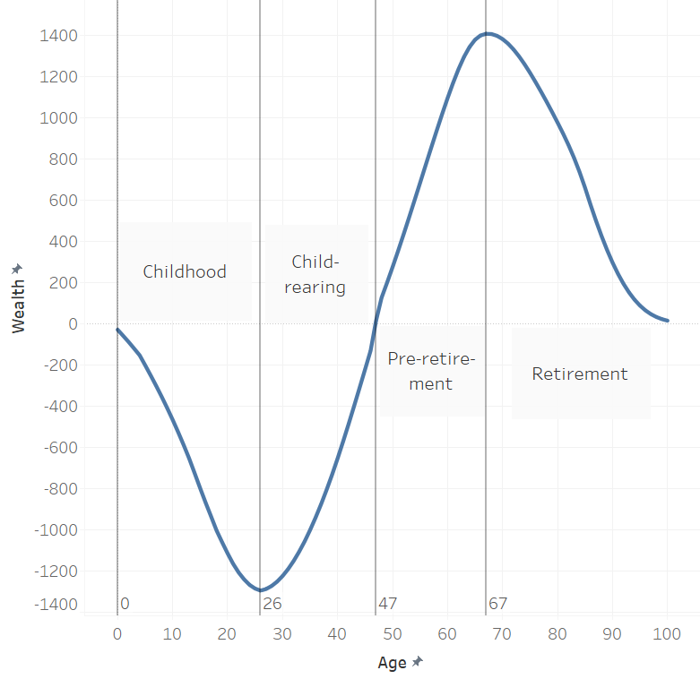

Note. Values are based on the US 2019 baseline scenario. Wealth is expressed as a percent of average core labor income for members of a birth cohort.

During the third lifecycle phase wealth is accumulated in anticipation of old-age needs, and, in the fourth phase, wealth declines as it is used to fund the lifecycle deficits faced at old-ages.

Lifecycle phases are assumed to be mutually exclusive, but the reality is that the phases overlap. Younger adults accumulate wealth devoted to their retirement and grandparents provide support to children. We rely on distinct phases to achieve analytic tractability.

The analysis presented here is confined to sustainable paths of consumption and wealth. By sustainable we mean that successive generations or cohorts begin and end life without depending on the wealth of other generations. Transfer debt accumulated at one age is repaid at another and, likewise, members of a cohort can only rely on accumulated assets to support their consumption. Wealth at the beginning and wealth at the end of life are zero (Willis 1988). A broader definition of sustainability would accommodate wealth that is constant in present value terms as it is passed on from generation to generation. This wealth could be used to increase or reduce consumption along some path.

# Simulation Model

Population and economic series are presented in turn. For both, age-profiles are given at a point in time, i.e., cross-sectional data, and for a representative cohort. The representative cohort is central to the simulations while the cross-sectional data are used primarily for descriptive purposes.

## Population

The analysis is limited to stable populations. Age-specific fertility and mortality rates are assumed to be constant and the population is closed to immigration. Given these assumptions the population growth rate and the age distribution of the population do not change over time. The total fertility rate is exogenous and used to infer the population growth rate. A total fertility rate of *f* and a mean generation length of 30 years implies a population growth rate, *n*, of approximately:



where replacement fertility is 2.1. The population of each age x in year t depends on the number of births in year t-x and the chances that those born in year t-x will have survived to age x. Let *B(t)* be the number of births in year t, then B(t-x) is equal to  Survival rates employ the lifetable with L(x) representing the person years lived by at age x by 100,000 births. The population of age x in year t is equal to:



The age distribution of the population is:



where  is the maximum years of life. The age distribution is determined by mortality and the rate of population growth and is independent of year.

A representative cohort is of particular interest to this analysis[1]. The cohort consists of the population born in year t that is tracked over its lifetime, 0 to , at age x in year t+x. The representative cohort is born in year t. The cohort population is:



And the age profile of the cohort (and the distribution over age of person years lived by the cohort) is:



Note that the age profile of a cohort will be steeper than the age distribution of the population if the population growth rate is negative. The population will be older than the distribution of years lived by the cohorts that comprise that population.

## Aggregate Income and Wealth

Per capita income and consumption at any age changes with increases in productivity. The age profiles might also change because of shifts in the age patterns of labor income and consumption. In the analysis presented here, however, we assume that the age patterns established in the baseline year persist. Thus, per capita age profiles of labor income and consumption upward at the rate of productivity growth, . The per capita age profiles of labor income and consumption in the baseline are designated by  and . Notation is simplified by setting the baseline year to zero. Thus, the per capita labor income and consumption profiles in year t are equal to:



Aggregate labor income and consumption at age x in year t is equal to:



using upper case letters to represent aggregate flows.

A cohort born in year t will experience labor income and consumption flows over its years of life equal to:



Aggregate labor income and consumption at age x for birth cohort t equal to:



Wealth and lifecycle phases

For a birth cohort wealth consists of assets and transfer wealth that vary over its lifespan. At birth, wealth is zero by assumption. Over time, however, children accumulate debt (negative wealth) because they must “borrow” to fund the lifecycle deficit, the gap between consumption and labor income. At each age, the stock of debt is equal to the debt accumulated at earlier ages, accrued interest on the accumulated debt, and additional debt required to fund the current lifecycle deficit. Once young people complete the deficit years of early life, they realize lifecycle surpluses on which they can rely to repay child debt. If the child debt is in the form of a negative asset, such as a loan, that debt plus interest must be paid to creditors. Much more frequently, intergenerational transfers are “repaid” through support of the subsequent generation of children. As the loan is repaid, lifecycle debt declines and reaches zero – a point at which the “financial” obligations to the next generation have been fulfilled. We mark the age at which this occurs as the end of the childrearing phase of the lifecycle.

Over subsequent ages, the cohort satisfies its lifecycle obligation by accumulating wealth that reaches a peak at “retirement” and then declines as wealth, both assets and transfer wealth, funds the lifecycle deficit that characterizes the retirement ages. Would the cohort members have sufficient time to accumulate the necessary wealth? Possibly but not necessarily.

If wealth is sufficient to fund old-age needs the lifecycle deficit will equal wealth in the final age of life, . Likewise, wealth at each previous age must be sufficient to fund the current deficit while leaving enough to fund needs at later ages. Working backwards from the end of life, the entire age profile of wealth can be constructed. It will reach zero at an age, the beginning of the pre-retirement phase, that the accumulation of retirement wealth must begin in order to sustain the specified consumption path.

If the age at which accumulating for retirement is less than the age at which childrearing responsibilities have not been completed, then the lifecycles of consumption and labor income are not sustainable.

The interest paid on assets is the market rate determined in financial markets. The interest paid on transfers is very different and governed by an underlying social contract. Per capita consumption rises at the rate of productivity growth and, therefore, per capita transfers required to fund consumption also rises at the rate of productivity growth. Total transfers grow at the rate of productivity growth plus the rate of population. Thus, transfers received at one age are repaid by transfers at a subsequent age and increase by the rate of aggregate economic growth. Transfers are governed by the biological rate of interest (Samuelson 1958).

The price of intergenerational reallocations depends on the mix of transfers and asset-based reallocations or the weighted sum of the biological interest rate and the market rate with weights equal to the shares of reallocations realized through transfers and asset-based reallocations.

Sustainability is achieved when the ages at which childrearing is completed and the accumulation of wealth towards retirement begins are the same. If the age at which childrearing obligations are satisfied exceeds the age at which the accumulation of retirement wealth must begin, the accumulation of wealth towards retirement will be insufficient. Or, alternatively, childrearing obligations will not have been satisfied. Hence, to achieve sustainability consumption must be lower relative to labor income. Alternatively, childrearing obligations may be satisfied before the accumulation of retirement wealth begins. In this case, sustainable consumption will be higher relative to labor income.

The consumption profile used in the simulations are expressed relative to the mean labor income of people 30 to 49 years-of-age. Thus, sustainability can be achieved by shifting the normalized values of consumption up or down. Sustainable consumption can be realized by shifting consumption profiles or labor income profiles or both.

Two assumptions underlying the model should be emphasized. The first is that the relationships between consumption, labor income, and age are fixed. The age profiles shift up or down but not their shape. Under this assumption, the costs or benefits of changes in age structure affect people at all ages equally in percentage terms. If aging leads to lower aggregate consumption, for example, people at all ages experience lower consumption. The second assumption is that the price of reallocations to children and to seniors are unaffected by differences in population age structure within those broad groups.

Consumption and labor income are measured as consumption at age x and labor income at age x relative to the mean of labor income at each age for those in the 30-49 age range. Thus, consumption is measured relative to labor income below.

### Child debt

Child wealth for a cohort is measured starting at birth when by assumption wealth is zero. Over subsequent years, wealth declines during the childhood ages depending on the excess of consumption over labor income and interest accrued on previously accumulated debt. Debt reaches a maximum and begins to decline as labor income exceeds consumption. Child debt reaches zero at the end of the childrearing phase. The rate of interest during the child/childrearing phase of the lifecycle, , is assumed to be constant and a weighted average of the rate of return to capital and the biological interest rate. The weights are determined by asset-based reallocations and net transfers as shares of reallocations to children. The path of debt and the age at which it reaches  depends on the exogenously specific level of consumption (relative to labor income),.

Wealth over the child/childrearing phase for the birth cohort born in year t is:



The end of the childrearing phase, , is endogenous identified by the age at which child debt rises to zero. In practice the age at which wealth is closest to zero is identified as the final age of the childrearing phase.

### Retirement wealth

Retirement wealth is equal to zero at the end of life having been accumulated during pre-retirement and dis-accumulated during the retirement phase of the lifecycle. We assume that cohort members rely on lifetime annuities to eliminate uncertainty about the age of death (Yaari 1965). The rate of return to wealth during the retirement and pre-retirement phases is the weighted average of the rate of return to capital and the biological interest rate. The weights are set to the ratio of asset-based reallocations and net transfers to total reallocations for persons belonging to the retirement phase. The potential paths of wealth are simulated by varying the level of consumption,. Only positive values of the wealth profile are relevant with the beginning of pre-retirement, , set to the age at which retirement wealth first turns positive.

Retirement wealth for the year t birth cohort at age x in year t+x is equal to:



where is retirement wealth of the year t cohort of age x in year t+x,  is the rate of return to retirement wealth,  is the age at which the accumulation of retirement wealth first begins,  is the maximum years lived, and other terms are defined above. Note that proportional shifts in the level of consumption relative to labor income,, are exogenously set.

### Sustainability

The sustainable level of consumption is reached when the age at which childrearing ends and the age at which pre-retirement begins are the same. (Because of the discrete nature of the calculations, by selecting the value of  that minimized the difference between the ages. In practice, the minimum is 0 or 1.) See Figure 2.

Figure 2. Sustainable level of consumption, , reached when age at transition from supporting children (x2) to preparing for old-age (x3) are equal.

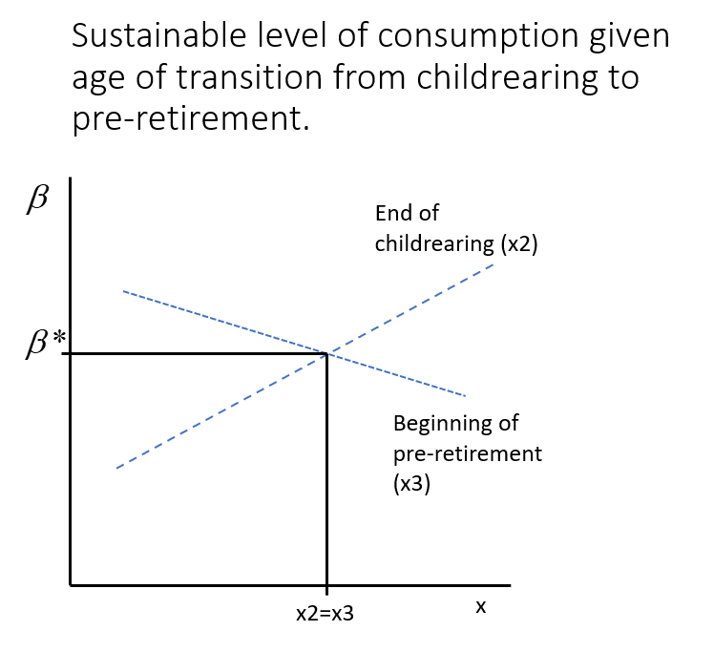

## Model inputs (add references but otherwise should be completed)

Three baseline scenarios are constructed for Japan using inputs for 1984, 2019, and 2065 and for the United States using inputs for 1990, 2019, and 2065.

Mortality is measured using life table data, person-years of life (Lx), by single years of age, 0 to 100+, and fertility is measured using the Total Fertility Rate (TFR). Values are taken from the UN World Population Prospects 2024 (United Nations Population Division 2024). Life-expectancy at birth is used to summarize mortality in Table 1, but is not an input into the simulation model.

Age profiles of real per capita labor income and consumption are based on National Transfer Accounts estimates for Japan, 1984 and 2019 (Reference) and the United States, 1990 and 2019 (Reference). Normalized values are constructed by dividing per capita values by core labor income, the simple average of labor income for persons 30-49. The baseline scenarios for 2065 use normalized age profiles of consumption and labor income for 2019.

The age profiles of per capita consumption for Japan, 1984 and 2019, and the US, 1990 and 2019, are shown in Figure 3. The labor income profiles for both countries shifted upwards because of the gains in labor income at older ages relative to core labor income. Consumption in Japan and the US both shifted upward at older ages particularly in Japan. Consumption among prime age adults declined in Japan.

Figure 3. Normalized per capita consumption and labor income by age, Japan, 1984 and 2019 and the US, 1990 and 2019.

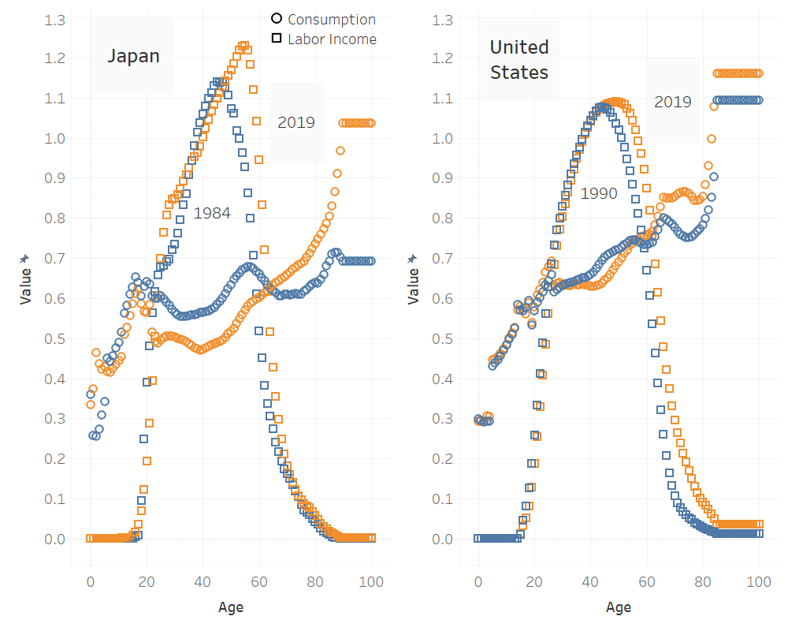

The longitudinal profiles for labor income and consumption are shown in Figure 4. These are normalized labor income and consumption for a cohort of 100 births in the base year, either 1990 and 2019, assuming that the cross-section profile is shifting upward by the rate of productivity growth (1% per year for the US and 1.4% per year for Japan as explained below). The longitudinal profiles are steeper than the cross-section profiles at young ages due to effect of productivity growth. At older ages, the longitudinal profiles decline as the effects of mortality become important. (The longitudinal profiles are per 100 births).

Figure 4. Consumption and labor income for birth cohorts, Japan, 1984 and 2019; US, 1990 and 2019. Simulated values with growth rate of 1.4% for Japan and 1.0% for the US. All values are expressed as a percentage of core labor income.

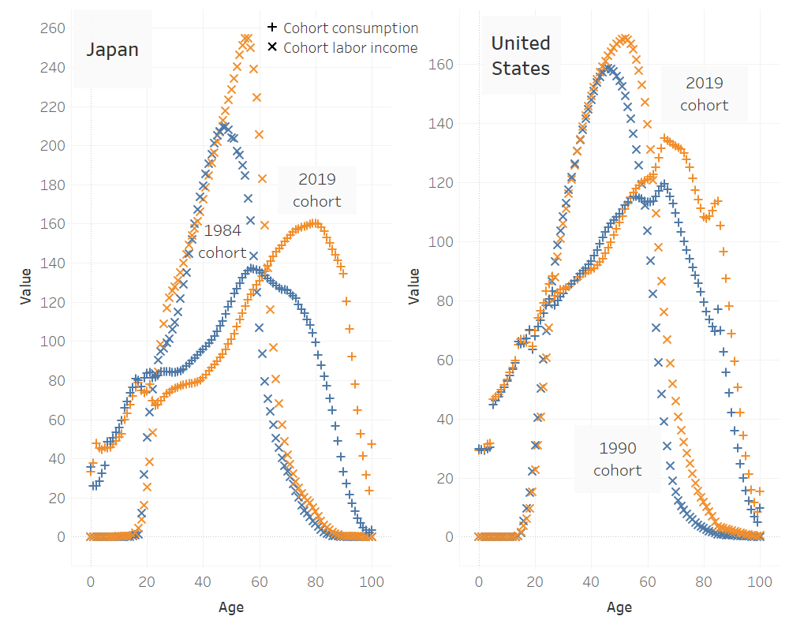

The reallocation systems are summarized by aggregate asset-based reallocations and transfers as a percentage of the aggregate life-cycle deficit for the observed baseline years. For children, the shares are calculated as a percentage of all aggregate net deficits over for children and young adults. (Children and young adults are those falling in the lifecycle deficit ages.) For seniors, the shares are calculated as a percentage of all aggregate net deficits for all older adults defined as the age range of with lifecycle deficit.

The reallocation systems for children are similar in Japan and the US with transfers playing a dominant role. In Japan 1984 and 2019 all reallocations for children were funded by transfers, and in the US 1990 transfers were also dominant funding 97 percent of child reallocations. In US 2019 transfers to children played a more important role than in 1990.

The old-age support systems in Japan and the US have relied on both transfers and asset-based reallocations. Japan placed greater emphasis on transfers: 73% in 1984 and 71.5% in 2019, with the remainder funded by asset-based reallocations. The US relies less heavily on transfers: 32.6% in 1990 and 27.1 percent in 2019 and more heavily on asset-based reallocations reaching more than two-thirds of old-age reallocations.

Productivity growth is estimated using the annual rate of growth of the lifetime labor income for a synthetic cohort of real per capita labor income:



Survival-weighting, person years lived, has little effect on the productivity estimate, but for this purpose survival weights were based on 2019 values for both Japan and the US. Productivity captures changes in lifetime labor income due to changes in labor supply that would arise, for example, if members of the population decided to work longer in t2 as compared to t1. A narrower definition of productivity uses average labor income in the 30-49 age range. Productivity measured in this fashion does not include the impact of increases in the labor supply for those 50 and older. The effects of incorporating increases in labor supply are assessed using the simulation model.

The rate of return or discount rate for wealth depends on the reallocation system. The discount rate for transfers is the biological rate of interest equal to the rate of productivity growth plus the rate of population growth (Samuelson 1958). The rates of return to assets (bonds, bills, equity, and housing) are based on estimates by Jorda et al. (2019) reported in Table XII, p.54.

The input values for Japan and the United States are reported in Table 1. In both Japan and the United States demographic change has led to rapid aging with Japan experiencing much sharper changes. By 2019 life expectancy reached 84.4 years in Japan and 78.9 years in the US with Japan experiencing a much greater increase over the historical period shown. At 1.78 the total fertility rate in Japan was below replacement in 1984 and even lower at 1.32 in 2019. The TFR in the US was at replacement in 1990 and moderately lower in 2019. The UN projects increases in life expectancy and slight changes in fertility in both countries. If UN projections are indicative, the difference between Japanese and US fertility will be smaller in 2065 than is currently the case.

The rate of population growth is determined by the fertility rate as explained in the section on population above.

Table 1. Baseline scenario inputs, Japan and the United States.

|  |  |  |  |  |  |  |  |  |  |
| --- | --- | --- | --- | --- | --- | --- | --- | --- | --- |
| Scenario (Mortality year) | Life expect-ancy | TFR | Pop growth rate (%) | NTA Profile year | Child Transfer Share | Old-age Transfer Share | Prod growth rate (%) | Bio Discount rate (%) | Discount rate (%) |
| Japan | | | | | | | | | |
| 1984 | 77.5 | 1.78 | -0.551 | 1984 | 100.0 | 73.0 | 1.4 | 0.849 | 4.23 |
| 2019 | 84.4 | 1.32 | -1.548 | 2029 | 100.0 | 71.5 | 1.4 | -0.148 | 4.23 |
| 2065 | 90.3 | 1.40 | -1.352 | 2029 | 100.0 | 71.5 | 1.4 | 0.048 | 4.23 |
| United States | | | | | | | | | |
| 1990 | 75.4 | 2.1 | 0.0 | 1990 | 97.0 | 32.6 | 1.0 | 1.0 | 6.58 |
| 2019 | 78.9 | 1.7 | -0.704 | 2019 | 93.4 | 27.1 | 1.0 | 0.296 | 6.58 |
| 2065 | 85.2 | 1.6 | -0.906 | 2019 | 93.4 | 27.1 | 1.0 | 0.0936 | 6.58 |

The simulation model uses “grid search” to determine the sustainable level of consumption, , that minimizes the difference between the ages at which childrearing is completed and pre-retirement begin, .

The inputs for three baseline scenarios are summarized in Table 1. Three baseline simulations are constructed for Japan using inputs for 1984, 2019, and 2065 and three baseline simulations are constructed for the United States using inputs for 1990, 2019, and 2065.

# Results This section seems redundant at the beginning

Current levels of consumption (the 2019 scenarios) are unsustainable in Japan and the United States. In Japan, sustainable consumption is 77 percent of estimated consumption given 2019 conditions. To achieve sustainability would require a 23 percent decline in consumption at every age. In the United States, sustainable consumption is 92 percent of the observed values. To achieve sustainability would require a smaller, but still large, downward shift in consumption of 8 percent (Figure 5).

This assessment tells only part of the story, however, because the observed levels of consumption in Japan and the United States were not the same in 2019. Consider consumption at the core ages, 30-49, relative to labor income at the core ages, as an indicator. In 2019, observed core consumption was 60 percent of core labor income in Japan. By comparison, observed core consumption was 69 percent of core labor income in the United States. The shift to sustainability is much greater in Japan even though the level of consumption was already relatively low. Sustainability of consumption requires that core consumption drop to 46 percent of core labor income in Japan while in the United States sustainable consumption is 64 percent of core labor income (Table 2).

Figure 5. Per capita 2019 age profiles of consumption and labor income and sustainable consumption. All values are normalized on core labor income. Baseline scenarios: 2019 mortality and fertility; 2019 NTA data; see Table 1 for additional simulation parameters. Sustainable consumption is 77% of current consumption for Japan and 92% of current consumption for the US.

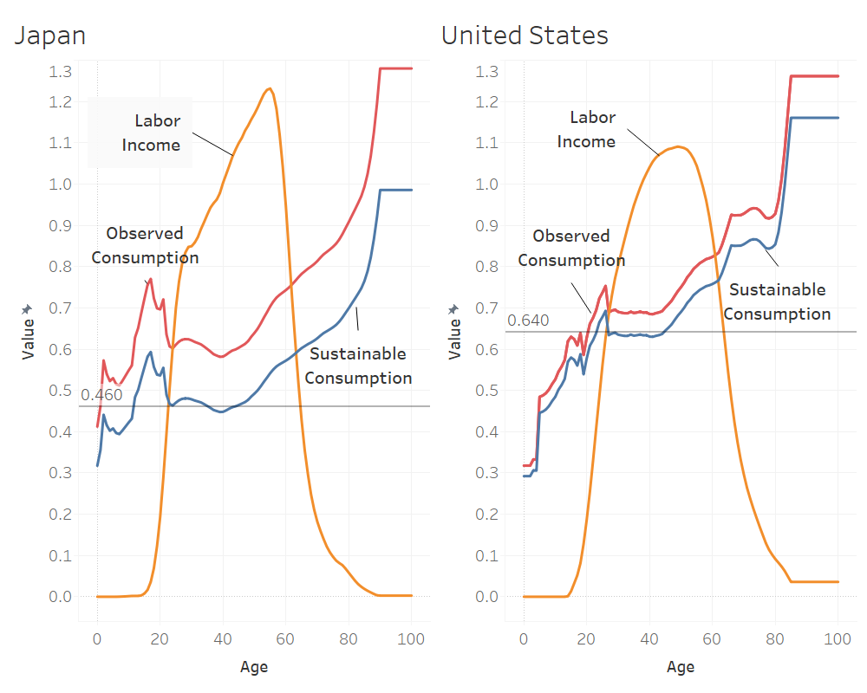

Note. Lines show average consumption of those 30-49 relative to core labor income.

Analysis of the conditions in 1984/1990 are instructive because consumption was close to sustainable in Japan and sustainable in the United States. Sustainability was nearly achieved in Japan in 1984, in part, because consumption, relative to core labor income, was slightly lower than in 2019. More importantly, fertility was higher, life expectancy was lower, and consumption at older ages, relative to core labor income, was much lower in 1984 than in 2019.

Observed consumption in the United States was also lower in 1990 than in 2019 contributing to the 1990 realization of sustainability. Moreover, US fertility and life expectancy were higher in 1990 than in 2019. In addition, consumption by seniors was not as high in 1990 as compared to 2019. In each of these areas, however, the shifts were smaller in the United States than in Japan.

The final set of baseline simulations assess the implications of further aging due to changes in fertility and life expectancy to levels anticipated for 2065. Changes in fertility are expected to be modest with a rise in TFR by 0.1 in Japan and a decline by 0.1 in the United States. The more important demographic change is anticipated in life expectancy rising to 90 in Japan and 85 in the US. Sustainable consumption is expected to decline by an additional three percentage points in Japan and four percentage points in the United States.

|  |  |  |  |  |
| --- | --- | --- | --- | --- |
| Table 2. Core consumption relative to core labor income, baseline simulations, United States and Japan. | | | | |
|  |  |  |  |  |
|  | Year | Sustainable level | Observed consumption | Sustainable consumption |
| Japan | 1984 | 0.97 | 0.57 | 0.55 |
| United States | 1990 | 1.01 | 0.66 | 0.67 |
| Japan | 2019 | 0.77 | 0.60 | 0.46 |
| United States | 2019 | 0.92 | 0.69 | 0.64 |
| Japan | 2065 | 0.71 | 0.60 | 0.43 |
| United States | 2065 | 0.88 | 0.69 | 0.61 |
| Note. Consumption values are expressed as a ratio to labor income of those aged 30-49. | | | | |

Many factors are contributing to changes in sustainable consumption and the differences between Japan and the United States. In the next section, the connection between these factors and sustainable consumption are explored in more detail.

## The price of intergenerational reallocations

The price of age reallocations is essentially the per capita value of a reallocation inflow at one age relative to the per capita value of reallocation outflow at another age. The price is different depending on whether the reallocations are transfers or asset-based reallocations. As explained above, the price of asset-based reallocations is the real rate of interest while the price of transfers is the biological rate of interest, i.e., the real rate of growth (population plus productivity). The price of reallocations for children is very different than the price for seniors. Children rely heavily on transfers and, hence, the price of age reallocations is low. This is an attractive feature of reallocations to children. Relying on transfers implies, for example, that spending outflows per parent yields high spending inflows per child. This is an obvious feature of low fertility or low child dependency.

Seniors rely more heavily on asset-based reallocations, an advantage for upward reallocations. Assets yields the market rate of return, which is generally higher than the biological rate of return. Japan and the United States vary greatly in their approach to funding old-age needs with important implications for the price of reallocations to old-age.

The interest rate or discount rate for children and seniors are the weighted averages the discount rates and shares for asset-based reallocations, equal to one minus the transfer share, and transfers shown in the first four columns of data. The annual rates are used to calculate generational rates, the price of shifting resources from one generation to another, assumed to be 30 years.

A generational discount rate of 28.9% for children, the value for 1984 Japan, implies that the cost of shifting reallocations by one generation is 28.9 yen for every 100 yen shifted. The cost of age reallocations is very low using 2019 and 2065 assumptions because nearly all reallocations are transfers and the biological interest rate is near zero. The US values are higher than those in Japan because fertility is lower and, hence, the biological interest rate is higher. Moreover, a larger share of reallocations for US children are funded by asset-based reallocations with its high discount rate.

The generational discount for seniors is much lower in Japan than in the US. Using the 2019 parameters, a 100 yen reallocation would result in wealth of 138.8 yen (100+38.8) after 30 years. In contrast, a 100 dollar reallocation would result in wealth of 417 dollars (100+317) after 30 years. The cost of reaching a given level of retirement wealth is much greater in Japan than in the United States.

|  |  |  |  |  |  |  |  |  |
| --- | --- | --- | --- | --- | --- | --- | --- | --- |
| Table 3. Price of generational reallocations | | | | | | |  |  |
|  | Discount rate (% ) | | Transfer shares (%) | | Discount rate (%) | | Generational Discount | |
|  | Assets | Transfers | Children | Seniors | Children | Seniors | Children | Seniors |
| Japan 1984 | 4.23 | 0.849 | 100 | 73 | 0.85 | 1.76 | 28.9 | 68.9 |
| Japan 2019 | 4.23 | -0.148 | 100 | 71.5 | -0.15 | 1.10 | -4.3 | 38.8 |
| Japan 2065 | 4.23 | 0.048 | 100 | 71.5 | 0.05 | 1.24 | 1.5 | 44.7 |
| US 1990 | 6.58 | 1 | 97 | 32.6 | 1.17 | 4.76 | 41.7 | 303.6 |
| US 2019 | 6.58 | 0.296 | 93.4 | 27.1 | 0.71 | 4.88 | 23.7 | 317.3 |
| US 2065 | 6.58 | 0.0936 | 93.4 | 27.1 | 0.52 | 4.82 | 16.9 | 310.8 |
| Note. Generational discount rate is the annual discount rate compounded over the length of a generation, assumed to be 30 years. | | | | | | | | |

## Total Fertility Rate

A decline in fertility, from replacement to well-below replacement, leads to a decline in sustainable consumption. This occurs because, other things equal, lower fertility leads to slower population growth, a decline in the biological rate of interest, and, hence, lower returns to upward reallocations to the extent that funding old-age needs relies on transfers. The impact of the TFR on the sustainable level of consumption is greater in Japan than in the US. In Japan, a reduction in the TFR from 2 births to one birth per women leads to a decline in sustainable consumption by between 15 and 17 percentage points. The effects are larger for the 2019 and 2065 conditions. In the US, a reduction in the TFR from 2 births to one birth per woman leads to a decline by 10 to 12 percentage points. Unlike Japan, the decreases are smaller in 2065, then 2019, and then 1990 (Figure 6).

Figure 6. Impact of the total fertility rate on the ratio of sustainable to per capita consumption for 1984, 2019, and 2065 in Japan and for 1990, 2019, and 2065 in the United States.

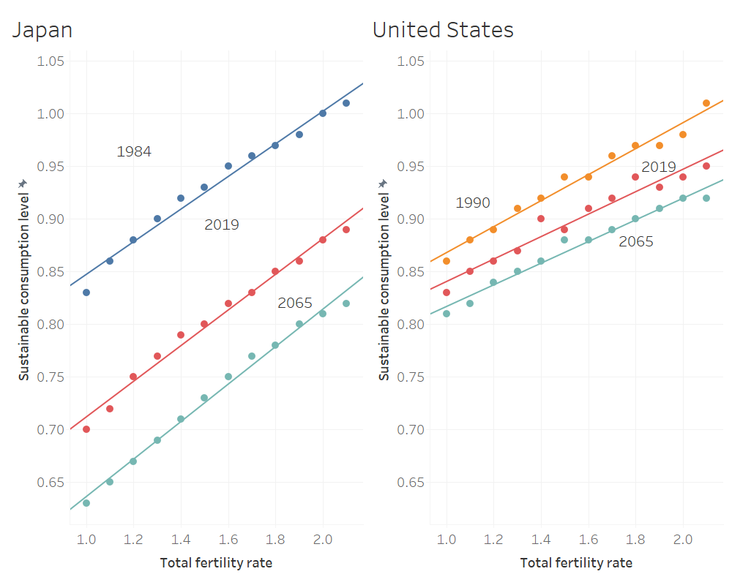

## The Reallocation Systems

All countries rely heavily on transfers to fund the lifecycle deficits of children. The US relies to a small extent on asset-based reallocations, but not Japan. The interest here, however, is on the reallocation systems employed to fund old-age deficits. These vary greatly among countries for which NTA estimates are available. Old-age transfers as a share of old-age reallocations vary from 100% to 0%. Japan and the United States do not fall at either of these extremes with old-age transfers roughly 70% of reallocations in Japan and roughly 30% in the United States.

The effect of the reallocation system on sustainable consumption is shown in Figure 7 given “historical” conditions (1984 for Japan and 1990 for the US), current conditions (2019), and conditions projected for the future (2065) (Figure 7).

Greater reliance on transfers to support old-age needs leads to a substantial decline in sustainable consumption under all circumstances. In the 1984/1990 simulations exclusive reliance on transfers produced a 16 percentage point decline in sustainable consumption in Japan and a 20 percentage point decline in the United States. The 2019-based and the 2065-based simulations indicate that the cost of relying on transfer systems has become much greater in Japan where relying fully on transfers rather than fully on asset-based reallocations would produce a decline in sustainable 2019 scenario by 28 percentage points, from 94 to 66 percent, and by 31 percentage points, from 92 to 61 percent, in Japan. By comparison the 2019-based scenario yields a decline of 22 percentage points, from 95 to 73 percent, from a shift to full reliance on transfers to seniors. Based on the 2065 demographic assumptions, full reliance on transfers in the US would reduce sustainable consumption from 92 to 64 percent, a 29 percentage point decline.

Figure 7. The old-age transfer share (OA T share) and level of sustainable consumption, Japan and the United States. The observed share is identified for Japan (.730 or .715) and the US (.326 or .271).

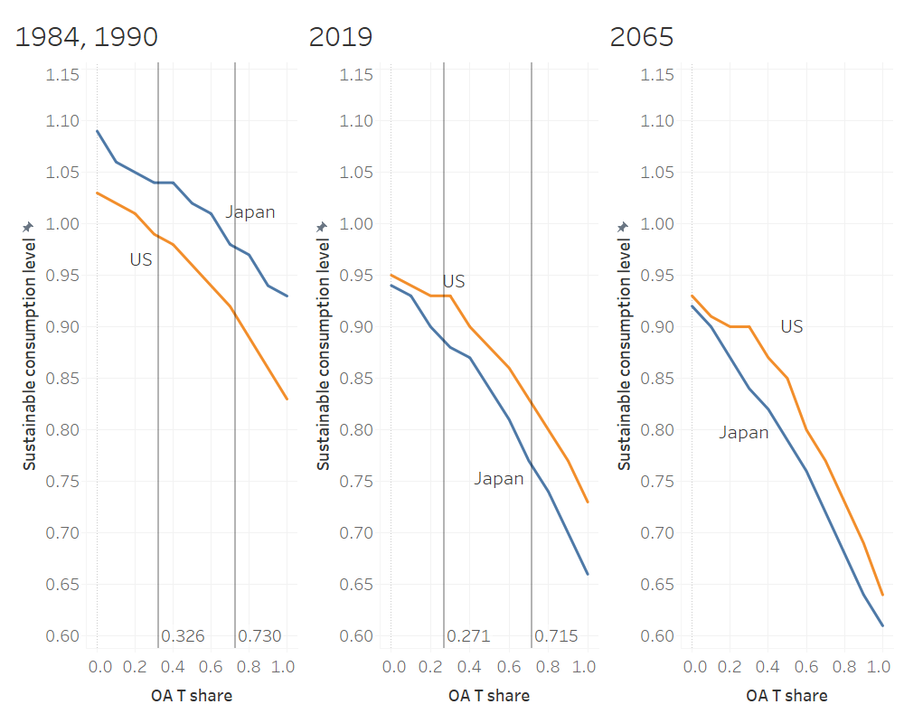

Shifting away from old-age transfer systems appears to be very attractive. The benefits may be elusive, however, because of transition issues. In many cases, these systems were implemented as a way of transferring resources to seniors who were impoverished relative to working-age adults in the past. This was particularly true in East Asia due to its rapid economic growth. To unwind these systems, however, is difficult because it would impose a double burden on current generations expected to fulfill obligations to current seniors and to save to meet their own old-age needs.

A second issue is that relying on asset-based reallocations requires strong financial systems and an ability to engage in long-run planning on the part of consumers.

# Issues and conclusions

Accepting our analysis at face value, people will have to reduce consumption in the future, relative to labor income. They will experience the effects of outliving their wealth and they will experience the effects of deteriorating old-age support systems. Governments will raise taxes, reduce benefits are some combination of the two. The precise path which reallocation systems will follow is uncertain, but there is no uncertainty that current approaches are unsustainable and will lead to lower levels of consumption.

Prospects for Japan are particularly pessimistic because of its heavy reliance on old-age transfers, high rates of consumption among the elderly, and severe aging. But Japan is not an isolated case. Many countries now have low or very low fertility, are experiencing rapid population aging, and rely heavily on transfer systems. Among high-income countries, the US is something of an outlier in some respects, at least for time being. US demographics are “favorable” in the sense that fertility is only moderately low and Americans don’t live as long as people in many countries. Moreover, the US relies less heavily on transfer systems and more heavily on an asset-based reallocation system that benefits from the high rates of return to capital in the US. An important caveat, however, is that per capita consumption by the elderly is very high because of spending on health care in the US. Despite these features, current US consumption is not sustainable and a decline of around 10 percentage points will be required to reach sustainability.

These are grim prospects and it leads one to wonder whether more optimistic outcomes are possible. First, consumption is expected to decline relative to labor income but labor income is growing at a healthy clip in the US, at 1% per year, and by even more at 1.4% per year in Japan. Productivity growth at these levels could continue due to technology but also due to heavy investment in education and capital deepening the can be traced in part to population aging (REFS). Second, adjustments in consumption may be gradual. The analysis tells us nothing about timing only that downward adjustments must eventually occur. Third, consumption could be supported by relying on wealth that is transferred from generation to generation. This could be in the form of bequests accumulated by previous generations or endowments such as mineral wealth or fossil fuels. These resources could be depleted over time but could be sustained if the return to those assets exceeds GDP growth.

Another factor not addressed here is immigration. In the very long run, immigration may have a limited impact on aging but they have a moderating influence for decades (REFS).

Migration is high in the US while it is very low in Japan. How does that matter? Could it be incorporated into the analysis? Perhaps we could just assume that the rate of population growth is higher because of migration.

Reallocations vary considerably by economic status. Those who are poor rely heavily on transfers while high income persons rely much more heavily on asset-based reallocations. Hence, the poor could be much more vulnerable to the effects of aging. How does Japan vary from the US?

# Appendix

## Productivity growth

Measures of growth in labor productivity are reported for Japan in Table A.1 and the US in Table A.2. All values are based on real labor income for 1984 and 2019 in Japan and 1990 and 2019 for the US. Labor income per person is reported as a matter of information but is not suitable for this analysis because it is affected changes in population age structure during the periods in question.

Average labor income of persons 30-49 is a simple measure that controls for age structure by using the simple average of per capita labor income by single-years-of-age in the 30-49 age range. The rates of growth over the time intervals measure changes essentially due to increases in wages, real per capita labor income of persons at the core working ages.

The synthetic cohort measures include the impact of real wages plus the impact of an increased supply of labor that have occurred primarily at older ages. This is a measure of expected life time labor income and the annual growth rates of those values.

|  |  |  |  |
| --- | --- | --- | --- |
| Table A.1. Labor productivity growth, Japan, 1984 and 2019 | | | |
|  | Labor income | |  |
|  | 2019 | 1984 | Growth Rate (%) |
| Labor income per person 15 and older | 3,063 | 2,158 | 1.00 |
| Average labor income of persons 30-49 | 4,601 | 3,124 | 1.11 |
| Synthetic cohort, lifetime |  |  |  |
| 2022 survival rates | 198,799 | 121,057 | 1.42 |
| 2065 survival rates | 201,976 | 122,731 | 1.42 |
| Thousands of yen, 2019 prices. |  |  |  |

|  |  |  |  |
| --- | --- | --- | --- |
| Table A.2. Labor productivity, US, 1990 and 2019. | | | |
|  | Labor income | |  |
|  | 2019 | 1990 | Growth Rate (%) |
| Labor income per person 15 and older | 51.2 | 39.9 | 0.86 |
| Average labor income of persons 30-49 | 75.5 | 61.9 | 0.69 |
| Synthetic cohort, lifetime labor income |  |  |  |
| 1990 survival rates | 3,040 | 2,259 | 1.03 |
| 2019 survival rates | 2,993 | 2,257 | 0.98 |
| 2065 survival rates | 3,182 | 2,368 | 1.02 |
| Thousands of dollars, 2021 prices. |  |  |  |

## Sustainable Wealth

The sustainable wealth profiles for the three baseline scenarios for Japan in 1984, 2019, and 2065 and the United States in 1990, 2019, and 2065 are shown in Figure A.1.

Figure A.1. Sustainable wealth for a birth cohort as a percentage of core labor income, Japan and the United States, three baseline scenarios. See Table 1 for details about the three baseline profiles.

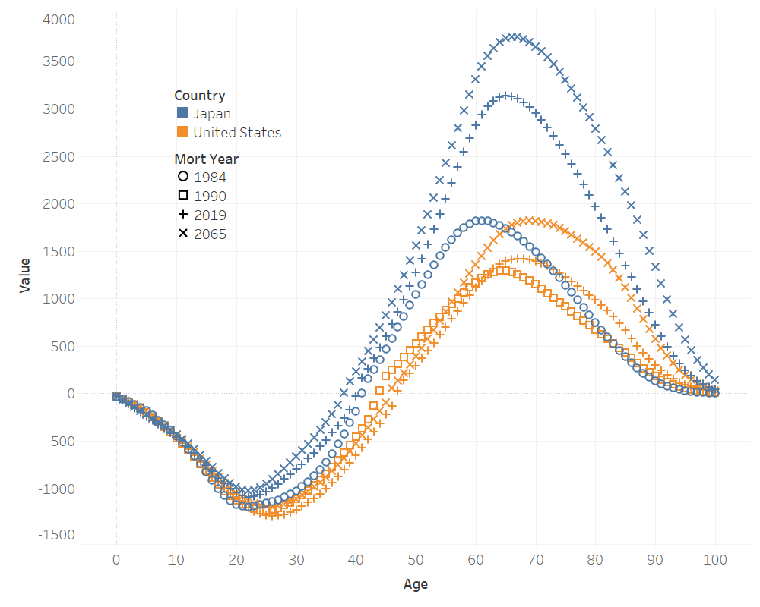

# References

Jordà, Ò., Knoll, Katharina, Kuvshinov, Dmitry, Schularick, Moritz, Taylor, Alan M (2019). "The rate of return on everything, 1870-2015." Quarterly Journal of Economics **134**(3): 1225-1298.

Lee, R., et al. (2014). "Is low fertility really a problem? Population aging, dependency, and consumption." Science **346**(6206): 229-234.

Lee, R., et al. (2003). "From Transfers to Individual Responsibility: Implications for Savings and Capital Accumulation in Taiwan and the United States." Scandinavian Journal of Economics **105**(3): 339-357.

Lee, R. and A. Mason, principal authors and editors (2011). Population Aging and the Generational Economy: A Global Perspective. Cheltenham, UK, Edward Elgar.

Lee, R. D. (1994). The Formal Demography of Population Aging, Transfers, and the Economic Life Cycle. Demography of Aging. L. G. Martin and S. H. Preston. Washington, D.C., National Academy Press**:** 8-49.

Lee, R. D. (1994). Population, Age Structure, Intergenerational Transfers, and Wealth: A New Approach, with Applications to the US. The Family and Intergenerational Relations, Journal of Human Resources. P. Gertler. **XXIX:** 1027-1063.

Lee, R. D., et al. (2001). Saving, Wealth, and Population. Population Matters: Demographic Change, Economic Growth, and Poverty in the Developing World. N. Birdsall, A. C. Kelley and S. W. Sinding. Oxford, Oxford University Press**:** 137-164.

Mason, A., et al. (2022). "Demographic Change, Economic Growth, and Old-Age Economic Security." Asian Development Review **39**(1).

Samuelson, P. (1958). "An Exact Consumption Loan Model of Interest with or without the Social Contrivance of Money." Journal of Political Economy **66**: 467-482.

United Nations Department of Economic and Social Affairs: Population Division (2013). National Transfer Accounts Manual: Measuring and Analyzing the Generational Economy. New York, United Nations.

United Nations Population Division (2024). World Population Prospects 2024. New York, United Nations.

Willis, R. J. (1988). Life cycles, institutions and population growth: A theory of the equilibrium interest rate in an overlapping-generations model. Economics of Changing Age Distributions in Developed Countries. R. D. Lee, W. B. Arthur and G. Rodgers. Oxford, Oxford University Press. **106-38**.

Yaari, M. E. (1965). "Uncertain Lifetime, Life Insurance, and the Theory of the Consumer." The Review of Economics Studies **32**(2): 137-150.

1. The term cohort is used to refer to a population born in the same year. Generation refers to a group of cohorts born in a span of several years.