**Aging And the changing nature of intergenerational flows:  
Policy Challenges and responses,**

***NTA WOrking Paper WP16-02***[1]

Andrew Mason (corresponding author)  
Department of Economics

University of Hawaii at Manoa, and

East-West Center

2424 Maile Way, Saunders 542

Honolulu, HI 96821

E-mail: [amason@hawaii.edu](mailto:amason@hawaii.edu)

Ronald Lee  
Departments of Demography and Economics  
University of California  
2232 Piedmont Ave  
Berkeley, CA 94720

E-mail: [rlee@demog.berkeley.edu](mailto:rlee@demog.berkeley.edu)

Diana Stojanovic

East-West Center

1601 East-West Road

Honolulu, HI 96848-1601

E-mail: dswongkaren@gmail.com

Michael Abrigo

Department of Economics

University of Hawaii at Manoa

2424 Maile Way, Saunders 542

Honolulu, HI 96821

E-mail: [mmabrigo@gmail.com](mailto:mmabrigo@gmail.com)

Syud Amer Ahmed

World Bank

E-mail: sahmed20@worldbank.org

March 15, 2015

Abstract

Transfer systems serve an essential economic function by shifting resources across and within age groups. Children and, in most societies, the elderly meet their material needs by relying heavily on public and private transfers. As population age structure changes, transfer systems must constantly rebalance with profound implications for economic development and generational equity. How changes in age structure will play out over the coming decades varies greatly depending on each country’s position in the demographic transition and its approach toward intergenerational transfers. To explore these issues this paper relies on a new simulation model that closely adheres to the National Transfer Accounts (NTA) framework. Alternative public policies and private sector responses are explored for 10 countries using NTA data. In the four post-dividend countries analyzed, population aging will severely strain public finances and impede growth in standards of living for all age groups. Life cycle reform, however, is a very effective response. For a few late dividend countries, e.g., China and Brazil, population aging will also create strains. For other countries, however, changes in population age structure should be favorable for several decades creating opportunities for these countries to prepare for the population aging that will eventually come.

Changes in population age structure influence the economy primarily through interaction with public and private transfer systems. Transfer systems serve an essential economic function shifting resources within and across age groups providing support in particular to children and the elderly. Changes in population age structure influence the terms under which intergenerational transfers take place – influencing the numbers of those who receive relative to those who provide. In many countries experiencing the demographic dividend, the number who provide has increased relative to the number who receive. In the future, however, population aging is leading to a decline in the number who provide relative to the number who receive. How transfer systems respond to shifting age structure will determine the ultimate distribution of economic resources across generations and the extent to which those resources are used to meet current material needs or to fund investment or to provide essential human capital.

National Transfer Accounts provide a rich, comprehensive and detailed description of these transfer systems, and form a natural basis for modeling these systems Lee and Mason (2011); (United Nations Population Division 2013). The simulations presented below help us understand the outlook for these systems themselves, identifying stress points and sustainability issues for both public and private transfers. The simulations also describe possible changes in the distribution of consumption by age, arising from the system of secondary distribution through interacting public and private transfer systems. Of course, the transfer systems themselves will be changing over time. Many developing countries have rudimentary public systems of old-age support and we expect they will be interested in implementing more extensive social insurance programs as their economies develop. We will consider status quo simulations that analyze transfer system structures as currently configured, but we will also consider other scenarios. In one, developing country public transfer systems gradually approach a European style welfare state. In another, developing country public transfer systems gradually approach a less generous and less costly capitalistic style, exemplified by the United States.

Advanced countries and some middle-income countries have very extensive public transfer systems and for these countries the status quo will be unsustainable in coming decades. Our simulations address the sustainability issues in two ways. In the first, we assume these countries maintain the essential structures of their current tax and transfer systems but rescale them as the size of government or public debt reaches unacceptable levels. To implement this approach, we impose constraints on the maximum share of GDP that may be spent on public transfers (usually 35 or 45%) and we impose a limit on the debt to GDP ratio (usually 90%). The debt/GDP ratio is a soft constraint; if it is exceeded (Japan already exceeds the debt constraint, for example) then adjustments will gradually restore a country to compliance. In the second approach, we explore the possibility of particular policies or behavioral responses in tax, transfer, and labor.

The approach taken here to simulating public transfers follows a long tradition of projecting the effect of population aging on age-targeted public transfers in a straightforward accounting manner without incorporating any feedbacks (Miller, Mason et al. 2011). A different analytic tradition examines public transfers in a general equilibrium context with limited age or other detail, focusing on consequences for factor markets and very broadly on income distribution between young and old.

There are only a handful of studies that model the dynamics of private transfers in aging populations. Here we will incorporate both public and private transfers taking a middle road in which we retain complete age detail in a partial equilibrium context with no feedbacks through asset or labor markets but with interactions between the public and private transfer systems. This approach enables us to consider in a new and more careful way the impact of changes in public transfer programs on patterns of consumption by age and generation. For example, if a nation initiates or expands a public pension system we can see how this affects consumption at each age after taking account of possible reductions in private transfers received by the elderly from their adult children, and possible increases in transfers by the elderly to their children and grandchildren. Likewise we can study the consequences of changing population age distributions such as population aging, for these changes must necessarily ramify throughout both the public and the private transfer systems, affecting consumption at each age.

To analyze and simulate the dynamic behavior of private transfers together with saving and consumption, we develop a system of equations that characterize the allocation of resources among consumption, saving, and private intergenerational transfers (among 101 age groups) subject to a resource constraint. The system is similar to a system of demand equations that are governed by changes in prices and income with the added complexity that the resource constraint is endogenous because intergenerational transfers are both inflow and outflow. Private transfers are non-market flows and, hence, we rely on a non-market clearing mechanism to realize an equilibrium outcome. Although there are no market prices in the model, changes in population age structure serve a similar role in guiding the allocation of private resources among intergenerational transfers, consumption, and saving. Changes in population age structure affect the price of realizing a per capita transfer inflow to inter-dependent age groups in the same sense that a decline in the number of children reduces the price of realizing a particular child quality in the Becker-Lewis Quantity-Quality model (Becker and Lewis 1973; Willis 1973). Because this model is aggregate and has realistic age structure, however, it necessarily allows for shared responsibility across multiple age groups.

# Key findings (in brief)

Dividend countries do not face serious fiscal problems over the foreseeable future. Even rapidly aging countries, such as, China and Thailand, do not need to reform their public sectors for budgetary reasons. In some cases, changes in population age structure will produce a fiscal dividend with revenues rising more rapidly than obligations under the influence of changing population age structure.

The situation is far different in post-dividend countries which are to varying degrees burdened by three realities: population aging, public sectors that promise high net public transfers to the elderly, and high level of public indebtedness due to the global financial crisis and possibly population aging.

Measured and well-conceived reform is nonetheless essential for dividend countries. Many dividend countries do not yet provide publicly-sponsored social insurance/welfare programs that will surely become increasingly valued as countries become richer and as their elderly populations grow. The challenge is to design programs that meet the needs of all age groups, including the elderly, and that are fiscally sustainable.

Public sector reform in dividend countries modeled on the policies of social welfare states would lead to substantially larger public sectors as compared with reform modeled on the policies of capitalist states.

Social welfare reform would raise consumption by children and the elderly directly by increasing net public transfers to the young and to the old. Although private transfers would provide a moderating influence, we find it to be small.

Social welfare reform would lead to lower saving rates as compared with capitalist reform.

In many post-dividend countries, population aging will present serious challenges. The bottom line is that per capita normalized consumption will decline by 0.5 to 0.9 percent per year between 2010 and 2035 as a consequence of population aging and the effects of conventional public sector reform. The challenges are greatest in Japan followed by Germany and the US.

The US is not aging as rapidly as Germany and net transfers to the elderly are more modest in the US. However, the US deficit and its public debt are much greater than Germany’s.

Lifecycle reform is potentially a very powerful tool for responding to population aging. If improvements in disability and health support a later retirement and reduced spending on the young elderly, aging will prove to be much more manageable.

# Model and Data

The purpose of the model is to assess how aging and changes in public policy influence the allocation of resources thereby determining the material standards of living of each age group or generation. In any economy the allocation of resources is determined by the interaction between the public and private sectors. The public sector is modeled via exogenously specified public policy (or exogenous assumptions about behavior) that directly governs taxes and spending and indirectly public saving and debt. Private sector responses are endogenous. Age groups respond to changes in population age structure and public policy allocating resources among consumption, private transfers, and saving.

The model is not an economic growth model and there are no feedbacks to economic growth through physical or human capital channels. Economic growth depends on growth of the effective labor force under the influence of age variation in labor force participation, unemployment, hours worked, wages. The survival linked scenarios will influence GDP growth by raising the effective labor supply at older ages, but otherwise GDP growth is not affected by public policy.

The results presented here are based on a simulation model described in full detail in Mason, Lee, et al. (2015). The model generates long-term projections of public sector variables including public spending, revenues, deficits, debt and more detailed components, e.g., spending on education, health care, and public pensions. The model uses population projections by age, age profiles of public sector variables such as those presented in Figure 1 below, and exogenously specified assumptions about labor productivity growth, inflation, interest rates, and economic structure.

Public policy is introduced using scenarios involving assumptions about age profiles of public transfer inflows (cash and in-kind benefits) and taxes normalized on the average of labor income of persons 30-49 years of age. Four kinds of scenarios are used:

* Status quo scenarios. Normalized age profiles of public transfer inflows and taxes are held fixed at their initial year values. These scenarios are used to assess the implications of changes in population age structure in the absence of reform.
* Target scenario. Normalized age profiles of public transfer inflows and taxes shift over time to an alternative set of age profiles. Two alternatives are consider in the analysis below – a *capitalist* target, similar to the observed patterns found in the United States, and a *social welfare* target, similar to the observed profiles found in Continental Europe.
* Survival linked scenarios. Normalized age profiles of labor income, public transfer inflows, and taxes are indexed on age-specific survival rates as a proxy for health status. The age specific values for each profile changes as the age-specific survival rate increases over time. These scenarios are used exclusively in countries with mature public old-age support systems to gauge the possibility of adjusting policies and behavior to increased life expectancy and to better health at each age.
* Fiscal constraints. Any of the scenarios can be subject to constraints on the size of the government measured by public transfer inflows as a share of GDP and the size of net public debt. The size of government constraint is a hard constraint and imposed by an immediate reduction in public transfer inflows. The net public debt constraint is a soft constraint met over an extended period of years. If the unconstrained policies lead to excess net public debt looking H years into the future, taxes are increased to bring debt within the prescribed limit by year t+H.

The private sector responds to changes in population age structure and public policy which affect the resources available to each age group. The resources available to an age group are comprised of labor income, private asset income, public cash transfer inflows, net private transfers from the rest of the world, and private transfers from residents. Each age group allocates the available resources among competing uses comprised of consumption, saving, taxes, and private transfers to residents.

Private transfer inflows and outflows among residents are modelled in detail distinguishing flows among each of 101 age groups, although values for an upper age group of 90+ are reported. A non-market clearing mechanism is used to insure an internally consistent set of flows. Decisions about the allocation of resources among consumption, saving, and transfers to each age group are governed by changes in population age structure and the private linkages among age groups that reflect the family connections that exist in each society.

All age profiles are based on National Transfer Account estimates for each country adjusted to match macroeconomic controls in 2009, 2010, or 2011. Macroeconomic controls are based on UN System of National Accounts data supplemented by estimates from the International Monetary Fund. Population projections are taken from World Population Prospects 2015 medium fertility scenario (UN 2015). Assumptions about productivity growth, inflation, interest rates, etc. are country specific and drawn from a variety of sources. Specific information and detailed sources are available in Mason, Lee, et al. (2014; 2015). National Transfer Accounts for each country are available on the NTA website [www.ntaccounts.org](http://www.ntaccounts.org).

# Population diversity

The economic impact of population will depend, in part, on the speed and nature of demographic change. Demographic conditions can be distinguished using a recent classification developed by the World Bank (2015). About half the countries of the world are pre- or early demographic dividend countries found mostly in the Middle East and sub-Saharan Africa where fertility rates are high and populations are very young. Expected fertility decline will lead to fewer child dependents and a higher concentration in the ages with high labor income leading to a demographic dividend. Changes in age structure in these countries may also lead to a fiscal dividend by increasing the concentration of the population at high taxpaying ages and reducing the population (children) receiving high levels of public sector support.

Another large group of countries, further along in their demographic transitions, are classified as late dividend countries. In these countries, fertility has already reached relatively low levels and population age structure is favorable as measured by the support ratio, the share of population in the working ages or similar metrics. The boost to economic growth from changing age structure has ended or will soon come to an end. These countries will experience a declining support ratio and demographic headwinds that will slow economic growth with potentially adverse implications for the public sector.

Post-demographic dividend countries are those furthest along in their demographic transitions. They have had low fertility for at least a generation. Their demographic experience will be dominated by population aging and, in some countries, by population decline. The public sector in most of the countries in this DD phase provides extensive support for the elderly and, hence, aging will put upward pressure on spending and downward pressure on tax revenues.

The analysis in this study explores conditions in eleven countries which vary along many dimensions including the demographic one (Table 1). Nigeria, the only pre-dividend country, has a higher fertility rate and a very young population. Three countries, South Africa, India, and Mexico, are classified as early dividend countries by the World Bank, but note that each is close to achieving replacement fertility. They are still relatively young with 35 to 40 percent under the age of 20 and between 5 and 10 percent age 60 and older. Late dividend countries are represented by Brazil, China, and Thailand. Their total fertility rates have recently dropped below replacement level, the share of children under 20 has dropped to between 23 and 31 percent while the percentage 60 and older has increased to between 12 and 16 percent. Four of the countries are post-dividend – Hungary which is still a upper-middle income country along with Germany, Japan, and the United States. The TFR has dropped to very low levels in Hungary, Germany, and Japan, only 1.3 or 1.4 births per woman. The US is the only post-dividend country in the group with near replacement fertility. The US is also the youngest of the four post-dividend countries with 21 percent above the age of 60 as compared with 25 to 33 percent 60 and older in the other post-dividend countries.

|  |  |  |  |  |  |
| --- | --- | --- | --- | --- | --- |
| Table 1. Demographic indicators, 2015 | | |  |  |  |
|  | Demographic dividend stage | Total fertility rate | Life expectancy at birth | Age structure (%) | |
|  | Under 20 | 60 and above |
| Nigeria | Pre-dividend | 5.7 | 52 | 54.3 | 4.5 |
| South Africa | Early-dividend | 2.4 | 57 | 38.9 | 7.7 |
| India | Early-dividend | 2.5 | 67 | 38.2 | 8.9 |
| Mexico | Early-dividend | 2.3 | 76 | 37.0 | 9.6 |
| Brazil | Late-dividend | 1.8 | 74 | 31.4 | 11.7 |
| China | Late-dividend | 1.6 | 75 | 23.0 | 15.2 |
| Thailand | Late-dividend | 1.5 | 74 | 24.2 | 15.8 |
| United States | Post-dividend | 1.9 | 78 | 25.4 | 20.7 |
| Hungary | Post-dividend | 1.3 | 75 | 19.6 | 24.9 |
| Germany | Post-dividend | 1.4 | 81 | 17.9 | 27.6 |
| Japan | Post-dividend | 1.4 | 83 | 17.6 | 33.1 |
| Source: World Bank (2015), United Nations (2015). | | | | | |

## Metrics for Economics of Aging

The measures and methods for analyzing the economics of aging are much newer than those used for population aging, but they are surely as important. A fundamental feature of any economy is that resources are produced at ages related to health and vitality, among other factors, but consumed at all ages with variation related in part to physiological need. In very young populations like Nigeria’s we see consumption concentrated at young ages while in older populations like Japan’s we see consumption increasingly concentrated at older ages. The age dimension of consumption is usefully summarize by the mean age of consumption (Ac) reported for 11 study countries around 2010 in Figure 1.

If people, on average, consumed the same amount at every age, the mean age of consumption would equal the mean age of the population. As an empirical matter, however, per capita consumption by adults is greater than for children and, hence, the mean age of consumption is greater than the mean age of the population. In some countries, like the United States and Japan, the elderly consume more than prime age adults raising the mean age of consumption further. Evaluating the effects of aging on the economy requires a trajectory of the population by age, but is also essential to understand what people are doing at every age. If the resources used by the elderly are greater or if consumption by college age students is very high, mean age of consumption captures these patterns.

Figure 1. Mean age of consumption and labor income, eleven countries in 2010 or 2011.

The mean age of labor income, an essential counterpart to the mean age of consumption, also depends on the age structure of the population and on how people behave – when they enter the labor force, when they retire, how hours worked vary by age. The mean age of labor income also depends on features of the economy and policies that may affect the returns to experience and employment opportunities for the young and the old.

In a young country, like Nigeria, the mean age of consumption is much less than the mean age of labor income. As a consequence, resources must be shifted or reallocated downward from older ages to younger ages as shown by the arrow in Figure 1. As the share of children in the population declines, the mean age of consumption increases reducing the gap between the mean age of consumption and labor income and demand for age reallocations, for shifting resources from older to younger ages. In only three of the eleven countries in our study, Hungary, Germany, and Japan, is the mean age of consumption greater than the mean age of labor income.

Several of the study countries currently have close to generational balance. Upward transfers and downward transfers nearly cancel as reflected in the mean ages of consumption and labor income being nearly equal. In the future, however, more countries will have old economies rather than young ones. Based on unconstrained status quo simulations, the mean age of consumption will exceed the mean age of labor income in nine of the eleven study countries in 2055, with South Africa and Nigeria being the only exceptions. Although Hungary and China are near generational balance at the moment, rapid population aging will lead to considerable imbalance with the mean age of consumption much greater than the mean age of labor income.

The mean age of an economic flow is a critical tool for analyzing the economics of aging, but it may be unfamiliar to some and a simple example may help with interpretation. Consider an economic flow of amount Z received by individuals on average at age A, held on average for d years, and then used on average at age A+d. The stock of resources held at every point in time would be the annual flow, Z, times the average number of years the flow is held: dZ. Under golden rule conditions, the mean age of consumption less the mean age of labor income times the annual flow, consumption, is equal to wealth required to deal with the mismatch between consumption and labor income. This is known as lifecycle wealth, W = (Ac – Ayl) C or lifecycle wealth relative to consumption is equal to Ac - Ayl.

In the analysis presented here, the difference between the mean age of consumption and labor income quantifies the lifecycle demand for shifting resources across age. Three economic mechanisms for achieving this reallocation are distinguished here: public transfers, private transfers, and asset-based reallocations. Using a formulation introduced in Mason, Lee, et al (2015) the lifecycle demand is approximately equal to the sum of three components: the weighted sum of the differences between the average ages of government transfers received and made, private transfers received and made, and the average age of asset based reallocations minus that of labor income. The weights in this sum are ratios of the aggregate flows of public and private transfers and asset income less saving to aggregate consumption, *vtg*, *vtf*, and *vra*. [2]



The components of lifecycle needs estimated for 2010 or 2011 for 10 study countries are reported in Table 2. Note that in every country private transfers are downward from older adults to younger adults reflecting the importance of transfers from parents (and to a lesser extent grandparents) to their children. Asset-based reallocations are upward shifting resources from the working ages (mean age of labor income) to older ages. Public transfers are the swing reallocation system downward in younger countries and upward in old countries.



The generational or lifecycle role of the public sector is of particular interest here. Public education programs provide important resources to children funded in ways that depend on the nature of the tax system in each country. Pensions serve the elderly often funded by taxing workers. Publicly funded health care typically provides benefits to all age groups but resources often are heavily allocated towards the elderly. The emphasis here is not on particular programs, however, but on the public sector taken in its entirety. Table 2 summarizes this role in each country, whereas a more detailed description can be seen in the per capita age profiles of public transfer inflows and taxes as shown in Figure 2 below. The per capita values for each country are expressed relative to the average per capita labor income for those in the 30-49 age group or YoLYs. A value of 0.1 public transfer inflows for example would mean that persons of that age on average receive cash and in-kind benefits equal to 10% of a prime-age adult (30-49) average annual labor income (YoLY). The normalized age profiles allow comparison of public transfer systems across countries at very different levels of development and with very different population age structures.

As is evident in Figure 2, the size and nature of public sectors vary greatly across countries. Rich countries tend to have larger, more extensive public sectors than low income countries with transfers to the elderly very important as is evident for Germany, Japan, and the United States. In contrast many low and middle-income countries have smaller public sectors which emphasize children more and seniors much less. India, Nigeria, and Thailand are clearly examples of countries with relatively under-developed public sector transfers to the elderly. Level of development is by no means the sole determinant of the size or generational nature of the public sector. China, Mexico, and South Africa provide substantial transfers to both children and the elderly in a relatively balanced way judging from per capita values. Brazil and Hungary stand out as two middle-income countries that provide public transfers to children and to the elderly that look quite similar to the patterns we see in Germany or the United States. (A careful look at Brazil shows public transfer inflows increasing at a much younger age than countries like Japan and the United States.)

Studies often emphasize the beneficiaries of public programs and pay less attention to the sources of funding, but these are also heavily influenced by age in ways that vary from country to country. We see, for example, much higher normalized tax payments at older ages in the United States and Japan than in Germany. In South Africa, public pensions are an important flow for elderly retirees, but tax payments by the elderly are high, as well.

Figure 2. Age profiles of public transfer inflows and taxes for the initial year (2010 or 2011), 11 countries.

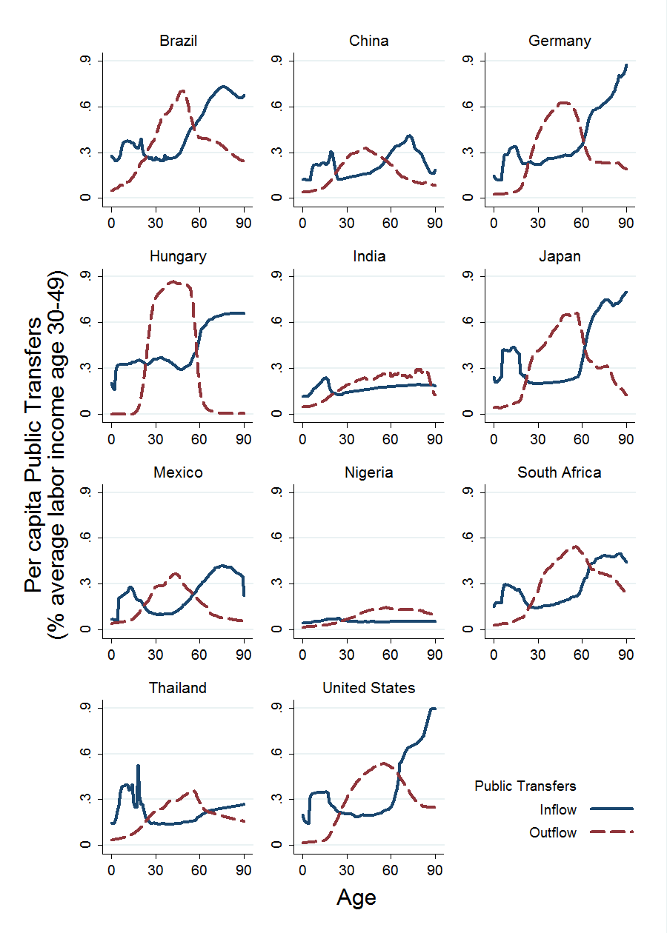

The per capita comparisons in Table 2 tell us something important about the orientation of the public sector, but its overall generational impact depends on total transfers by age under the influence of both per capita patterns and population age structure. The role of the public sector in reallocating resources across age is shown in Table 3. The generational orientation of the public sector is captured in the first three columns that report the mean ages of public transfer inflows and outflows and the difference between the too. The public sector flows are broadly consistent with the overall generational needs summarized by comparing the mean ages of consumption and labor income. The public sector is essentially balanced in China, elderly oriented in Hungary, Germany, and Japan, and youth oriented in the remaining seven countries. Public transfers are heavily downward in Nigeria, South Africa, India, and Thailand; much more moderately downward in Mexico, Brazil, and the United States. The impact also depends on the size of public transfers as a percentage of consumption which ranges from a low of 9 percent in Nigeria to 67 percent in Hungary. The product of the difference in mean ages and the share of transfers in consumption measures the intergenerational impact of the public transfer program (Mason, Lee et al. 2014). In Nigeria, the public sector reallocation of resources was sufficient to cover only 1.2 of the 12.5 years difference between consumption and labor income. The contribution of the Mexican public sector program to providing for the needs of youth was also quite small. In South Africa and Thailand the public sector reallocations contributed half of the needed downward reallocations.



In elderly oriented economies, the public sector is playing a very important role in reallocating resources. About two thirds of the needed reallocation of resources is being realized in Japan and over 80 percent in Germany. In Hungary, upward transfers by the public sector are far more than sufficient to meet the life cycle needs of its economy.

Countries differ in the health of their public finances and, hence, the extent to which they are prepared to deal with future generational. Of the eleven study countries, all but China and Thailand have net public debt (Table 4). Japan’s net debt exceeded its GDP and was about three-quarters of GDP in Hungary and the United States. Japan’s debt burden is eased considerably because the interest it pays on public debt is very low. Public asset income as a share of GDP is greater (less negative) than for any of the debtor countries. The United States also benefits from low interest rates paid on public debt.

|  |  |  |  |  |
| --- | --- | --- | --- | --- |
| Table 4. Initial public finances | | | | |
|  | Initial year | Public assets | Public asset income | Public saving |
| Brazil | 2009 | -0.415 | -0.017 | -0.016 |
| China | 2009 | 0.737 | 0.019 | 0.042 |
| Germany | 2010 | -0.582 | -0.019 | -0.024 |
| Hungary | 2010 | -0.767 | -0.031 | -0.058 |
| India | 2010 | -0.321 | -0.018 | -0.025 |
| Japan | 2010 | -1.131 | -0.006 | -0.084 |
| Mexico | 2010 | -0.362 | -0.011 | 0.012 |
| Nigeria | 2010 | -0.143 | -0.015 | -0.108 |
| South Africa | 2010 | -0.293 | -0.026 | -0.041 |
| Thailand | 2011 | 0.018 | 0.000 | 0.021 |
| United States | 2011 | -0.762 | -0.021 | -0.090 |
| Sources: Mason et al (2015). | | | | |

Public saving as a share of GDP is a measure of the extent to which current public spending exceeds revenue. Deficit spending is particularly high in Japan, Nigeria, and the United States.

## Implications of aging for public finances

Changes in population age structure influence public finances through their influence on both the spending and the revenue side. Imbalances arise when the influence on revenues differs from the influence on spending. In countries experiencing the demographic dividend, in the absence of adjustment to tax and spending patterns, changes in age structure would tend to reduce spending because of the decline of the share of children in the population and to increase tax revenues because of the higher concentration of the population in the working ages. The demographic dividend also leads to higher economic growth so that the impact of age structure on tax revenues as a share of GDP is uncertain.

The impact of age structure on taxes and public transfer inflows (TGI) as a share of GDP is reported in Figure 3 for 2015 to 2035. For the three early dividend countries in our study countries, South Africa, Mexico, and India, the effects of population age structure are mixed. Tax revenues as a share of GDP are relatively insensitive to changes in population age structure - rising by 0.005 (or one-half percentage point) in South Africa, declining by one-half percentage point in Mexico, and left unchanged in India. The impact on public spending is more substantial leading to a reduction in public spending as a share of GDP by 2.3 percentage points in South Africa and 1.2 percentage points in India. The net effect would be to reduce the public transfer deficit (or increase the public transfer surplus) by 1.2 percent of GDP in India and by 2.7 percent of GDP in South Africa. In Mexico, however, the changes in population age structure would lead to a higher public transfer deficit (lower public transfer surplus) by 0.7 percent of GDP. These are not small changes for countries where public transfer inflows were only about 15 percent of GDP in Mexico and India and 26 percent of GDP in South Africa. The larger effects in South Africa are largely a consequence of the larger size of the public sector in that country.

Figure 3. Change in taxes and public transfer inflows (TGI) as a share of GDP between 2015 and 2035 holding age patterns of taxes and spending fixed at their initial year values.

In the late and post-dividend countries, changes in population age structure would lead to both substantially higher tax revenues and public transfer inflows as a share of GDP. The sole exception to this generalization is Hungary where tax revenues would decline by 0.5 percent of GDP. With the exception of Thailand, the increase in tax revenues would be less than the increase in public transfer inflows leading to substantial increase in the public transfer deficit. The impact in Germany would be the greatest leading to a rise in the public transfer deficit or decline in the public transfer surplus by 8 percent of GDP. But very large negative shifts would experience in Japan (6.3 percent of GDP), Hungary (4.7) and the US (4.3). Among the late dividend countries, the imbalance would be equal to 2.9 percent of GDP in China and 1.5 percent of GDP in Brazil.

A long term perspective is afforded by looking at the thirty year period between 2035 and 2065 (Figure 4). In every country changes in population age structure will lead to an increase in both taxes and public transfer inflows as a share of GDP. In two late dividend countries, South Africa and India, taxes would increase more than spending. In the remaining countries, taxes will increase by much less than spending as a share of GDP. The increase in Brazil is particularly striking where an additional 12 percent of GDP would go to public transfer inflows. The imbalance between taxes and inflows is especially in Brazil, as well, at 6.9 percent of GDP. But the gap between the rise in taxes and spending is even larger in Hungary at 7.4 percent of GDP and Japan at 7.1 percent of GDP.

Figure 4. Change in taxes and public transfer inflows (TGI) as a share of GDP between 2035 and 2065 holding age patterns of taxes and spending fixed at their initial year values.

Over the entire 50 year period charted in Figures 3 and 4, South Africa and India will experience a fiscal dividend in that tax revenues will rise by more than public transfer inflows given the current age pattern of taxes and spending. In the remaining countries, changes in population age structure will be unfavorable to public finances. Maintaining current age patterns of spending would require very substantial increases in taxes beyond that produced as a natural consequence of changes in population age structure.

The status quo public transfer deficit is one useful measure of how population aging will affect public finances, but countries differ in the extent to which their economies can accommodate extended deficit periods. Governments that enter challenging periods with strong balance sheets will better position than those already heavily indebted. In countries with robust economic growth, deficit spending has smaller impact on debt relative to GDP. Countries may vary in the burden of servicing a given debt because interest rates are low.

The impact of aging on public finances in light of these influences can be assessed using projected values of public assets as a share of GDP (Figure 5). Again four countries stand out as facing difficult fiscal problems due to population aging. In Germany, Japan, Hungary and the United States, absent reform, net public debt as a share of GDP would more than double between 2015 and 2035. No other countries face medium term debt problems. Demographic conditions would lead to accumulation of substantial wealth in Thailand and Mexico and a substantial reduction in debt in India and South Africa. China would experience some decline but continue to be a net creditor in 2035.

The long-term prospects projections for the advanced aging countries show us little more than the impossibility of maintaining the status quo. Reform, or financial crisis, is unavoidable in these countries. Debt problems in Brazil would also grow to impossible levels in the long-term in the absence of reform. Brazil represents one of the difficulties in implementing sustainable old-age support programs. Despite the large net transfers committed to the elderly by the public sector, changing population age structure is not projected to adversely influence public debt in the medium term. Simulated debt declines modestly between 2015 and 2035. Thereafter, however, serious debt problems would emerge very quickly pushing net debt to more than twice GDP by 2065.

Figure 5. Public assets relative to GDP, 2015, 2035, and 2065, 10 countries, status quo scenario.

The fiscal pressure is very severe in countries like Germany and Japan which have very low fertility, are experiencing rapid aging, and generous public support systems for the elderly. The US is by no means immune to these pressures but the US fiscal challenges are not entirely a consequence of population aging. High debt levels and deficit spending has a considerable influence on the US fiscal picture. In part, current conditions may reflect the entry of the baby boom into retirement age, but the great recession has played a very important role. As has been widely noted aging is not just a rich country problem. Four middle-income countries – Brazil, China, Hungary, and Mexico – will experience rapid population aging in the coming years. Only Brazil has public programs in place that will be fiscally unsustainable. Public finances are not particularly vulnerable to the effects of population aging, but that is because they lack public programs that will be viewed as increasingly important in the future. Among the middle income countries, public finances in Thailand are least vulnerable to population aging, again as a consequence of Thailand’s relatively underdeveloped public support system. For many developing countries, the challenge is to develop essential systems of old age support that are consistent with fiscal realities and meet important needs of a growing old-age population.

# Policy Scenarios

Many low and middle-income countries face the challenge of introducing public programs that meet the needs of a growing older population in a fiscally responsible or sustainable way. In the analysis presented here we make use of a number of scenarios that represent a range of options, but are not intended as policy proposals for any particular country. On option of course is to maintain the status quo approach to taxes and provision of benefits. This incorporated into the scenarios by holding the age profiles of taxes and public transfer inflows fixed relative to the average labor income of adults 30-49. In other words, taxes and spending would be adjusted upward in keeping with productivity gains. As shown in the preceding section, the status quo scenario is not a feasible policy from a fiscal perspective because of the persistent and growing deficits it would produce as societies age. But for some countries the status quo is a possible option. Mexico, for example, public debt under the status quo option would only reach 38 percent of GDP, an entirely manageable level of debt.

Our main focus, however, is on reform that involves the introduction of public programs that provide support to a growing elderly population by introducing reform in 2020 that would be completed as the country reaches a level of per capita GDP consistent with current definitions of high income status. We consider two possible approaches to reform based on current practice in high income countries. Social welfare reform is relatively expansive providing more generous benefits and assessing higher taxes. This reform is based on age patterns of taxes and spending in Japan and several continental European countries. The capitalistic reform scenario is less expansive that the social welfare scenario. Taxes and public spending are lower similar to what is found in the United States, for example. Some middle income countries, including Hungary and Brazil, currently have relatively expansive public sector systems. For them, the capitalistic scenario would lead to a substantial scaling back of the role of the public sector.

With population aging the reform scenarios may lead to very substantial increases in the size of government and public debt. We provide additional scenarios that adjust spending and taxing to satisfy constraints on the size of government and net public debt relative to GDP. We constrain public transfer inflows to a maximum of 45 percent of GDP under the social welfare scenario and 35 percent of GDP under the capitalistic scenario. For both scenarios we constrain net public debt to 90 percent of GDP. The size of government constraint is a hard constraint that cannot be violated in any year. The debt constraint is a soft constraint in that taxes are adjusted to meet the debt constraint after an extended period of time.

The implications of the alternative scenarios for taxes and public transfer inflows are shown in Figure 6 for Mexico from 2004 to 2100. Four scenarios are shown in the figure the status quo scenario, the constrained and unconstrained social welfare scenario, and the unconstrained capitalistic scenario. The constraints are not binding for the capitalistic scenario in the Mexican case so that taxes and transfers are identical to the unconstrained values.

Under the status quo scenario little happens until 2035. After that public transfer inflows grow steady approaching 25 percent of GDP. Taxes change very little and, hence, deficits emerge and increase after 2050. Under the social welfare scenario, taxes and transfers grow steadily after 2020. The social welfare does not lead immediately to deficits. This occurs only later – again beginning in 2050. Eventually deficits become quite large and starting in 2065 tax increases are required to avoid exceeding the debt constraint. Eventually, the size of government constraint binds and further growth in public transfer inflows no longer occurs.

An important feature of all of the reform scenarios is that they generate substantial surpluses over an extended period of time. This occurs as taxes on workers increase but social benefits paid to them is delayed. Under the capitalistic scenario net public assets exceed GDP by 2060 while for the social welfare scenario net public assets are about 40% of GDP in 2060. The cumulated surpluses postpones the day of reckoning for the social welfare scenario and especially the capitalistic scenario.

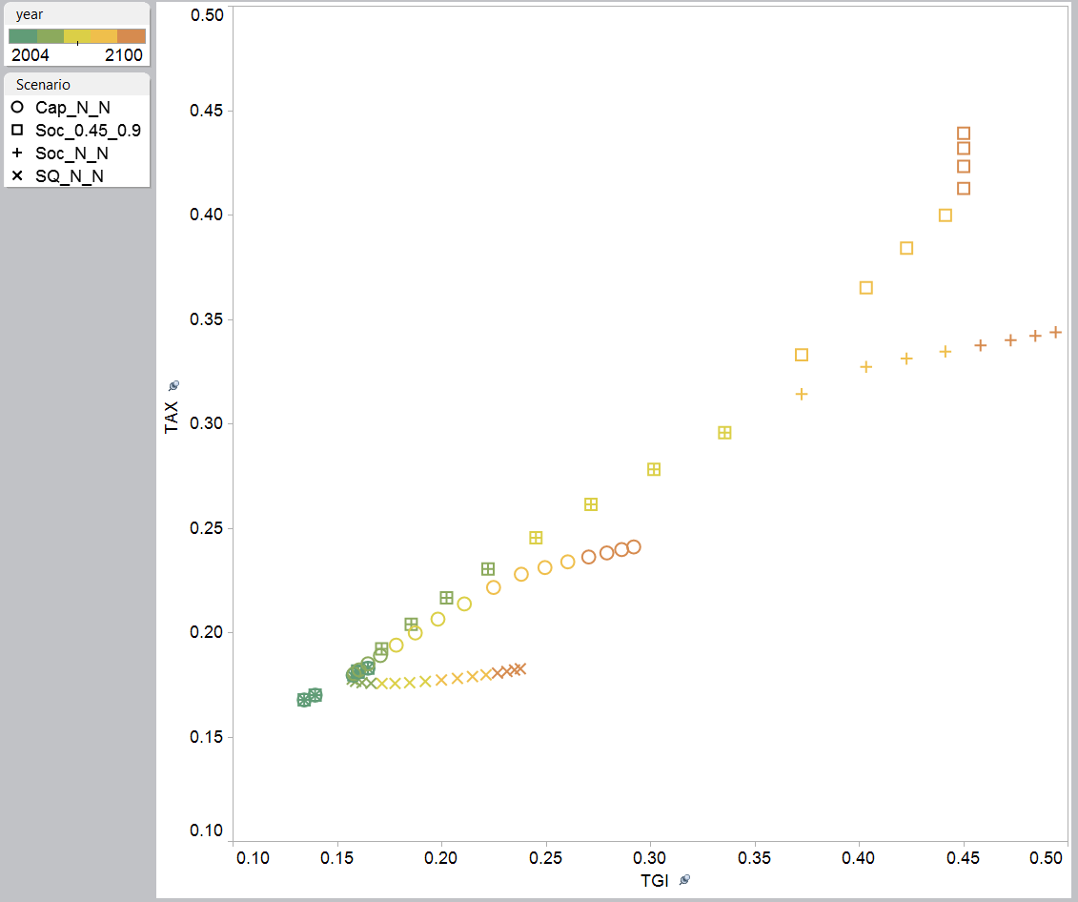

Size of government constraint binds leading to benefit reduction.

Debt constraint binds leading to higher taxes.

Surplus: Tax > TGI

Deficit: Tax < TGI

2004

2015

2100

2100

2100

2100

Figure 6. Taxes (TAX) and public transfer inflows (TGI) as a share of GDP, Mexico, 2004-2100, four scenarios: Status quo (SQ), capitalistic reform (Cap), and social welfare reform unconstrained (Soc_N_N) and constrained (Soc_.45_.9).

The scenarios for China in Figure 7 are broadly similar to those shown for Mexico. Under the status quo scenario China would expert moderate growth in both taxes and spending as a share of GDP. China’s transfer surplus would turn to a deficit after 2030 which continue to grow. Under either of the reform scenarios the share of taxes and public transfer inflows in GDP would grow dramatically but particularly under the social welfare scenario. The size of government constraint does not come into play for the capitalistic reform scenario but the debt constraint binds starting in 2070 driving taxes higher over the remainder of the simulation as compared with the unconstrained capitalist scenario. The social welfare constrain hits the debt constraint much earlier beginning in 2040 and the size of government constraint in 2065.

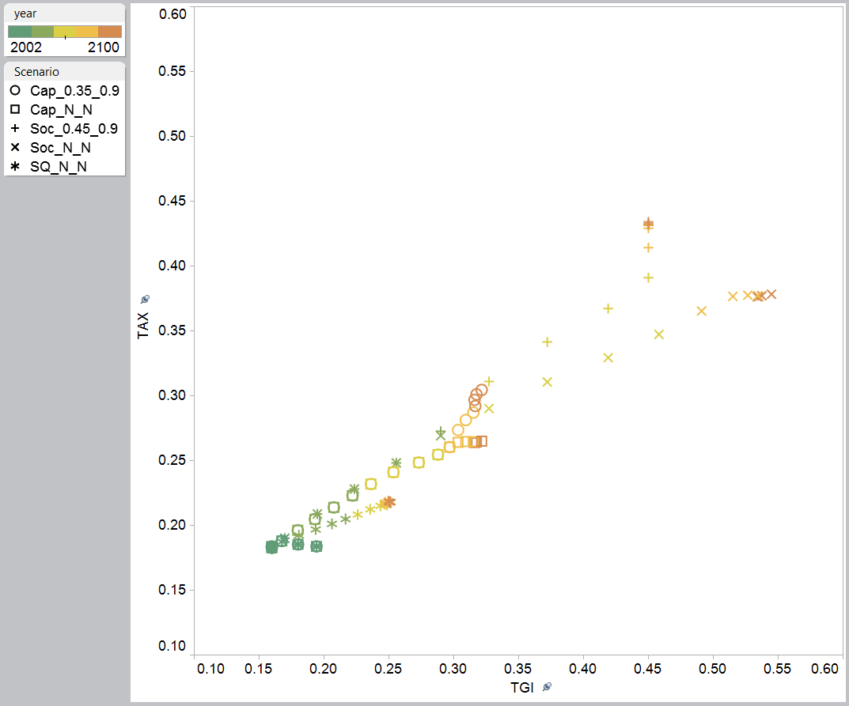

Size of government constraint binds in 2060 under the social welfare scenarios

Debt constraint binds in 2070 under the capitalistic scenarios

Debt constraint binds in 2040 under the social welfare scenarios

2100

2100

2100

2015

2002

Figure 7. Taxes (TAX) and public transfer inflows (TGI) as a share of GDP, China, 2002-2100, five scenarios: status quo (SQ), capitalistic reform (Cap), and social welfare reform (Soc). Capitalistic and social welfare scenarios are evaluated with and without constraints.

Like Mexico and China, India and Thailand are two countries that are likely to experience growth in the public sector over coming decades. More detailed information about them is provided in the accompanying case study on Thailand (Suphannada, Lee et al. 2015) and for India the detailed discussion of the model in Mason, Lee et al. (2015).

In South Africa, none of the constraints come into play and, hence, only the unconstrained scenarios are presented in Figure 8. South Africa’s fiscal dividend is very apparent under any of the scenarios but particularly under the status quo or capitalistic scenario public transfer inflows decline as a share of GDP while taxes are relatively unaffected by changes in age structure. The public sector plays a more important role under the status quo scenario than under the capitalistic scenario with taxes reaching 32 of GDP and public transfer inflows 29 percent of GDP at the end of the simulation in 2100. In contrast, taxes and public transfer inflows are 27 percent and 26 percent of GDP in 2100 under the capitalistic scenario. Tax revenues rise very steeply under the social welfare scenario generating large public transfer surpluses. By 2050 taxes would reach 33 percent and public transfer inflows 31 percent of GDP. Eventually the impact of population aging is felt in South Africa. By 2075 a transfer deficit emerges but South Africa’s simulated net public assets have reached 150 percent of GDP by that time so that budget deficits could be sustained for many years without problem.

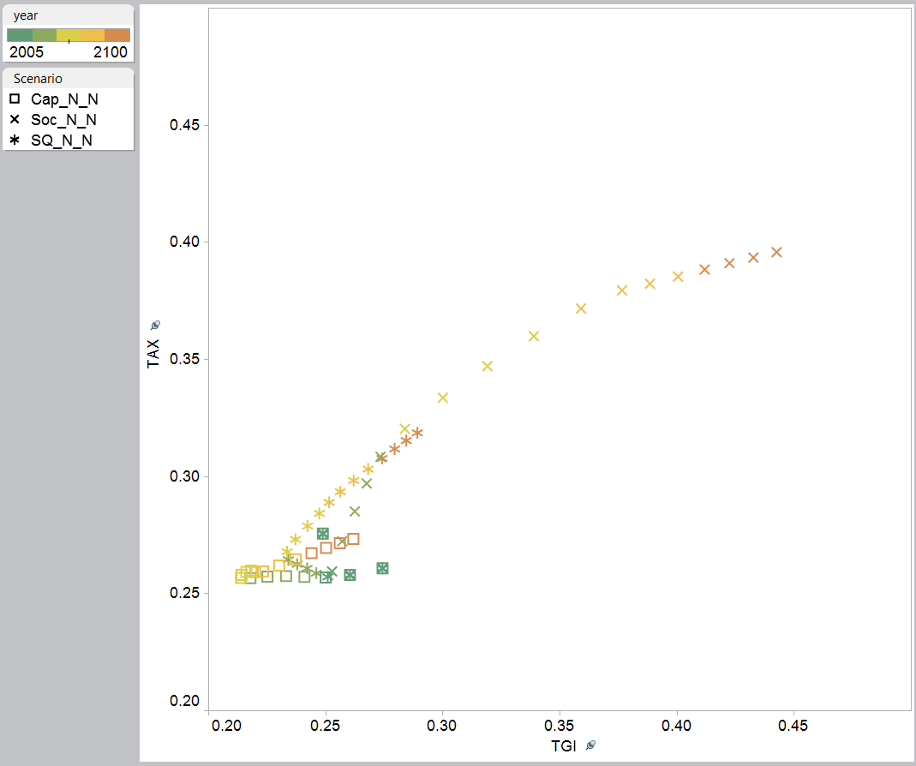

2100

2100

2100

2015

Figure 8. Taxes (TAX) and public transfer inflows (TGI) as a share of GDP, South Africa, 2005-2100, three scenarios: status quo (SQ), capitalistic reform (Cap), and social welfare reform (Soc) all of which are unconstrained.

Two other middle income countries, Hungary and Brazil, provide extensive public support for the elderly. The Brazil case (Turra, Queiroz et al. 2015) provides detailed information about conditions there. Here we will focus our attention on Hungary with its low fertility, rapid aging, and expansive public programs.

For Hungary it is instructive first to look at the unconstrained scenarios (Figure 9). Under the status quo scenario, public transfer inflows would rise sharply in coming decades while taxes as a share of GDP would actually decline. This would lead to very large public transfer deficits and unachievable levels of public debt (more than 7.7 times GDP in 2060). The social welfare reform scenario would lead to somewhat higher levels of spending and substantially higher levels of taxes, but debt would still rise to implausibly high levels (6.7 times GDP in 2060). Capitalistic reform would lead over time to a much smaller public sector than is the case today, but it does not resolve the debt problem. By 2060 debt would still reach 5 times GDP.

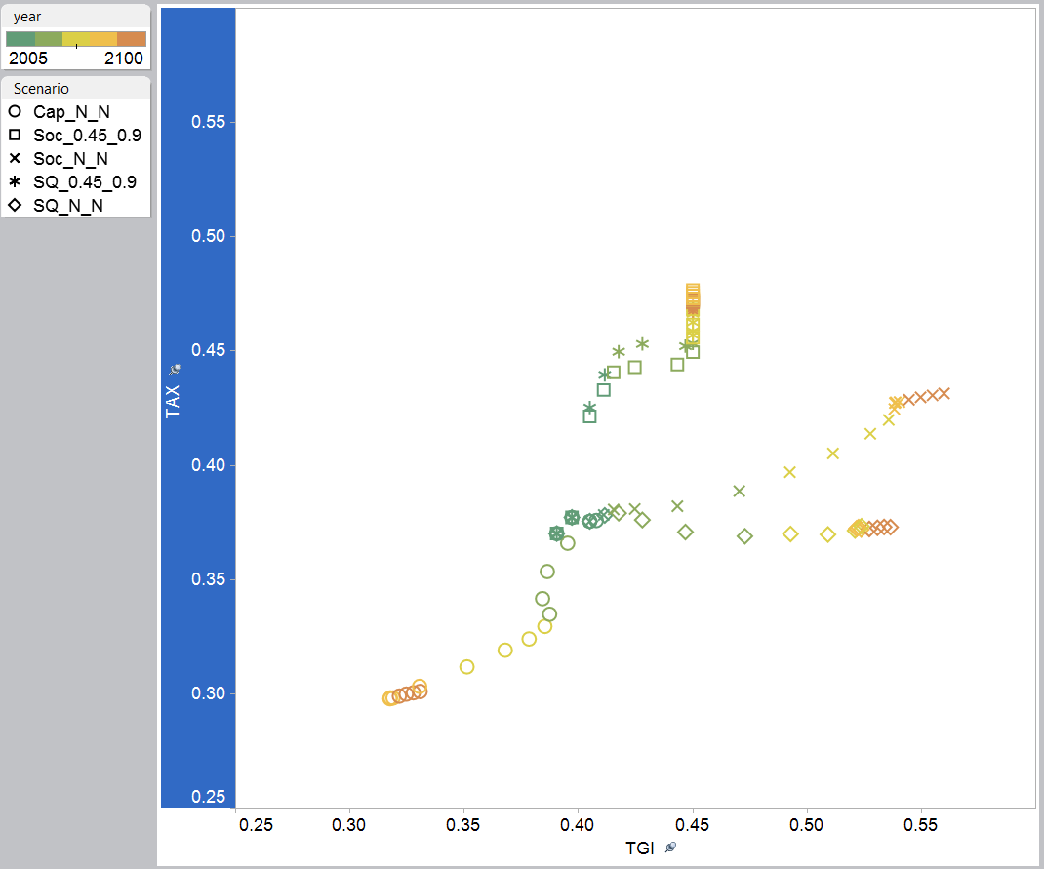

Taxes = Public transfer inflows

2004

Debt constraint binds in 2015 leading to higher taxes in constrained scenarios

Size of government constraint binds in 2040 leading to cap on spending

2100

2100

2100

2100

Figure 9. Taxes (TAX) and public transfer inflows (TGI) as a share of GDP, Hungary, 2004-2100, five scnearios: Status quo (SQ) and social welfare reform (Soc) with and without constraints (TGI/GDP <.45; Net debt/GDP < 0.9); capitalistic reform (Cap) without constraint.

Under any scenario the debt constraint is initially binding producing sharp increases in taxes starting in 2015. Taxes would jump from 38 percent of GDP in 2010 to 42 percent of GDP in 2015. And they would rise from there. Under either scenario the size of government constraint binds in 2040 with public transfer inflows equal to 45 of GDP.

Among the post-dividend countries we review only Japan in any detail. Japan faces very serious fiscal problems burdened by a large current deficit, high public debt, a public support system that provides relatively generous benefits to the elderly, and very rapid population aging. One of the few positives for Japan is that interest rates on public debt are quite small. Debt would rise to 600% of GDP under the status quo scenario so substantial reform is unavoidable. Capitalistic reform would be helpful, but public debt would reach 420% of GDP under this scenario. Capitalist reform with a constraint of 35 percent on the size of government as a share of GDP and a debt goal of 90 of GDP, would lead to an immediate reduction of government spending by 3.4 percent of GDP and an immediate increase in taxes by 3.1 percent of GDP. This would reduce public debt to about 90 percent of GDP by 2055. This all assumes that reform did not throw Japan into deep recession – a doubtful assumption.

Suppose that Japan implemented policies that successfully extended the work life (raising labor income, taxes, and reducing pensions) and curtailed growth in spending on publicly-funded health care in response to improved health among the elderly. The survival linked scenarios provide one plausible (perhaps optimistic) assessment of what such reform might look like. Figure 10 shows how labor income, taxes, and public transfer inflows would change under the survival linked reform. For this scenarios we employ a constraint that public transfer inflows cannot exceed 45 percent of GDP but retain the 90 percent of GDP debt goal.

Labor income at older ages would increase very dramatically under this scenario. In 2010, labor income of an individual age 61 was 60% of a YoLY, but by 2070 a person aged 71, ten years older, would be earning 64% of a YoLY. Essentially the work life has been extended by ten years over a sixty-year period. Public transfer inflows drop in equally dramatic fashion. The 71 year old would be receiving 37 percent of a YoLY in public transfer inflows in 2070 as compared with 40 percent of a YoLY for the 61 year old in 2010.

The tax profiles shift for all age groups due to the net debt constraint and, in addition, for the elderly due to the survival linked scenario. A sixty-year old in 2030 is paying taxes of 64 percent of a YoLY as compared with 42 percent of a YoLY in 2010. This is a 50 percent increase in under the influence of both the survival linked scenario and the constraint on indebtedness, but the increase is about half of the increase in labor income for 60-year-olds.

High tax rates are maintained through 2050 under the scenario, but eventually the debt problem is ameliorated by the higher taxes paid at older ages and the more rapid growth of GDP. The effect of this on taxes is seen in 2070 when tax rates for most adults are lower. The age-specific tax rates decline very little after 2070 (not shown) and are still higher at all ages than was the case in 2010. Of course, the 2010 tax rates produced a very substantial deficit so returning to those levels is not a realistic goal without substantial reductions in public sector benefits.

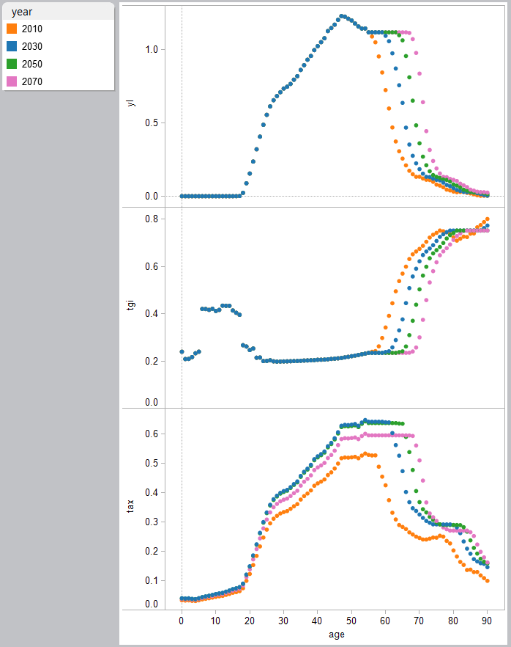

Figure 10. Labor income (yl), public transfer inflows (tgi), and taxes (tax) by age, Japan, 2010 to 2070, survival linked scenario with public transfer inflows constrained to 45 percent of GDP and net debt to 90 percent of GDP. Age profiles are normalized on the average labor income of persons 30-49 years of age.

Taxes and public transfer inflows as a share of GDP are charted for Japan from 2004 to 2100 (Figure 11). Two scenarios are shown both with public transfer inflows constrained to 45 percent of GDP and public debt to 90 percent of GDP. One scenario is the status quo scenario so age profiles of taxes and transfers adjust proportionately as need to satisfy the constraints. The other is survival linked scenario with age profiles adjusting as shown in Figure 9.

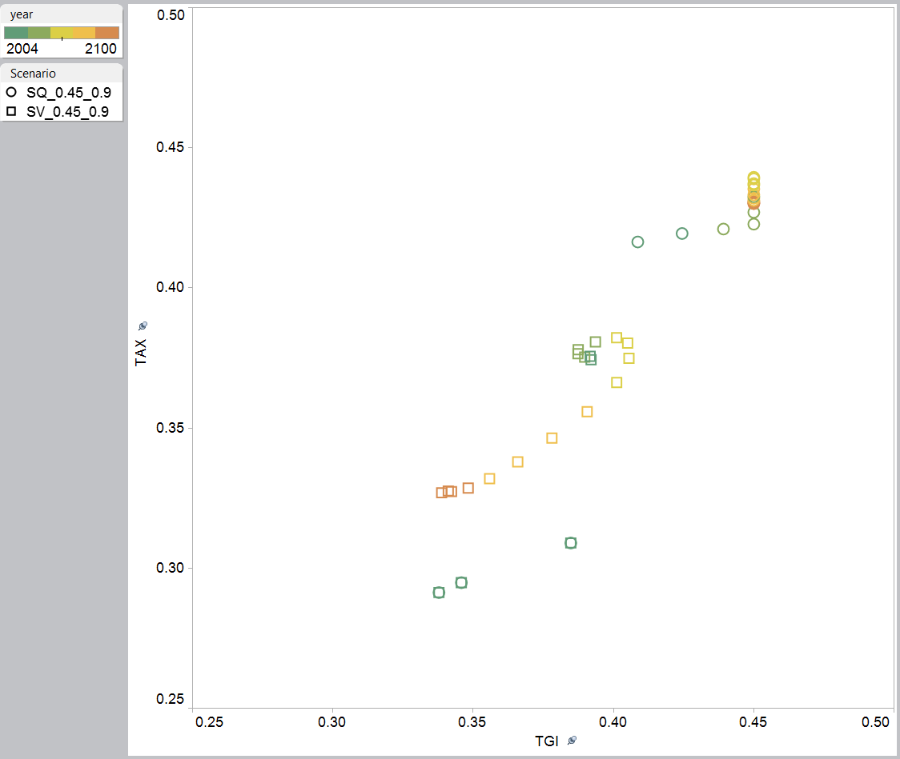

2050

2050

2015

21000

21000

2010

Figure 11. Taxes (TAX) and public transfer inflows (TGI) as a share of GDP, Japan, 2004-2100, two scenarios: status quo (SQ) and survival linked (SV) both constrained. Public transfer inflows no more than 45 percent of GDP; net public debt no more than 90 percent of GDP.

The debt constraint in Japan is immediately binding requiring higher taxes under either scenario in 2015. The adjustment is somewhat smaller under the survival-linked scenario because spending grows more moderately under this scenario but also because GDP is growing more rapidly. Under the status quo scenario, public spending rises sharply hitting the size of government constraint in 2030. Thereafter, taxes rise until 2050 and then decline because servicing public debt is becoming less burdensome.

Both taxes and spending begin to decline around 2050. The decline is much more substantial driven by the shifts in survival-linked age profiles of labor income, public transfer inflows, and taxes. By 2100 Japan will have completed its transition to a very old population, but public transfer inflows and taxes will have dropped to only 34 and 33 percent of GDP respectively.

# Incorporating private sector responses

The analysis presented above is focused squarely on the public sector. In the next few sections we will focus on the broader implications of aging and public policy incorporating both public and private sector responses.

## Consumption patterns

One strategy for dealing with population aging is to maintain the existing approach to public sector programs to the extent possible. Benefits would be scaled back and taxes raised only to the extent necessary to achieve sustainability. This approach is modelled using the status quo scenario constrained as necessary to avoid public sector spending and public debt that is unacceptably large. For the nine countries for which results are presented only four, Germany, Hungary, Japan and the US, face sustainability issues. For Germany, Hungary, and Japan we constrain public transfer inflows to 45 percent of GDP and for the US we constrain spending to 35 percent of GDP. The spending constraint is varied in an effort to capture different views about the acceptable of government. In all countries, a debt goal of 90 percent of GDP is imposed. The other five countries do not violate these constraints and, hence, values for the status quo scenarios without constraint are reported in Tables 5 and 6.

The policy responses to aging are minimalist. Countries are not undertaking major structural reform that would influence the general approach to intergenerational transfers. Nor are countries undertaking reforms that might influence the broad features of the lifecycle.

Average consumption normalized on labor income varies in these simulations for two reasons. The first dividend effect is operating. Changes in the support ratio given the saving rate influence normalized consumption. Saving rates do vary in the simulations, however. Thus, higher consumption may be realized by reducing saving rates. The saving responses are explored below. With the sole exception of India, normalized consumption declines due to aging between 2010 and 2035. The adverse effect is largest in Japan where normalized per capita consumption declines at a striking 0.9 percentage points per year. Real productivity growth in Japan is anticipated to be slightly higher than this at 1.5 percent per annum. But in the absence of second dividends effects or other factors that might boost productivity growth, real consumption per person would grow very slowly at 0.6 percent per year. The negative effects are also very large in Germany, the US, and Hungary.

This is a transitory phenomenon to a considerable extent and we see the adverse effects of age structure begin to moderate between 2035 and 2065 as the leading aging countries begin to stabilize at older populations. Among the younger countries, Thailand and South Africa are expected to experience very substantial aging effects in the coming decades as consumption declines by 0.5 percent per annum in Thailand and by 0.55% per year in South Africa. A surprising result is that China’s consumption growth is relatively unaffected by aging. This occurs because China’s saving rate declines from 38% of GDP in 2035 to 32% of GDP in 2065. The share of GDP devoted to consumption rises by a very substantial eight percentage point of GDP. Thailand’s saving rate is relatively constant over this period at 15 percent of GDP. South Africa’s saving rate rises substantially, from 9.4 to 20.2 percent of GDP driven by a rise in public saving. Essentially consumption is depressed in South Africa as the country accumulates wealth. This will serve to ease the costs of aging in the future but at the cost of those contributing to greater wealth today.

|  |  |  |  |  |  |  |  |  |
| --- | --- | --- | --- | --- | --- | --- | --- | --- |
| Table 5. Trend in consumption with parametric reform as needed. | | | | | | | | |
|  |  | Average consumption | | |  | Annual growth rate (%) | |
|  | Scenario | ~2010 | 2035 | 2065 |  | 2010-35 | 2035-65 |
| Japan | SQ_.45_.9 | 0.71 | 0.56 | 0.50 |  | -0.90 | -0.40 |
| Germany | SQ_.45_.9 | 0.60 | 0.50 | 0.46 |  | -0.68 | -0.28 |
| US | SQ_.35_.9 | 0.81 | 0.68 | 0.66 |  | -0.70 | -0.14 |
| Hungary | SQ_.45_.9 | 0.60 | 0.53 | 0.47 |  | -0.50 | -0.39 |
| China | SQ_N_N | 0.43 | 0.42 | 0.41 |  | -0.11 | -0.05 |
| Thailand | SQ_N_N | 0.73 | 0.68 | 0.57 |  | -0.31 | -0.58 |
| India | SQ_N_N | 0.79 | 0.81 | 0.72 |  | 0.09 | -0.39 |
| Mexico | SQ_N_N | 0.84 | 0.80 | 0.71 |  | -0.16 | -0.40 |
| S Africa | SQ_N_N | 0.61 | 0.61 | 0.50 |  | -0.05 | -0.64 |
| Note: Average consumption is simple average of normalized consumption by single year of age for those 0 to 84 with each age equally weighted. SQ_X_Y is status quo scenario with constraint on public transfer inflows as a share of GDP of X and net public debt as a share of GDP of Y. N means no constraint. | | | | | | | |
| Source: Calculated by authors. | | | | | | | |

In Table 6 we consider how the age distribution of consumption is affected by aging given minimalist reform to public sector systems. First, we do not see evidence that aging leads to higher consumption among the elderly at the expense of lower consumption for children. In none of these simulations, does the consumption of children decline noticeably compared with that of prime age adults. In two cases, Hungary and Thailand, consumption by children rises sharply in comparison to that of adults. In both of these countries, consumption by the elderly relative to prime age adults increases as well. In Japan and South Africa, we see fairly significant decline in consumption by the elderly as compared with prime age adults.

|  |  |  |  |  |  |  |  |  |
| --- | --- | --- | --- | --- | --- | --- | --- | --- |
| Table 6. Consumption of children and elderly relative to prime age adults, 2010/11, 2035, and 2065. Parametric reform as needed. | | | | | | | | |
|  |  | Consumption 0-24/25-59 | | |  | Consumption 60-84/25-59 | | |
|  | Scenario | 2009/11 | 2035 | 2065 |  | 2009/11 | 2035 | 2065 |
| Japan | SQ_.45_.9 | 0.91 | 0.93 | 0.89 |  | 1.33 | 1.37 | 1.29 |
| Germany | SQ_.45_.9 | 0.81 | 0.81 | 0.79 |  | 1.11 | 1.07 | 1.00 |
| US | SQ_.35_.9 | 0.76 | 0.76 | 0.75 |  | 1.35 | 1.32 | 1.29 |
| Hungary | SQ_.45_.9 | 0.88 | 0.96 | 0.95 |  | 1.14 | 1.41 | 1.42 |
| China | SQ_N_N | 0.86 | 0.88 | 0.88 |  | 1.33 | 1.45 | 1.47 |
| Thailand | SQ_N_N | 0.88 | 0.93 | 0.95 |  | 0.94 | 1.10 | 1.03 |
| India | SQ_N_N | 0.69 | 0.68 | 0.69 |  | 1.17 | 1.19 | 1.18 |
| Mexico | SQ_N_N | 0.67 | 0.69 | 0.71 |  | 0.96 | 0.96 | 0.97 |
| S Africa | SQ_N_N | 0.64 | 0.63 | 0.65 |  | 0.88 | 0.83 | 0.71 |
| Note: Consumption for each age group is a simple average of normalized values by single year of age. Source: Calculated by authors. | | | | | | | | |

How does policy influence these outcome? First let’s consider the five dividend countries. Social welfare reform promotes consumption growth uniformly as shown in Table 7. The effects are largest in China where normalized consumption grows at an additional 0.25 percent per year between 2010 and 2035. The effects in other countries are smaller. Between 2035 and 2065, social welfare reform has large effects relative to the status quo policy in Thailand and India where normalized consumption declines less rapidly by 0.3 percentage points in Thailand and about 0.2 percentage points in India.

Capitalist reform has trivial effects on consumption growth between 2010 and 2035 and inconsistent effect between 2035 and 2065. Capitalist reform has little effect in China or India during either period. Between 2035 and 2065, Cap has a substantial pro-consumption impact in Thailand and anti-consumption effects in Mexico and South Africa.

|  |  |  |  |  |  |  |  |
| --- | --- | --- | --- | --- | --- | --- | --- |
| Table 7. Policy Matrix for Dividend Countries: Growth in normalized consumption | | | | | | | |
|  |  |  |  |  |  |  |  |
|  | Annual growth, 2010-2035 | | |  | Annual growth, 2035-2065 | | |
|  | Status quo | Capitalist reform | Social welfare reform |  | Status quo | Capitalist reform | Social welfare reform |
| China | -0.11 | -0.09 | 0.14 |  | -0.05 | -0.01 | -0.02 |
| Thailand | -0.31 | -0.28 | -0.17 |  | -0.58 | -0.35 | -0.27 |
| India | 0.09 | 0.10 | 0.17 |  | -0.39 | -0.40 | -0.21 |
| Mexico | -0.16 | -0.18 | -0.11 |  | -0.40 | -0.53 | -0.32 |
| South Africa | -0.05 | -0.08 | 0.00 |  | -0.64 | -0.75 | -0.41 |
| Note: Capitalist reform assumes 0.35/0.9 constraints; social welfare reform 0.45/0.9 constraints. | | | | | | | |
|

Lifecycle reform is strongly pro-consumption growth in all countries and periods (Table 8). This is not surprising because lifecycle reform leads to greater lifetime consumption. The largest effects are found between 2010 and 2035, but they are still substantial after 2035. Between 2010 and 2035, lifecycle reform adds between 0.4 and 0.5 percent annually to consumption growth except in the United States where consumption growth is higher by 0.27 percent per year. Between 2035 and 2065, consumption growth is higher by 0.42-0.47 percent per year except in the US, where the gain is 0.17 percent per year.

|  |  |  |  |  |  |
| --- | --- | --- | --- | --- | --- |
| Table 8. Policy Matrix for post-dividend countries: Growth in normalized consumption. | | | | | |
|  |  |  |  |  |  |
|  | Annual growth, 2010-2035 | |  | Annual growth, 2035-2065 | |
|  | Sustainable status quo | Lifecycle reform |  | Sustainable status quo | Lifecycle reform |
| Japan | -0.90 | -0.39 |  | -0.40 | 0.07 |
| Germany | -0.68 | -0.16 |  | -0.28 | 0.14 |
| United States | -0.70 | -0.43 |  | -0.14 | 0.03 |
| Hungary | -0.50 | -0.08 |  | -0.39 | 0.01 |
| Note: All scenarios impose a 0.45/0.9 constraint for Japan, Germany, and Hungary and a 0.35/0.9 constraint for the United States. | | | | | |
|

Policy also influences consumption by the elderly and children relative to prime age adults. The social welfare policy has beneficial effects for the elderly in all countries and period. The largest effects are estimated for 2065. These gains do not come at the expense of children however. Consumption by children relative to prime age adults is unaffected in Thailand and rises elsewhere. Capitalist reform has similar though more modest effects. The elderly benefit in all countries in both 2035 and 2065. Children are about as well off or slightly better off relative to prime age adults. They experience a moderate decline in Thailand.

|  |  |  |  |  |  |  |  |  |  |  |  |  |  |  |  |
| --- | --- | --- | --- | --- | --- | --- | --- | --- | --- | --- | --- | --- | --- | --- | --- |
| Table 9. Policy matrix for Dividend Countries: Average normalized consumption of children and elderly relative to prime age adults | | | | | | | | | | | | | | | |
|  |  |  |  |  |  |  |  |  |  |  |  |  |  |  |  |
|  | Children, 2035 | | |  | Children, 2065 | | |  | Elderly, 2035 | | |  | Elderly, 2065 | | |
|  | SQ | Cap | SW |  | SQ | Cap | SW |  | SQ | Cap | SW |  | SQ | Cap | SW |
| China | 0.88 | 0.91 | 0.95 |  | 0.88 | 0.97 | 1.04 |  | 1.45 | 1.52 | 1.71 |  | 1.47 | 1.69 | 2.19 |
| Thailand | 0.93 | 0.92 | 0.92 |  | 0.95 | 0.91 | 0.95 |  | 1.10 | 1.22 | 1.25 |  | 1.03 | 1.50 | 1.89 |
| India | 0.68 | 0.71 | 0.73 |  | 0.69 | 0.80 | 0.86 |  | 1.19 | 1.29 | 1.36 |  | 1.18 | 1.53 | 1.79 |
| Mexico | 0.69 | 0.70 | 0.72 |  | 0.71 | 0.77 | 0.81 |  | 0.96 | 0.98 | 1.04 |  | 0.97 | 1.00 | 1.27 |
| S Africa | 0.63 | 0.63 | 0.65 |  | 0.65 | 0.63 | 0.70 |  | 0.83 | 0.88 | 0.97 |  | 0.71 | 0.87 | 1.23 |
| Note: For all constraints public transfer inflows constrained to 35% of GDP for capitalist scenario and 45% of GDP for social welfare scenario. All scenarios constrain public debt to 90% of GDP. | | | | | | | | | | | | | | | |

Lifecycle reform extends the work life leading to higher labor income among the elderly, but also higher taxes and lower benefits. The net effect is to raise their consumption relative to the status quo scenario in Japan, Germany, and the US, but not in Hungary where taxes and benefits are particularly high. The relative effects on children favor them in Japan, Germany, and the US, but again not in Hungary. Note that consumption is higher in general under lifecycle reform. Normalized consumption for children under the SQ scenario is 10.0 in 2065 under the SQ scenario while it rises to 13.0 under lifecycle reform.

|  |  |  |  |  |  |  |  |  |  |  |  |
| --- | --- | --- | --- | --- | --- | --- | --- | --- | --- | --- | --- |
| Table 10. Policy matrix for Post-Dividend Countries: Average normalized consumption of children and elderly relative to prime age adults. | | | | | | | | | | | |
|
|  | Children, 2035 | |  | Children, 2065 | |  | Elderly, 2035 | |  | Elderly, 2065 | |
|  | SQ | LC |  | SQ | LC |  | SQ | LC |  | SQ | LC |
| Japan | 0.93 | 0.95 |  | 0.89 | 0.96 |  | 1.37 | 1.44 |  | 1.29 | 1.48 |
| Germany | 0.81 | 0.83 |  | 0.79 | 0.84 |  | 1.07 | 1.18 |  | 1.00 | 1.26 |
| US | 0.76 | 0.78 |  | 0.75 | 0.78 |  | 1.32 | 1.37 |  | 1.29 | 1.40 |
| Hungary | 0.96 | 0.92 |  | 0.95 | 0.91 |  | 1.41 | 1.23 |  | 1.42 | 1.20 |
| Note: US public transfer inflows constrained to 35% and other countries to 45% of GDP. For all countries, US debt is constrained to 90% of GDP. | | | | | | | | | | | |
|

## Saving

Saving rates play an important but a limited role in this model of population aging. A growth model would include feedbacks whereby changes in saving would influence investment, asset income, labor productivity, and interest rates. We do not explore this channel here. The effect of aging and public policy on the allocation of resources between current consumption and saving is of interest in its own right, however.

The impact of aging on saving rates is an important issue that has attracted a great deal of attention. In the lifecycle model saving demographic factors play a very important role. An age composition effect exerts its influence as the concentration of population at high or low saving ages varies. Changes in child dependency may influence the age profiles of consumption and saving. Rising life expectancy may influence the duration of retirement and incentives to accumulate wealth during the working ages. An alternative to the lifecycle model take a more empirical approach by emphasizing the effects of age structure given persistent patterns of saving by age. The simulation model employed here includes some elements of the lifecycle model. Age structure influences saving because of observed variation in saving rates by age as captured in the NTA data. The age patterns of saving (and consumption) vary over time, however. Changes in child and old-age dependency both exert an influence on saving at each age through private transfers. Depending on the public policies pursued changes in age structure affect taxes and public transfers which directly influence private and public saving and indirectly influence private saving through their effect on private transfers.

Saving rates, net saving as a share of GDP, in the initial year (2009 – 2011) varied substantially across the nine study countries presented here. Among the dividend countries China’s saving rate was highest at 44% of GDP in 2009 while South Africa’s was lowest at 2% of GDP. Saving rates in Thailand, Brazil, and India ranged between 14% and 24% of GDP. Saving rates in the post-DD countries were generally lower (with some overlap). Germany’s saving rate was 8% of GDP, while saving rates in the other three post-dividend countries ranges from 3% in Hungary down to -1% in the US.

In the post-dividend countries initial year public saving ranged from -3% of GDP in Germany to -9% of GDP in the United States. In large part the high rates of dis-saving reflect the influences of recession although aging may have played a role, as well. In any case, these high rates of dis-saving are unsustainable and all of the scenarios considered below are restricted to those that are. In particular, the scenarios all assume that public debt will not exceed 90 percent of GDP in 2065. Meeting this goal requires higher public saving rates and, because private saving rates are relatively insensitive to variation in public saving rates, higher total saving rates. The prospects of the impact of population aging on public debt thus lead to an increase in saving rates between the initial year and 2015 that is modest in Germany and very substantial in Japan and the United States (Figure 12).

The patterns for Germany, Hungary, and Japan are similar. Saving rates are higher under the constrained status quo scenario than the survival linked scenario in both 2015 and 2065. Under either scenario, saving rates decline between 2015 and 2065. The differences across time and scenarios are not very large, amounting to one or two percentage points. In the United States, saving rates are quite insensitive to the scenario or the influences of population aging. Examining more detailed simulated trends in saving, not shown here, reinforces the overall conclusion that aging and sustainable policy responses do not have a large systematic effect on aggregate saving rates. Over some periods the effects of aging are negative and over other periods positive in every country irrespective of the scenario. The simulated values for the demographic dividend countries are constrained to a relatively narrow range between 4 percent and 9 percent of GDP with the US and Hungary on the slow side of that range and Japan and Germany on the higher side.

Figure 12. Net saving as a percentage of GDP for four post-dividend countries; initial year (2009-2011) and simulated values for 2015 and 2065 under two scenarios. SQ is the status quo scenario and SV the survival linked scenario. In all case, public debt is constrained to reach 90% of GDP over a 50 year time horizon beginning in 2015. Public transfer inflows are constrained to be no more than 45% of GDP in Germany, Hungary, and Japan and no more than 35% of GDP in the US.

The simulated effects of policy and aging on saving rates in dividend countries are relatively strong and persistent (Figure 13). Two of the dividend countries, China and Thailand, have very low fertility and will face rapid population aging in the not too distant future. Saving rates are not affected to any great degree by age under the status quo policy in Thailand. Otherwise, changes in population age structure lead to substantially lower saving rates. The greatest decline occurs with social welfare reform and the smallest with the status quo.

In three dividend countries aggregate saving rates are projected to increase between 2015 and 2065 under the influence of changing population age structure. These countries are experiencing favorable changes in age structure and the effects on saving are substantial irrespective of the scenario. The scenario does matter, however. In 2065, the saving rate under the capitalist scenario is higher by three to five percentage points depending on the country.

Figure 13. Net saving as a percentage of GDP for five dividend countries; initial year (2009-2011) and simulated values for 2015 and 2065 under three scenarios initiated in 2020. Under the status quo and capitalist scenario public transfer inflows are constrained to 35% of GDP; under the social welfare scenario the constraint is 45% of GDP. In all case, public debt is constrained to not exceed 90% of GDP over a 50 year time horizon beginning in 2015.

## Intergenerational Redistribution

In some countries, the elderly consume about the same as younger adults, while in others they consume substantially more. In a few countries with multiple NTA, we can observe a recent rise in the relative consumption by the elderly, as in the US, Japan, and Sweden. In the US, the ratio of consumption by an 80 year old relative to that of a 20 year old doubled between 1960 and 2010. In the US, Japan and Sweden the steepening of consumption by age accompanied the expansion of welfare state transfers to the elderly for pensions, health care and long term care. It may appear that the changing age distribution of consumption has been driven by the growth of these public transfers to the elderly.

However, a theoretical literature in economics suggests that generations within families are altruistically linked, and that parents and grandparents aim for some distribution of consumption across generations and then use intergenerational transfers to achieve this distribution (Barro 1974; Becker and Barro 1988). If the public sector raises taxes on working age people to fund increased transfers to the elderly, then the elderly will respond not by consuming these new transfers, but rather by increasing their private transfers to younger generations, their children and grandchildren. This will be easier for pension cash benefits than for in-kind health care and long term care, but younger family members who might previously have helped pay these grandparental costs themselves can reduce such private transfers when they become redundant, which would effectively reduce net private transfers made by the elderly, making them less positive or more negative.

Among the NTA countries, Brazil is the posterchild for this sort of offsetting substitution of public and private transfers, since it has both the highest public transfers to the elderly and the highest private transfers by the elderly to younger family members. Yet if we exclude Brazil, the other NTA countries do not offer strong support for this pattern. A different empirical literature has looked in detail at the way that increased public pension benefits in rural parts of South Africa have led to increased transfers to children and grandchildren, resulting in observable improvements in anthropometric measures, for example (Duflo 2003). This is exactly the kind of qualitative response that the Barro or Becker-Barro theories would predict.

These points are important as we consider the potential growth of public sector transfers to the elderly. Will it lead to a big increase in consumption by the elderly relative to younger ages? Or will the elderly largely neutralize the effects of the public transfers by making their own transfers to younger family members, generating a “trickle-down” effect across the age distribution? We can use the model and simulations developed in this paper to explore these important questions by comparing the results of different scenarios, because these simulations explicitly incorporate the private response to public transfers based on observed patterns in NTA data.

Even if there were no change in public sector programs, population aging by itself would affect the intergenerational distribution of consumption, as discussed earlier. Population aging changes the relative numbers of people at ages which give transfers versus ages which receive transfers, forcing balancing changes in either the size of the per capita transfers received or of transfers given, or both. For this reason, it will not suffice to trace how the age distribution of per capita consumption changes if we introduce a more generous public transfer system in coming decades. Some of the changes we see will result from population aging. Instead we must compare the age distribution of consumption under the Social Welfare scenario to that under the Status Quo scenario, allowing us to isolate the effect of a increased public transfers to elderly while netting out the effect of population aging.

Of course, the effect of switching to the Social Welfare scenario will depend on the prior public system in each country. In some cases, the SQ system might be more generous than the SW system, for example. In Mason, Lee et al. (2014) Figures 15 and 17, and Table 1, we see that national public transfer programs differ greatly in how they reallocate income across age and generation in 2015. Seven of the eleven countries shift resources on net to younger ages through the public sector, while four shift resources upwards including Japan, Germany, Hungary and China (see Table 1). Furthermore, there are large differences among countries in the size of the public sector.

We can simulate how these patterns of public reallocation across age would change if program structures remain the same, as in the status quo scenario with no constraints, shown in Figure 17 of (Mason, Lee et al. 2014). Those simulations assume no response by private transfers, and do not impose any balancing adjustments to the public systems. The figure compares the direction of net public transfers in 2015 to that with the population age distribution projected for 2065, a half century later. For Nigeria, transfers remain downwards by 15 years, and for India they remain downwards by around 8 years. For all other countries, population aging will lead to big changes. In Brazil, from -3 years to +4 years; in China, from +2 to +7 years; in Thailand, from -6 to +3 years; for the US, from -4 to +1 years; and for Japan, from +4 to +9 years.

Simulations like these give us some insights because they isolate a pure demographic component of change. However, their value is limited by the assumption that public program structures remain unchanged, while we know that change will be forced by growing fiscal imbalances in some countries, and we expect that economic development will lead nations toward more generous public benefits for children and the elderly. Elsewhere we discuss how rescaling of tax and benefit age profiles can be triggered by constraints on debt/GDP ratios or on the size of public transfer programs relative to GDP. Their value is also limited because they assume no interaction between public sector transfers and private sector transfers, of the sort discussed above. Now we will turn to simulations that include the private sector interactions, and consider how changes in public sector policies might alter the age distribution of consumption.

## Dividend Countries

We begin the empirical analysis by considering dividend countries, most of which do not yet have highly developed public transfer systems. We also include Hungary by way of contrast. Rather than considering the entire age profile of consumption, we will focus on its average age or other summary measures. To isolate the role of different public sector policy scenarios, we will focus on the year 2065, contrasting the status quo scenario to two others. In the social welfare scenario, public benefits and taxes rise toward target age profiles based on European welfare states. In the capitalist scenario, the target public spending and tax profiles, based on values for Spain and the US, are lower than the social welfare profiles. Here we discuss how these policy options differentially affect the age/generational aspect of the public sector redistribution (Figure 14).

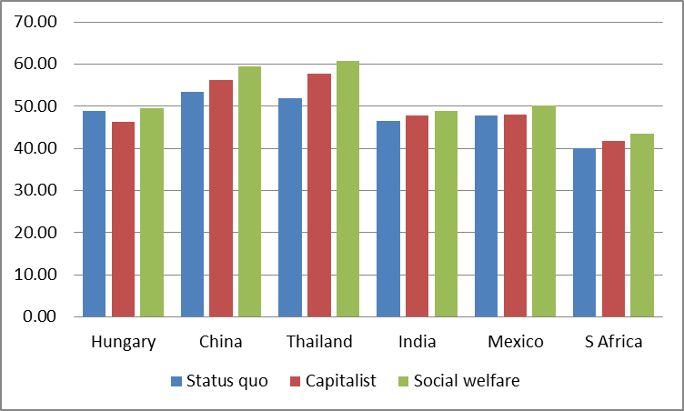

Figure 14. Average age of consumption in 2065 under three policy scenarios: status quo (SQ), capitalist (Cap), and social welfare (Soc); no constraints.

For Hungary, which already has a social welfare state, moving to the capitalist program would reduce transfers to the elderly and thereby reduce the mean age of consumption, while moving to the social welfare regime would make virtually no difference. For dividend countries, however, moving toward capitalist or social welfare state policies would shift consumption toward older people relative to the status quo by as much as 9 years in the case of Thailand and 6 years in China. These very large increases in the average age are not merely due to population aging, because they are measured relative to the status quo policy in 2065 which also reflects population aging. The increases do, however, reflect an interaction of population aging with the new policies toward children and the elderly. For the other developing countries shown in the figure the differences are smaller but all are in the same direction.

It may seem obvious that increasing public transfers to the elderly would have these effects, but Figure 14 shows the *net* effect after accounting for any offsetting private transfer flows (or asset-based reallocations). The results shown in the figure are inconsistent with the view that private transfer flows would completely undo the effects of the public programs, as discussed earlier.

To deepen our understanding of the contrasts shown in Figure 14 we next consider in more detail what lies behind them. Mason et al (2016, Paper 1, equation 3) decomposes the difference between the average age of consumption and the average age of labor income, Ac-Ayl, as a weighted sum of the differences between the average ages of government transfers received and made, private transfers received and made, and the average age of asset based reallocations minus that of labor income. The weights in this sum are ratios of the aggregate flows of public and private transfers and asset income to aggregate consumption, *vtg*, *vtf*, and *vra*. [3]



or alternatively



In our developing country simulations, there is no change in labor income by age, so changes in the mean age of earning, AYL, will be shared by all policy outcomes in 2065. For this reason, the decomposition shown above applies equally to the difference in average ages, *AC-AYL*, or to the average age of consumption itself, *AC*. While saving behavior and asset holdings will be affected by the public policies, our focus here will be on the public and private transfers and the tradeoffs between them.

A public sector shift from SQ to SW will have two direct effects on AC. First, for most developing countries, although it will increase public transfers both to children and to the elderly, the increase in transfers to the elderly will typically predominate, raising the size of (*ATGI-ATGO*)*.* That will tend to raise the AC. Second, the volume of public transfers will increase, raising *vtg* relative to its size under SQ. This further raises AC. For these reasons, we should strongly expect that SOC will have higher AC than will SQ. But we must also consider the indirect effects. We have already discussed the possibility that increased public transfers may displace private transfers to some degree. If private transfers are initially mainly to children, then ATFI-ATFO would be negative. Under the Soc scenario, public transfers to the elderly are increased and we would expect them either to reduce upward private transfers or to promote downward transfers from the elderly to their children and grandchildren. In this case, AFTI will become smaller and ATFO will become greater because transfers by elderly people will have grown. Therefore the difference between the two will become even more negative relative to SQ. We might also expect the volume of private transfers to decline under the Soc scenario as parents reduce their expenditures on private education for their children, but downward transfers from the elderly may increase and the net effect is not obvious. In NTA data, we do in fact find that as the size of the public flow rises, that of the private flows shrinks, as seen in Lee and Donehower (2011) in cross-sectional data. If the volume of private transfer flows stays the same while the average age gap becomes more negative, then the indirect private effect of the transition to the Soc scenario will be to offset some of the increase in AC, relative to SQ.

This discussion provides the background to understand and interpret the charts below. Because the capitalist scenario in Figure 14 lies midway between the status quo and the social welfare case for developing countries, we will drop it from the remaining figures for simplicity, and concentrate instead on the contrast between SQ and SW in 2065.

Figure 15 shows that the mean age of receiving public benefits (AGTI) is substantially higher under the social welfare regime than under the status quo, even though transfers to children for public education will be much higher. The average age is more than ten years higher in Thailand; the increase is smaller, but substantial in other dividend countries.

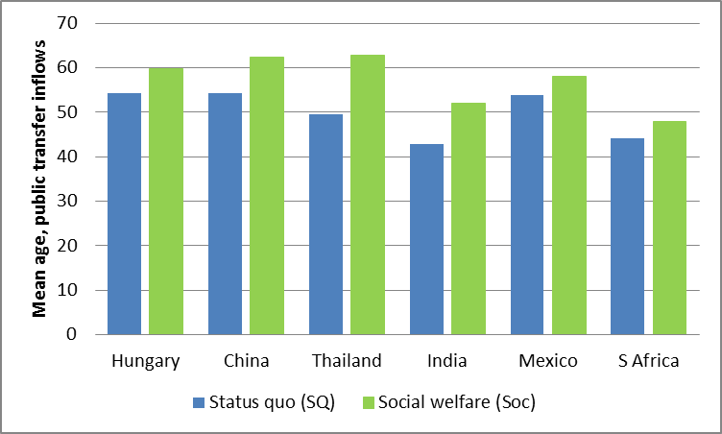

Figure 15. Mean age of public benefits received in 2065 under the status quo and social welfare scenarios with no constraints.

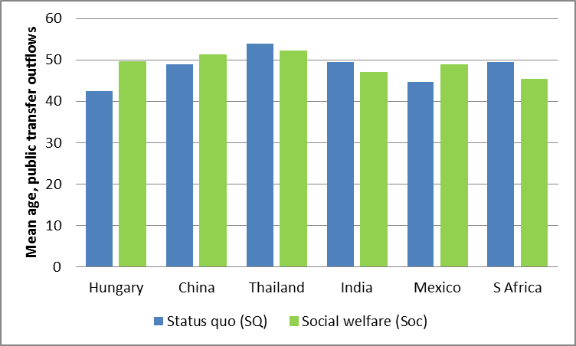

Figure 16. Mean age of public transfers given in 2065 under the status quo and social welfare scenarios with no constraints.

Figure 16 shows that the mean age of giving private transfers also rises in all dividend countries, suggesting that the elderly are distributing some of their increased public transfers to younger family members as predicted by theory. However, in most cases these effects are small relative to the increased age for receiving public transfers, with South Africa the only exception.

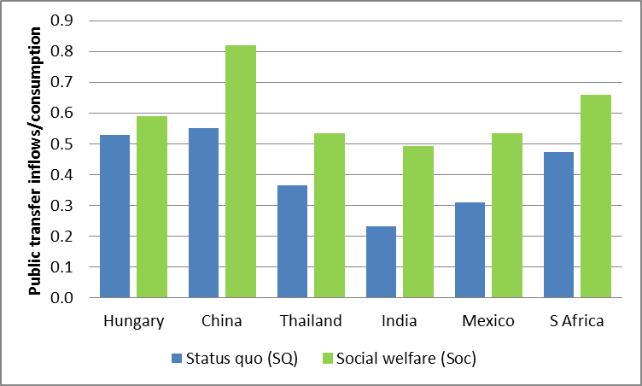

Figure 17. Public transfer inflows relative to consumption under status quo and social welfare scenarios without constraints.

The volume of public transfer flows relative to aggregate consumption is generally much larger in the social welfare regime than in the status quo, which is no surprise. The changes are very substantial ranging from 17 percentage points in Thailand to 27 percentage points in China (Figure 17). The volume of private transfer inflows declines relative to consumption in every country supporting the view that an increase in public transfers will crowd out private transfers (Figure 18). The decline in volume for private transfers is substantially smaller than the increase in the volume for public transfers. The ratio of the change in private to the change in public ranges from a low in South Africa of about -0.1 to a high in Thailand of -0.37.

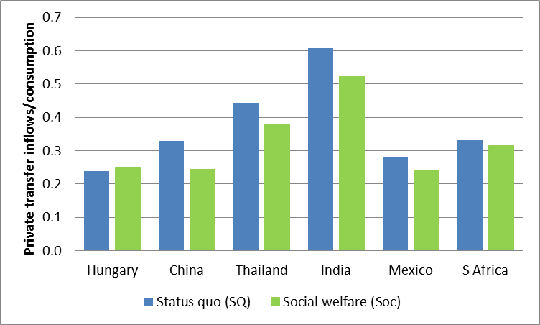

Figure 18. Private transfer inflows relative to consumption under status quo and social welfare scenarios without constraints.

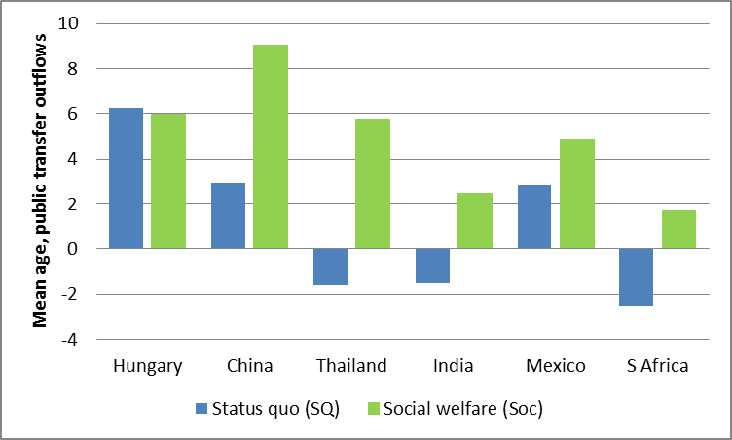

Figure 19. Total direct effect of public transfers on the average age of consumption under the status quo and social welfare scenarios without constraint.

Figure 19 shows the “total” direct effect of public transfers on the average age of consumption, by which we mean the product *vtg(ATGI-ATGO)*. For China and Thailand this is 6 and 7 years; for other dividend countries the effect is 2 to 4 years.

By contrast, Figure 20 shows the indirect effects of the public policy regime arising through the private transfer response. Although the contribution of familial transfers is typically to offset the public transfers, the size of this offset is generally quite small. The biggest are in Thailand at 1.7 years and China at .5 years. In Mexico the change in private transfers actually reinforces the change in public. This is reflects reduced private transfers for education, since these are crowded out by increased public education. It is interesting to note that severe population aging in China, coupled with a tradition of familial support of the elderly, leads to upward net private transfers in 2065 under both the status quo and social welfare scenarios, which is not true for the other developing countries.

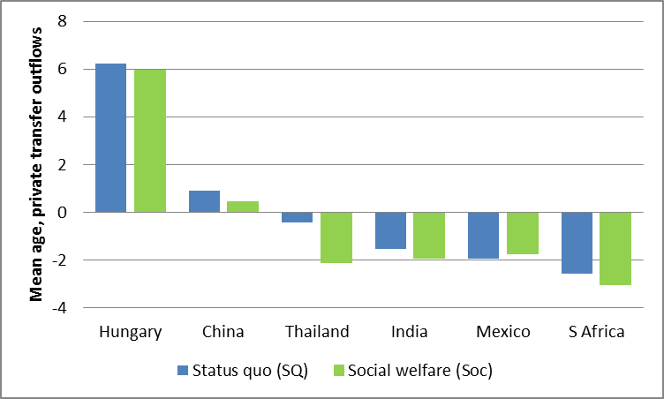

Figure 20. Total effect of private transfers on the average age of consumption under the status quo and social welfare scenarios without constraint.

## Post-dividend countries

Aging in three of the post-dividend countries, Germany, Hungary, and Japan, is expected to be severe and the public sectors in these countries, Hungary in particular, play a relatively important generational role. The US is distinctive in two important ways that bear on the analysis presented below. Aging will be more moderate in the US and the US relies less on public intergenerational transfers.

The consequences of these differences are apparent in Figure 21. In 2015 Japan and Germany have the highest mean ages of consumption while the United States has the lowest. Per capita consumption at older ages in the US is very high as compared with Germany, but this is more than offset by the young US population as compared with Germany’s. The average age of labor income in 2015 is highest in Japan and the United States reflecting higher per capita labor income at older ages in those two countries.

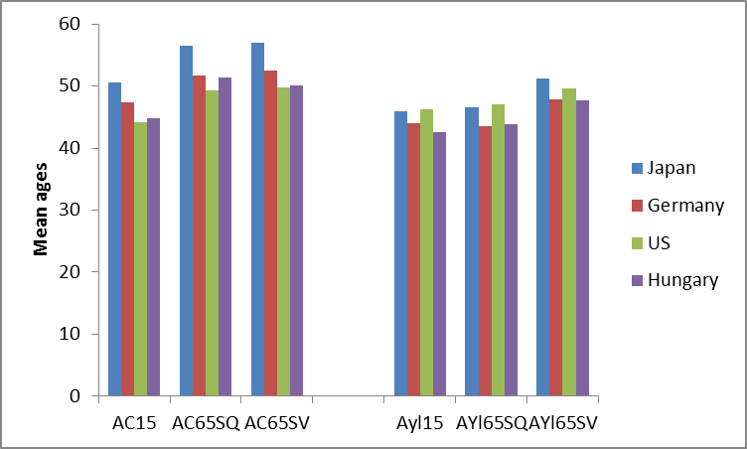

Figure 21. Mean ages of consumption (AC) and labor income (AYl), post-dividend countries, 2015 and for two scenarios in 2065. SQ scenario is constrained status quo while SV is constrained survival indexed. Debt is constrained to not exceed 90% of GDP in all countries. Public transfer inflows are constrained to be less than 35% of GDP in the US and 45% of GDP in Japan, German, and Hungary.

For post-dividend countries with strong welfare state programs, it is not interesting to consider transitions to the social welfare scenario, since this is already the status quo or close to it. Likewise, the capitalist scenario is similar to the status quo scenario for the US and we will not consider it. For these countries the interesting contrasts are between the constrained status quo and the survival-indexed scenario, also constrained – since later retirement is not itself sufficient for sustainability. We will discuss the simulations for Japan, Germany, and Hungary, bounding public transfers at 45% of GDP, and for the US with a constraint that public transfer inflows not exceed 35% of GDP. The debt to GDP constraint is 0.9 for all countries. There is little point in considering the unconstrained scenarios, since these lead to highly implausible ratios of debt to GDP.

Population aging per se has little effect on the average age of labor income in the absence of lifecycle reform. Between 2015 and 2065 under the status quo scenario, the mean age of labor income would rise by .5 years in Japan, .7 years in the US, and 1.1 years in Hungary, while declining by .4 years in Germany. But indexing old age labor supply to improvements in old age survival under the SV policy option adds very substantially to the average age of labor income: 3.7 years in Japan, 3.5 years in Germany, 3 years in the United States, and 4.5 years in Hungary.

In contrast to the minimal effect on the timing of labor income, aging leads to a substantial increase in the mean age of consumption in the post-dividend countries. Again, comparing 2015 to the 2065 status quo scenario, the average age of consumption increases by 4.2 years in Germany, 5.2 in the US, 5.9 in Japan, and 6.5 years in Hungary. The mean age of consumption is much less sensitive lifecycle reform than the mean age of labor income; survival-indexing adds only 0.4 years to the mean age of consumption in Japan and the US and 0.9 years in Germany. In Hungary, the mean age of consumption would actually decline by 1.3 years with lifecycle reform. The relative insensitivity of consumption to lifecycle reform is important. If higher labor income merely leads to higher consumption at old ages, lifecycle reform will provide no relief from the strains on intergenerational transfers created by population aging.

In 2015 in all countries, private transfers shifted resources downward, from adults to children, and asset-based reallocations shifted transfers upward, primarily from the working ages to retirement (Figure 22). Hungary is unusual in that asset-based reallocations are so unimportant in the 2015 age reallocation process. In 2015 Germany, Japan, and especially Hungary, public transfers shift public resources upward from younger taxpayers to public program beneficiaries who are older on average. Net public transfers have a similar but somewhat smaller impact than asset-based reallocations in Germany and Japan, while in Hungary upward reallocations are essentially only public transfers. The US standouts in that net public transfers are downward in 2015.

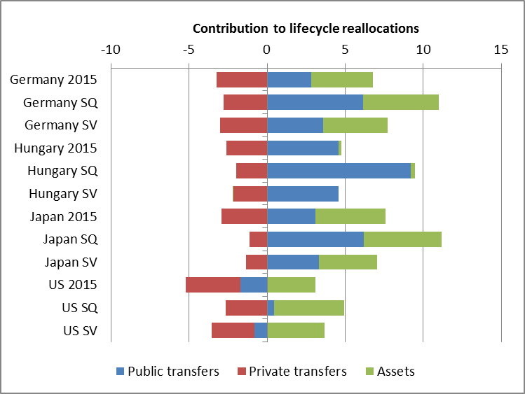Figure 22. Contribution of public transfers, private transfers, and asset-based reallocations to age reallocations in four post-dividend countries in 2015 and 2065, two scenarios. SQ: status quo scenario and SV: survival-indexed scenario. Public debt constrained to not exceed 90% of GDP; public transfer inflows constrained to not exceed 35% of GDP in the US and 45% of GDP in other countries.

Aging, as assessed by comparing the 2015 and 2065 status quo scenario, has its primary impact on public transfers. Public transfers shifted resources upward by an additional 4.6 years in Hungary, 3.3 and 3.1 years in Germany and Japan, respectively, and 2.2 years in the US. Private transfers shifted resources upward by a substantial 1.8 years in Hungary and between 0.5 and 0.9 years in the other countries. Asset-based reallocations shifted resources upward by an additional 0.5 years in Japan, 0.9 years in Germany, and 1.4 years in the US. The change in Hungary was small at 0.1 years of age.

Public transfer inflows increased in importance between 2015 and 2065 because in every country public transfer inflows increased as a share of consumption and because the mean age of public transfer inflows increased by between 6 to 8 years while the mean age of public transfer outflows increased by 2 to 3 years. Private transfer remained constant as a share of total consumption in Japan, but declined in Germany, Hungary, and the US. The mean age of private transfer inflows increased substantially in Japan (by 6 years), but by much less in other countries. The mean age of private transfer outflows changed relatively little in any of the countries.

Lifecycle reform leads to substantially different outcomes as compared with maintaining the status quo structure of public transfer systems. The strains on the reallocation system are substantially diminished as the years of labor income earned at older ages increase (Figure 21 above).

Under the constrained survival-indexed scenario, government inflows are to beneficiaries younger by about a year or two and outflows are to recipients older by 1 to 4.2 years in 2065. So the gaps between the mean ages of paying and receiving are substantially smaller as compared with the status quo scenario. In Hungary, the changes are greatest with the reduced by about 5 years as compared with 3 years for the other countries. At the same time, the ratio of public transfer inflows to consumption are substantially reduced, by 8 to 10 percentage points for the social welfare states and by 2 percentage points for the US. The result is that the product of the two, that is the intergenerational effect of public transfers declines by 40 to 50 percent in the social welfare states as compared to the constrained status quo policy. In the US, the intergenerational public transfer effect shifts from upward by 0.4 years to downward by -0.8 years.

The impact on family transfers of the survival-indexed reform is similar in Japan, Germany, and the US. They are made between one and years older under the SV scenario, and received at a somewhat later age as well; the net effect is that family transfers are downward by an additional 0.5 to 0.8 years than under the Status Quo. The volume of family transfers changes very little, rising very slightly in Japan and Germany while declining slightly in the US. The net effect is small with family transfers to children somewhat more important under the SV reform than the status quo reform.

The pattern is very different in Hungary. The mean ages of inflows and outflows are both younger by roughly two years of age under the SV reform. Private transfer inflows as a share of consumption rise slightly. The net effect is small with family transfers to children slightly less important under the SV reform than the status quo reform.

Lifecycle reform also leads to a reduced importance of asset-based reallocations in meeting the needs of an aging population. This is to be expected as labor market reform reduces the duration of retirement and the reliance on assets to meet retirement needs. The share of asset based reallocations relative to consumption is actually somewhat higher under the SV scenario except in the US, but in every country the gap between the age at which labor income is earned and the age at which asset-based resources are used declines quite substantially. On net, assets are less importance for allocating resources to older ages in every country. Reform has the largest effect in Japan and the smallest in Hungary.

Lifecycle reform as a whole tends to preserve current reallocations in the face of substantial population aging. In most cases, the lifecycle shifts transfers and asset-based reallocations realized under survival-linked reform are much closer to the 2015 values than the 2065 status quo values (Figure 22). The largest effects are on public transfer shifts which become very large given the status quo reform scenario, but much less so under the survival-linked reform. Asset-based reallocations are affected in a similar manner, although the US is something of an outlier.

# Conclusions

Changes in population age structure have been highly favorable for economies at all levels of development for many years. High income countries no longer enjoy a demographic dividend, however, and many middle income countries will soon exit the dividend phase of economic development. Responding for population aging and public sector reform will be high on the agenda for every post-dividend country.

Currently dividend countries are in a different place – even those which will experience rapid population aging in coming decades. Budgetary problems due to population aging are still a remote prospect. Dividend countries have considerable latitude about how they approach public spending on education, pensions, health care, and other public programs. Commitments that are made today may be impossible to keep as dividend countries begin to face population aging. Dividend countries are well-positioned, however, to establish programs that are sustainable and meet critical needs for children and the elderly for decades to come.

# References

Barro, R. J. (1974). "Are Government Bonds Net Worth?" Journal of Political Economy **82**(6): 1095-1117.

Becker, G. and H. G. Lewis (1973). "On the Interaction between the Quantity and Quality of Children." Journal of Political Economy **81**(2): S279-288.

Becker, G. S. and R. J. Barro (1988). "A Reformulation of the Economic Theory of Fertility." Quarterly Journal of Economics **103**(1): 1-25.

Duflo, E. (2003). "Grandmothers and Granddaughters: Old Age Pension and Intrahousehold Allocation in South Africa." The World Bank Economic Review **17**(1): 1-25.

Lee, R. and G. Donehower (2011). Private transfers in comparative perspective. Population Aging and the Generational Economy: A Global Perspective. R. Lee and A. Mason. Cheltenham, UK and Northampton, MA, Edward Elgar**:** 185-208.

Lee, R. and A. Mason, principal authors and editors (2011). Population Aging and the Generational Economy: A Global Perspective. Cheltenham, UK, Edward Elgar.

Mason, A., R. Lee, et al. (2014). "The Fiscal Impact of Population Aging: Accounting for the Role of Demography." National Transfer Accounts Working Paper **14**(3).

Mason, A., R. Lee, et al. (2015). "The Impact of Population Aging on Public and Private Economic Flows " National Transfer Accounts Working Paper **2015**(4).

Mason, A., R. Lee, et al. (2015). "A Model for Simulating the Impact of Population Aging on Public and Private Economic Flows " National Transfer Accounts Working Paper **2015**(3).

Miller, T., C. Mason, et al. (2011). The Fiscal Impact of Demographic Change in Ten Latin American Countries: Education, Health, and Pensions. Population Aging: Is Latin America Ready? D. Cotlear. Washington, D.C., The World Bank**:** 233-272.

Suphannada, L., S.-H. Lee, et al. (2015). "Population Aging and Fiscal Sustainability in Thailand: The National Transfer Accounts (NTA) Approach." National Transfer Accounts Working Paper **15-05**.

Turra, C. M., B. L. Queiroz, et al. (2015). "New Estimates of Intergenerational Public Transfers for Brazil: 1996-2011." National Transfer Accounts Working Paper **15-06**.

United Nations Population Division (2013). National Transfer Accounts Manual: Measuring and Analysing the Generational Economy. New York, United Nations.

Willis, R. J. (1973). "A New Approcah to the Economic Theory of Fertility Behavior." Journal of Political Economy **81**(2, Part 2): S14-S64.

World Bank (2015). Global Monitoring Report 2015/2016: Development Goals in an Era of Demographic CHange. Washington, D.C., World Bank.

1. This paper is part of the NTA/World Bank project: Aging and the Changing Nature of Intergenerational Flows in Developing Countries.
2. The equation is an approximation that holds exactly in a closed economy. We can multiply both sides of this equation by consumption per capita or by total consumption. In the golden rule case, evaluation of these terms under the different policy regimes would show us how the regimes alters the form in which life cycle wealth is held as well as changing the shapes of the economic life cycle, for example by raising consumption at older ages.
3. We can multiply both sides of this equation by consumption per capita. Under golden rule conditions, this gives life cycle wealth on the left hand side, which on the right hand side is decomposed into public and private transfer wealth and assets. In this case, evaluation of these terms under the different policy regimes would show us how the regimes alters the form in which life cycle wealth is held as well as changing the shapes of the economic life cycle, for example by raising consumption at older ages.