Draft 4
November 19, 2009

New perspectives from National Transfer Accounts for national fiscal policy,
social programs, and family transfers

Andrew Mason (corresponding author)
Department of Economics
University of Hawaii at Manoa, and
Population and Health Studies
East-West Center
2424 Maile Way, Saunders 542
Honolulu, HI 96821
E-mail: amason@hawaii.edu

Ronald Lee
Departments of Demography and Economics
University of California
2232 Piedmont Ave
Berkeley, CA 94720
E-mail: rlee@demog.berkeley.edu

Expert Group Meeting on Population Ageing, Intergenerational Transfers and Social Protection, Santiago, Chile, 20-21 October 2009.

Research for this paper was funded by parallel grants from the National Institutes of Health to Lee and Mason, NIA R37 AG025247 and R01 AG025488, a grant from the United Nations Population Fund, as well as by grants from MEXT.ACADEMIC FRONTIER (2006-2010) through Nihon University Population Research Institute (NUPRI). During the final preparation of this paper Mason was Visiting Professor, Department of Global Health and Population and the Center for Population and Development Studies, Harvard University. We are grateful for help from Gretchen Donehower, Marjorie Pajaron, and Turro Wongkaren, and grateful to all the country research teams in the NTA project for the use of their data. The researchers are identified and more detailed information is available for many countries in working papers on the NTA website: www.ntaccounts.org.
The Generational Economy

The generational economy consists of institutions and economic mechanisms that are employed to shift economic resources across age groups or generations. The generational economy is important because the timing of consumption over our lives differs so greatly from the timing of our labor production. In all human societies, past and present, children depend heavily on resources generated by working adults. And in all contemporary societies, those who are old depend on resources that originate during the prime working ages.

The generational economy is important for many reasons. At the most basic level, insuring that the young and the old have the economic resources necessary for a fulfilling life is one of the most important challenges shared by families, governments, and other social institutions. Economic growth depends, in part, on the assets accumulated by those who plan for retirement or to pass on wealth to their descendants. Likewise, economic progress depends on how successfully we invest in our children – providing for their basic needs, their health, and their education. Decisions about childbearing are heavily influenced by the costs of bearing and rearing those children. Health and mortality are influenced by how much is invested in health both late in life and during childhood. Few of the important features of our economy are untouched in one way or another by decisions about how economic resources should be allocated across age or generations.

Key features of the generational economy are changing in important and inter-related ways. First, the economic lifecycle, the balance between what is consumed and what is produced through our labor, is changing over time and as economies develop. The duration of child dependency is increasing as the returns to education increase and children spend more years in school, as productive economic opportunities for children decline, and as child labor laws restrict the employment of children. The importance of retirement has increased as societies have become wealthier leading to an increase in the demand for leisure, as public pension and health care systems have developed providing support for the elderly, as the importance of formal employment has increased, and as mandatory retirement and a variety of incentive systems have been adopted that discourage work by older adults (Costa, 1998, Gruber and Wise, 1999).

Second, the reallocation systems are changing. In traditional societies, families and in some cases local communities (villages) were exclusively responsible for reallocating economic resources across age. In more contemporary settings, governments have become increasingly involved in transfers both to children and to the elderly (Lee, 2003). There is no one-to-one relationship, however, between the level of development and the importance of the public sector. Even some of the least developed countries have introduced important public transfer systems and regional and inter-country differences in systems are widespread.

Assets in various forms also play an important role in age reallocations. Hunting and gathering societies probably accumulated little in the form of assets, but with the arrival of settled agriculture property rights in land and the accumulation of capital became a more important economic opportunity. Capital served two roles. First, it raised the productivity of labor and fostered more rapid economic growth. Second it created an economic mechanism by which economic resources generated through labor during the prime working ages could be stored and used to support consumption at older ages. In contemporary societies there is a vast array of assets. As financial systems have developed the accumulation of assets is no longer exclusively an individual or family business endeavor. Moreover, the development of financial systems has led to the development of credit markets. This has been important because the existence of debt means that individuals can to a limited extent rely on asset systems to fund current consumption out of labor income that will be accumulated in the future.

The third important change in the generational economy can be traced to the global transition in population age structure. One of the important points that will emerge below is that changes in population age structure have enormous effects on the generational economy. Changes in population age structure are leading to changes in the direction of net intergenerational transfers and they are straining the systems that are so important to the generational economy.

The Global Age Transition

The global age transition is an intrinsic feature of the demographic transition that has dominated the developing world since 1950 and the developed world much earlier. Early in the transition, the decline in infant and child mortality, sometimes reinforced by higher fecundity and childbearing, led to an increase in the share of children in the population. Later, as fertility rates declined, the share of children in the population declined and the share of the working-age population increased. As the end of the transition approaches in many countries, continued low fertility and higher survival rates at older ages are leading to an increase in the share of the older population.
Although the basic demographic processes are similar in all countries, there are important differences between the developing and the developed world. The transition began much earlier in the industrialized world. Mortality began to decline in some European populations in the 18th Century and fertility in the 19th Century. The changes were more gradual in the West and, as a consequence, the swings in age structure have been slower and more moderate than in the developing world. Further complexity was introduced into the age transition in the West by the temporary increase in birth rates in the aftermath of World War II, known as the baby boom. The share of the child population increased and then ebbed, followed by an increase in the working-age population and now the older population.
The age transition is traced out separately for non-industrial countries and industrial countries in Figure 1 based on population estimates from 1950 and later and projections to 2050 (UN 2008). The child share (percentage under 25) is plotted against the percentage 60 and older separately for countries experiencing an increase in the percentage under 25 and a decrease in the percentage under 25.
As the child share declines the percentage 60 and older increases, but very gradually at first. As a consequence the percentage in the 25-59 age group increases, first passing 40 percent of the population and the peaking at almost 50% of the population.
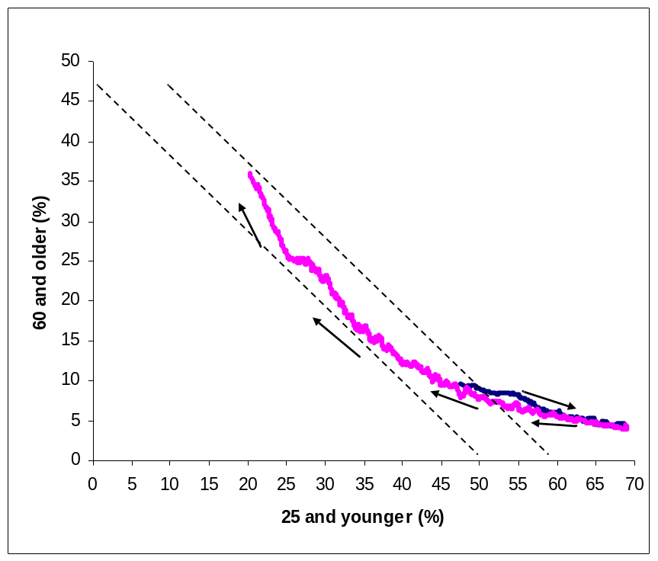

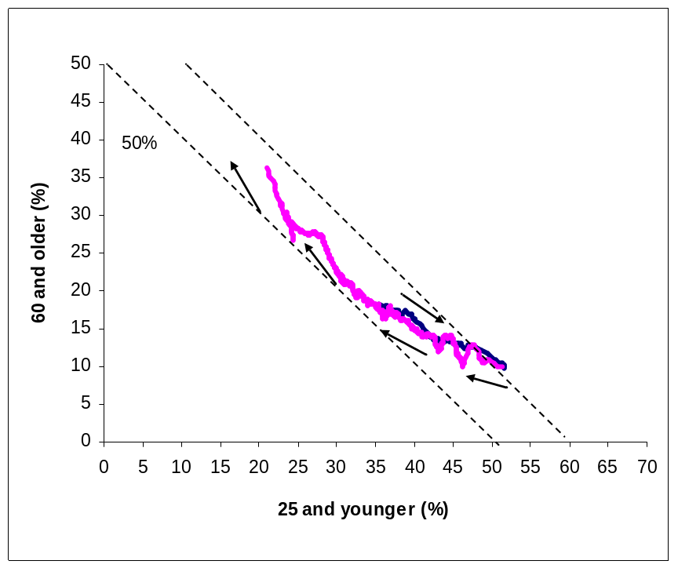
Diagonals show
percentage 25-59

Figure 1. Age Transition Path, 1950-2050, Non-Industrial Countries (upper panel); and Industrial Countries (lower panel). Source: Constructed from UN population projections and estimates (United Nations Population Division, 2009)

For a period, the percentage 25-59 is relatively stable as the decline in the percentage in the child ages is matched by an increase in the percentage at older ages. Eventually, however, the decline in the child share moderates and the increase in the share at older age is matched by a significant decline in the working-age population. By the end of the transition as measured in the UN projections to 2050, the percentage 25-59 is approaching 40%.
The age transition for industrialized countries for 1950-2050 differs from that for the developing world in several important ways. The industrialized countries were much older than developing countries at the beginning and the end of the baby boom. The child share did not reach 55% before it began to decline. In contrast, the child share for many developing world countries approached 70%. A second difference is that the industrialized countries did not experience an increase in the share of their working-age population (25-59) as large as that for the developing world. In other respects, the age transition paths followed in the developing and the developed worlds are similar. Many developing countries, however, will not be near the end of the age transition by 2050.
The timing of the age transition varies widely around the world. In many African countries the child share of the population has been increasing until very recently and they are just beginning to experience a decline in the child share and an increase in the share of the working-age population. Many countries in the West, Latin America, and Asia have essentially completed the second phase of the age transition – the share of their working-age population is near its peak. And a few countries in the West have begun the final phase of the age transition. The share of the working age population has begun to decline and the share 60 and older is rising (Figure 2).

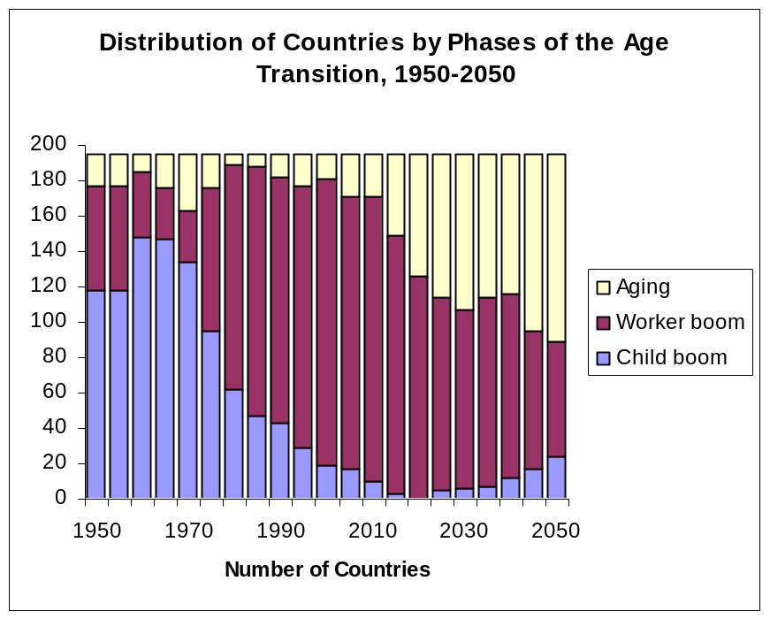

Figure 2. Distribution of Countries by Phases of the Age Transition, 1950-2050

The countries in the National Transfer Account study, on which we draw below, have been selected in part to capture the full range of the age transition to date (Figure 3). Japan is the oldest country in the world with almost 30 percent of its population 60 and older. In other Western countries the share of the working age population has begun to decline (Germany, Finland, Sweden, and the United States) or will soon begin to decline (Spain, Hungary, and Slovenia). Japan aside, Asian countries are somewhat earlier in their age transitions but they are changing very rapidly. South Korea’s population is heavily concentrated in the working ages, but decline will commence starting in 2010. The situation in China, Taiwan and Thailand is similar to that in Korea, while other Asian countries (India, Indonesia, and the Philippines) are at earlier points in their age transitions. The age structures in Latin American countries represented here are similar in some respects to Asian developing countries. They have
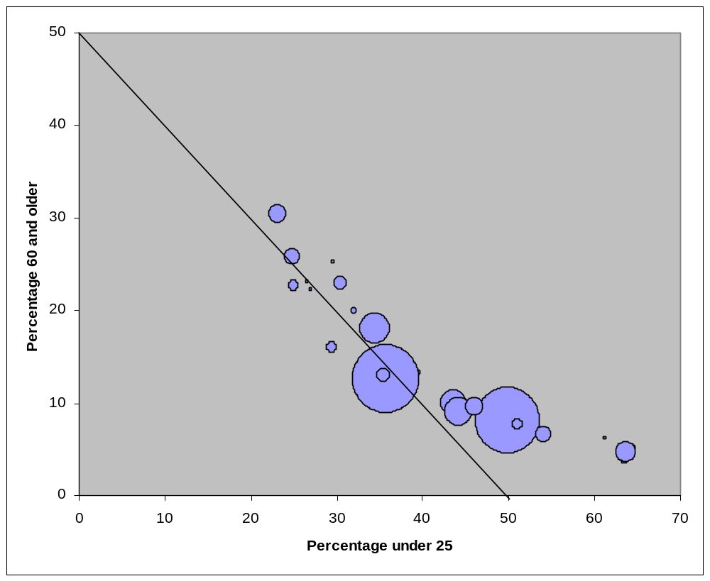
India
China
Japan
US
Nigeria
Germany
Spain
France
Indonesia
Brazil
S. Korea
Senegal
Philippines
S. Africa
Mexico
Thailand
Uruguay
Chile
Finland
Sweden
Austria
Australia
Slovenia
Kenya
Mozambique
Hungary
Costa Rica

Figure 3. Age Structure of Study Countries, 2010. Area of balloon is proportional to population. Constructed using population estimates from the UN Population Division (UN 2009).

younger populations than in the West and the working shares of their populations are increasing. Uruguay has the oldest population in Latin America while Mexico has the youngest population of any Latin American country included here. The Latin American
path is somewhat different than the Asian path. Given the child share of the population, Latin American countries have a large share 60 or older and a smaller share 25-59. The differences are small, however. The share 25-59 of the combined population of Latin America reaches a peak of 46.6% in 2025 while the share for the combined Asia population reaches a peak of 47.8% in 2030.

III. Data: National Transfer Accounts

The analysis presented here is based on National Transfer Accounts (NTA) which provide aggregate measures of how those at each age acquire and use economic resources. The accounts are constructed in a manner consistent with National Income and Product Accounts, but extend the accounts to allow a comprehensive tracking of flows across generations (Lee et al., 2008, Mason et al., 2009). The conceptual foundations for the accounts rely heavily on work by Willis (1988) and Lee (1994). Construction and further development of the NTA system relies on research teams from twenty-eight countries listed in Figure 3 above. Complete information about the NTA network and the research teams and a full description of the methods are available on the NTA website (www.ntaccounts.org).
National Transfer Accounts are governed by the flow identity:
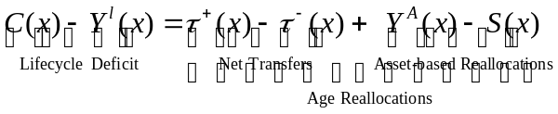
The lifecycle deficit is the excess of consumption over labor income (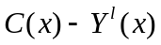) for each age x. Inter-age flows or age reallocations come in two economic forms: net transfers, 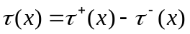 and asset-based reallocations (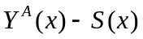) for age group x. Although the flow constraint as written in equation emphasizes the connection between the economic lifecycle and age reallocations, it must hold irrespective of the motives or purpose governing any of its elements. The constraint is an accounting identity that follows from a simple principle that for any age group inflows (labor income, transfer inflows, and asset income) must be matched by outflows (consumption, transfer outflows, and saving).
The economic lifecycle reflects many behavioral and non-behavioral factors that influence the relationship between age, on the one hand, and consumption and labor income, on the other. Average labor income at each age depends on hours worked, labor force participation, the age profile of wages and the many cultural, political, social, and economic factors that influence each of these elements of labor income. In similar fashion, average consumption at each age is influenced by historical events, by preferences, by prices including interest rates, by political systems, and by many other forces.
At the aggregate level the economic lifecycle also reflects the population age structure. In young populations, the aggregate economic lifecycle is dominated by the large lifecycle deficit, the economic resource requirements, of the young. Over the course of the demographic transition, populations age and the lifecycle deficit of the old becomes increasingly important. The importance of age structure is apparent in comparing the Philippines, with a relatively young age structure, and Germany, with a relatively old age structure (Figure 4). The major generational problem facing the Philippines is to generate resources for the young, while in Germany the young and the old have lifecycle deficits that are more nearly equal.

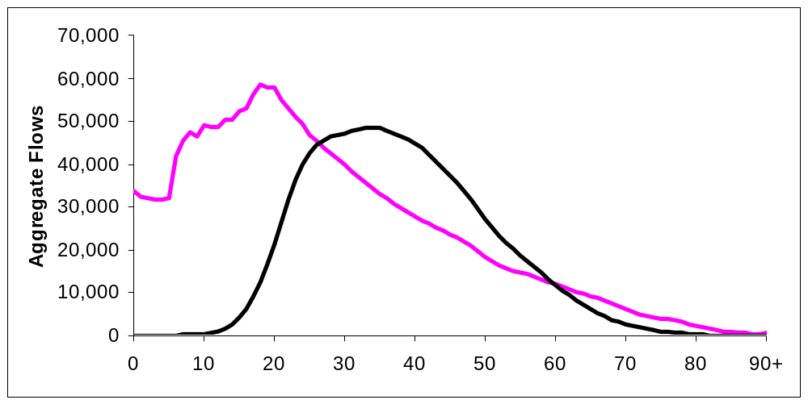
Life cycle deficits
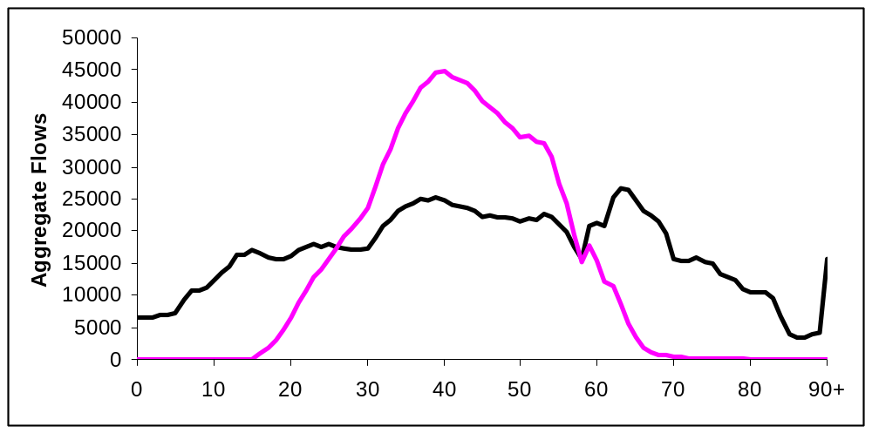
Figure 4. Aggregate consumption and labor income by age, Philippines 1999 and Germany 2003. Values for the Philippines are millions of pesos and for Germany millions of euros. Source: Racelis and Salas (2009) and Kluge (2009).

The mechanisms by which economic resources are reallocated across age are illustrated in Figure 5 using results for the Philippines. (Note that the values plotted in Figure 5 are aggregate, not per capita, values and taper down as age increases only because of the population age distribution.) First, the lifecycle deficit of the young is met almost entirely through transfers. In the Philippines, the young depend much more on private transfers, namely intra-household transfers, than public transfers. Assets do not play a role. Net public transfers are negative between the ages of about 21 and 71 while net private transfers are negative between the ages of 27 and 70. Net transfers turn positive for the elderly only when they are in their 70s and even at these advanced ages they are relatively modest. Those 72 and older fund 2 percent of their lifecycle deficit from net public transfers, 27 percent from net private transfers, and the remainder relying on assets.
Asset-based inflows are essentially positive at all adult ages in the Philippines. This means that asset income exceeds saving. The largest inflows come during the 40s because labor income is insufficient to cover consumption of those in these age groups and net transfers flow mostly to children. Thus, assets are being used to fund the large amount of resources being directed toward the consumption of children. Asset-income also plays a very important role in funding the lifecycle deficit of the elderly. This does not necessarily mean, however, that the elderly are funding their retirement by dis-accumulating their wealth. They may be using asset income rather than disposing of their assets. This has proven to be the case in all countries that have been analyzed to this point.

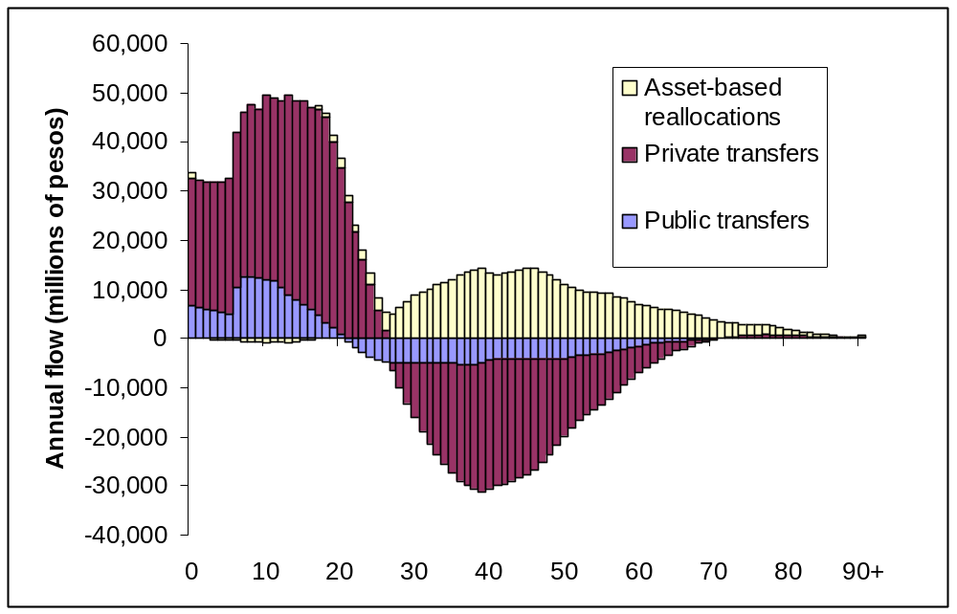
Figure 5. Aggregate Age Reallocations for the Philippines, 1999, in millions of pesos.
Source: Racelis and Salas (2009).

IV. Five Key Findings

The results presented below summarize five key findings about the generational economy and population aging based on NTA estimates.

In all countries private transfers are downward, dominated by transfers from adults to children.

How private transfers evolve over the demographic transition is an important issue. Several theories of fertility have emphasized private intergenerational transfers. Caldwell , for example, argued that the fertility transition began when economic flows reversed from downward to upward. Other scholars have hypothesized that children are a form of investment with downward flows to children matched by return flows to parents in old age. This has been called the payback hypothesis (Lillard and Willis, 1997). These ideas are also closely related to a the quantity-quality tradeoff theory of fertility in that they provide an estimate of “quality” as used by Becker (Becker and Lewis, 1973), i.e., per child spending by parents.
Estimates for Japan in Figure 6 illustrate NTA estimates of private transfers and the methods used to summarize them. In 2004, those under the age of 30 and over the age of 77 had net positive transfers while those between the ages of 30 and 77 had net negative transfers. As is apparent net private transfers to the young greatly exceed net transfers to the old and clearly the direction of net transfers is downward.

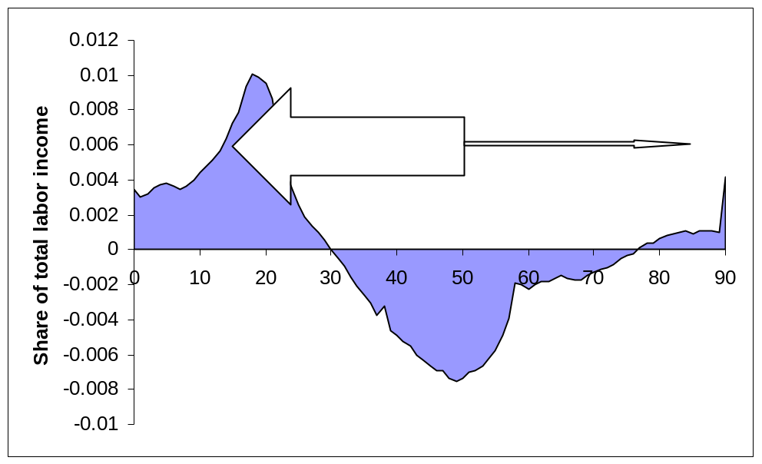
Figure 6. Net Private Transfers by Age as a Share of Total Labor Income, Japan, 2004. Mean age of outflows: 50.0; mean age of child inflows: 15.2; mean age of old-age inflows: 86.4. Private child transfers as a share of total labor income: 0.146; private old-age transfers above age 77 as a share of total labor income: 0.012. Source: Ogawa et al., 2009.

A useful way of summarizing transfers, however, is to employ arrows as shown in Figure 6 that represent the direction, the magnitude, and average age span of transfers. For downward transfers, those to children, the annual flow was 14.6% of total labor income while for upward transfers the average flow was only 1.2% of total labor income. The mean age of inflows for downward transfers was 15.2 years and for upward transfers was 86.4 years. The average age of net transfer outflows was 50.0 years. As has been shown by Lee (1994), under highly specialized assumptions, the product of the annual transfer flow and the mean age span gives a measure of transfer wealth. Under more general and realistic circumstances, however, the product of the flow and mean age span provides a good indicator of transfer wealth. In the figure transfer wealth is represented by the area of the respective arrows. If the arrow is pointed toward younger ages, transfer wealth is negative and if the arrow is pointed toward older ages, transfer wealth is positive. Thus, downward transfer wealth in Japan was .146 X (15.2 – 50.0) = - 5.09 times total labor income and upward transfer wealth was 0.012 X (86.4 – 50.0) = 0.54 times total labor income.
How do we interpret these values? Let’s begin with upward transfer wealth. Under special circumstances (Golden Rule growth), this is the net present value of upward transfers made less upward transfers received over the lifetime of the current population. This is the same method used to convert any stream of income into a measure of wealth. In this case, the wealth is the commitment or obligation of future generations to maintain the current system of transfers. The counterpart of net upward transfer wealth is implicit debt on the part of future generations. Those who are not yet born are obligated to provide these transfers to the current population in the future.
Downward transfers have a similar interpretation although in this case downward transfers are an obligation of the current population to future generations. Hence, transfer wealth is negative and the counterpart for future generations is an implicit asset – the value of the transfers future generations will receive in the future from the current population.
Comparing the downward and upward wealth conveys important information. If the two were equal, it would imply that the value of the private transfers that future generations will receive from the current population are identical to the value of the private transfers that future generations will give to the current population. The combined transfers would net to zero meaning that the current population is not burdening future generations through their private transfers nor are they unduly benefiting from current generations. Rather current generations would be receiving the golden rule rate of return on transfers.
A final point to be made here is the importance of incorporating the span of transfers into the calculation. It is important to know more than the magnitude of transfers in each period. It also matters how long the lag is between when transfers are made to the young and when return transfers are received. This information is incorporated appropriately using the differences between the mean ages of transfer inflows and outflows.
The case of Japan is instructive. Private downward transfer debt exceeds private upward transfer wealth by a massive amount. For families in Japan children do not represent an investment for old age support, because the expected returns in old age are very small as compared to the investment made.
In the absence of additional information, the imbalance of net private transfers appears to be consistent with the low fertility found in Japan. Japan’s total fertility rate is about 1.3 births per woman, among the lowest in the world. Estimates presented in Table 1 show that this conclusion is unwarranted. These values do not distinguish downward and upward flows, but present results only for the combined flows – downward private transfer wealth plus upward private transfer wealth. The estimates are arranged in order of per capita income with the highest income at the top and the lowest income at the bottom of the table. In every country the transfer wealth estimates, listed in the second to the last column, are negative showing that downward transfers to children dominate upward transfers to the elderly. The highest values (relative to labor income) are found in the lowest income countries with generally higher fertility. Economic transfers always flow downward and particularly so in high fertility, low income countries.

Table 1. Private transfer summary, with own and standard population age distributions.
Country (from richest to poorest) | Average age of inflows | Average age of outflows | Transfers/ Normalized labor income | Wealth | Adjusted Wealth
United States | 34.2 | 46.9 | 0.25 | -3.17 | -3.47
Austria | 36.4 | 46.2 | 0.17 | -1.67 | -2.34
Japan | 42.1 | 50.6 | 0.29 | -2.46 | -4.03
Slovenia | 32.6 | 43.4 | 0.19 | -2.05 | -3.17
Taiwan | 31.3 | 40.3 | 0.35 | -3.15 | -3.31
South Korea | 33.8 | 44.2 | 0.45 | -4.68 | -5.13
Mexico | 28.1 | 42.6 | 0.47 | -6.81 | -5.86
Chile | 30.3 | 45.2 | 0.33 | -4.92 | -4.46
Costa Rica | 28.6 | 42.4 | 0.35 | -4.83 | -4.11
Thailand | 33.3 | 43.7 | 0.33 | -3.43 | -3.26
Brazil | 28.9 | 44.0 | 0.39 | -5.89 | -4.72
Indonesia | 24.8 | 43.8 | 0.29 | -5.51 | -5.07
China | 32.9 | 43.9 | 0.2 | -2.20 | -2.25
Philippines | 27.6 | 42.9 | 0.42 | -6.43 | -4.23
Private transfers are normalized on the labor income of those in the 30-49 age group.
Adjusted wealth uses a standard population age distribution to calculate private transfers.
Source: Lee and Mason (2009a).

An additional point follows from the final column in the table. The calculations here use the per capita transfer profiles for each country and the “average” age distribution for all countries to recalculate transfer wealth. The variation in transfer wealth is greatly reduced by eliminating the effects of the population age distribution. For the countries in the table there is no relationship between adjusted wealth and income. As a first approximation, low income countries have large downward transfers and large negative transfer wealth relative to their labor income because they have so many children.

The direction of public transfers reverses from downward in the least developed to upward in the most developed economies. As populations age public transfer wealth will grow and, hence, implicit debt on future generations will increase.

The magnitude and direction of public transfer programs are summarized for NTA countries in Figure 7 using arrow diagrams and calculations of transfer wealth as explained in the preceding section. The direction of public transfers is much more varied than the direction of private transfers. In Europe public transfers are upward and in some cases relatively substantial. Public transfer wealth is particularly high in Austria, Sweden, and Slovenia, ranging from 170 percent to 185 percent of the labor income of 30-49 year olds, so equal to nearly two years of labor income. In Latin America, public transfers are upward and strongly so in Uruguay and Brazil. In Japan, public transfers are also upward and substantial. Mexico is the only Latin American country with strongly downward public transfers, and the United States is the only industrialized country among the NTA group with downward public transfers. Japan aside public transfers are strongly downward in the Asian NTA countries particularly so in South and Southeast Asia.

Age distribution is an important factor that affects the direction of public transfers. In the youngest populations public transfers to children, particularly of education, outweigh public transfers to the elderly in the form of pensions, health care, and long-term care. The compositional effects of age structure can be judged using the same kind of analysis employed above for private transfers. The age-specific transfers for each country have been multiplied by a common population age distribution – the average age distribution for the sample. The results, displayed in Figure 8, show age structure plays an important, but by no means exclusive role in determining the directly of public transfers.

Consider first the industrialized countries of Europe, the United States, and Japan. Population age structure shifts the transfers in an upward direction in these countries. Indeed, if the countries had the younger age structure characterized by the combined population, few would have upward public transfers. Comparing among these countries, the United States and Japan stand out as having per capita patterns that are less favorable to the elderly than European countries.

Among the non-industrialized countries, the patterns observed above are reinforced with South and Central American countries having strongly upward public transfer programs, while Mexico and Asian developing countries have strongly downward public transfer systems.

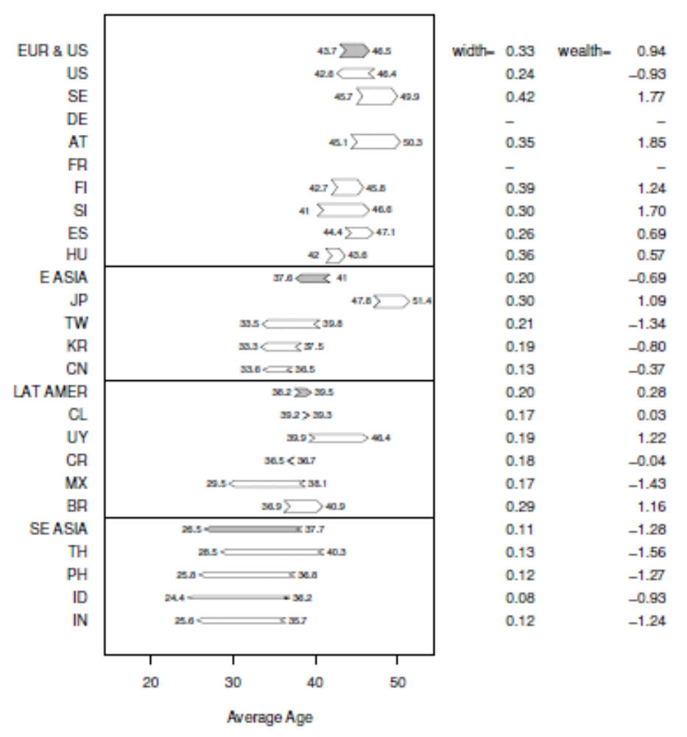
Figure 7. Public transfers wealth for regions and NTA countries. Wealth is per capita and normalized on mean labor income of 30-49 year olds. Source: Lee and Mason (2009a)

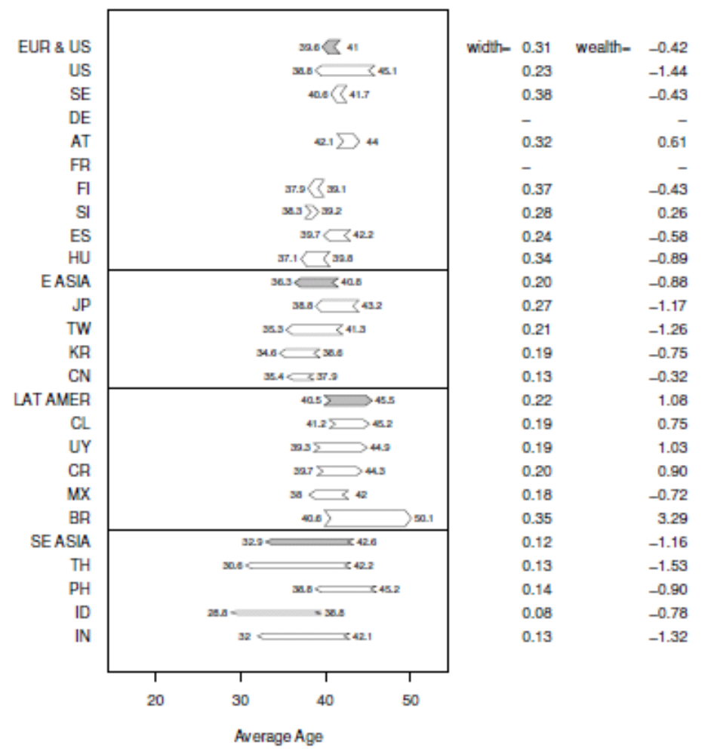
Figure 8. Public Transfer Wealth Controlling for Population Age Structure. Values are constructed using age-specific profiles for each country but a common population age distribution which is the average of all countries. Wealth is per capita and normalized on mean labor income of 30-49 year olds.

The importance of age structure as a determinant of public transfers inevitably leads to questions about the future when populations will be much older than today in every country under consideration. Several governments, including the European Union, the United States, Australia, New Zealand, the United Kingdom, have recently begun to issue long-run projections of their budgets. Tim Miller, Carl Mason, and Mauricio Holz (2008) have recently completed projections for Latin American countries. They show, first, that on average, the fiscal impact of population aging will be as large in Latin America as in Europe. Second, the fiscal impact of population aging varies among the 10 countries – with pension reforms playing a large role. Third, increases in health care obligations are likely to rival those of pensions. Fourth, population aging greatly reduces the costs of educational investments in the region.

Support systems for the elderly vary widely in ways not closely connected to the level of development. Public transfers are very important in Latin America and Europe. Private, familial transfers play a significant role in developing Asian countries. Reliance on assets by the elderly varies widely.

The elderly rely on three sources to fund their lifecycle deficit: net public transfers, net private transfers, and assets. The share of each of these three components for each country is represented on the triangle graph (Figure 9). A number of features of the old-age support system are striking. First, net familial transfers to the elderly are positive in only four economies, China, Thailand, South Korea, and Taiwan, all developing Asian economies. In all other countries, net family transfers to the elderly are zero (Japan and Finland) or negative (the US, most European countries, the Philippines, and every Latin American country). In this latter group, the elderly are providing more financial support to younger generations than they are receiving.

Second, the importance of public transfers varies widely among countries. In six countries, the Philippines, Mexico, Thailand, Taiwan, South Korea, and the US, public transfers range from about 40 percent of the lifecycle deficit in the US down to slightly negative values in Thailand and the Philippines (meaning they pay more in taxes than they receive in benefits). In the remaining countries, Japan, European countries, and most Latin American countries, public transfers range from more than 50 percent in Uruguay up to over 95% in Austria.

Third, the importance of assets also varies very substantially. In four countries, the US, Thailand, Mexico, and the Philippines, asset-based flows are equal to at least two-thirds of the lifecycle deficit. In Taiwan, Germany, Finland, and Austria, asset-based flows are less than one-third of the lifecycle deficit. These figures refer to the use of assets to fund the life cycle deficit. In many countries the elderly hold substantial assets, but save their asset income rather than using it to finance consumption.

One cannot on the basis of these simple descriptive statistics reach firm conclusions about substitution across support systems. Outside of developing Asia, support systems appear to vary primarily along two dimensions – relying heavily on asset-based flows or heavily on public transfers. But the role of familial transfers is more pervasive than suggested by Figure 9, because in most Asian and Latin American developing countries net familial transfers increases with age. Typically those who are 75 or older have positive net family tranfers. It is difficult to say whether expansion of public transfer programs will lead to a decline in familial support or asset-based flows or some combination of the two. Time series data for South Korea and Taiwan, not shown here, indicate that there has been a substantial increase in public transfers and decline in familial transfers over the last few decades. Among the Latin American NTA countries, assets are used only where public pensions are weak (Mexico), and in countries with more generous public pensions and similar levels of asset income, it is saved.
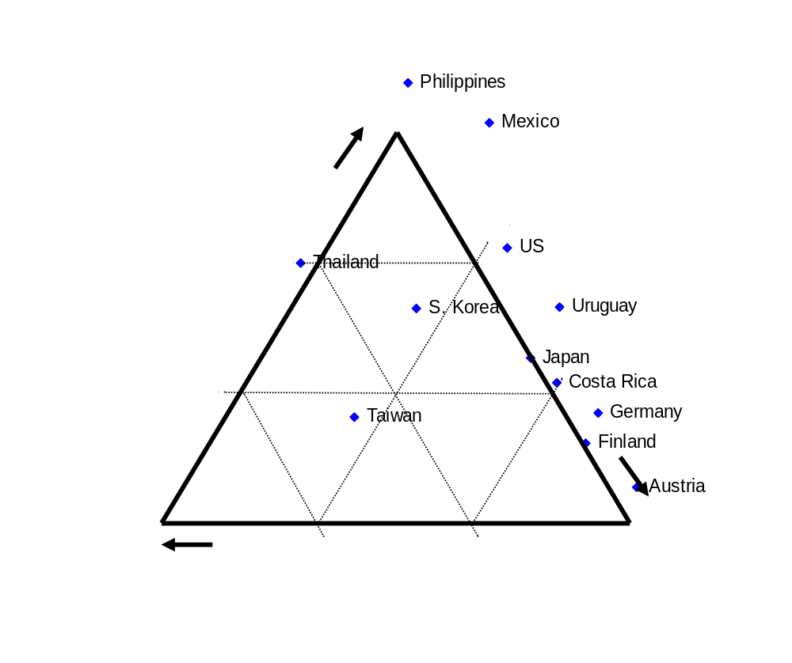
Figure 9. Sources of Support as a Share of Lifecycle Deficit, Persons 65 and Older, NTA Countries. Source: www. ntaccounts.org.

There is a strong tradeoff between human capital spending on children and fertility. Low fertility will lead to populations with fewer workers and a lower support ratio, but those workers may be much more productive due to the higher investment in their human capital.

There is a tradeoff between the quantity and quality of children, according to an influential hypothesis introduced by Becker, Willis, and others (Becker and Lewis, 1973, Becker and Tomes, 1976, Becker and Barro, 1988, Willis, 1973). In the economic model of fertility decision-making, a decline in the number of children lowers the price of raising higher quality children. Likewise, raising higher quality (more expensive children) increases the price of have many children. Thus, changes that encourage lower fertility also encourage more spending per child, while changes that encourage more spending per child encourage lower fertility.

The existence of a quality – quantity tradeoff is important to understanding the economic implications of population aging because population aging is primarily a consequence of low fertility. When we focus our attention exclusively on the numbers of people in the working ages, we are missing a very important part of the picture – the quality of those workers. If the quality – quantity tradeoff is strong enough, and if productivity is raised strongly by human capital, then the smaller workforce of the future will be as productive, or even more productive, than the larger workforce of the present because of the increase in the resources invested in children.

Although all resources invested in children may influence their productivity, we focus our attention here on human capital spending, i.e., spending on health and consumption. We construct a synthetic cohort measure of human capital spending per child as the sum of both public and private age specific spending per child on health, summed over the 0 to 17 age span, and education, summed over the 0 to 26 age span. Health spending above age 17 is excluded because much of this spending is for maternal health. The value is shown for Korea in Figure 10 as the shaded area. To facilitate cross-country comparisons and to control for differences in income, human capital spending is divided by the mean labor income of persons aged 30-49.

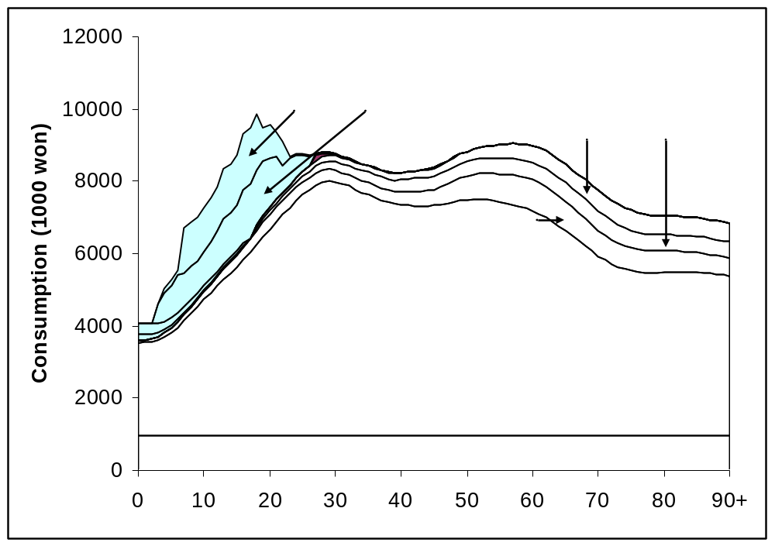
Figure 10. Human capital spending and components (shaded) and others components of consumption, Korea, 2000. Source: An et al., 2009.

Estimates of the quantity-quality tradeoff for 22 NTA countries for a recent year are plotted in Figure 11. There is a relatively close relationship between human capital spending per child and the total fertility rate. Regressing the natural log of human capital on the natural log of TFR, purely as a descriptive device, yields an estimated elasticity of -0.91.

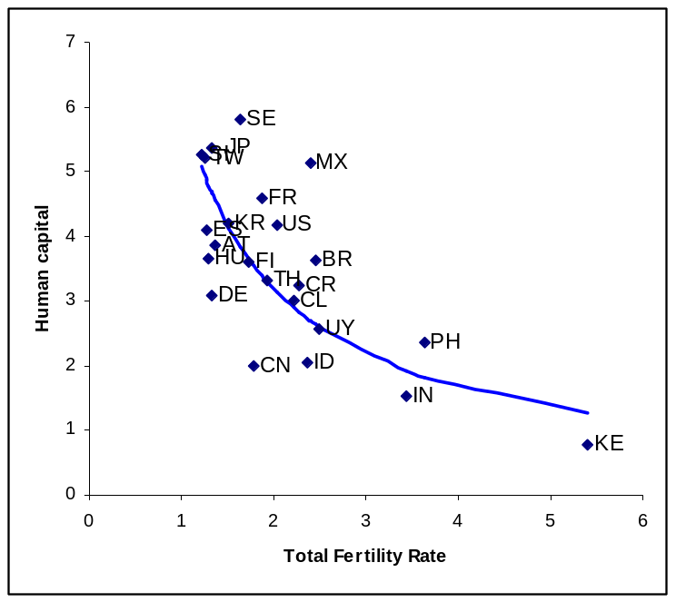
Figure 11. Human capital, synthetic cohort values normalized on mean per capita income of persons 30-49 versus the total fertility rate; 22 countries for a recent year. Source. Lee and Mason 2009 European Journal of Population (updated).

The analysis can be replicated using time series estimates for a few economies for which a time series of NTA estimates are available: Japan 1984-2004; Taiwan 1976-2004; and the United States 1960 to 2003. The estimated elasticity for Japan and Taiwan are very high at -1.46 and -1.40 respectively. For the US the estimated elasticity is somewhat less than for the cross-sectional data at -0.72.

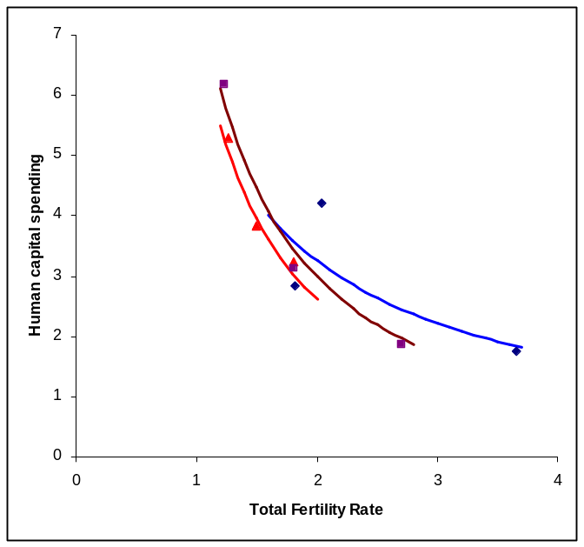
Figure 12. Human capital, synthetic cohort values normalized on mean per capita income of persons 30-49 versus the total fertility rate; time series estimates for Japan 1984-2004 at five year intervals; Taiwan 1977-2003 annually; and the United States, 1960-2003 for selected years. Sources: Ogawa et al. (2009) for Taiwan and Japan.

High elasticities have important implications for assessing the economic consequences of low fertility and population aging. An elasticity of -1 implies that the total stock of human capital does not decline with the drop in fertility. Rather the same amount of human capital investment is spread across fewer individuals. The implications depend, first, on the effectiveness with which human capital spending enhances the abilities of those in whom the resources are invested; and, second, on the extent to which enhanced abilities result in higher productivity once “higher quality” children become adults. Using estimates of the returns to human capital investment found in the literature, Lee and Mason (2009b) show that human capital investment may be sufficient to entirely offset the decline in the support ratio due to population aging.

Assets play two important lifecycle roles in the generational economy. First, in many countries, the elderly are relying to an important degree on assets to support themselves in old age. Second, asset-based inflows to working-age adults are critical to meet their heavy financial obligations – supporting their own consumption, that of their children, and, through the taxes they pay and familial transfers, the consumption of the elderly.

In the conventional lifecycle saving model that has been widely used by economists, saving during the working years is used to support consumption during retirement. This is very important because saving serves a dual purpose – dealing with the old-age lifecycle problem but also providing the capital needed to build a high-performing industrial economy.

NTA estimates show that the importance of assets to funding the old-age lifecycle deficit varies substantially around the world (Figure 9). In the United States, Mexico, the Philippines, and Thailand, the elderly are funding a substantial portion of their old-age needs by relying on assets. They are not dis-saving, on average, but they are relying heavily on asset income. In contrast, European countries and some Latin American ones are relying heavily on public transfer programs and very little on assets to fund their retirement needs. In these countries, the pension motive for saving is very weak which undermines capital accumulation.

The importance of assets to prime-aged adults has received much less attention although it is widely recognized that many middle-aged adults are subject to a financial squeeze due to their lifecycle circumstances: funding their own consumption, that of their children, as well as that of the elderly. Some of this burden is private, but also much of it is public and felt through a high tax burden.

Results presented for Japan in Figure 13 illustrate the point. The solid blue area in the figure shows the per capita lifecycle deficits and surpluses by age. In Japan the lifecycle surplus, the gap between labor income and own consumption, reaches a peak at around age 50. Net transfers are shown as the solid line. They also reach a peak (in negative terms) at about age 50. Moreover, net transfer outflows consistently exceed the lifecycle surplus throughout the surplus ages. The gap can only be filled in one way – through asset-based inflows. Prime-age adults are relying on assets to fund their own consumption and the large net transfers with which they are burdened.
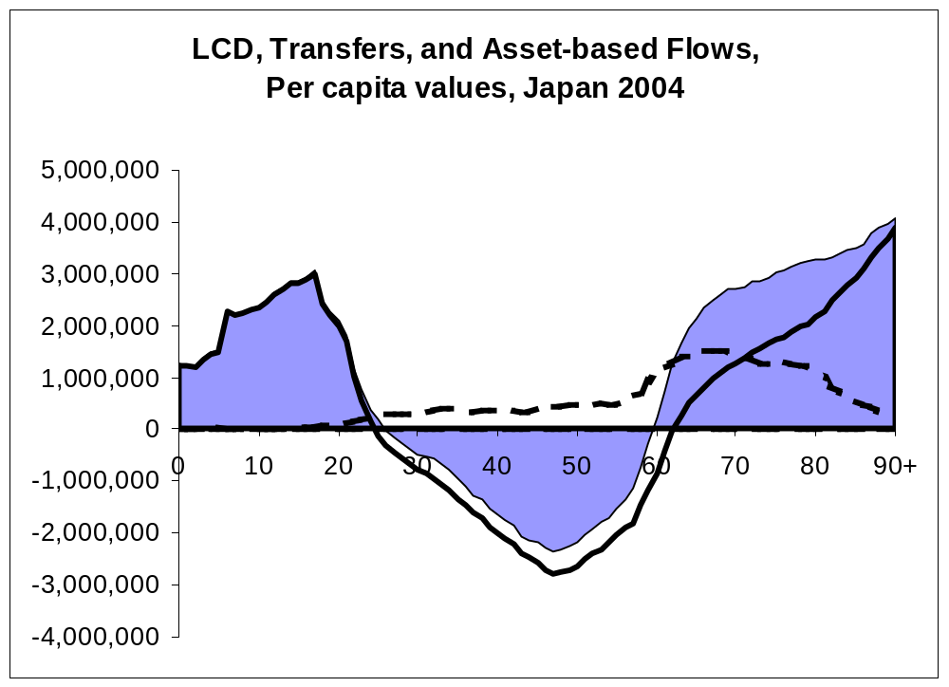
Figure 13. Lifecycle deficit, net transfers, and asset-based reallocations (yen), annual per capita flows, Japan, 2004. Source: Ogawa et al. 2009.

Asset-based inflows are generated in a variety of ways that vary across countries. First, inflows can be generated by relying on public debt, rather than taxes, to fund public transfers and consumption. Second, young adults may accumulate personal debt (student loans or credit card, for example). Third, those who have assets (financial assets, a business, a farm, or a home, for example) can rely on the income generated from those assets to fund their consumption and transfers. And, fourth, those with assets can dis-save, liquidating their assets, for example, to fund their lifecycle needs.

Japan is the oldest country in the world. The upward transfers are large as compared with many other countries, although as shown above, upward transfers are no larger in Japan than in some European countries, nor are they as large as will likely be the case in Latin American countries barring significant reform. However, reliance on assets by prime age adults is not confined to aging populations. Indeed, transfers just to children in developing countries exceed the lifecycle surplus in most cases. In Figure 14, we compare the lifecycle deficit of children to the lifecycle surplus. In most countries in the West, the lifecycle cycle surplus is sufficient or more than sufficient to fund the child deficit. The one exception is the United States. In none of these countries, however, is the lifecycle surplus greater than the combined deficit of children and the elderly. The situation in East Asia is similar to that found in the West. The exception is China, the only country in which the lifecycle surplus exceeds the combined deficit of children and elderly. In Southeast Asia and Latin America, however, the child deficit is far greater than the life cycle surplus. In all of these countries, asset-based inflows are critical to meeting the consumption and transfer obligations of prime age adults.

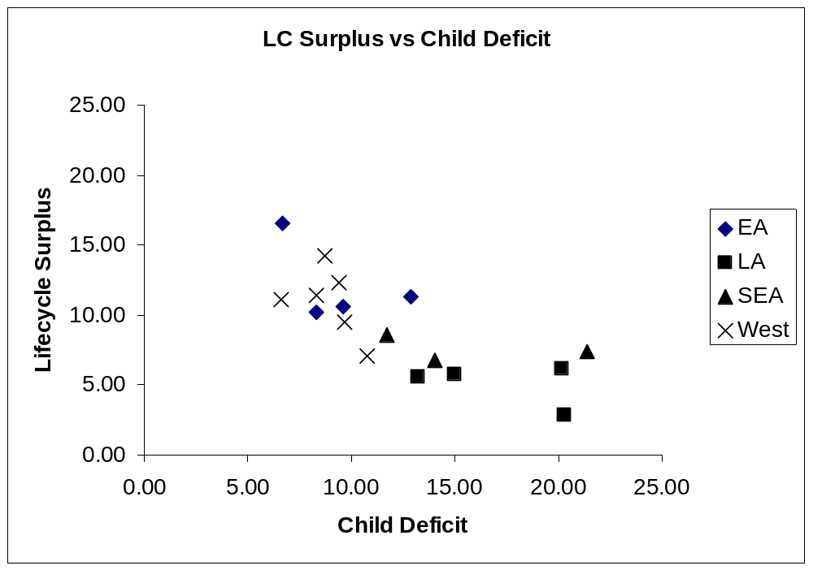

Figure 14. Aggregate lifecycle surplus versus the aggregate child deficit, available NTA countries. All values normalized on aggregate labor income from 30-49 (divided by 30). Cumulated across ages for which LCD is negative and for which LCD is positive. Source: www.ntaccounts.org.

V. Conclusions

In high fertility, low-income countries the resource needs of children are very substantial and lead to large public and private downward transfers. These economic resources are spread over many children and, consequently, spending per child and human capital investment per child are low as compared with industrialized countries. As fertility declines, human capital spending per child increases, which attenuates the effects of a declining support ratio as the population ages. The causal mechanisms that link fertility and human capital investment are complex, however. Policies that reduce fertility by no means guarantee that more human capital investment will take place. Indeed, much of the additional investment in human capital has been undertaken by the public sector not by parents. The key point here is that policies that match reduced fertility with higher investment in children are likely to have long-term success in sustaining economic growth over the global age transition.
Public policy towards old-age transfers is also very important. In many European and Latin American countries upward transfers are very large as compared with the retirement needs of the elderly. Heavy reliance on public transfers undermines a potentially important motive for accumulating wealth. The consequences of this may be to reduce capital accumulation, and thereby reducing job creation and wages.
As populations age the share of the population employed is expected to decline. If disincentives including both pension structures and mandatory retirement policies are phased out, the employed share of the population will decline more slowly. It almost certainly will decline, however. Other things equal this will lead to lower standards of living and render unsustainable public transfer programs targeted at the elderly. However, effective public policies can yield a much more favorable long-term outcome. Those policies include investment in human capital and avoiding excessive reliance on large-scale transfer programs to the elderly. It is equally important to strengthen financial systems and to develop mechanisms for encouraging higher rates of saving.
REFERENCES

Becker, G., Lewis, H. G. 1973. "On the Interaction between the Quantity and Qulity of Children", in Journal of Political Economy,Vol. 84, No. 2 pt. 2.
Becker, G., Tomes, N. 1976. "Child Endowments and the Quantity and Quality of Children", in Journal of Political Economy,Vol. 84, No. 4 pt. 2.
Becker, G. S., Barro, R. J. 1988. "A Reformulation of the Economic Theory of Fertility", in Quarterly Journal of Economics,Vol. 103, No. 1.
Costa, D. L. 1998. The Evolution of Retirement: An American Economic History, 1880-1990. Chicago, The University of Chicago Press.
Gruber, J., Wise, D. A. 1999. Introduction and Summary. in J. Gruber, D. A. Wise (eds.) Social Security and Retirement around the World. Chicago, The University of Chicago Press.
Lee, R. 2003. "Demographic Change, Welfare, and Intergenerational Transfers: A Global Overview", in GENUS,Vol. LIX, No. 3-4.
Lee, R., Mason, A. 2009a. Generational Economics in a Changing World. Workshop on Long-term Consequences of the Demographic Transition. Madrid, Spain.
Lee, R., Mason, A. 2009b. "Low Fertility, Human Capital, and Macroeconomics", in European Journal on Population.
Lee, R. D. 1994. The Formal Demography of Population Aging, Transfers, and the Economic Life Cycle. in L. G. Martin, S. H. Preston (eds.) Demography of Aging. Washington, D.C., National Academy Press.
Lee, R. D., Lee, S.-H., Mason, A. 2008. Charting the Economic Lifecycle. in A. Prskawetz, D. E. Bloom, W. Lutz (eds.) Population Aging, Human Capital Accumulation, and Productivity Growth, a supplement to Population and Development Review 33. New York, Population Council.
Lee, Ronald, Andrew Mason and Timothy Miller (2003) "Saving, Wealth, and the Transition from Transfers to Individual Responsibility: The Cases of Taiwan and the United States," The Scandinavian Journal of Economics, v. 105, No. 3, pp.339-357.
Lillard, L. A., Willis, R. J. 1997. "Motives for Intergenerational Transfers: Evidence from Malaysia", in Demography,Vol. 34, No. 1.
Mason, A., et al. 2009. Population Aging and Intergenerational Transfers: Introducing Age into National Accounts. in D. Wise (ed.) Developments in the Economics of Aging. Chicago, NBER and University of Chicago Press.
Ogawa, N., et al. 2009. Declining Fertility and the Rising Cost of Children: What Can NTA Say about Low Fertility in Japan and Other Asian Countries (paper presented at Conference Declining Fertility and the Rising Cost of Children: What Can NTA Say about Low Fertility in Japan and Other Asian Countries, June 19-21).
United Nations Population Division. 2009. World Population Prospects: The 2008 Revision. New York, United Nations.
Willis, R. 1973. "A New Approach to the Economic Theory of Fertility Behavior", in Journal of Political Economy,Vol. 81, No. 2 pt. 2.
Willis, R. J. 1988. Life cycles, institutions and population growth: A theory of the equilibrium interest rate in an overlapping-generations model. in R. D. Lee, W. B. Arthur, G. Rodgers (eds.) Economics of Changing Age Distributions in Developed Countries. Oxford, Oxford University Press.

The reasons for these differences are not an important issue here, but are due in part to the greater speed of the demographic transition in the developing world.
If the percentage under age 25 increased during a five-year period, both the beginning and ending year were counted as being in the child boom phase. If the child share declined and the share 25-59 increased, both the beginning year and the ending year were included except for those years already counted in the child boom phase. The aging phase includes year not otherwise counted. Child share must be declining and working age must be declining.
Calculations are in world age transition.xls.
Some forms of asset income are negative, e.g., interest on debt or a business loss. These are treated as negative inflows, but could as easily be classified as outflows. Likewise, saving is an outflow if positive, where as negative saving (dis-saving) generates an inflow. I the classification used here, saving is counted as an inflow and dis-saving as a negative inflow.
Calculations have been simplified by assuming that the average age of outflows is the same for upward and downward transfers. To the extent that this assumption does not hold, estimates of downward and upward transfer wealth will be influenced, but not the estimate of combined transfer wealth.
There may be returns in other forms not captured in these calculations. Children made give personal attention to their parents. They may insure against risks that are not realized. Presumably children provide “consumption value” that justifies large spending on children.
Note that the average age of outflows for Japan is slightly different in this table than in the figure because calculations are based on gross rather than net flows. Also the annual flow is larger because it represents the gross rather than the net flow. The calculation of transfer wealth, however, is unaffected by these differences.
China is something of an outlier because of its very high rate of saving. Consumption at all ages is low and, hence, transfers relative to labor income are quite low. If China is excluded there is a modest positive relationship between per capita income and transfer wealth. The effect of age structure is about twice as great as the effect of per capita income with China excluded.
Movement along axes and gridlines in the triangle graph show changes in two of the components holding the third component constant. Along the bottom of the triangle, asset-based flows are zero; along the right-hand side private, family transfers are zero; and along the left-hand side, public transfers are zero.

