Public Sector for PDR Paper

The public sector grew dramatically during the 20th Century with important implications for age patterns of consumption and indirectly production. Governments began to fund education programs that benefited the young and later health services that often disproportionately benefited the elderly. Transfers and subsidies increased very rapidly in industrial countries fueled, in part, by the expansion of public pension programs. The gains were especially pronounced between 1960 and 1980. For industrial countries subsidies and transfers increased from 9.7 to 21.4 percent of GDP, public education rose from 3.5 to 5.8 percent of GDP, and public spending on health increased from 2.4 to 5.8 percent of GDP (Tanzi and Schuknecht 2000). Since the 1980s the public sector has largely stabilized relative to GDP, although there has been a resurgence of health spending in the last few years.

Data are more limited for the developing world, but the trends are very similar to those in the industrial world to the extent that they can be quantified. Growth in public consumption as a share of GDP and public spending on education essentially paralleled the trends in the industrial world (Figures).

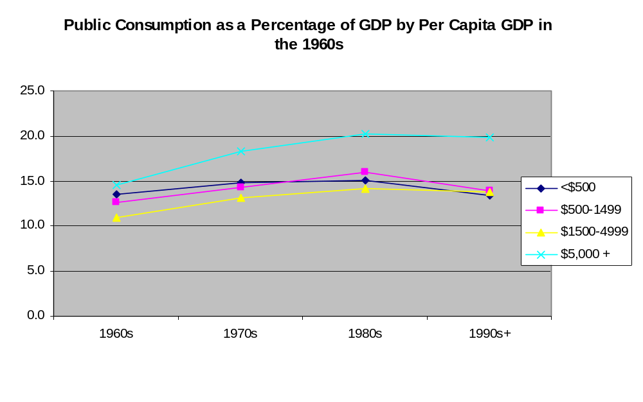

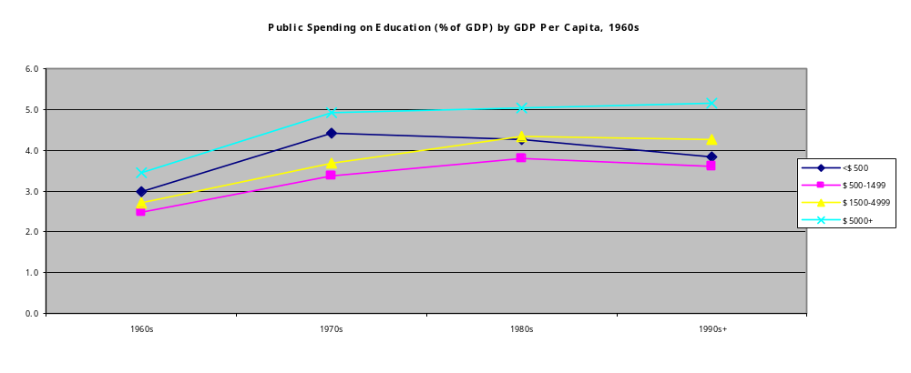

The importance of the public sector does vary considerably across countries. On average, the public sector is larger as a share of GDP in higher income countries, although there is considerable variation within income classes. In 2000, public consumption was 16% of total consumption in countries with a GDP per capita of less $1,000 as compared with 25% in countries with a GDP per capita of $10,000 or more.

Public Consumption as a Share of Total Final Consumption Expenditure, 2000.
Per Capita GDP, PPP, 1995 Prices | Total | Education | Health | Residual
Less than $1,000 | 15.6 | 3.0 | 2.2 | 10.5
$1,000-4,999 | 16.1 | 4.5 | 2.9 | 8.6
$5,000-9,999 | 20.7 | 5.9 | 4.6 | 10.2
$10,000 or more | 25.4 | 7.0 | 7.1 | 11.3
Number of countries | 155 | 111 | 152 | --
Source: World Bank, World Development Indicators 2004.

By and large, public consumption by high income countries is greater because they are spending more on education and health. In 2000, the highest income countries public consumption of education and health amounted to 14 percent of total consumption. In the lowest income countries, public consumption of education and health amounted to only 5.2 percent of total consumption.

The trends in the major intergenerational transfer programs – education, health, and pensions – have been similar to the overall trends in the public sector. Each grew rapidly during the 1960s and 1970s and more slowly in recent years. Public spending on education has grown more slowly than public spending on pensions or health care, probably reflecting the decline in the number of children relative to the number of elderly.

Why public spending, in general and for specific programs, has slowed and how it will change in the future is a critical issue. Lindert (2004) emphasizes three factors in his analysis of long-term trends in public spending – democratization, per capita income, and population aging. Each of these factors are likely to push public spending higher in developing countries over the coming decades. In the industrial countries, however, further democratization will not play any further role. Economic growth is likely to push public spending higher although not necessarily as a share of GDP. The effects of aging are complex. Older citizens favor public programs, both for themselves and for others. However, the growth in the elderly population is generating fiscal pressures that serve as a counterbalance. Based on his statistical analysis of OECD data, Lindert predicts a continued rise in public pensions and total social transfers as a share of GDP between 1990 and 2020. However, the rise in spending does not keep pace with the rate of population aging so that average pensions decline relative to per capita income. This analysis is broadly consistent with the conclusions of Gruber and Wise that population aging in the industrial countries is likely to reduce per capita public spending on both the elderly and non-elderly (Gruber and Wise 2001).

Education Spending

Education is a critical feature of the consumption profile. Spending on education is strongly age-targeted as compared with most other forms of consumption. Changes in spending on education have a large effect on the mean age of consumption because the differences between the average age of consumption and the average age of educational consumption are so large. (Do we mention something about education as human capital investment?)

Although one might well expect spending on education to decline with the number of school-age children, the available evidence does not support this view (Schultz 1987; Kelley 1996; Schultz 1997). This finding is consistent with the emphasis of fertility decision-making models on the quality-quantity tradeoff. Higher income, declining child mortality, structural transformations, and technological innovation are among the factors that may lead parents to choose fewer children and spend more on the education of each (Becker and Tomes 1976; Galor and Weil 2000; Kalemli-Ozcan 2003).

The importance of the quality-quantity tradeoff is illustrated by Figure x which requires some explanation. The horizontal axis measures age structure as the ratio of working-age adults to children. The vertical axis measures public spending on education per child relative to GDP per working-age adult. This normalization controls for the effects of income in a crude, but useful way. The data are drawn from the World Bank, World Development Indicators, 2004. Values for the 1960s, 1970s, 1980s, and 1990s, are the average values for those decades for which any observation is available. The 1990s includes all years greater than 1990. A simple linear regression line for each of the periods is plotted with the coefficient of determination for each line.
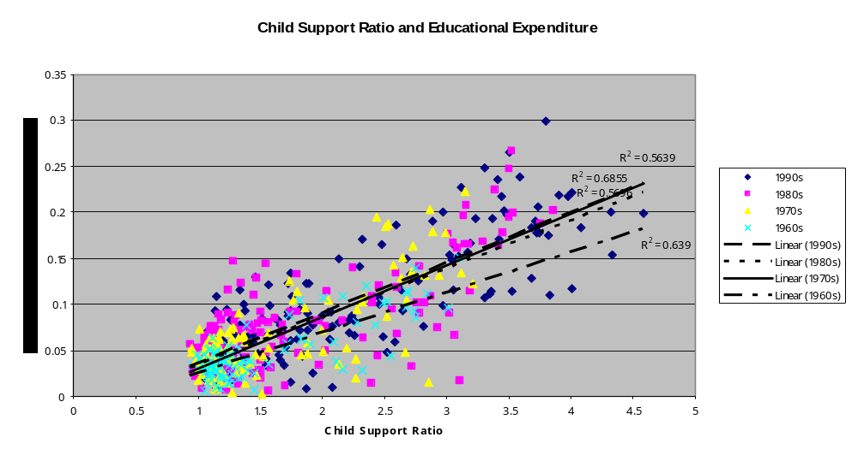There is a strong and surprisingly stable relationship between public education spending per child and the child support ratio. Spending shifted upward from the 1960s, a phenomenon discussed above, but the regression lines are virtually indistinguishable thereafter. Given a child support ratio of 1 working age adult per child, each dollar of GDP per working-age adult produced 3 cents in public education spending per child. Given a child support ratio of 4 working age adults per child, each dollar of GDP per working-age adult produced 20 cents in public education spending per child in the 1970s and later. A four-fold increase in the support ratio yields a more than six-fold increase in spending per child.

Note: It would be interesting to see how Taiwan and the US look on this chart.

Health Spending
In the United States public support for health care is predominantly health care for the elderly. Decisions to expand or contract Medicare, thus, directly influence the consumption of the elderly. In other countries, the link between public spending and consumption of health care is more amorphous. Despite the lack of explicit age-targeting, however, the elderly in all countries for which data are available are dis-proportionately consuming health care.

Age data are limited but appear to provide a consistent picture. Cross-sectional data for OECD countries in the 1990s show that spending for health care for the elderly is consistently higher than spending on the non-elderly. Circa 1993 per capita spending on those 65 and older ranged relative to those under age 65 ranged from 2.7 for Germany to 4.8 for Japan in 11 OECD countries. The ratio in Portugal was much lower at 1.7 (Kinsella and Velkoff 2001). In eight OECD countries reporting results for 1998-2000, acute health care spending for those 65 and older relative to those under the age of 65 ranged from 2.9 in the Netherlands to 4.2 in New Zealand. For five countries, the ratio for total health spending ranged from 3.9 in the UK to 5.2 in Canada (Sheiner 2004). In Japan the ratio of elderly to non-elderly acute health care spending has been relatively stable between 1982 and 1997. In Canada, the age pattern for both acute and total health spending was also relatively stable between 1980 and 2000. In the US, however, the ratio of elderly to non-elderly acute health care spending essentially doubled between 1970 and 1987, although it dropped to lower levels in 1996 and 2000 (Sheiner 2004).

The age data for developing countries is relatively limited. In the Philippines in 1994 public spending on those 60 and older relative to those under the age of 60 is estimated to have been 4.0 (Mason, Racelis et al. 2004). In Taiwan, National Health Insurance reimbursements to the elderly were 2.25 times those to the non-elderly in 1998 (DGBAS 1998).

Thus, the available evidence indicates that increases in public spending on health care generate substantial increases in health consumption by the elderly relative to the non-elderly populations.

In industrial countries, public spending on health was quite modest in the early part of the 20th Century – less the 0.5 percent of GDP. The public sector began to expand rapidly after 1930 and even more so in the 1960s and 1970s, and by 1980 public spending on health matched and thereafter exceeded public spending on education. The growth of health spending as a share of GDP has slowed during the 1980s and did not increase at all during most of the 1990s. The last few years, however, have seen a resurgence in public spending on health (Figure X).

Comprehensive data on public spending on health in developing countries are not available. The World Bank’s World Development Indicators reports public spending on health beginning only in 1997. For all countries public spending on health averaged about 3.5% of GDP based on these data.

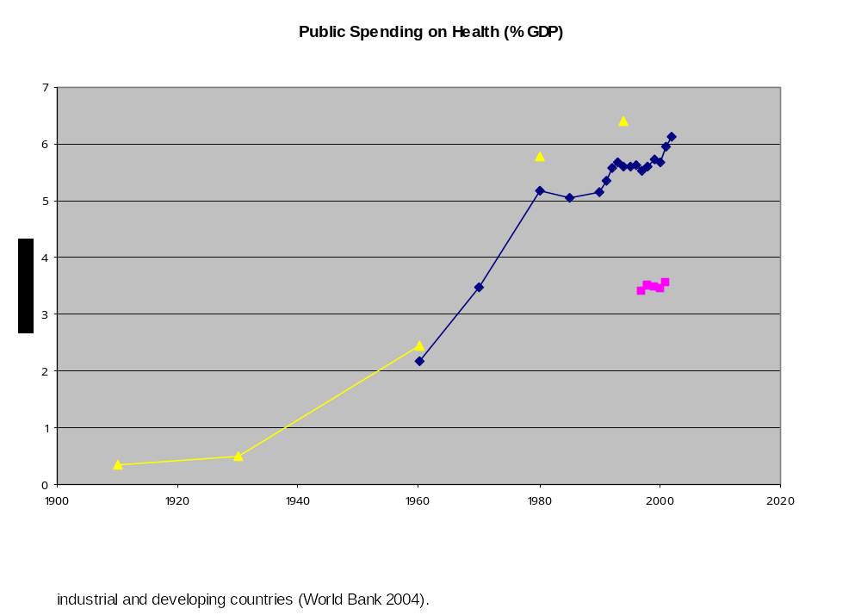
The trends in public spending on health in developing countries cannot be readily documented because WDI data are limited to 1990 and later. Presumably spending levels were even lower in the developing world early in the 20th Century, but this cannot be demonstrated. In 2000, as shown in Table XX above, public spending on health ranged from 2 percent of total consumption in low-income countries (under $1000 per person) to 7 percent in high-income countries (over $10,000 per person).

In the WDI cross-section for the 1990s, the share of public spending on health in GDP bears a strong statistical relationship to per capita GDP and the percentage 65 and older. An OLS estimate yields the following:

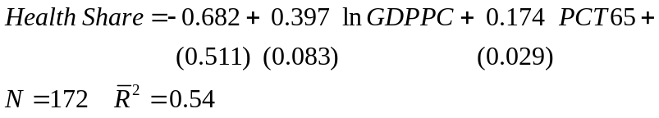

where standard errors are in parentheses beneath the coefficients. These naïve cross-sectional results imply an income elasticity of health expenditure significantly greater than 1. This is higher than usually found in more careful empirical analysis. [This is kind of simple-minded. Perhaps better to just cite other studies.]

The effect of aging is substantial. If the effects of aging are purely compositional, the coefficient on aging implies that public spending on health care for a person 65 or older is equal to 17.4 + x percent of GDP per capita where x is public spending on health care for a person under 65 as a share of GDP per capita. There may well be non-compositional effects, however. Political economy effects may lead to a rise in per capita spending on the elderly as their share of the population increases (Preston) or to a decline (Gruber and Wise).

There is an extensive empirical literature based on OECD data on health expenditure. Typically income elasticities of around 1 are estimated, but there is a relatively wide range. Sen (see appendix) estimates an income elasticity ranging from 0.2 to 0.5 using fixed effect models.

A question: how do the Medicare trustees project health expenditures in the US?

Public Pensions
The influence of public pension policy on consumption and earning profiles is indirect. To the extent that more generous pensions increase consumption and decrease production by the elderly, they increase the lifecycle deficit of the elderly, i.e., the magnitude of their economic dependency. [more here]

Public pensions were first introduced in Europe and New Zealand in the late 19th Century and spread to other industrial countries in the 20th Centuries (Lindert 2004). By 1960 public pension expenditure averaged 4.5 percent of GDP in the industrial countries for which are available. As with other public spending, pension expenditures grew rapidly between 1960 and 1980 when they reach 8.4 percent of GDP in the industrial countries (Tanzi and Schuknecht 2000). Public pension spending has grown in the past as coverage has spread to a larger share of the labor force, the generosity of benefits has increased, and systems have matured, i.e., covered workers have reach retirement age. Population aging has played a secondary role to this point. Holzmann (1988) estimates that less than 20 percent of the rise in pension benefits in OECD countries between 1960 and 1985 was a consequence of population aging, but the effect of population aging will be much more important in the future.

Pension spending has continued to increase but at a more moderate pace than the 1960-1980 period. The share of GDP spent on pension increased by 1.2 percentage points to 9.6 percent of GDP in 1993. There is considerable variation among the industrial countries. Canada, Australia, Ireland, Japan, the US, and the UK were spending 7.5% of GDP or less on public pensions circa 1993. Austria, France, Germany, Italy, the Netherlands, and Sweden were spending 12% or GDP or more on public pensions circa 1993 (Tanzi and Schuknecht 2000). Moreover, many transition and Latin American countries not shown in Figure X have relatively high public pension spending. As a share of GDP circa 1996, public spending for pensions in Uruguay were 15.0%, in Croatia were 11.6%, and in Hungary 9.7% (Kinsella and Velkoff 2001).

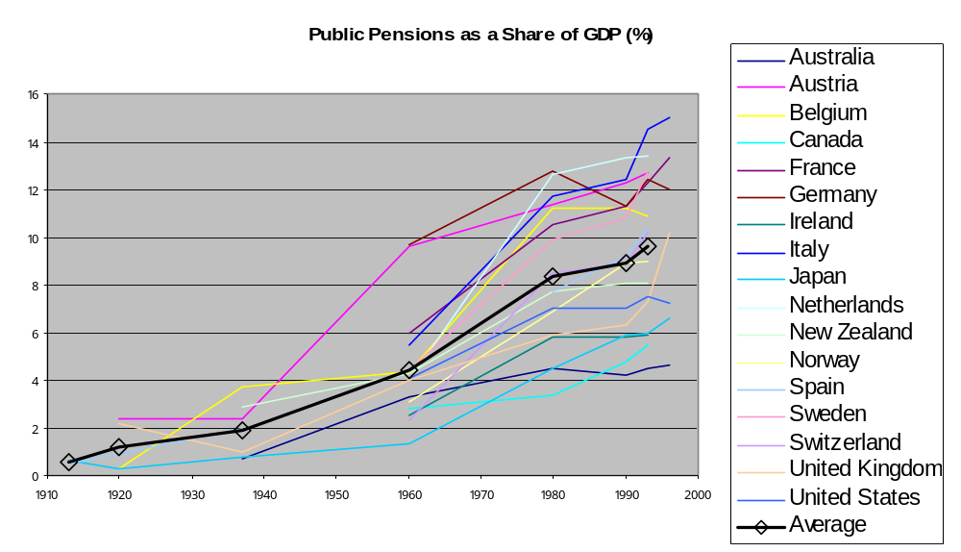

- Conclusion: Growth in the public sector led to a rise in transfers and probably consumption (as a share of GDP) to both children and the elderly. Incidence of rising taxes on child consumption could be important.

Becker, G. S. and N. Tomes (1976). "Child Endowments and the Quantity and Quality of Children." Journal of Political Economy 84(4 pt. 2): S143-62.
DGBAS, T. (1998). National Family Income and Expenditure Survey. Taipei, DGBAS.
Galor, O. and D. Weil (2000). "Population, Technology, and Growth: From Malthusian Stagnation to Demographic Transition and Beyond." American Economic Review 90: 806-828.
Gruber, J. and D. Wise (2001). "An International Perspective on Policies for an Aging Society." NBER Working Papers W8103.
Holzmann, R. (1988). Reforming Public Pensions. Paris, OECD.
Kalemli-Ozcan, S. (2003). "A Stochastic Model of Mortality, Fertility, and Human Capital Investmen." Journal of Development Economics 70: 103-118.
Kelley, A. C. (1996). The Consequences of Rapid Population Growth on Human Resource Development: The Case of Education. The Impact of Population Growth on Well-Being in Developing Countries. D. A. Ahlburg, A. C. Kelley and K. O. Mason. Heidelberg, Springer-Verlag: 67-138.
Kinsella, K. and V. A. Velkoff (2001). An Aging World: 2001, International Population Reports. Washington, D.C., US Census Bureau.
Lindert, P. (2004). Growing Public: Social Spending and Economic Growth Since the Eighteenth Century. Cambridge, Cambridge University Press.
Mason, A., R. Racelis, et al. (2004). Aging Populations: Health Systems and Policy Reform. Honolulu, East-West Center.
Schultz, T. P. (1987). School Expenditures and Enrollments, 1960-80: The Effects of Income, Prices, and Population Growth. Population Growth and Economic Development: Issues and Evidence. D. G. Johnson and R. D. Lee. Madison, Wisconsin University Press 413-479.
Schultz, T. P. (1997). Demand for Children in Low Income Countries. Handbook of population and family economics. Volume 1A. Handbooks in Economics, vol. 14. M. R. Rosenzweig and O. Stark. Amsterdam; New York and Oxford, Elsevier Science: 349-430.
Sheiner, L. (2004). "The Effects of Technology on the Age Distribution of Health Spending: A Cross-Country Perspective." Unpublished manuscript.
Tanzi, V. and L. Schuknecht (2000). Public Spending in the 20th Century: A Global Perspective. Cambridge, Cambridge University Press.

Appendix: Research on aggregate health care expenditure

Note: Jerry Russo suggests that we look at the OECD data base that has detailed public and private health spending data for OECD countries. He says the quality of the data is much better than the WDI data and that the time series may be longer. Data for countries that recently joined OECD may not be as good.

References from Jerry (Search for more recent papers):

Schieber, George J. and Jean-Pierre Poullier (1990), “An Overview of
International Comparisons of Health Expenditures," in: Health Care
Systems in Transition: The Search for Efficiency, (Paris:
Organization for Economic Cooperation and Development), pp. 9-15.

Schieber, George J., Jean-Pierre Poullier, and Leslie M. Greenwald
(1992), “U.S. Health Expenditure Performance: An International
Comparison and Data Update,” Health Care Financing Review, Vol. 13,
No. 4, pp. 1-87.

Schieber, George J., Jean-Pierre Poullier, and Leslie M. Greenwald
(1991), “Health Care Systems in Twenty-Four Countries,” Health
Affairs, Vol. 10, No. 3, pp. 22-38.

Gerdtham, Ulf-G., Jes Søgaard, Fredrik Andersson, and Bengt Jönsson
(1992), “An Econometric Analysis of Health Care Expenditure: A Cross-
Section Study of the OECD Countries,” Journal of Health Economics,
Vol. 11, No. 1, pp. 63-84.

Getzen, Thomas E. 2000. Health care is an individual necessity and a
national luxury: applying multilevel decision models to the analysis
of health care expenditures. Journal of Health Economics 19 (2)
(March): 259-270.

Hitiris, Theo and John Posnett. 1992. The determinants and effects of
expenditures in developed countries. Journal of Health Economics 11
(2): 173-181.

Jacobzone, S., E. Cambois, E. Chaplain and J.M. Robine. 1998. The
health of older persons in OECD countries: Is it improving fast enough
to compensate for population ageing? Labour Market and Social Policy
Occasional Papers No. 37. Paris: OECD.

Wagstaff, Adam, Eddy van Doorslaer, Hattem van der Burg, et al. 1999.
Equity in the finance of health care: some further international
comparisons. Journal of Health Economics 18 (3) (June): 263-290.

Anindya Sen. 2005. Is Health Care a Luxury? New Evidence from OECD Data
International Journal of Health Care Finance and Economics Volume 5, Number 2
June 147 - 164

Abstract Most research using cross-country data find income elasticities equal to or exceeding unity with respect to health expenditure. These conclusions might be confounded due to omitted variables bias and the presence of unobserved country and year specific determinants of per capita health expenditures. I obtain results supporting these hypotheses using recent (1990–98) data from fifteen OECD countries. Specifically, OLS coefficient estimates drop by more than 50% with the use of two-way fixed effects models and the inclusion of various demand and supply based determinants of per capita health expenditures, implying income elasticities of between 0.21 and 0.51. Weighted Least Squares (WLS), Generalized Least Squares (GLS) and Instrumental Variables (IV) estimation yield similar results.

