Preliminary Draft
March 2, 2007

Consumption, Saving and Capital Accumulation as Age Distributions Change

Ronald Lee
Demography and Economics
University of California
2232 Piedmont Ave
Berkeley, CA 94720
E-mail: rlee@demog.berkeley.edu

Andrew Mason
Department of Economics
University of Hawaii at Manoa, and
Population and Health Studies
East-West Center
2424 Maile Way, Saunders 542
Honolulu, HI 96821
E-mail: amason@hawaii.edu

Acknowledgements: Research for this paper was funded by two grants from the National Institutes of Health, NIA R37 AG025247 and R01 AG025488. The authors are grateful to other project participants for use of their estimates for other countries and to Timothy Miller and Gretchen Donehower for assistance in designing and programming the simulations. This paper was prepared for presentation at the 2007 annual meetings of the Population Association of America.

Abstract

Over the demographic transition changes in population age distribution interact with age patterns of production and consumption to generate the first and second dividends. The second dividend arises from induced variations in aggregate saving and wealth holding, and depends on the relative size and upward or downward direction of intergenerational transfers in an economy. We draw on National Transfer Accounts estimates of transfers, labor productivity, and consumption by age for a number of countries to assess these effects, and estimate the first and second dividends. We derive concrete results for several different theoretical approaches and models. First, we analyze comparative golden rule steady states. Second, we simulate three different dynamic economic models of saving, life cycle consumption, and economic growth over the transition: individualistic life cycle saving; interdependent altruistic sharing; and an optimizing social planner. We find that all three simulations exhibit a second dividend, demonstrating that it is robust, although the size and timing may differ depending on specific institutions and behavior.

Introduction
Over the demographic transition changes in population growth rate and age distribution interact with age patterns of production and consumption to generate changes in dependency, savings, and capital intensity. These changes are sometimes called the first and second demographic dividends. The first dividend reflects systematic improvements in the support ratio—the ratio of effective workers to effective consumers-- that occur at an intermediate stage in a classic demographic transition, after fertility has begun to fall and before population aging seriously erodes the support ratio. The first dividend can extend over a period of 40 to 80 years, and can cumulatively boost income per effective consumer by 30 to 60%. However, as population aging advances it reduces the support ratio, which eventually returns to a value close to that at the start of the demographic transition. Thus the first dividend is transitory, and the gains it brings are reversed by population aging.

However, there is an important difference between the age distribution generating the support ratio at the start of the transition, when there is a high proportion of children and low proportion of elderly in the population, and at the end when the proportion of children is far lower and the proportion of elderly is very much higher. We will argue that this change in the population age distribution over the transition can cause a substantial and permanent increase in assets per capita and, for a closed economy, in capital per worker, leading to higher per capita incomes and higher consumption than otherwise. The extent to which population aging brings economic benefits through this route depends on several factors: first, the shape of the age profiles of consumption and labor income over the life cycle; two, the extent to which consumption in old age is provided through saving and asset accumulation rather than through familial or public transfer systems; and three, whether the economy is closed or open to international capital flows. Because nations differ along these three dimensions, assessments of the quantitative impact of changing population age distributions will also differ across countries. Another possibility which we do not explore here is that labor supply at older ages increases as population ages. Such changes have been very modest, as in the United States, or have not yet been observed empirically in any country to the best of our knowledge, and at most we might expect them to offset increased longevity but not the consequences of low fertility.

The National Transfer Accounts project provides estimates of the age profiles of consumption and labor income from which support ratios can be calculated, and past and future changes in the support ratio can be projected on the assumption that these age profiles remain similar in shape over time, an assumption that is largely born out by the data. The degree of openness of economies has generally been increasing in recent decades, and assessing the economic implications is a topic worthy of further exploration. The greatest uncertainty, it seems to us, is in the response of national savings rates and growth in capital to demographic change—the so-called second demographic dividend. The main contribution of this paper is to investigate the occurrence, timing and size of the second dividend using different models incorporating standard and non-standard assumptions about the motivation of individuals and society.

We will first consider the highly artificial but illuminating case of golden rule steady states, in which succeeding generations maintain the capital labor ratio which maximizes per capita consumption. We then turn to simulations of non-steady state dynamic trajectories of population, saving, assets, income and life cycle consumption. Any simulation must be based on a particular theory about how economic behavior responds to the changing population age distributions. Any theory rests on assumptions which can themselves be challenged. For this reason we will carry out simulations based on three quite different theories. First we will consider individualistic life cycle saving with and without familial or public sector transfers for old age support. Next we will consider a dynamically maintained mix of transfers and asset accumulation shaped by intergenerational altruism. Finally we will consider the Ramsey-Cass-Koopmans model with a Social Planner who guides asset accumulation to maximize a social objective function. Comparison of results of these three kinds of simulations indicate that the claim of a second demographic dividend is robust with respect to model specification.

We should acknowledge at the outset the economic effects we will be considering are relatively small compared to the dramatic gains made in recent years by China and India, for example. To some degree this is because we are considering only physical capital and not human capital; both have changed dramatically in recent decades. In future work we hope to integrate investment in human capital in our analysis. However, other factors such as the adoption of market oriented policies are doubtless also important, and are well beyond the scope of our analysis. Similarly, we will not consider any natural resource or environmental constraints on population growth, and we will assume constant returns to scale. These factors we ignore are certainly important in their own right, but here we choose to focus narrowly on the consequences of age distributional change.

Comparative Golden Rule Steady States
Here we will begin by considering the effect of steady state differences in the population age distribution and growth rate on capital intensity, per capita income, and life cycle consumption. We will consider a very special case in which capital intensity, saving, and consumption stay at the level which maximizes per capita consumption. This case is called “golden rule” because it requires that each generation that receives this optimal amount of capital in turn passes it on to the next generations rather than enjoying higher consumption by running down the capital stock – thus it does unto later generations as the preceding generations have done for it. This special case is unrealistic because neither populations nor economies are likely to be in steady state and because even if they were, those steady states would be unlikely to “golden rule”.

The value of considering this special case is two-fold. First, it allows us to reach important qualitative conclusions about how population growth and age structure influence saving, capital, and per capita and lifetime consumption. Moreover, we can explore how these outcomes are affected by the relative importance of transfer systems. Second, the “golden rule” case establishes a benchmark against which to assess population changes and population and economic policy. This provides useful context for later parts of the paper when we consider non-golden rule cases in simulations.

A golden rule steady state is the one in which, for any population age distribution, per capita consumption is maximized through appropriate choice of the levels of aggregate saving and capital per worker. In the standard neo-classical framework, a steady state with slightly more rapid population growth n + dn will have a slightly higher optimal level of saving and slightly lower capital labor ratio. The reason is that the more rapidly growing labor force must be equipped with capital, and this costs a slightly higher proportion of current output. (If depreciation is taken into account this result is reinforced). With slightly lower output per worker and slightly higher savings out of that output, consumption per capita must be a bit lower. Golden rule analysis abstracts from the behavioral question of whether the saving rate will in practice tend to be higher or lower when the population growth rate is higher. It just tells us that the optimal saving rate will be higher. It thus focuses our attention on how a different demographic regime with more rapid population growth affects the highest level of per capita consumption that could be sustainably achieved.

For simplicity, we will employ a stripped down model with no technological progress and no depreciation of capital. Some standard results hold with or without age distribution:
- In golden rule steady state the rate of return on capital equals the population growth rate, that is r = n.
- All income from labor is consumed and all income from capital is saved.
- An increase in the population growth rate reduces per capita consumption. Differentiating per capita consumption c with respect to n across golden rule steady states we find:
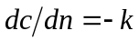
where k is the golden rule amount of capital per person.

These three results hold when we introduce age structure into the standard Solow model, but additional important results also hold. More rapid population growth leads to a younger stable age distribution (μ(x) =be^{-nx}l(x), where μ(x) is the proportion of the population at age x and l(x) is the life table proportion surviving from birth to age x). A younger age distribution could be an economic advantage or disadvantage, depending on circumstances that we will now consider.

Let c(x,r) be the preferred age pattern of consumption of a representative individual in steady state, perhaps as a result of individual optimization or perhaps for other reasons--all that concerns us here is the preferred age pattern, not its origin. Let labor income age x be y_{l}(x). Both c(x,r) and y_{l}(x) are average values at age x in the population. Since aggregate consumption must equal aggregate labor income in a golden rule steady state, we know that the population weighted integrals of c(x,r) and y_{l}(x), call these C(r) and Y_{l}, must be equal: C(r,n) =Y_{l}(r,n). These depend on n because n determines the population weights. Note that in golden rule r = n, so the stable population weighting that leads to aggregate consumption C and Y is proportional to the life cycle weighting by e^{-rx}l(x) that is used to calculate a survival weighted present value at birth for consumption or earnings, for example:
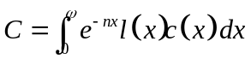

The life cycle budget constraint sets C computed in this way equal to Y_{l} computed similarly, and we see that the aggregate social budget constraint for golden rule, that all labor income, and no more, be consumed, is identical to the life cycle budget constraint of an individual that says that over the life cycle the present value of survival weighted consumption must equal that of labor earnings. (This formulation requires the existence of institutions that spread the risk of mortality so that the constraint need hold only for average mortality conditions.)

An important paper by Arthur and McNicoll (1978) analyzed a model similar to this and showed that:

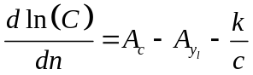

This tells us that if the population growth rate is slightly higher then there will be a proportional change in the present value of life time consumption equal to the average age of consumption (A_{c}) minus the average of labor income (A_{yl}) minus the capital dilution effect, equal to capital per person divided by per capita consumption. There are two additive effects: the increase in the population growth rate leads to capital dilution as in the standard model, but it also leads to a younger age distribution which will raise C if consumption generally occurs at an older age than earning or reduce it if the reverse is true. The implication is that although per capita consumption is necessarily lower on a golden rule steady state with a slightly higher population growth rate, life time consumption can actually be either higher or lower depending on age patterns of consumption and labor supply. The equation dc/dn = -k must continue to be true. But once we have introduced age distribution, c is no longer the most informative measure of individual consumption. It is more useful to examine what happens to the present value of life time expected (survival weighted) consumption, that is C.

Another striking result, this one due to Robert Willis (1988), concerns aggregate demand for wealth, W. For a given age x, W(x) is the amount of wealth an individual would need to hold in order to fund all consumption after age x less labor earnings after age x. The population weighted average of W(x) across all ages x is the per capita demand for wealth W. Willis showed that:

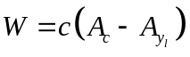
This result can be substituted into to find:

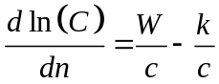

Aggregate and age specific wealth can be held either as an asset such as capital, say k(x), or as the expectation of net future transfers to be received, say τ(x). Let the pattern of transfers be described by τ⁺(x) = transfers received, and τ⁻(x) = transfers given at each age, with the net transfer received being τ(x). We can define transfer wealth at any age x, T(x), as the present value of survival weighted future net transfers, τ(x). Let the sum over all ages of τ(x), weighted by the population age distribution, be aggregate transfer wealth, T. Similarly, age specific holdings of capital k(x) aggregate to and average of K.

Life cycle wealth W is held in one of two forms, capital K or transfer wealth T, so:

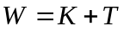

Transfer wealth is the present value of expected net transfers from all sources from the current population. Transfer wealth is positive if transfers are upward on average because members of the current population anticipated transfers from those who are not yet born, e.g., future taxpayers. Transfer wealth is negative if transfers are downward on average – from parent to children, for example. The reason is that on average the current population has obligations to future generations that must be fulfilled.

Combining these last two equations, we find the important result first derived in Willis (1988):
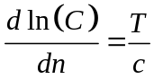

The effect on lifetime consumption (C) of a small increase in the population growth rate (dln(C)/dn) is T/c. This result requires some explanation. First note that this has nothing to do with whether a change in population growth leads to saving rates that allow higher steady-state consumption; we are already assuming that the system is on a golden rule trajectory, and moves onto a new golden rule trajectory when n changes. The adjustment of savings is taken for granted. The only question is whether the adjustment of savings comes at the expense of life cycle consumption C.

Consider the situation in which transfer wealth is zero. This will occur if there exists some population growth rate n at which r=n and aggregate consumption equals aggregate labor earnings. If such a steady state exists, it will be golden rule, that is the saving rate and capital intensity that will maximize per capita consumption for this particular population growth rate. This would be a very special golden rule steady state, one in which the optimal amount of saving and capital accumulation results purely from life cycle saving.

Then even though must hold, and therefore per capita consumption must be lower at higher population growth rates, C does not change at all in the neighborhood of n. With life cycle saving, younger people consume less than they earn, and their share in the population increases when n is higher. Therefore age specific consumption does not have to be reduced at slightly higher population growth rates, in order to achieve the higher aggregate saving rate that is required to stay on the golden rule path. This result will hold anytime that a steady state economy is on golden rule and has no transfer wealth. This condition could be satisfied with downwards transfers to children and upwards transfers to the elderly so long as these balance out in the sense that transfer wealth is zero. It can also have any pattern of borrowing and lending across age, and the result will still be true.

Now consider golden rule paths more generally, when transfer wealth is not zero. Indeed, public or familial intergenerational transfers may be precisely the policy through which golden rule is attained. It may be helpful to give some examples of ways in which transfers can boost the capital stock independent of live cycle saving. First, consider a bequest motive. With a bequest motive, people save over their life cycles and do not consume those savings toward the end of life. Rather they preserve them for their children, and we can imagine them making an inter vivos transfer of their capital to their children at the moment just before they die. This additional component of the capital stock will be passed down from generation to generation, growing at the rate n, and augmenting a second component of capital that is saved by individuals when younger in order to be able to consume when older – life cycle saving, in short. One might also imagine the government playing the same role in a socialist economy, taxing the population and investing the revenues in capital which is passed from generation to generation, and which augments any life cycle saving that is done. In principle it is possible that life cycle saving would generate an amount of capital above the golden rule amount, and this excess could then be offset by some upward transfers such as social security or familial elder support that substitute for capital in satisfying the life cycle saving motive. In this case, T>0, and more rapid population growth would be associated with higher life cycle consumption across golden rule steady states. The age structure of life cycle saving generates too much additional capital at slightly higher population growth rates, which must be offset by increased upward transfers the costs of which are much reduced by the younger population.

Figure 1 takes the population growth rate n as given, and shows the demand for capital by producers, that is the amount of capital demanded for productive purposes at each interest rate r and population growth rate n, expressed per capita. The golden rule amount of capital per capita corresponds to the demand for capital when r = n. But we also want to know how much capital members of the population want to hold. This will depend on their demand for wealth needed to achieve their desired consumption trajectory over their life cycle given their planned trajectory of labor income. This demand for wealth also will vary with r and with n (although n is fixed in this figure). Three alternative demand for wealth schedules are shown in Figure 1, corresponding to different tastes, incentives, cultural values, and institutional arrangements. Case A has the lowest demand for life cycle wealth, perhaps because people plan to work longer in old age or to consume less in old age. The demand for life cycle wealth is less than the golden rule amount of capital, so only if T<0 so that there is a “bequest” demand for wealth can golden rule be attained. This could happen if people are motivated to make substantial transfers to the young either privately, e.g. through bequests, or publicly, e.g. through a large publicly owned capital stock to which new births automatically gain a share.

Next comes Case B, in which the demand for life cycle wealth happens to be exactly equal to the producers’ demand for capital at r=n. If transfer wealth T is 0, then this corresponds to the very special golden rule case discussed earlier. Case C has the greatest demand for life cycle wealth, perhaps because people plan to retire very early and to consume more in old age than in youth. In this case to achieve golden rule it would be necessary to satisfy a part of this large demand for life cycle wealth through upward transfers such as familial support of the elderly or a Pay As You Go public pension system or perhaps through increased government debt as Diamond (1965) considered.

If the economy is in golden rule of the Case A sort, then population aging (lower n) while remaining in golden rule would lead to higher life cycle consumption. If the economy is in golden rule of the Case C sort, then population aging while remaining in golden rule would lead to lower life cycle consumption. And in the Case B situation, population aging while staying in golden rule would involve no change at all in life cycle consumption.

More realistically, economies might be in non-golden rule steady state. D marks one possible non-golden rule steady state equilibrium with a low demand for life cycle wealth as in Case A combined with 0 transfer wealth. Other institutional arrangements leading to other values of T would generate different non-golden rule steady state equilibria.

Lessons from the golden rule case:
- More rapid population growth leads to capital dilution, a reduction in the capital labor ratio and therefore lower per capita consumption, across golden rule steady states. Slower population growth associated with lower fertility and population aging boosts consumption for the same reason.
- Although population aging may cause lower aggregate saving rates, it may at the same time cause increased capital per worker and higher consumption. (See Cutler et al, 1990).
- If intertemporal consumption preferences are such as to generate exactly the golden rule amount of aggregate capital through life cycle saving, and T=0, then a small increase (decrease) in the population growth rate has no effect on life cycle consumption, even though it reduces (raises) per capita consumption.
- If life cycle saving alone would generate more than (less than) golden rule capital stock, then golden rule can be attained by satisfying some of the aggregate demand for wealth through upward (downward) transfers, public or private, so that T<0 or T>0. Increased government debt or public pensions would raise T while saving for bequests would reduce T. (Diamond, 1965; Willis, 1988; Lee 1994).
- In this case, the proportionate effect on life time consumption of a slight increase (decrease) in the population growth rate equals transfer wealth relative to per capita consumption, T/c. Thus faster population growth would raise life cycle consumption across golden rule steady states if transfers to the elderly dominate, or reduce life consumption if transfers to children dominate. Reduced population growth rates, and therefore population aging, have the opposite effect. Thus if transfers to children dominate, population aging would raises life time consumption. (Willis 1988, Lee 1994).

These lessons from the very special golden rule case yield insights that are useful in understanding more general cases.

Cross-national variation in transfer systems
The foregoing discussion emphasized how preferences and institutional arrangements influence the way changing population age distributions affect holdings of capital and levels of life cycle consumption in the macro economy. While much is known about individual parts of these arrangements across many countries-- such as public pension systems, systems of public education, family living arrangements, and labor supply—no comprehensive view is available which combines all of these and more in a consistent framework.

The National Transfer Accounts project (Mason et al, in press; Lee et al, in press) seeks to fill this gap by developing empirical estimates of support systems in different countries. Here we present estimates of the sources of financial support for consumption by the elderly in four countries: Japan, US, Taiwan and Thailand for a year near 2000, in Figure 2. These countries vary widely in the extent to which elderly consumption is financed through transfers, either familial or public, through asset accumulation, or through continuing labor. The US and Thailand stand out as financing more of old age through assets and less through transfers, whereas Japan and Taiwan rely heavily on transfers and very little on assets. Economies like Japan and Taiwan will have more positive or less negative values of T than will those like the US or Thailand, other things equal.

Non-golden rule steady states
Most actual economies are believed to save at less than the golden rule rate and to have less capital than golden rule would require, because the subjective rate of time preference of individuals is too high and altruism is too low to motivate the required level of saving. At this point, we introduce some behavioral assumptions to shed light on the actual saving rate as opposed to the optimal one. We can then consider whether certain demographic changes interact with individual motivation and institutions so as to move the economy closer to an optimal situation or in the opposite direction. The kinds of effects analyzed for the golden rule case will continue to occur, but movement relative to golden rule will lead to additional effects on life cycle consumption. For this analysis we will pass to the more realistic dynamic case.

Simulations of realistic dynamics
More generally, consider a non-golden rule steady state. Transfers may be in any direction, upward or downward, on average.

The difficulty with analyzing consumption levels and capital stocks across non-golden rule steady states is that although it is straightforward to analyze the compositional effect of the changing population age distribution on savings and consumption, it is impossible to consider the effect of a changed rate of return on savings and consumption behavior without a behavioral theory of saving and consumption. The golden rule results were derived without any behavioral theory, by simply assuming that the saving rate is always at the golden rule level.

Once we introduce a behavioral theory such as some version of life cycle saving, then we can turn to macro simulation and drop the steady state assumption altogether. We can expect, however, that all the ingredients of the golden rule case will be retained in some form, and new ones will be added. Thus we should expect that capital dilution will occur if the growth rate is more rapid. To the extent that there is life cycle saving, a younger population will generate additional aggregate savings at least partially offsetting this capital dilution. To the extent that transfers occur, these will reinforce or offset capital dilution depending on whether their net direction is downward or upward. In addition, when we are no longer on a golden rule growth path, there will be gains or losses depending on whether the behavioral response moves us closer to that path, or away from it.

Simulated Life Cycle Savings over the Demographic Transition With and Without Transfers
Our life cycle saving approach assumes that adults save in anticipation of their old age retirement, based on current age patterns of labor supply projected into the future. They also take into account the consumption needs of their children, and plan to save and dissave over their life times so as to maintain a regular trajectory of household consumption per effective consumer, depending on their rate of time preference. In related simulations, differing degrees of familial support or public pensions are taken into account in the formulation of these life time plans for saving and consumption. The assumption is that individual actors take these transfer programs as given, based on social norms or on explicit public policies, and formulate their savings plan so that given these transfers in conjunction with their savings plan, consumption will vary optimally over the life cycle.

Under life cycle savings without transfers, we would expect that as life expectancy rises, individuals would tend to raise their savings rates to provide for consumption during a longer expected period of retirement. As fertility falls, individuals would probably devote a smaller share of their life time income to their fewer children and more to their own consumption, which would require higher savings during the working years to fund higher consumption in retirement. As mortality falls more births will survive, tending to offset the effect of lower fertility, however. In addition, with lower fertility and longer life the age distribution of household heads will become older, and this will generate additional effects. All these demographic changes are combined with the complex dynamics outside of steady state, and perhaps with rapid economic change, as when productivity growth accelerated in Taiwan. With all these changes occurring together, it becomes difficult to grasp the outcome intuitively. When changing transfer systems are added, the system becomes still more complex.

In our macro simulations, we find that saving rates rise during the middle of the demographic transition when support ratios rise (so consumption is lower than otherwise), and then fall back to relatively low levels as the population ages. The ratio of wealth per worker or of wealth to income, however, increases substantially and remains high. Unlike the first dividend, which is transitory, the second dividend leads to a permanent change. This effect is stronger when provision for retirement through familial transfers or public pensions is weaker. In the absence of such transfers, the capital to income ratio permanently doubles or triples. Details of life saving simulations for Taiwan and the US are provided in Lee et al (2000, 2003). Results for Taiwan are displayed in Figures 3 and 4, for savings rates and the ratio of capital to labor income. Note that both savings rates and the capital-labor income ratio are lower under the system of familial support for the elderly (more positive or less negative T) as compared to pure life cycle saving with no upward transfers (T<0, since children are still receiving transfers). Also note that even though savings rates fall with population aging, because the labor force is growing more slowly (lower n) the capital intensity of the economy increases.

Simulated Interdependent Utilities Across Generations and Mix of Saving and Transfers
The point of departure in this analytic approach is the assumption that the observed cross sectional age profile of consumption for a recent year reflects deep underlying altruistic linkages and preferences within families and within society at-large. Support for this view can be found in the relative stability in the shapes of these profiles across countries with differing rates of economic growth and levels of per capita income and within countries over extended periods of time. In Taiwan, for example, the cross-sectional consumption profile has been remarkably stable during the last 30 years for which estimates are available. This is the rationale for assuming that the shape of consumption by age is unchanging over time in the simulation. This unchanging shape is maintained through a combination of saving and transfers through the family and through public sector programs, and it reflects the interdependency and altruistic linkage of generations in contrast to the individual optimization of the classic lifecycle model.

Figure 5 plots the consumption profile that is used here for Taiwan, and also those for the US that will be used in the Social Planner model to be considered later, as well as an average for four Third World countries that will be used for Niger in that model, and is referred to as the average LDC profile. It can be seen that the age schedule for Taiwan is quite similar to the average LDC profile, except that consumption by children is higher in Taiwan. The most striking feature of these profiles is the big increase of consumption with age in the United States.

As is true of the other two simulation models analyzed here, the cross-sectional age profile of productivity, i.e., labor income, is also assumed to be constant. The economy is assumed to be small and open to international financial flows. Thus, the labor productivity profile shifts upward at the exogenously determined rate of productivity growth. Under the small, open economy assumption, a change in the demand for capital by residents has no effect on domestic capital. Any increase in the lifecycle demand for capital leads to an increase in capital in the rest of the world. And because the simulated economy is small, it has no discernible effects on the global economy. The global economy is not immune to the influences of global aging. In particular, international interest rates decline as a consequence of global aging.

The final important element of the model is the treatment of transfers. By assumption, the gap between labor income and consumption for children is filled entirely by familial and public transfers. This is consistent with available National Transfer Account estimates (Mason, Lee, et al., forthcoming; Lee, Lee, and Mason, forthcoming). Results reported in Mason and Lee (2006) show that the simulations are insensitive to the share of child transfers that are through families or publicly funded. The gap between consumption and labor income for the elderly is filled by a combination of transfers and lifecycle saving. Implicitly the choice between transfers and saving may reflect time preference or altruism toward future generations; or it may be the outcome of entirely different processes. Our approach is to assume that the share of transfer wealth in lifecycle pension wealth, denoted by is constant throughout the simulation. Lifecycle pension wealth is the present value of consumption at older ages less the present value of labor income at older ages and must equal assets devoted to supporting the elderly during their retirement plus lifecycle pension wealth. The values of used in the simulations are based on National Transfer Account estimates. Two values are employed to represent a low saving society in which 65% of lifecycle pension wealth is transfer wealth (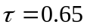) and a high-saving society in which 35% of lifecycle pension wealth is transfer wealth (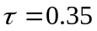). A complete description of the model, the solution algorithm, and results are provided in Mason and Lee (2007 forthcoming).

Simulated values for wealth and saving only are presented here as more comprehensive results for this model are presented elsewhere and more comprehensive results for the social planner model are presented in the next section. In Taiwan mortality conditions were very poor in 1900. The expected years lived at old age did not begin to increase until after World War II ended, at which point adult mortality improved very rapidly (Kinugasa and Mason 2007). Taiwan also had a very rapid transition to low fertility that began in the 1950s.

The simulated effects of these demographic changes are quite striking in Figure 6. For either scenario pictured, the capital intensity of the economy increased from the low levels that characterized the first half of the 20th Century. Between 1950 and 2000 the ratio of capital to labor income increased from virtually zero to about 1.0 for the high transfer wealth scenario and to between 2.0 and 3.0 for the low transfer wealth scenario. The corresponding saving rates in Figure 7 reach elevated levels during the period in which wealth is increasing most rapidly – high rates of saving are required to generate rapid increases in the capital stock.

In the simulation presented here life expectancy is assumed not to increase after 2050. This is unrealistic but it allows us to make a useful point about the time paths of saving and wealth at the end of the demographic transition. As aging begins to dominate the demographic situation, the demand for wealth stabilizes at a high level. Saving rates decline because population growth has slowed and because assets are no longer rising rapidly relative to labor income. Thus, asset income is permanently higher. In the case of a closed economy, as we will see below, capital is permanently higher. For this reason, the demographic transition leads to a permanent second dividend.

Simulated Optimal Saving and Consumption for Interdependent Utilities and a Social Planner
Similar to the previous approach, we assume that the cross sectional age profile of consumption reflects some deep altruistic values. Let the height of the cross sectional consumption profile in year t be γ(t). A social planner seeks to maximize a social welfare function equal to the integral of utility from consumption, u[γ(t)] , over an infinite time horizon discounted by the social rate of time preference ρ.

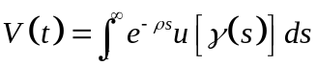
where
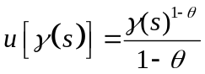

We also assume that the planner has perfect foresight about the entire future population. The economy is closed to trade, capital flows and migration, and all relevant economic parameters are known such as the rate of depreciation, the rate of technological progress, and the parameters of the production function. The planner chooses a level of aggregate saving for each year, trading off future consumption against current consumption and determining asset accumulation.

In the actual optimization process we have followed common practice in multiplying quantities by a factor of e^{-g(s-t)} to remove the effects of labor augmenting technological progress at rate g. We assume a constant returns to scale Cobb-Douglas production function with capital and labor coefficients of 1/3 and 2/3, depreciation at .03 per year, technological progress at .015, a rate social time preference of .01, and an elasticity of intertemporal substitution of .4. The rate of social time preference reflects the degree of altruism that current members of society feel toward future generations, with a lower rate indicating greater altruism. With sufficiently great altruism, society will pass on substantial assets to future generations (T<0), and with sufficiently weak altruism society may enforce negative bequests on future generations, for example through costly PAYGO pension programs or increasing government debt (T>0).

We carry out our analysis for three countries: the US, Taiwan (for which we simulate a past without immigration from the mainland China) and Niger. We assume that an optimal economic and demographic steady state has been reached by 2300 based on United Nations long run projections and the steady state optimization conditions, and we then solve numerically for the optimal trajectory from the present up to 2300.

Figure 8 plots the support ratios for the US, Taiwan and Niger. These depend in part on the different demographic levels and trends in each country, and in part on the different c(x) and y_{l}(x) curves that are used. As discussed earlier, the US consumption schedule is strikingly different from the other two. At the end of the simulation period in 2150 the demography in the three countries is projected to be very similar, so the differences in support ratio at that point are reflecting only differences in the age profiles of consumption and labor income. At the start the support ratio for Niger is very low because Niger has extremely high fertility. As it moves through the projected transition it passes through the first dividend phase from 2020 to 2080, and then its support ratio drops with population aging. In Taiwan the support ratio drops for a few decades with population aging but then stabilizes. In the US the support ratio drops as the baby boom generations retire, and then after a pause it drops further. Its high level of consumption in old age give it a lower support ratio throughout the simulation, from start to finish, than it would otherwise have.

Figure 9 shows the trajectories of the optimal net savings rates. These depend largely on the population growth rate, and hence are extremely high in pretransitional Niger and are similar in the US and Taiwan, both with relatively low growth rates.

Figure 10 shows trajectories of the capital-labor ratio, per capita wealth, and transfer wealth. Figure 11 shows simulated consumption per effective consumer. From inspection of these figures, we observe the following:
- The demand for wealth for life cycle saving (consumption smoothing) is not nearly enough to sustain the optimal capital labor ratios. Attaining these requires a strong transfer of wealth to future generations, inconsistent with pure life cycle saving behavior for own retirement consumption. On the optimal trajectories for all countries transfer wealth is between negative 5 and negative 40 times total output. Transfer wealth can be seen to be least negative in the optimal plan for the US. This is because the age profile of consumption in the US is particularly high at the older ages, and therefore higher life cycle savings are required to provide for this consumption in old age in the US. That means that a smaller amount of capital needs to be passed down from generation to generation in order to remain on the optimal capital intensity.
- Despite substantial population aging in the US and Taiwan, consumption per effective consumer is expected to increase relative to initial levels because capital intensification more than offsets the decline of the support ratio. In Niger the increase is dramatic while in Taiwan and US it is more modest. Nonetheless, the optimistic message is clear that in the optimal plan as structured here, aging is not expected to lead to reduced consumption even in low fertility nations.
- This result, rising consumption accompanying population aging, is consistent with our comparative golden rule analysis in the case in which transfer wealth is negative (T<0). In these Social Planner simulations, transfer wealth is very negative indeed. Note that consumption per effective consumer is analogous to life time consumption in the golden rule analysis.
- With population aging, optimal net saving rates fall over the coming century. Nonetheless, capital labor ratios rise. This is again consistent with the comparative golden rule analysis.

Comparison of results
Simulation outcomes for all the cases considered are shown together for the case of Taiwan in figures 12 and 13. All three simulations indicate that ratio of wealth to labor or income will rise over the course of the demographic transition and will remain high. Capital intensity is highest in the Social Planner simulation, which is to be expected. Somewhat surprising is that capital intensity in the pure life cycle saving simulation is quite close to the Social Planner’s. In the first two approaches the second dividend is diminished when transfers to the elderly are larger and future changes in support systems will therefore influence the size of the second dividend. This is perhaps the most important implication for policy: careful attention should be given to the long run influence of future transfer policies toward the elderly on the macro economy. In the Social Planner simulation, transfers are endogenous, generated within the model optimization itself, rather than being taken as given so the comparable comparison is not possible.

Conclusions
Over the demographic transition fertility and mortality fall to low levels, and the population growth rate declines from a high level before fertility decline to a low or perhaps negative one as the age distribution effects of these changes work through to their long run outcome. The view is not uncommon that the fertility transition brings only transitory and mechanical economic advantage through the increase and decrease it causes in the support ratio. The view is also not uncommon that population aging which faces all countries that pass through the demographic transition will be economically painful, as support ratios fall.

Here we have examined the macroeconomic effects of these demographic changes under a variety of assumptions about economic and social institutions and behaviors. Under each set of assumptions we have found that the demographic transition in its middle stage as well as in the final state of population aging brings an increase in life time consumption. Although support ratios do indeed decline during the aging stage, the favorable consequences of the increased demand for life cycle wealth more than offset the lower support ratio. If consumption by the elderly is provided entirely through transfers, either public or private, then the capital deepening effects we find would be muted, as our simulations show. In the extreme, if there were no capital at all, consumption would decline at the same rate as the support ratio. If older people increase their labor supply in response to longer life, then on the one hand the support ratio will not fall so much, and on the other hand, higher savings and capital deepening will not occur to as great an extent, as under our assumption of unchanging patterns of labor supply.

Our social planner simulations assumed a closed economy, so that increased ownership of capital raised labor productivity as well as generating income directly. The other assumptions assumed open economies, so that the productivity gains of greater capital holdings were dispersed across the globe. We have not yet explored the patterns of international capital flows that might result.

There are certainly other consequences of population change that we have not considered here, such as pressure on natural resources and the environment, possible economies of scale, and so on. We have limited our discussion to certain aspects of changing population growth and age distributions.

Our analysis has largely abstracted from pressures that may fall heavily on particular elements in the transfer systems, such as families with increased responsibilities for supporting elderly parents or workers with increased tax burdens to support public pension systems or health care systems. But these systems are just parts of a larger picture, and assessing the implications of population change – and policy – should be guided by a broader view.

References
Amonthep, Chawla, 2006. “National Transfer Accounts for Thailand”, mimeo.
Arthur and McNicoll
Arthur, Brian W. and Geoffrey McNicoll
1978 "Samuelson, Population and Intergenerational Transfers," International Economic Review, vol. 19, no. 1 (February), pp. 241-246.
Auerbach, Alan J., Jagadeesh Gokhale, and Laurence J. Kotlikoff
1991 "Generational Accounts: A Meaningful Alternative to Deficit Accounting," in David Bradford, ed., Tax Policy and the Economy (MIT Press, Cambridge, for the National Bureau of Economic Research), pp.55-110.
Barro, Robert J.
1974 "Are Government Bonds Net Wealth?," Journal of Political Economy v.28, n.6 (November/December), pp.1095-1117.
Becker, Gary and Kevin Murphy
1988 "The Family and the State," Journal of Law and Economics v.31 (April) pp.1-18.
Cutler, David, James Poterba, Louise Sheiner, and Lawrence Summers (1990) "An Aging Society: Opportunity or Challenge?" Brookings Papers on Economic Activity v.1, pp.1-56 and 71-73.
Diamond, Peter A.
1965 "National Debt in a Neoclassical Growth Model," American Economic Review, v. 55, pp.1126-50.
Feldstein, Martin
1974 "Social Security, Induced Retirement, and Aggregate Capital Formation," Journal of Political Economy v.82.
Gale, David (1973) "Pure Exchange Equilibrium of A Dynamic Economic Models," Journal of Economic Theory 6, 12-36.
Kinugasa, T. and A. Mason (2007). "Why Nations Become Wealthy: The Effects of Adult Longevity on Saving." World Development 35(1): 1-23.
Kotlikoff, Laurence J. and Lawrence H. Summers
1981 "The Role of Intergenerational Transfers in Aggregate Capital Accumulation", Journal of Political Economy v.89, pp.706-732.
Kotlikoff, Laurence J. and Lawrence H. Summers
1988 "The Contribution of Intergenerational Transfers to Total Wealth: A Reply," in Denis Kessler and Andre Masson, eds., Modeling the Accumulation and Distribution of Wealth (Oxford: Clarendon Press), pp. 53-67.
Lee, R. D., S.-H. Lee, et al. (2005). "Charting the Economic Lifecycle." National Bureau of Economic Research Working Paper No. 12379 (AG). http://papers.nber.org/papers/W12379.
Lee, R., A. Mason, et al. (2000). "Life Cycle Saving and the Demographic Transition in East Asia." Population and Development Review 26(Supplement).
Lee, R., A. Mason, et al. (2003). "From Transfers to Individual Responsibility: Implications for Savings and Capital Accumulation in Taiwan and the United States." Scandinavian Journal of Economics 105(3): 339-357.
Lee, Ronald (1994). "The Formal Demography of Population Aging, Transfers, and the Economic Life Cycle," in Linda Martin and Samuel Preston, eds., The Demography of Aging (National Academy Press, 1994).
Lee, Ronald and Shelley Lapkoff (1988) "Intergenerational Flows of Time and Goods: Consequences of Slowing Population Growth," Journal of Political Economy v.96 n.31 (June), pp.618-651.
Lee, Ronald D. (1980) "Age Structure, Intergenerational Transfers and Economic Growth: An Overview," in George Tapinos, ed., Revue Economique: special issue on economic demography, vol. 31, no. 6 (November), pp. 1129-1156.
Lee, Ronald D. and Timothy Miller (1990) "Population Growth, Externalities to Childbearing, and Fertility Policy in the Third World," Proceedings of the World Bank Annual Conference on Development Economics, 1990, Supplement to The World Bank Economic Review and to The World Bank Research Observer, pp.275-304.
Mason, A. (forthcoming). Demographic Transition and Demographic Dividends in Developed and Developing Countries, United Nations Population Bulletin..
Mason, A., R. Lee, et al. (forthcoming). “Population Aging and Intergenerational Transfers: Introducing Age into National Accounts”. Economics of Aging Series. D. Wise. Chicago, NBER and University of Chicago Press.
Mason, A. and R. Lee (2007 forthcoming). "Transfers, Capital, and Consumption over the Demographic Transition". in Population Aging, Intergenerational Transfers and the Macroeconomy. R. Clark, A. Mason and N. Ogawa, Elgar Press.
Modigliani, Franco (1988) "Measuring the Contribution of Intergenerational Transfers to Total Wealth: Conceptual Issues and Empirical Findings," in Denis Kessler and Andre Masson, eds., Modeling the Accumulation and Distribution of Wealth (Oxford: Clarendon Press), pp. 21-52.
Ogawa, Naohiro and Rikiya Matsukura, forthcoming. The Role of Older Persons' Changing Health and Wealth in an Aging Society: The Case of Japan. United Nations Population Bulletin.
Rangel, Antonio (2003) “Forward and Backward Intergenerational Goods: Why Is Social Security Good for the Environment?” American Economic Review v.93 n.3 (June) pp.813-834.
Samuelson, Paul (1958) "An Exact Consumption-Loan Model of Interest With or Without the Social Contrivance of Money," Journal of Political Economy, vol. 66, no. 6 (December), pp. 467-482.
Tobin, James (1967) "Life Cycle Saving and Balanced Economic Growth," in W. Fellner et al, eds., Ten Economic Studies in the Tradition of Irving Fisher (Wiley, New York), pp.231-256.
Willis, Robert (1987) "Externalities and Population," in D. Gale Johnson and Ronald D. Lee, eds., Population Growth and Economic Development: Issues and Evidence (University of Wisconsin Press), pp.661-702.
Willis, Robert (1988) "Life Cycles, Institutions and Population Growth: A Theory of the Equilibrium Interest Rate in an Overlapping-generations Model," in Ronald Lee, W. Brian Arthur and Gerry Rodgers eds., Economics of Changing Age Distributions in Developed Countries (Oxford University Press), pp.106-138.
Figure 1.

Figure 1. Three Different Levels of Demand for Life Cycle Wealth and How Golden Rule Could Be Achieved for Each Through Appropriate Transfer Wealth

Producers’ demand for K = K(r,n)
r=n
B. Life cycle demand for K exactly right for golden rule
C. Life cycle demand for K above golden rule; need to satisfy partially through upward transfers
A. Life cycle demand for K too low for golden rule, must augment through downward transfers.
Demand for Total Wealth, Capital K, and Transfer Wealth T
T<0
T>0
D
Possible non-golden rule equilibrium for case A with 0 transfer wealth

Note: The heavy line is the demand capital by producers, equating r to the marginal product of capital. The lifecycle demand for wealth by households (for purposes of achieving planned life cycle consumption given planned life cycle labor earnings) is shown for three different cases. In case B, when r=n it just happens to equal exactly the producers’ demand for capital at r=n with transfer wealth T=0, and therefore corresponds to the golden rule case. In case A the life cycle demand for wealth when r=n is less than the golden rule amount, perhaps because people plan to work longer in old age or to consume less in old age. In this case, only if people make substantial transfers to the young either privately, e.g. through bequests, or publicly, e.g. through a large publicly owned capital stock to which new births automatically gain a share, can golden rule be achieved. In case B the life cycle demand for wealth at r=n is greater than the golden rule level, perhaps because people plan to retire very early and to consume more in old age than in youth. In this case to achieve golden rule it would be necessary to satisfy a part of this demand for life cycle wealth through upward transfers such as familial support of the elderly or a Pay As You Go public pension system. D marks a possible non-golden rule steady state equilibrium with a low demand for life cycle wealth as in Case A combined with 0 transfer wealth. Other institutional arrangements leading to other values of T would generate different non-golden rule steady state equilibria.

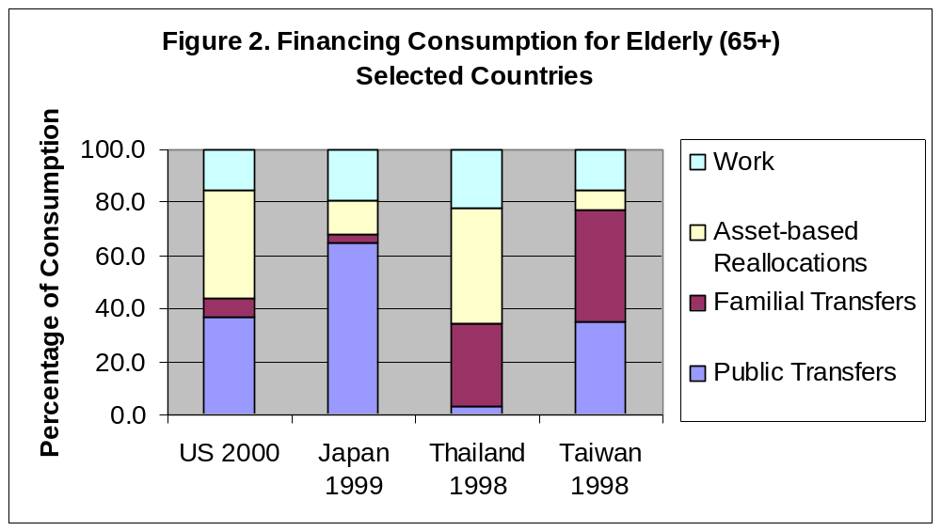

Source: Amonthep (mimeo); Mason et al (2006); Ogawa and Matsukura (forthcoming).

Figure 3. Life Cycle Savings
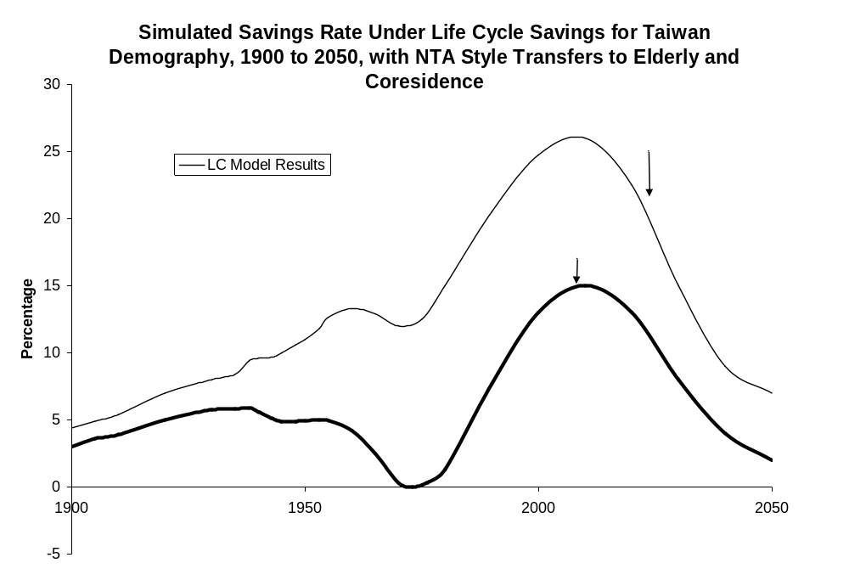

Figure 4. Capital Income Ratio
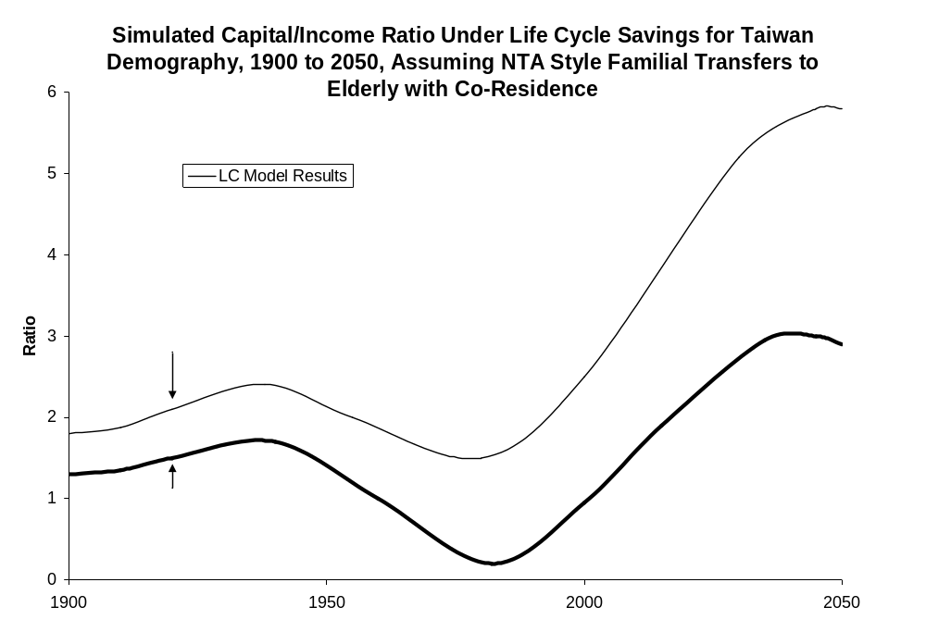
Figure 5.
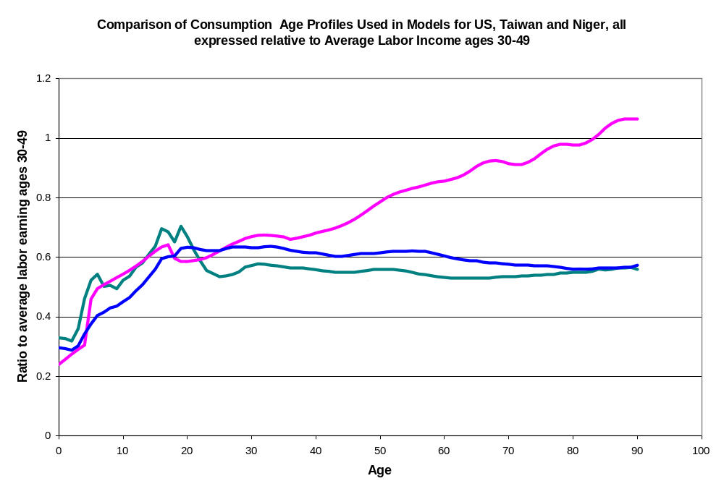

Figure 6. The ratio of capital to labor income that results from maintaining the age shape of cross-sectional consumption and the relative importance of transfers and assets in providing for retirement, with specified transfer shares of 35% and 65%. Based on Taiwan demography.

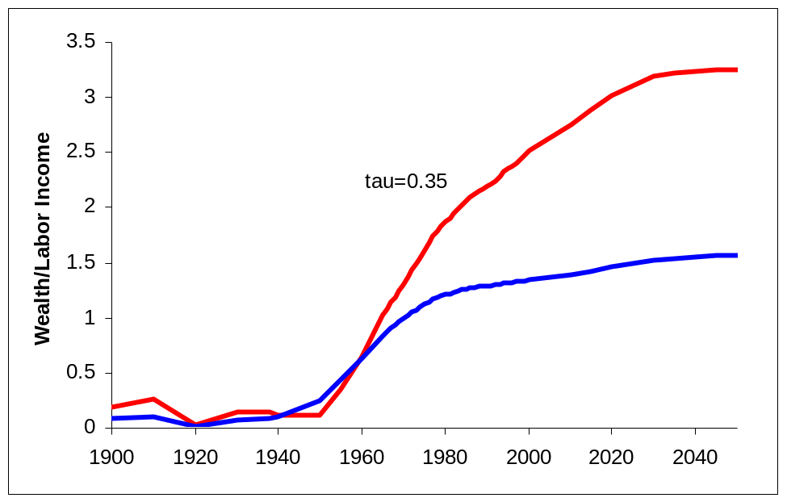

Figure 7. The savings rate that results from maintaining the age shape of cross-sectional consumption and the relative importance of transfers and assets in providing for retirement, with different transfer shares of 35% and 65%.
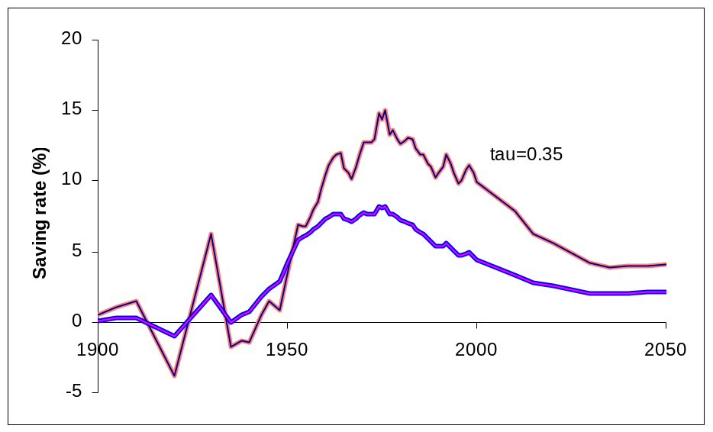

Figure 8. Projected Support Ratios for Taiwan, Niger and US.
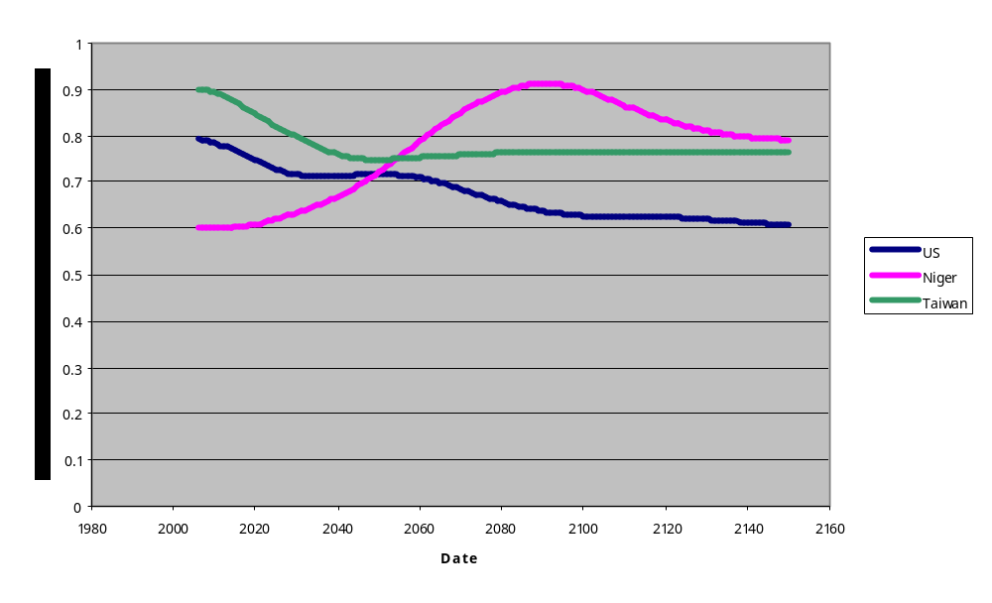
Notes: For US and Taiwan, based on consumption and labor income age profiles observed around 2000. For Niger, consumption and labor income profiles are the average across four Third World countries in East Asian and Latin America.

Figure 9. Social Planner’s Optimal Net Saving Rates for the US, Taiwan and Niger, based on projected demography.

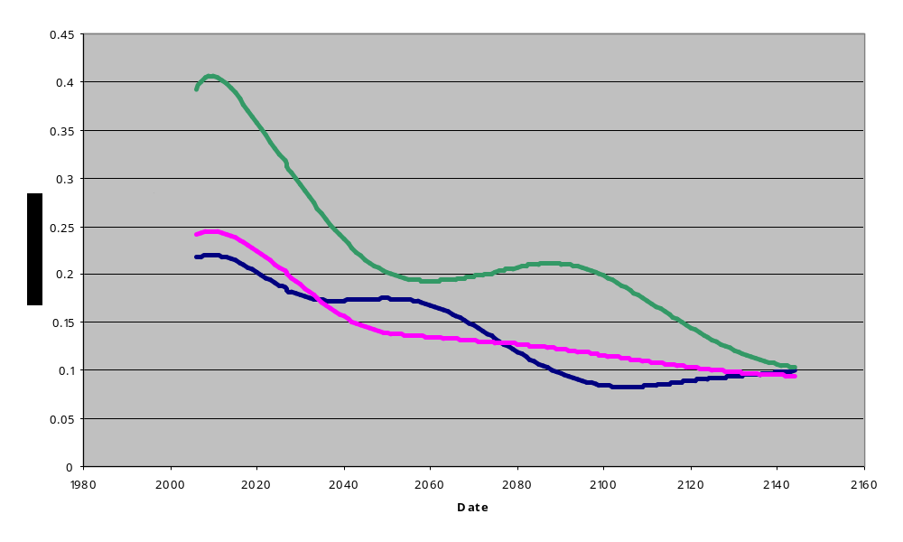
Note: Based on a Ramsey-Cass-Koopmans model with a constant returns to scale Cobb-Douglas production function with capital and labor coefficients of 1/3 and 2/3, depreciation at .03 per year, technological progress at .015, a rate of social time preference of .01, and an elasticity of intertemporal substitution of .4. The social welfare function maximizes the discounted value of consumption per equivalent adult consumer, unweighted by population size.
Figure 10: The Aggregate Demand for Wealth and the Social Planners Choice of Capital/Labor ratio and Transfer Wealth, for Niger, Taiwan and the US
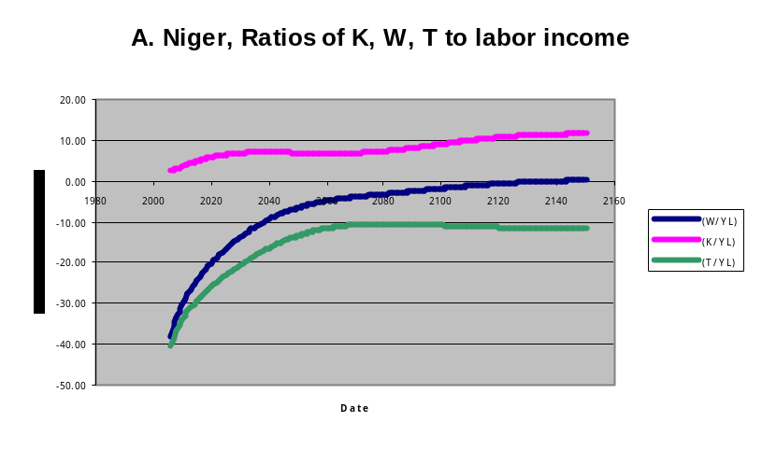
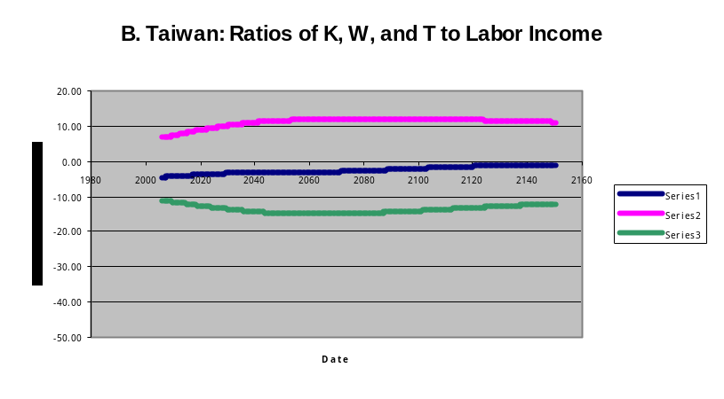
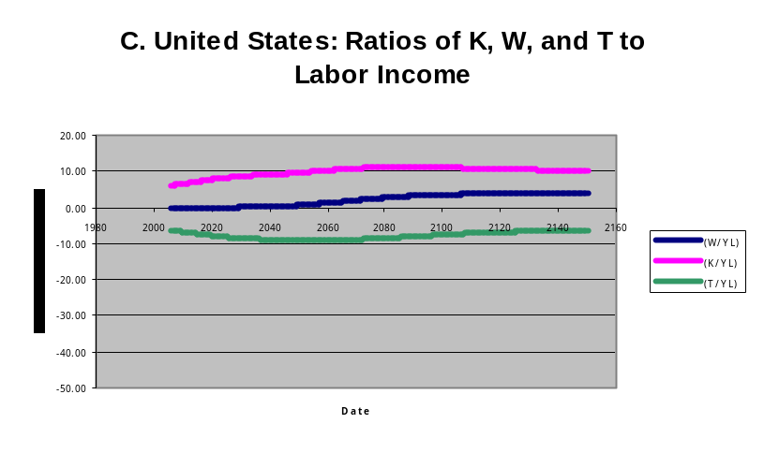
See note to Figure 8.
Figure 11. Consumption per Effective Consumer relative to 2006: Social Planner for US, Niger and Taiwan, 2006 to 2150
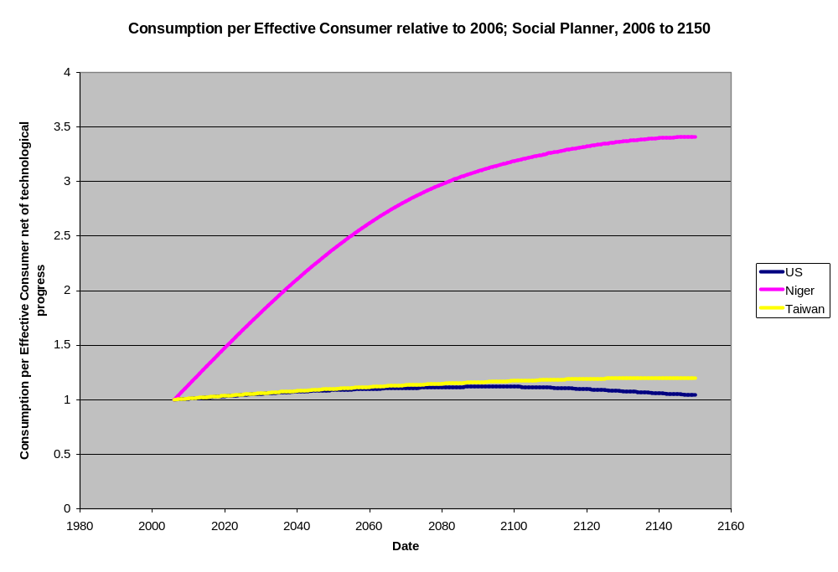
See note to Figure 8.

Figure 12. Comparison of Simulated Savings Rates for Taiwan Under Different Model Assumptions: Life Cycle savings with and without familial transfers to elderly; Persistent Patterns; and the Social Planner’s optimal path, plus data on actual savings measures.
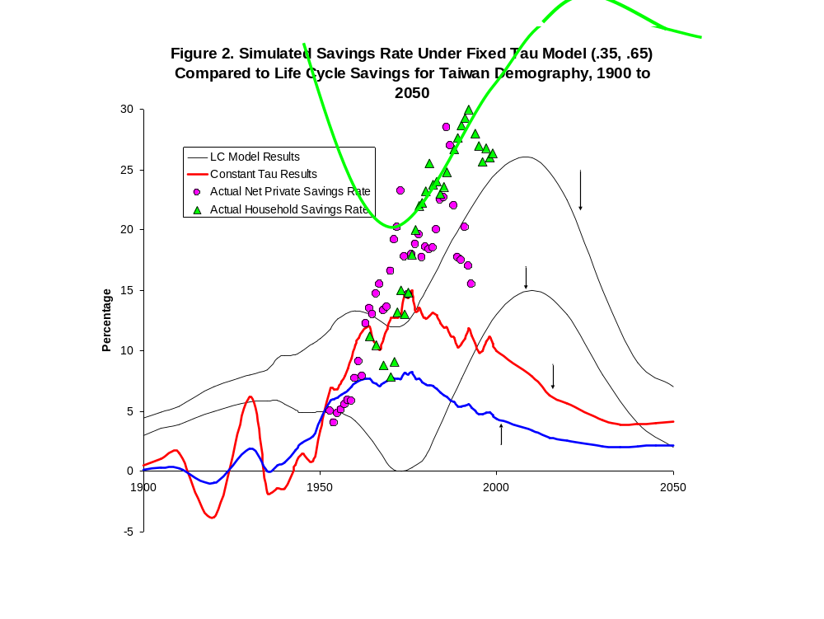

Note:

Note: Measures of savings differ. The “actual” data points are for net private and net household savings, and thus exclude government savings.

Figure 13. Comparison of Simulated Capital/Income ratios for Taiwan under Different Model Assumptions: Life Cycle savings with and without familial transfers to elderly; Persistent Patterns; and the Social Planner’s optimal path, plus data on actual related measures.

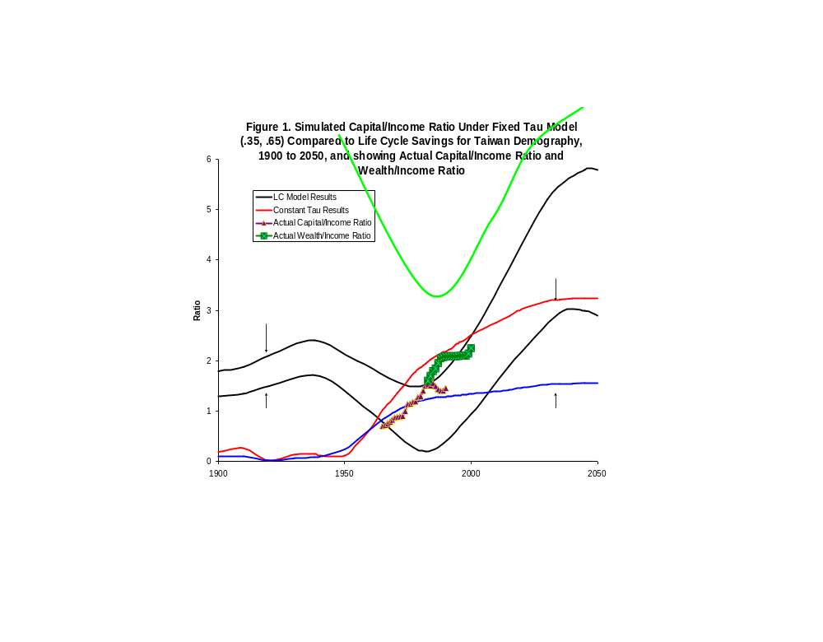

Note: Measures of capital income ratios differ. The “actual” data points are for both capital and wealth, and are to all income. Some of the simulated ratios are to labor income.

It is possible to keep this general setup but to decentralize the planning to heads of dynastic families as was done in Becker-Barro (1988). The role of altruism in determining the outcome is then more transparent. See also Calvo and Obstfeld (19**).
We should mention that if instead the social welfare function weights future values of γ(t) by population size at time t then the results are quite different, and in particular there is no capital dilution with more rapid population growth nor increase in capital intensity with slower population growth. In this and some other respects we differ from Cutler et al (1990.)

