Airport Transfer

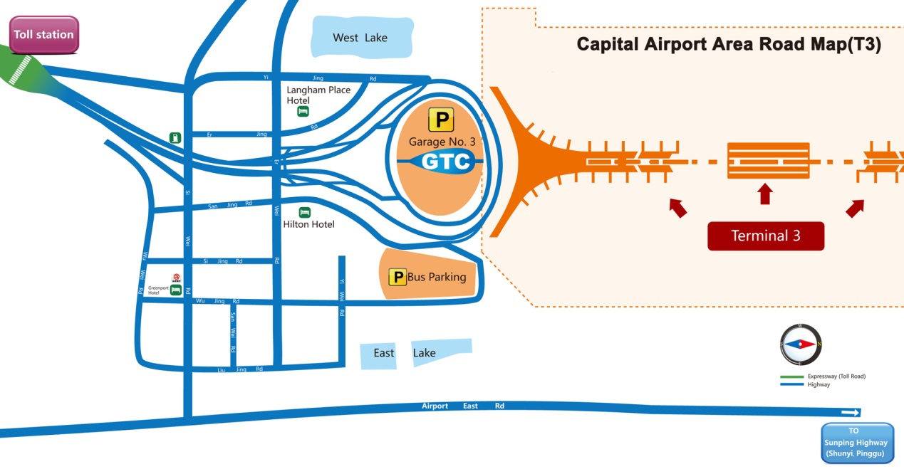

**Taxi**

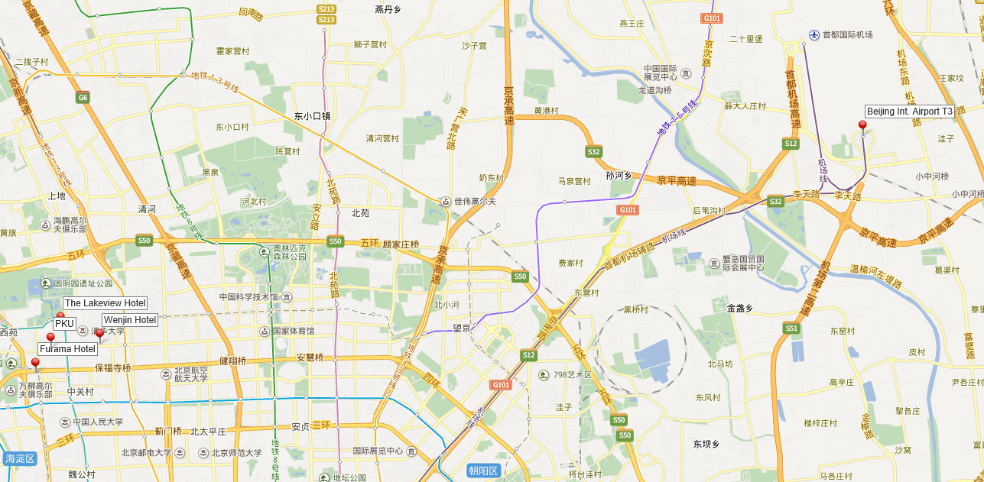

There are designated taxi areas at the airport where passengers can wait for their taxi ride.

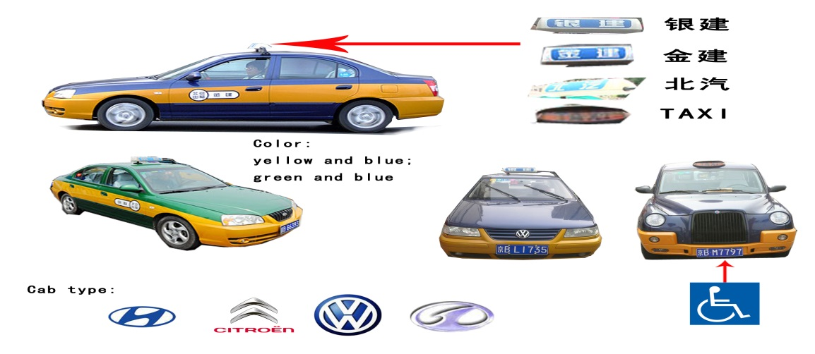Below are pictures on the various types of reliable taxis in Beijing:

**Metro**

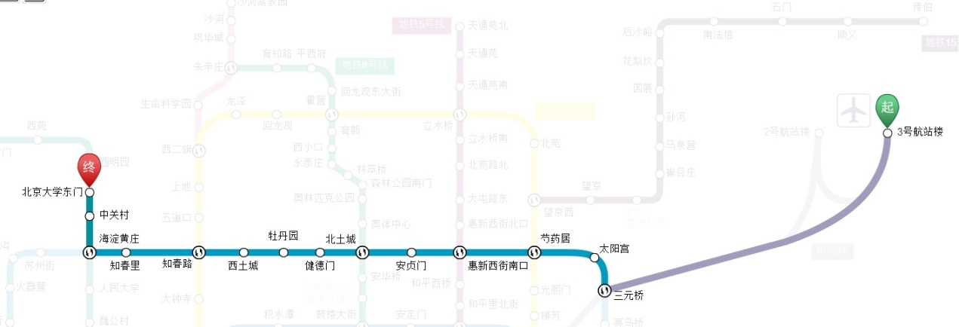

1. You can board the Airport Express following instructions in the Airport.
2. Transfer at metro station SANYUANQIAO（三元桥） to Line 10.
3. Transfer at metro station HAIDIANHUANGZHUANG（海淀黄庄）to Line 4.
4. Exit at metro station East Gate of Peking University （北京大学东门）.

**Airport shuttle bus**

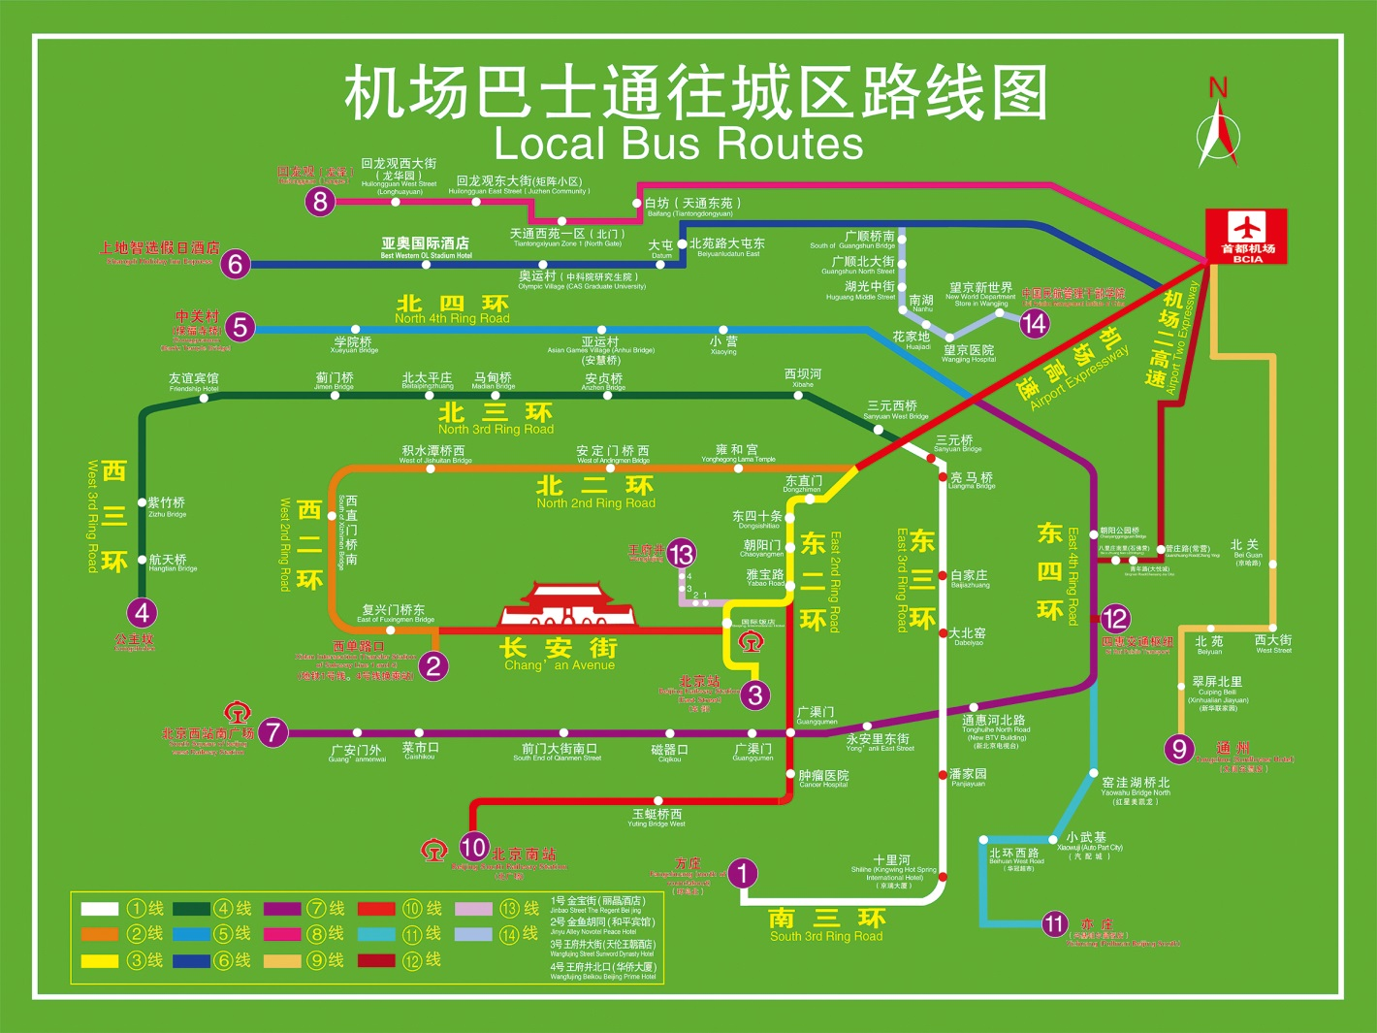

Beijing China International Airport to ZHONGGUANCUN (line5)

Time 6:50~ 24:00, every 20 minutes.

**MEETING VENUE**

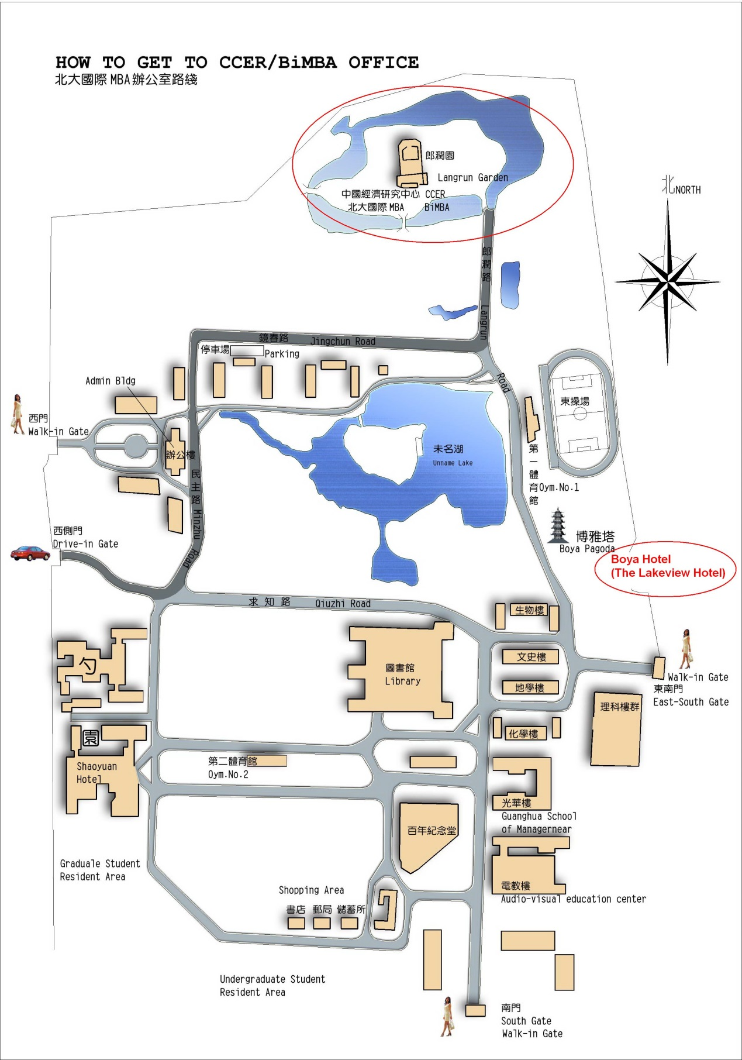

For conference participants who are lodging outside of PKU, please have the taxi take you to the Northeast gate of PKU, since taxis are not allowed into PKU campus. On the first day you enter through the gate, you will be asked to register by completing an information form and you must show your passport in order to get access to the Langrun Garden. Once you enter past the Northeast gate, you will need to walk to Langrun Garden according to the map (approximately 5 minute walk from the gate to the conference venue)

**Hotel**



**A Langrun Garden(CCER)**

**B Lake View Hotel**

**F FX Hotel （zhongguancun）**



**A Wenjin Hotel**

**Map of Beijing**

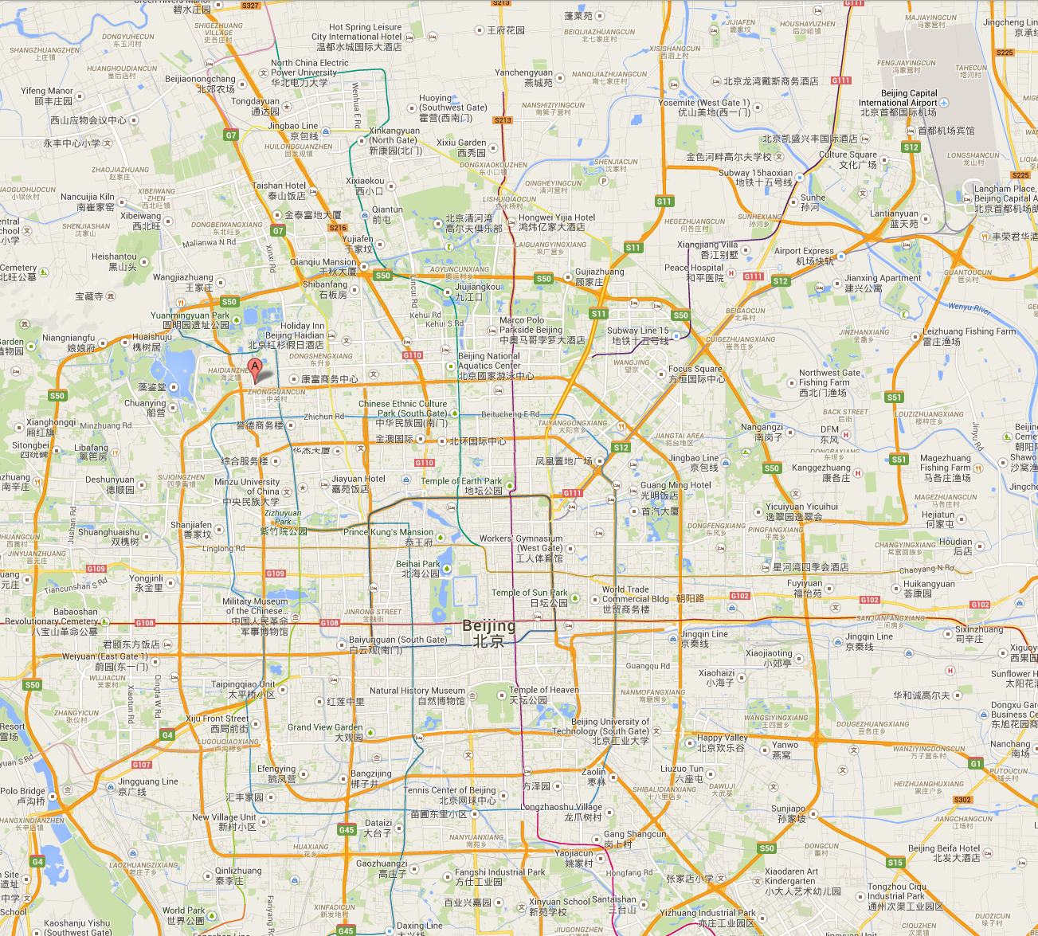

**Subway Map**

