Dr Agnieszka Chlon-Dominczak is an Assistant Professor at Warsaw School of Economics and Educational Research Institute in Warsaw.

In 2008-2009 she was a Deputy Minister of Labour and Social Policy. Previously she headed Department of Economic Analyses and Forecasting in the same Ministry. Her responsibilities included, among others the oversight of the social insurance system. She was the vice president of Social Protection Committee of the European Council and chair of the Working Party on Social Policy of Employment, Labour and Social Affairs Committee of the OECD.

She was a member of the pension reform team in Poland that prepared the changes implemented in 1999. As a consultant, she participated in numerous activities related to pension reforms in the region of Central and Eastern Europe, cooperating with the World Bank, ILO and the OECD. She participated in numerous conferences on pension issues, where she shared the experience of the Polish pension reform with other participants. She is an author and co-author of many publications in the field of pensions and labour markets. Her research interest include: demography, pension systems, labour markets, social policy, health and education.

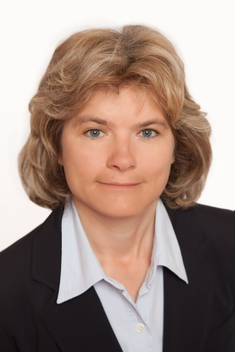Alexia Fürnkranz-Prskawetz is Professor of Mathematical Economics at the Vienna University of Technology (since 2008) and deputy director at the Vienna Institute of Demography, Austrian Academy of Sciences (since 2003). Since July 2013 she is also research associate at the International Institute of Applied Systems Analysis, Laxenburg, Austria. After her study of Technical Mathematics and attendance of a postgraduate study as Fulbright scholarship holder at the University of Chicago in Economics she joined the Institute of Demography at the Austrian Academy of Sciences as research assistant from 1992 to 1997. From 1997 to 1998 she obtained a Max Kade scholarship and spent one year as a postdoctorate at the Demography Department of the University of California, Berkley. In 1998 she received the Venia for “Population Economics and Applied Econometrics” at the Vienna University of Technology. From October 1998 through October 2003 she was head of an independent research group on “Population, Economy and Environment” at the Max Planck Institute for Demography, Rostock. She is member of different demographic and economic societies (American Economic Association, Population Association of America, etc.) and referee of several international journals (Demographic Research, Journal of Economic Growth, etc.). In 2007she was elected as corresponding and in 2011 as full member of the Austrian Academy of Sciences. Her main areas of research are in the economic consequences of population and individual ageing, long run economic growth, fertility dynamics and female labor force participation and agent based computational demography. During the last years she also won several research proposals (FP7, WWTF, FWF) that aim to investigate the complex interrelationship between the ageing process and economic performance. Most recently she has been awarded a collaborative research proposal by the EU where she acts as the coordinator of 9 partners. The aim of the project is to investigate the role of ageing on explaining and projecting trends in public finances based on the methodology of National Transfer Accounts (NTA). Alexia Fürnkranz-Prskawetz has been actively involved to set up a European network on the development of NTA.

Alimm Jihen is a principal assistant secertary of Ministry of Finance Malaysia.

Amy Tsui is professor of Johns Hopkins Bloomberg School of Public Health.

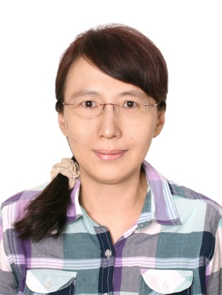An-Chi Tung, is an associate research fellow at Institute of Economics, Academia Sinica (IEAS) in Taipei, Taiwan.

IEAS is a public research institute, but not a government think-tank. As a researcher, she is quite lucky to be free to choose whatever topic she is interested in.

She is a development economist, with a special focus on East Asia. She used to work mainly on industrial policies, and she still do, as she has always been curious about why some countries and firms develop better and more smoothly than the others. She is fortunate to have a great mentor and long-term collaborator in this field, who has taught her how to read the world with an economist’s mind.

She began to develop a new field in population economics after joining the NTA project a decade ago. Through working with Ron, Andy and the entire NTA team, she has not only learned economic demography, but also macroeconomics, public finance, social insurance system, family economics and many other areas. Again, she feels very lucky to have joined this research group, which opened her eyes to how a person and a family behave in economics.She is thankful that these studies make her understand the outside world as well as the inner self much better.

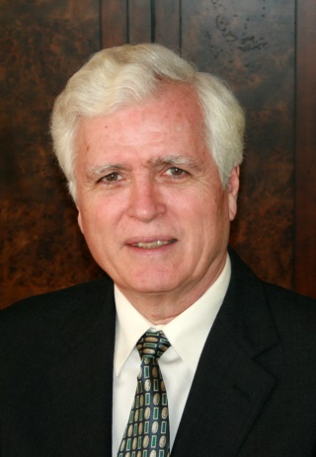Andrew Mason is Professor of Economics, University of Hawaii at Manoa and Senior Fellow at the East-West Center, Honolulu, Hawaii. He is a member of the Center for the Economics and Demography of Aging (CEDA) at the University of California, Berkeley. Mason and Ron Lee co-direct the National Transfer Accounts

(www.ntaccounts.org) network, an international project involving researchers from over forty countries developing a comprehensive approach to measuring and studying changes in population age structure and the generational economy in both rich and poor countries. Their recent book, Population Aging and the Generational Economy: A Global Perspective, was a finalist for the Paul A. Samuelson Award and selected as an Outstanding Academic Publication by Choice Magazine. Mason’s current research is concerned with the economic lifecycle, intergenerational issues, and the effects of population change on development, economic growth, and public and private transfer systems. He earned a Ph.D. in economics from the University of Michigan.

Arjan Bruil studied general economics in the University of Groningen, and completed his studies in 2005. After that he worked in consultancy for a year, and in market research for another.

Currently he is working as a statistical researcher at Statistics Netherlands, in the Sector Accounts department. He has worked in this role for the past two years now, before he worked on the development of new statistics in labour accounts, for the illegal economy, and local taxes. The Sector Accounts are part of the National Accounts, he is responsible for the households sector and the non-profit institutions serving households.

Also, at the beginning of this year, he started a Ph.D. research at the University of Tilburg. This followed upon work done at Statistics Netherlands, where they came upon the NTA project. The subject of the Ph.D. will be the development of the NTA framework for the Netherlands.

Bakutuvwidi Makani is a researcher and teacher of Statistics College Kinshaka in Democratic public of Congo.

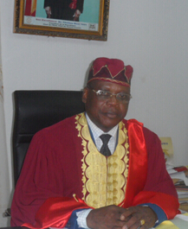

From the Republic of Benin, Professor Barthélémy BIAO is since February 2012 Vice-Chancellor of the University of Parakou.

As resource person, Prof. BIAO collaborated with several regional and international institutions, including United Nations Economic Commission for Africa (ECA), United Nations Development Programm (UNDP), International Labour Organization (ILO), the Central Bank of West Africa States (BCEAO), Organization of African Unity / African Union, the World Trade Organization (WTO), the United Nations Conference on Trade and Development (UNCTAD), the Economic Community of African States (ECOWAS), Africa Capacity Building Foundation (ACBF).

Professor BIAO, for his teachings and research activities focus on International Economics (Trade and Finance), Economic and Monetary Integration, Macroeconomics and Economic Policy.He is Head of the Research Unit in Economics and Management of University of Parakou, Head of the Benin Team on "National Transfer Account" (NTA).

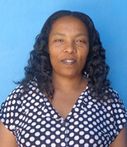 Berhane Assefa Merdassa is a health officer graduated from Jimma University in 2003 and Masters graduate in Public Health (MPH) from Addis Ababa University in 2012 .Before she joined the university study, she had been working as registered Nurse with different levels of responsibility in Governmental Health institutions for nine years. Following her post basic study, she has been working for the last three years as Head of District Health office and also for the last seven years working with different levels of responsibility in Federal Ministry of Health Ethiopia till now.



Chanmi Yang is a Researcher in Population Policy Research Department at Korea Institute for Health and Social Affairs (KIHASA) in Seoul, Korea. She does policy-oriented social welfare research for the elderly and long-term care system.

She received Bachelor’s Degree and Master's Degree in Social Welfare from Yonsei University in Seoul.

In KIHASA, she has been involved in studies of Health and Long Term Care of the Unhealthy Elderly and Leisure and Lifelong Education in Healthy Elderly.

This year, she and Dr. Hwang are researching on the Sharing Status of Public and Private Transfer through National Transfer Accounts (NTA), and they expect to review the fact macroscopically for the old-age income security.

Concepció Patxot Cardoner is an Assoc-Professor of Universitat de Barcelona in Spain.

Daniel Sakyi is a lecturer of Kwame Nkrumah University of Science And Technology in Ghana.

David McCarthy is a visiting research fellow of NIESR in UK.



Dieynaba SAKHO holds a Master in Economics of human resources (education, health and work), and she worked for over 10 years at the Center of Studies of Political for Development in the Ministry of Economy, Finance and Planning. The Center provides a framework for studies, analyzes, research and training to further strengthen the capacity to develop and manage social and economic policies of socio-economic actors Senegal. So she rises in research on issues related to employment, education, health, gender and all social issues.

  Her recent accession to the NTA network in May 2014 allowed her to contribute to the planning of "policy brief" on the counting women's work in Senegal and the Center is now the structure of the administration that is in partnership with the CREFAT to work on the accounts of transfers.

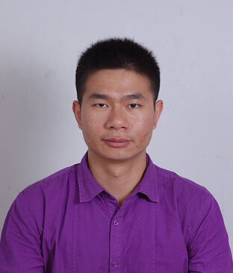

Ding Li is an assistant professor of The School of Sociology and Population studies at Renmin University of China. He graduated from Peking University at 2011 with doctor’s degree and has deep research on social stratification and mobility of Chinese peasants. He is well trained with demography theory and analysis skills. Recently he focuses his research on population aging and social change in China.

Edgard Rodriguez is a Sr. Program Specialist (Economist) of International Development Research Centre in Canada.

Eduardo Klien is a Regional Director of Helpage International in Thailand.

Elisenda Rentería Pérez is a Post-Doctor of University of Barcelona in Spain.

 Estela Rivero holds a Master’s in Demography from El Colegio de México (COLMEX) and a Ph.D. in Demography and Public Affairs, from Princeton University. She has extensive experience designing and implementing research projects. Currently she is an Associate I at the Population Council office in Mexico, where she is responsible of the development and supervision of gender, youth and reproductive health projects. Prior to joining the Council, Estela was a Professor-Researcher for the Center for Demographic, Urban and Environmental Studies at El Colegio de México (COLMEX) where she led or significantly contributed to qualitative and quantitative research focusing on gender, aging, health, and migration, amongst other topics.

Eugenia Amporfu is the head of Department, Economics of Kwame Nkrumah University of Science And Technology in Ghana.

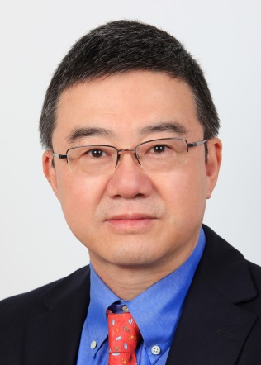Wang Feng is professor of sociology and demography at Fudan University and professor of sociology at the University of California, Irvine. He is also a non-resident senior fellow of the Brookings Institution. Wang Feng received his BA degree in Economics from Hebei University in China in 1982, and MA. and Ph.D. degrees in sociology from the University of Michigan in 1984 and 1987 respectively.

Professor Wang has served in numerous professional roles in addition to his academic work. He was a member of the scientific panels of the International Union for the Scientific Studies of Population (1991-1994, 2010-2013), Global Agenda Council on Population Growth of the World Economic Forum (2009-2011), and Expert Group for United Nations Population Division. Between 2010 and 2013, Wang Feng served as the director of the Brookings-Tsinghua Center for Public Policy in Beijing. Prior to that he was the chair of the Department of Sociology at the University of California, Irvine (2007-2010).

Germano Mwabu is a professor of University of Nairobi and School of Economics in Kenya.

Gretchen Donehower works at the University of California at Berkeley for the Center for the Economics and Demography of Aging ([www.ceda.berkeley.edu](http://www.ceda.berkeley.edu/)).  She has worked on the National Transfer Accounts Project for ten years as a member of the US country team.  She also assists with the global NTA group, developing NTA methodology, coordinating global project activities, and reviewing NTA estimates and research. She is currently the project director for Counting Women's Work ([www.countingwomenswork.org](http://www.countingwomenswork.org/)), a project within the NTA research network to estimate NTA age profiles by gender, and add accounts to NTA that measure the value of time spent on unpaid care and housework.  Dr. Donehower has a BA in Economics and Mathematics from Yale University, an MA in Statistics from UC Berkeley, and a PhD in Demography from UC Berkeley.  She has worked previously as a statistician in the technology industry, an investment analyst, and a US Peace Corps volunteer teaching mathematics in rural Nepal.

Guadalupe SOUTO-Nieves is an Assoc-Professor of Universitat Autonoma Barcelona in Spain.

 Gustav Öberg is employed as a research assistant and he works specifically with data creation, writing software, agent based modelling and data analysis.

Together with Kirk Scott and Nichoas Adjei he produces NTA- and NTTA-data for Sweden together at the Institute for Future Studies.

The Institute for Future Studies does work relating to long-term prognosis as well as promotes a future-oriented perspective in Swedish research. At the institute he provide support in areas such as economics, demography and he also compiles historical economic data.

Right now he is working with Nicholas Adjei and Kirk Scott on an attempt to quantify the economic value of household production for Sweden.

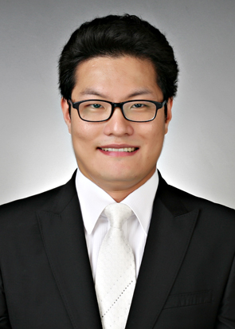Hyun Kyung Kim is from the Republic of Korea. He is now working as a Deputy Director of the Statistical Research Institute in Statistics Korea. His major area of research is in management engineering, with a special interest in the field of finance statistics. Presently, He is doing research pertaining to the development of the National Transfer Accounts for the Republic of Korea.

As a member of the Statistical Research Institute, he is currently planning and coordinating public finance statistics to provide various economic statistics. In particular, Statistics Korea and the Statistical Research Institute keenly feel the necessity of developing the National Transfer Accounts and the related economic statistics in the Republic of Korea. In this connection, he is now carrying out the research on the National Transfer Accounts, and have been doing so for the past two years.

Jan W. van Tongeren was an Adviser and Consultant of Ex-Chief National Accounts

at UN Statistical Division in Netherlands. Now he is retired.

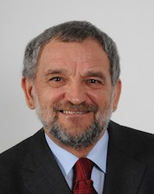

Prof. Janez Malacic, Ph. D. graduated at the Faculty of Arts (1973) and at the Faculty of Economics (1974) of the Ljubljana University. He finished Ph. D. thesis at the Faculty of Economics, University of Ljubljana (1983). The title of the thesis is “The Elements of the Population and Labour Force Reproduction Theories”.

Prof. Malacic has been employed since the graduation at the Faculty of Economics of the University of Ljubljana. He has spent his career in the positions from assistant to full professor. The subjects thought by prof. Malacic have been Economic statistics, Labour economics, Demography, Introduction to the economics and Introduction to the national economy. Prof. Malacic has collaborated with different institutions, from the government to the international organizations such as European Commission and United Nations. In 1994, he participated at the UN Conference on Population and Development in Cairo. He is a member of different Slovenian and international professional societies where he served as a president of the Slovenian Statistical Society (1985-87) and the Union of the Yugoslav Statistical Societies (1986-88). For two years he also served as a vice dean of the Faculty of Economics (1997-1999).

The fields of interest of prof. Malacic are migration studies, demography, population and labour force reproduction, labour market, population and employment policies, human capital, education, economic statistics, regional development. Prof. Malacic has done some research at the National institute of Demography, Paris, 1993 (3 months), University of Pittsburgh, 1990 (2 months), Case Western University, Cleveland, 1995 (1 month). He also participated at many Slovenian and international professional conferences on variety of topics. The recent research work of prof. Malacic has covered the fields of the index of creativity, immigration in Slovenia and employment of foreigners especially from Balkan countries, the role of migration in modern demographic regime etc.

Jariah Masud is a Research Fellow of Universiti Purta Malaysia.

Javier Olivera Angulo is a Research Associate of University of Luxembourg.

Joonkyung Ha is a Professor of south Korea.

Jordi Lopez-sintas is an Assoc-Professor of Universitat Autonoma Barcelona in Spain.

Jose Rimon is a Director/ Senior Scientist of Johns Hopkins Bloomberg School of Public Health in US.

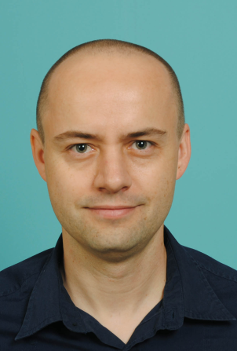Joze Sambt is an assistant professor for the field of Economics at the University of Ljubljana, Faculty of Economics. He’s giving lectures on topics like labour economics, demography, statistical methodology and research methodology.

The main topic of his research is the population aging, related to the transfers across age groups and long-term sustainability of the public system. In his Master thesis he constructed Generational Accounts (GA) for Slovenia and in his PhD he applied National Transfer Accounts (NTA) methodology on Slovenian case. He is currently involved in ‘Seventh Framework Programme’ project of European Union with acronym ‘AGENTA’. The project deals with application of NTA method for explaining and projecting trends in public finances.

He has been working in several projects developing microsimulation pension models. By using microsimulation and other models he is involved in estimating impacts of the pension reform proposals and long term sustainability of the public sector in general. The results are often used by the by Slovenian government. Using different models he provides calculations for Slovenian Ageing Working Group (body of the European Commission) for preparing projections on long-term sustainability of the public system.He’s a member of Slovenian team for population projections periodically prepared together with Eurostat.

He closely collaborates with Statistical office of the Republic of Slovenia – for example, he’s a co-author of the latest complete life table for the population of Slovenia. In the past he has been collaborated with various international organizations like International Labour Organization (ILO), OECD and TAIEX (European Commission). He’s a member of EAPS (European Association for Population Studies), IUSSP (International Union for the Scientific Study in Population) and Statistical Society of Slovenia.

Shen Ke is currently assistant professor at Demographic Research Institute of Fudan University, which she joined in September 2011. Shen Ke received a PhD in economics from Peking University. Her major research fields include health economics, population aging and population polices. She has published papers in academic journals such as Demographic Research and Social Science & Medicine.

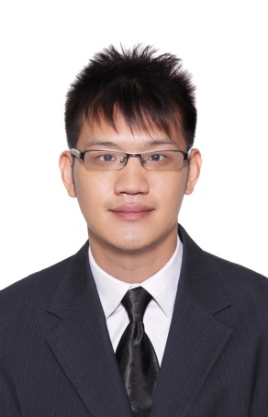Mr Lim Tien Chai Kenny joined the public service in 2014. He is currently an analyst of the Policy and Planning Directorate, National Population and Talent Division.

In this role, he is involved in the formulation and review of overarching policy issues related to population and demography, with a view towards a sustainable population for Singapore. His key research interests include looking at the economic outcomes of demographic changes. More particularly, he likes to investigate the effects of demographic changes in the labor market, the effects of increased flow of international migration on native worker’s labor outcomes. He is also keen in learning modern analytical tools like geospatial regressions, geospatial mapping, K-clustering and other tools to help achieve his research goals.

Mr Kenny is an Economics graduate from the National University of Singapore and his interests lies in modern marcoeconomic concepts and international trade. His thesis topic was on the effects of territorial disputes; the Sino-Japan disputes, on international trade. He likes to read current news and to find out naturally occurring events to justify randomness to study effects of a shock as a naturally occurring experiment.

My Kenny hopes to be able to contribute positively to the public sector and hopes to know more colleagues of common research interests as him as well.



Holds a PhD in Economics, Latif Dramani worked long at the National Agency of Statistics and Demography (ANSD) of Senegal. Currently, he is professor of Economics and Statistics at the University of Thies and Coordinator of the Centre for Research in Applied Economics and Finance of Thies (CREFAT).

It also coordinates the research network on Generational transfers Accounts (NTA) in Francophone Africa.

Dr Dramani also teaches at other universities in Africa and is associated with universities and research centers worldwide in international research projects.

Lili Vargha is a research fellow at the Hungarian Demographic Research Institute and a PhD candidate in Demography at the Doctoral School of Demography and Sociology (Pécs, Hungary). She studied History and Sociology at Eötvös Loránd University (Budapest, Hungary), Vrije Universiteit (Amsterdam, Netherlands) and she holds an MA in Sociology. She joined the global research network of NTA (National Transfer Accounts) in 2011 and recently she is involved in the European AGENTA project (Ageing Europe: An application of National Transfer Accounts (NTA) for explaining and projecting trends in public finances). Previously she participated in SHARE project (Survey of Health, Ageing and Retirement in Europe) and in the Hungarian Generational Accounting project.



Marina Zannella is a Post-Doc Scholar Researcher at the Vienna Institute of Demography (Austria) since February 2014. In 2012, she received a doctorate in demography at the University of Rome “Sapienza”, Italy. In 2008 Dr. Zannella joined the National Transfer Accounts and, as a part of her doctoral dissertation, she developed NTA and NTTA estimates for Italy.

Dr. Zannella main areas of interest are: macroeconomic consequences of population ageing, intergenerational public and private transfers, life-cycle gender differences in time use.

Her current research focuses on the comparative analysis of welfare arrangements within the family and their implications for the gender division of market and non-market work and leisure inequality.

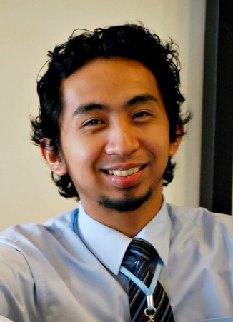

Michael R.M. Abrigo is Research Specialist at the Philippine Institute for Development Studies (PIDS), and graduate student at the University of Hawai`i (UH) at Manoa. As Research Specialist at PIDS, he has been involved on research in education, labor mobility, trade, and spatial issues. Michael received his BA in Development Studies (magna cum laude) and Master of Statistics degrees from the University of the Philippines. He is currently a PhD Economics student and Graduate Research Assistant at UH.

Miguel Sánchez-Romero obtained his Ph.D. in Economics from Universidad Autónoma de Madrid (Spain) in December 2006. He was a Fulbright postdoctoral researcher under the supervision of Prof. Dr. Ronald D. Lee at the Center on Economics and Demography of Ageing (CEDA) at the University of California, Berkeley (2008-2010). Before joining the Wittgenstein Centre (IIASA, VID/ÖAW and WU), Vienna Institute of Demography/Austrian Academy of Science in 2014, he worked from 2010 to 2014 as scientific researcher at the Max Planck Institute for Demographic Research (MPIDR) in Rostock, Germany.

Miguel’s main research interest deals with the effect of the interaction between demographic changes and intergenerational transfers on economic growth. He is author of several articles published in peer-reviewed journals such as the Journal of Economic Theory, Journal of Population Economics, and Labour Economics, among others. To perform his analysis, he develops theoretical models as well as computable general equilibrium models that incorporate realistic demography and public and private transfers based on National Transfer Accounts (NTA) data.

Moses Muriithi is a Senior Lecturer of University of Nairobi, School of Economics in Kenya.

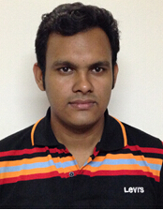 Muhammad Moshiur Rahman is currently working as a Research Associate at South Asian Network on Economic Modeling (SANEM) in Bangladesh. He has been graduated in Economics from the University of Dhaka in 2011. He has started his career as a Research Associate at SANEM since 2012. He worked in several research projects i.e. “Dynamic Stochastic General Equilibrium Model” (DSGE) for Bangladesh Bank (Central Bank of Bangladesh); paper named “Is an agriculture-focused development strategy the right choice for Bangladesh? An empirical assessment of farm-nonfarm growth linkages” to analyze the intuition of sustainable macroeconomic growth with agricultural and industrial sector; “Willingness to Pay for Electricity- for The People of Dhaka City” for Asian Development Bank (ADB); “Surveys for the updating of the Input-Output table in Bangladesh” to update the I-O table; “ Willingness to Pay for Solar Irrigation for Rain Fed Cropping” also for Asian Development Bank (ADB); constructed ”SAM ( Social Accounting Matrix)” of Sri Lanka of year 2012 for UNESCAP and so on. He is working in the projects i.e. “RCT (Randomized Controlled Trial)” an experimental research; “Changing labour markets in Bangladesh: Understanding dynamics in relation to economic growth and poverty” collaborated with International Development Research Centre (IDRC). He had participated in several workshop/training programs in Bangladesh and abroad. He had participated the workshop/training program titled ESCAP/WTO Eighth ARTNeT Capacity Building Workshop for Trade Research “Recent Advances in the Field of Trade Theory and Policy Analysis Using Micro‐Level Data” ; “Fifth South Asian Training Programme on CGE Modelling”; “Capacity Building on Economic Modeling for National Strategies for Sustainable Development” and “ The Counting Women's Work -Asia Teams Workshop.” which were held in Thailand, Nepal, Australia and United States of America respectively. He is interested in the field of in Microeconomics; Macroeconomics; Development Economics with Labour and Population Economics.

 Nicole Mun Sim Lai is a Population Affairs Officer at the United Nation Population Division in New York. She holds a Ph.D. in Economics from University of Hawaii at Manoa. Before joining the United Nations, she was teaching economics as an Assistant Professor at California State University at Bakersfield, and teaching finance as a Senior Lecturer at Monash Unversity Sunway Campus. Her research and current work focuses on intergenerational transfers, population ageing, and population policy and development. She engaged actively in the National Transfer Account project since its establishment. She enjoys listening to music and picking up new languages.

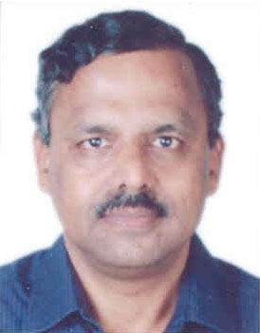

Dr M.R. Narayana is Professor of Economics in the Centre for Economic Studies and Policy at the Institute for Social and Economic Change (Bangalore, India). He earned the Ph.D from the University of Tsukuba in Japan. He has over two decades of teaching and research experience in economics in India and abroad including a recent Visiting Professorship at the Faculty of Economics in University of Tokyo (Japan) and University of Victoria (Canada). His current research topics include the construction and application of National Transfer Accounts and Generational Accounting for India for economic analyses of age structure transition on economic growth, fiscal impacts of population ageing, fiscal sustainability of expected reforms on universal old age pensions and universal health coverage policies, and inter-generational allocation of resources and equity in India. His professional background, recent research publications and conference presentations, recently completed and on-going research projects and academic outreach activities are available at: http://www.isec.ac.in/mrn.htm . He may be contacted by email at: mrnarayana@yahoo.com or mrn@isec.ac.in

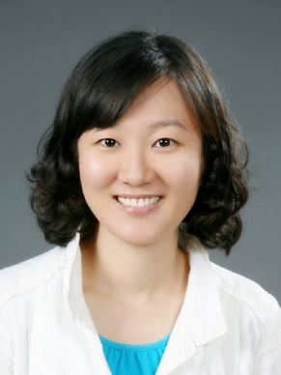

Namhui Hwang is an Associate Research Fellow in Population Policy Research Department at Korea Institute for Health and Social Affairs (KIHASA) in Seoul, Korea. She does policy-oriented socio-economic research in the field of ‘welfare for the aged’ and ‘population aging’ as well as ‘public finance’.

She received my B.D. in business administration from Sung-Kyun-Kwan University in Seoul, and M.D. and Ph.D. in economics from the same university.

She introduced National Time Transfer Accounts (NTTA) into the Korean academic research field with the doctorate thesis in 2012, and it was followed by some research papers on the subjects of National Transfer Accounts (NTA), subjective equivalence index, social participation for the aged, the lives of the pre-elderly adults, and labor market regarding youth and temporary worker.

Her current research interests includesintergenerational transfer, old-age income support, income distribution, social participation for the aged, and unpaid household work.

Nazli Sahanogullari is a Research Assistant of Istanbul Bilgi University in Turkey.

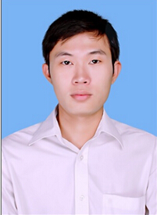

NGUYEN Thanh Tuan is a researcher at the Institute of Labour Science and Social Affairs, after graduation he worked here in 2011. He graduated in Economic Mathematics, National Economics University in 2011, currently he’s learning this degree on economic cybernetics, National Economics University. His main tasks:

• Conduct research in the field of forecast and evaluate the impact of Labour and Social Affairs

• Advising Support, consulting in the field of information, strategic analysis and forecasting (field labour, employment and labour market)

• Manage active field forecast labor, employment and labour market

• Develop, implement and monitor strategies, projects, field research information, strategic analysis and forecasting (field labour, employment and labour market)

• Carry out of synthetic, policy evaluation, database systems field information, strategic analysis and forecasting

• Participate in the training of econometric

• Research project proposal for network planning compulsory detoxification

• Study participants forecast the impact of economic fluctuations on the structure of the labor market

• Participate in research issues in social labor process restructuring the economy.



Nguyen Van Trang is from Vietnam. She is currently working as a researcher at the Institute of Labour Science and Social Affairs (ILSSA) and she truly enjoys this position. ILSSA is the scientific research unit of Ministry of Labour Invalids and Social Affairs (MoLISA) that has function of basic research, strategic research, and applied research serving the state management in the areas of labour, social and public individuals, management of scientific research activities of the Ministry. This is an ideal environment to pursue her passion for the study of social issues.

Her main task is to study about female labours and gender equality in the fields of population, labour, salaries, gender, etc. Her university has equipped me with a pretty good theoritical foundation but how to apply those theories into practice is a big question. At ILSSA, she has an opportunity to participate in field surveys, pose questions and seek answers after synthesizing results. She really loves the work of mine and wants to spend more time on study.

She is interested in NTA from 2 years ago, this year she has a chance to attend the Tenth Meeting of the Working Group on Macroeconomic Aspects of Intergenerational Transfer : International Symposium on Demographic Change and Policy Response. This will be a good opportunity for her to develop and learn new research methods.

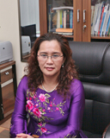 Dr. Nguyen Thi Lan Huong is the Director General of Institute Of Labour Science and Social Affairs (ILSSA), Ministry of Labour, Invalids and Social Affairs (MoLISA) since 2008. She has a Doctorate degree in Labour Economics from National Economics University, Viet Nam, a Masters in Business Administration from University of Technology of Sydney, Australia and a Bachelors degree of Economics of Labour from the Economics University of Sofia, Bulgaria.

Dr. Nguyen Thi Lan Huong leads research studies and surveys on social and labour development related issues on assessing impact of implementation of the social-economic development policies and programs on labour and social affairs. She makes recommendations on measures to better address the prevalent labor and social issues and advises on policy amendments in the country. She also provides technical assistance for preparation, implementation and evaluation of the labor and social related programmes and projects which will be or/and being undertaken by different local and international stakeholders.

She has many years of research and consulting experience in a wide range of areas related to labor standards, labour market development, social protection, poverty reduction, labour relation and corporate social responsibility.

Nicholas McTurk is a Population & Development Specialist of United Nations Population Fund.

Patima Chongcharoentanawat is a policy and plan analyst at Office of the National Economic and Social Development board (NESDB), Thailand. As a policy maker at the core planning agency of Thai government, she has involved in the whole socioeconomic policy implementation process; the in-depth studying for evidence-based policy advocacy, designing of feasible and sustainable policy formulation and establishing of appropriate indicators for policy evaluation. As a result, she has learned a great deal and gained a unique perspective and experience on socioeconomic issues such as poverty, inequality, human development and social protection.

She is currently responsible and involved in numerous projects including Thailand national transfer accounts and policy implications of population aging in Thailand, impact of ASEAN integration on inequality in Thailand, life cycle development framework and national progress on millennium development goals (MDGs).

Regarding education, she is economist by training. After receiving the bachelor of economics degree with first class honor from Chulalongkorn University, she was awarded the government scholarship and pursued her master degree in economics at the University of Michigan where her passion on economic development has been continually developed ever since.

Thailand is now facing the rapid demographic transition. According to the NESDB projection, by 2040, working-age population will shrink in both of its number and percentage while elderly group will be as high as 32.12 percent of the total. National Transfer Accounts, therefore; is expected to be the main analytical tool to examine the consequence of these demographic changes and help prepare Thailand for the aging era. She is positive that the exchange of experiences and network built during the 10th NTA meeting would help influence Thailand in designing, implementing and improving population and other significant policies.

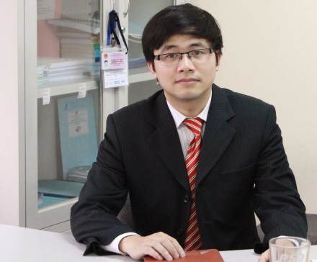

Pham Ngoc Toan is Deputy Director of Center for Information, Strategic Analysis and Forecast, Institute of Labor Science and Social Affairs (ILSSA). He obtains master degree in Econometrics from National Economic University, Ha Noi.

Toan’s research areas include: population, gender issues, labor and employment; salaries and wage. One of his research duties is also largely concerning the technical studies on the analyzing and evaluating the situation and forecast of the labor market trend. He is also deeply involved in considering for building of labor demand model especially the model of labor demand and analyzing the impact evaluation of policies on labor market.

His research outcomes have been published in journals, research papers, and reference books. He also has been a consultant for a number of domestic and international organizations, including Ministry of Labor, Invalids and Social Affairs (MOLISA), UNFPA, ADB, GTZ, ILO, IDRC, the World Bank, UNIDO, …

Pham Toan is a Vice Director of Institute of Labor Science and Social Affairs in Vietnam.



Prince Boakye Frimpong is a lecturer in the Business School, Garden City University College, Kumasi, Ghana. He holds a BA (Economics & Geography), MA (Economics) from the Kwame Nkrumah University of Science and Technology, Ghana; MSc (Economic Development and Growth) from the University of Warwick, UK and MSc (Economic Development and Growth) from Lund University, Sweden. He is currently a team member working on “Counting Women’s Work” project funded by William and Flora Hewlett Foundation and the International Development Research Centre. His research interests are within the fields of economic development, applied econometrics and nonstationary panels. He can be contacted at

winconsin@yahoo.com.

Qingfeng Li is a Research Associate of Johsn Hopkins University in US.

Reijo Vanne is the Director of the Economic Analysis Unit of the Finnish Pension Alliance TELA. TELA is an association of the statutory pension insurance providers in Finland. His primary focus is in the sustainability issues of the pension system and population economics. Funding, investment and allocation of assets are among the main tools of improving and maintaining the pension system sustainability in the long term. Previously Vanne used to work in economic research units and ministries. He holds a MSc (Econ.) degree in the University of Helsinki, Finland.

He has published several articles on population, public finance, investment and intergenerational issues, the recent main contributions being “On predictive distributions of public net liabilities” with prof. J. M. Alho (2006), “Government Finances by Age in Finland” with Dr. R. Vaittinen (2006), “Changing Patterns of Intergenerational Resource Allocation in Finland” with Dr. Marja Riihelä and Dr. Risto Vaittinen (2011), “National Transfer Accounts for Finland with Dr. Risto Vaittinen in Lee, R. and A.Mason (2011): “Population Aging and the Generational Economy”. His latest publication in English is “Pensions and Public Finances in Finland – A Generational Accounting Perspective with Dr. Risto Vaittinen (2013).

Reuben Mutegi is a Lecturer of University of Nairobi, School of Economics.

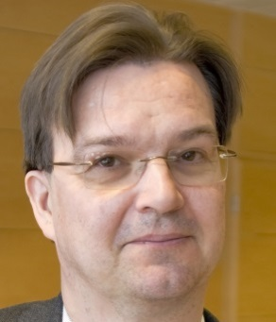

Risto Vaittinen works as an economist at the Research Department of the Finnish Centre for Pensions. His interests are in the topics of financial sustainability and generational fairness of the pension schemes. He has analyzed the economic impact of age-related income transfers using generational accounting and national transfers accounts.

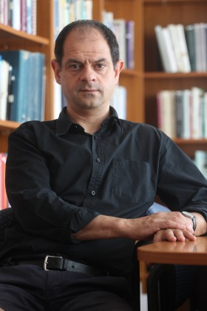Robert Ivan Gal (http://www.linkedin.com/pub/robert-gal/8/667/475) is Senior Research Fellow at the Hungarian Demographic Research Institute (http://www.demografia.hu/en/index.php/staff-gal-robert-ivan), Senior Extern at TARKI Social Research Institute, and Affiliated Professor at the Corvinus University (CUB), all in Budapest. He holds his MSc in Economics from CUB and his PhD in Sociology from the University of Groningen, the Netherlands. He participated or is currently participating in ageing related projects such as ANCIEN: Assessing Needs of Care In European Nations (DG Research, EC); PENMICRO: Monitoring pension developments through micro socio economic instruments (DG EMPL, EC); EuroNTA: National Transfers Accounts in Europe (European Science Fund); AIM: Adequacy of old-age income maintenance in the EU (DG Research, EC), PIE (Project on Intergenerational Equity (Ministry of Science and Technology, Japan); SHARE: Survey of Health, Ageing and Retirement in Europe (DG EMPL, EC) and MIDAS_HU, the dynamic microsimulation project of the Central Administration of the National Pension Insurance Fund of Hungary. In the National Transfers Accounts project he is a member of the Gender and Time Use working group and leads the Intergenerational Indicators working group. As a consultant he has been repeatedly invited by the European Commission (as a member of the ASISP and ESPN expert networks), the International Labour Organisation as well as various governmental agencies and non-governmental bodies in Hungary.

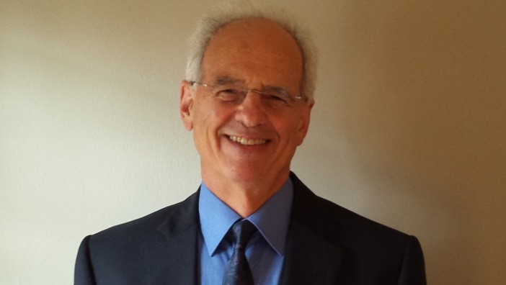Ronald Lee is Professor of the Graduate School in Demography and Economics at the University of California, Berkeley, and founding director emeritus of the Center for the Economics and Demography of Aging. His research focuses on intergenerational transfers and population aging. He co-directs the National Transfer Accounts project, which estimates intergenerational flows of resources through the public and private sectors and currently includes collaborating research teams in 46 countries. He co-chairs a National Academy of Sciences Committee on the Long-run Macroeconomic Effects of the Aging U.S. Population. A separate project investigates the interrelations between intergenerational transfers and the evolution of life histories through natural selection. He continues to work on modeling and forecasting demographic time series and government budgets including Social Security. He is a former President of the Population Association of America and is an elected member of the US National Academy of Sciences, American Association for the Advancement of Science, American Academy of Arts and Sciences, the American Philosophical Society, and a Corresponding Fellow of the British Academy. He enjoys tennis and hiking.

Sahlu Haile is a Regional Advisor of Packard Foundation.

Sang-Hyop Lee is a Professor of University of Hawaii.

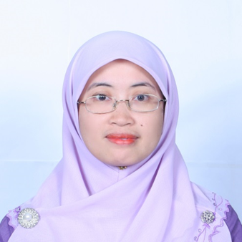

Sharifah Azizah Haron is a lecturer at the Universiti Putra Malaysia (UPM) specializing in Consumer and Family Economics. She graduated with a Bachelor degree in Economics (Honors) form the International Islamic University Malaysia, MSc (Consumer Sciences) from the University of Alabama-Tuscaloosa and PhD (Consumer and Family Economics) from the University of Missouri-Columbia. She is currently attached to the Institute of Gerontology (IG) as the head of Social Gerontology Laboratory. Her research interests include consumer behaviours and empowerment, family economic wellbeing (including study on poverty) and ageing.

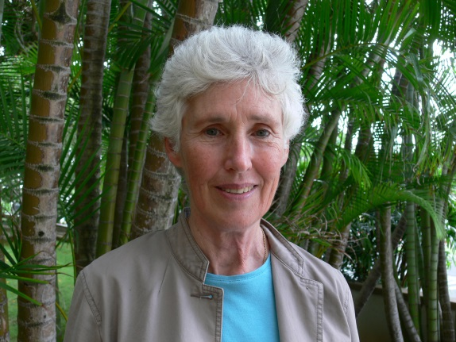Ms. Westley has worked as a writer, editor, and publications director for more than 40 years, including 22 years in East Africa. Before joining the East-West Center in 1994, she worked for research organizations in the fields of forestry and agroforestry, immunology and molecular biology, animal science, development, and African history. At the East-West Center, she has worked on a variety of publication projects, including The future of population in Asia (with Robert D. Retherford) and Asia's energy future: Regional dynamics and global implications (with Kang Wu and Fereidun Fesharaki). From 1994 to 2004, she was the Series Editor and principal writer for the East-West Center's quarterly publication, Asia-Pacific Population&Policy, and she is currently the Series Editor for the National Transfer Accounts (NTA) Bulletin. From 1996 to 2011, Ms. Westley coordinated an annual workshop on Communicating with Policymakers about Population and Health as part of the East-West Center's Summer Seminar on Population. She holds a B.A. degree in government from Smith College.

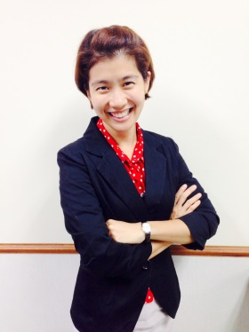

Suphannada Lowhachai is a Policy and Plan Analyst, Professional Level at Social Database and Indicator Development Office, Office of the National Economic and Social Development Board (NESDB), Government of Thailand (962 Krung Kasem Road Pomprab District, Bangkok 10100, Thailand, E-mail: Suphannada@nesdb.go.th). Together with the NTA working group at NESDB, She has been working on the compilation of National Transfer Accounts of Thailand 2011 since the year 2013. Prior to this, she had been working at the National Accounts Office, NESDB where she was in charge of the compilation of the data for real sectors of the Flow-of-Funds Accounts (namely, households, non-financial corporations, government and the rest of the world sectors) and the real estate production sector of the GDP. Suphannada earned a PhD in Economics from School of Oriental and African Studies, University of London. Her research focuses on provincial disparities—both economic and social aspects of Thailand.

Syer Tazim Haque is a Research Associate of South Asian Network On Economic Modeling.

Tanja Istenič is a PhD student at the Faculty of Economics, University of Ljubljana. The main topic of my PhD research is the intergenerational dependency and its connection with the population ageing. She works as a researcher on a project with acronym “AGENTA” and the full title “Ageing Europe: An application of National Transfer Accounts for explaining and projecting trends in public finances”, financed by 7th Framework Programme for Research and Technological Development. She also works as a teaching assistant at the Faculty of Economics where she teaches Introductory Statistics.

She has received the Bachelor’s degree in 2011 and the Master’s degree in 2014, studying Money and Finance at the Faculty of Economics. The title of her Master’s thesis was “Evolution of transfers between different age groups in Slovenia”. In her Master’s thesis she applied the National Transfer Accounts methodology on Slovenian data between 2000 and 2010.

During the Bachelor’s programme she has started to hold SPSS and Excel workshops within the course of Introductory Statistics. During her Master’s programme, she has become a teaching assistant for Introductory Statistics, Monetary Economics and Intermediate Macroeconomics at the Faculty of Economics and Faculty of Mathematics and Physics, University of Ljubljana. The courses were based on teaching modern macroeconomic theory, solving different optimization problems and based on modelling monetary policy, emphasizing the overlapping generations model. Additionally, she worked as a research assistant helping different researchers in collecting and analysing the data and preparing the literature reviews from different research fields such as macroeconomics, statistics, econometrics and finance.

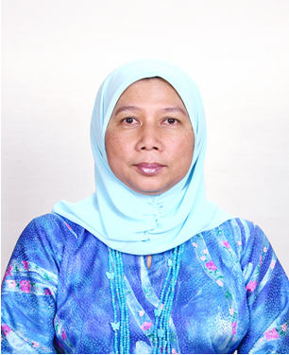Prof. Dr. Tengku Aizan Hamid is the founding Director of the Institute of Gerontology, Universiti Putra Malaysia (UPM) since 2002. She joined UPM as a lecturer in 1983 at the Department of Human Development and Family Studies, Faculty of Human Ecology. As one of the early pioneers of gerontology, Prof. Dr. Tengku Aizan has been instrumental in the development of gerontological research and education in Malaysia. Her extensive research experience is evident from the publications in over 40 ISI-cited journals and successive strings of national and international grants for studies on quality of later life, older families, elder abuse, old age poverty, primary care, mental health and lifelong learning. She is currently a member of both the National Advisory and Consultative Council on Ageing and the Technical Committee on the Health of Older Persons. She has also twice served as the President of the Gerontological Association of Malaysia (1996-2000; 2002-2004). At the international level, Prof. Dr. Tengku Aizan is a member of the INIA-SAGE ASEAN Centre of Ageing and she is an active advocator of regional cooperation and development in gerontology and geriatrics. She is currently leading a capacity building project for the financial empowerment of mature women with the support of United Way Worldwide via Citibank Foundation.

Vu Thu Trang is a Researcher of Development Strategy Institute, Ministry Of Planning and Investment, Vietnam.

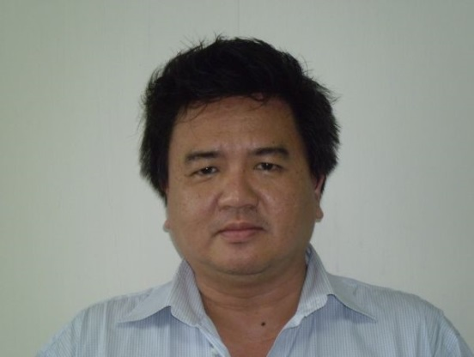

Wanchat Suwankitti has his Ph.D. in Regional and Rural Development Planning from Asian Institute of Technology (AIT), Master degree in Public Policy from University of Wellington, and a Bachelor of Arts in Political Science, Chulalongkorn University. He works as a policy and plan analysts at the National Economic and Social Development Board (NESDB), a central planning agency for the Royal Thai Government. NESDB has the main responsibilities in formulating the National Economic and Social Development Plan (which is now, the 11th Plan); providing recommendations to the government, and conducting researches and monitoring and evaluating the country development. In NESDB, Wanchat acts as the head of the social policy monitoring unit with main responsibilities to conduct new researches on social development issues, to provide recommendations on social policies for the government, and to construct new monitor and evaluation technics and indicators for social development issues and policies. This includes a research on National Transfer Account: Thailand, using 2011 data conducted in 2013. The 2011 Thailand NTA is developed to be a tool for policy identification, formulation and monitor particularly for the long term national policy on population development and the life cycle development policy. Results from NTA is also be planned to be an input for the final MDGs report for the analytical part in order to provide recommendations for the post MDG development agenda.

Wei-Jun Jean Yeung is a Professor of National Univeristy of Singapore.

Werner Peña possess an BA in Economics from the Central American University "José Simeón Cañas". He works at Dr. Guillermo Manuel Ungo Foundation of El Salvador. His areas of research are demographic transitions and social protection systems. He is part of El Salvador NTA team since 2012; since that date, he has been in charge to estimate the National Transfers Accounts for El Salvador.

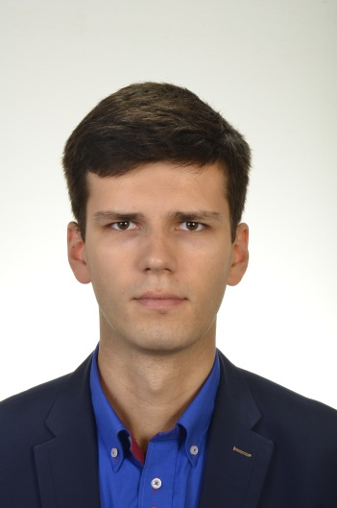Wojciech Łątkowski is currently studying as a PhD student and working as a Research Assistant at Warsaw School of Economics, Poland. He has a Master degree in Economics but now his doctoral dissertation is focused on Demography. The main area of interest are population projections and health, especially among the elderly. In dissertation he is working on a multistate projection model including health status and living arrangements status to be able to assess future demand for formal and informal care among the elderly in Poland. Recently, he has graduated from the European Doctoral School of Demography, a yearly programme providing a solid knowledge base on causes and consequences of demographic change, population data, statistical and mathematical demography, as well as modeling, simulation and forecasting. In my Research Assistant position he is mainly involved in AGENTA project for Poland. In his previous experience in business he took analytical positions in international companies from banking and market research sector.

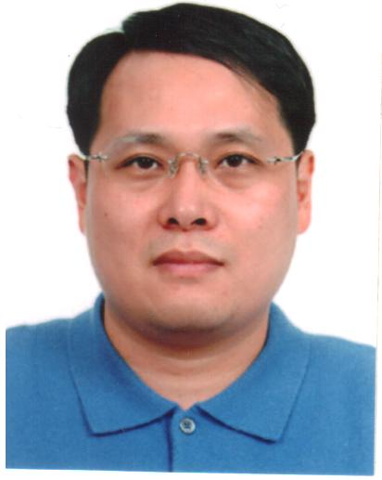

Young Jun Chun is a public finance economist. His primary research interest is in taxation, social welfare policies, and other issues related with intergenerational redistribution. He studied in Seoul National University (1983-1987, B.A. in economics) and in University of Pennsylvania (1990-1995, Ph.D. in economics). He started his career in Korea Institute of Public Finance (KIPF) in 1995, which is a state-run research institute and provides research support for the fiscal policy implementation of Korean government. After 6-and-a-half year working at KIPF, he moved to University of Incheon in 2002. In 2007, he joined Hanyang University, where he is currently working. His research covers wide range of social issues. He visited the pension reforms and their economic effects including intergenerational redistribution, the welfare effects of the earned income tax credit (EITC), the 1996 US social welfare reform, which replaced the AFDC (Aid to Families with Dependent Children) with the TANF (Temporary Assistance to Needy Families), the growth effects of population aging, the fiscal sustainability of government budget, and the optimal tax burden. His new research interest is in the public health insurance (PHI). He is currently working on the effects of the PHI revenue structure, which is represented by the tax-financing proportion of PHI revenue, on health expenditure from the perspective of political economy. He is also trying to address the optimal proportion of tax-financing. To address these issues, he usually depends on general equilibrium modelling and policy simulations, and empirical analysis. He also uses generational accounting (GA) for the analysis of fiscal sustainability of government budget and intergenerational equity issues.

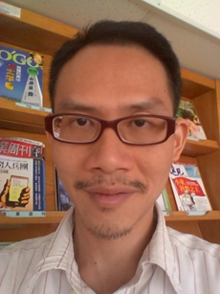Yu-Ching Hsieh is a postdoc research fellow in IEAS in Taiwan. He did his PhD study in Kobe University in Japan during 2002 to 2009. His fields are Population Economics, Applied Econometrics, and Socio Security System. He is interested to know why both speedy aging and baby bust occurred in East Asian countries, and how these countries deal with the big problem with policies.

After returning to Taiwan in 2009, he has taught applied econometrics and statistics in Soochow University from 2009 to 2011. He joined the NTA group when working in IEAS since 2012. He still remember how he was amazed by the magical LCD equation when he was first introduced to NTA. During the past two years, he has been further amazed by how the framework can be used to solve so many economic and demographic puzzles. He wants to learn more about this method and to improve his knowledge and skill in studying changes in demographic structure.

He is very pleased to participate in this big family and to know everyone at NTA10. He looks forward to seeing everyone in Beijing.