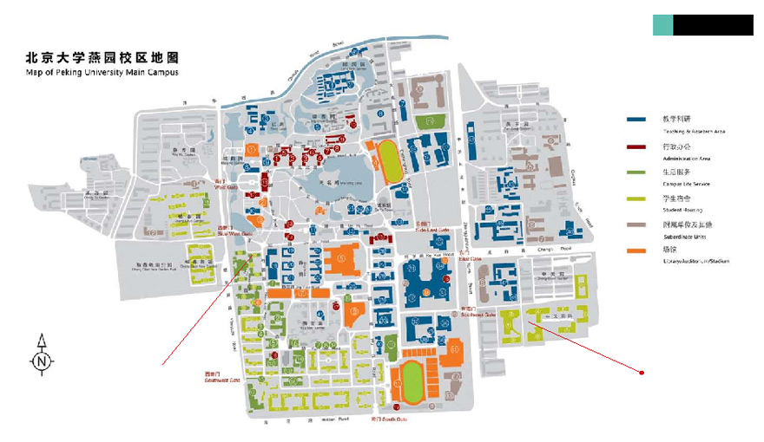

**Restaurants**

**(Suzhou Street)**

FX Hotel

**East Gate**

**(Subway line 4, Peking University Station)**

**Map of Restaurant Near Campus**

**South Gate**

**Restaurants**

**Northeast Gate**

**Southwest Gate**

**West Gate**

Wenjin Hotel

**Restaurants and Bars**

**(Subway line 13, Wudaokou Station)**

Zhongguan Xinyuan Hotel

**Changchun Garden Food Street**

**Restaurants**

Lake View Hotel

National School of Development