WESS Background Paper

Population Aging, Wealth, and Economic Growth: Demographic Dividends and Public Policy

January 2, 2007
Ronald Lee
Demography and Economics, University of California
2232 Piedmont Ave, Berkeley, CA 94720
e-mail: rlee@demog.berkeley.edu

Andrew Mason
Department of Economics, University of Hawaii at Manoa, and
Population and Health Studies, East-West Center
2424 Maile Way, Saunders 542, Honolulu, HI 96822
e-mail: amason@hawaii.edu

Introduction
As countries pass through their demographic transitions, changes in fertility, mortality and migration lead to major changes in the growth rate and size of the population, but also in the population age distribution – that is, in the relative numbers of children, elderly, and working age people. In this paper we are particularly interested in how these age distribution changes affect the macro economy. Changes during two phases of the transition are particularly important. First is a 40 to 80 year period in the middle of the transition, after fertility has begun to decline and before population aging has started. Most Third World countries are in this phase. Second is the period of rapid population aging, which is the phase in which all the industrial countries are located, and which many Third World countries will soon be entering. Despite the challenges of a rapidly growing labor force, the first phase is generally viewed as a time of economic opportunity, whereas the second phase is viewed as a time of economic hardship if not catastrophe, due to the rapid increase in dependent elderly. In this paper we will investigate the macroeconomic consequences of both phases, and find that the potential gains during the first phase are larger than the demography alone might suggest, and that the economic pressures feared for the second phase are less important than is generally thought, and indeed that population aging may instead bring macroeconomic benefits through capital intensification.

During the first phase, the proportion of people in the working ages rises relative to the sum of the young and the elderly, giving a considerable boost to the growth rate of per capita income. This boost is knows as the “demographic dividend” or the “first demographic dividend” and the period during which it occurs is referred to as the “demographic window” or sometimes as the “window of opportunity”(Bloom and Williamson 1998; Mason 2001; Bloom, Canning and Sevilla 2002; Mason and Lee 2006 forthcoming). It results from changes in the ratio of the effective numbers of producers to effective number of consumers, which is called the support ratio. The first dividend is transitory, because this period is followed by a period of population aging during which the working age population shrinks relative to the number of consumers, retarding the growth of income per capita.
Sometimes the dividend and window are defined in terms of rates of change of the support ratio and sometimes in terms of its levels. In this report, the concepts are defined using rates of change. Hence, the dividend is said to be positive when the support ratio is increasing, causing more rapid growth in income per effective consumer. The dividend is said to be negative when the support ratio is declining, causing slower growth in income per effective consumer. The demographic window or window of opportunity is defined as the period during which the first dividend is positive.
The demographic window first “opened” for the developing world during the 1970s. In Latin America, East and Southeast Asia, the Pacific Island nations, and the Middle East and North Africa all began to enjoy the dividend during this decade. The durations of the first dividend period for countries in these regions are expected to average around 50 years, but with considerable variation. The window opened later in South Asia – around 1985 – and in sub-Saharan Africa – around 1995. The duration of the first dividend period is projected to be somewhat longer in these regions– perhaps 60 to 80 years – but this remains uncertain because demographic events are difficult to predict far into the future (Mason 2005).
The demographic window offers a unique opportunity to realize more rapid economic development. During the window consumption per effective consumer can rise at the same time that the share of GDP consumed declines, because of the more favorable age distribution. This means that a larger share of national output can be diverted from consumption into investment opportunities without sacrificing current living standards. A second important consideration is that the demand for resources to support old age consumption begins to emerge during the first dividend period. It is at this early point that countries can most easily establish an institutional framework that will allow them to realize a second demographic dividend (Mason and Lee 2006 forthcoming).
As population age distributions change, the changing balance of workers and consumers generates the first dividend. But people contribute to output as savers and investors as well as by working, and there is also a distinct age pattern for holding assets. The second dividend, which is examined below, arises from the changing balance of asset holders and workers, boosting labor productivity and raising asset income, but at the cost of an initial phase of slower growth in consumption. Unlike the first dividend, the second one is a permanent feature of an older population.

II. Modeling Age Structure and Economic Growth
Dependency ratios are often used to quantify the economic effects of changing population age distributions. The ratios are constructed by dividing the number of children, the number of elderly, or both, by the number in the working ages. The boundaries of these age categories are conventionally taken to be 18, 20 or 21 at the low end, and 60 or 65 at the high end. Thus the Old Age Dependency Ratio might be the population age 60 and over divided by the population age 20-59. While useful, this kind of measure has limitations. People are not equally productive at all working ages, particularly if we restrict attention to activities that are counted in GDP. Nor do people consume equally at all ages. The zero-one classification used in the dependency ratios is necessarily somewhat arbitrary. Furthermore, there may be important differences among countries and regions in these aspects of economic behavior.
Age profiles of consumption and labor productivity shown in Figure 1 illustrate the difference between the discrete ad hoc dependency measure and a continuous empirically-based measure of dependency. The values in Figure 1 were constructed based on detailed estimates for a number of developing countries using methods described in more detail below. The values have all been normalized by dividing by the average labor productivity of those in the prime working ages, 30-49. This normalization facilitates interpretation, but does not influence any of the analysis. The heights of these age profiles are calculated to be consistent with aggregate consumption and labor income at the national level. Typically aggregate consumption exceeds aggregate labor income, with the difference made up by consumption of some income from assets.
The broad outlines of the profiles are not surprising. Children and the elderly are consuming, but they are producing nothing or relatively little through their labor. Many of the specifics, however, are informative. There is considerable variation in consumption among adults, with consumption in the cross-section peaking at age 24. Young children consume much less than teenagers or the elderly and, thus, impose less of an economic burden. The age range during which individuals are producing more than they are consuming is surprisingly narrow, between the ages of 24 and 59.
The economic support ratio is an alternative measure of dependency that explicitly incorporates age-variation in consumption and labor productivity. Age profiles of consumption and labor income can be estimated for different countries and allowed to vary over time. Or standard profiles, such as the ones shown in Figure 1, can be employed. In either case the values at each age are used as population weights to provide estimates of the effective numbers of consumers and the effective numbers of producers.
Let N(t) represent the effective number of consumers and L(t) the effective number of producers. The support ratio is the effective number of producers per consumer:
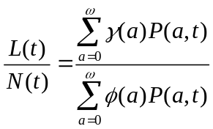

where P(a,t) is the population aged a at time t and 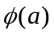and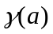 are age-specific, time-invariant vectors of coefficients measuring age variation in consumption and productivity, respectively.

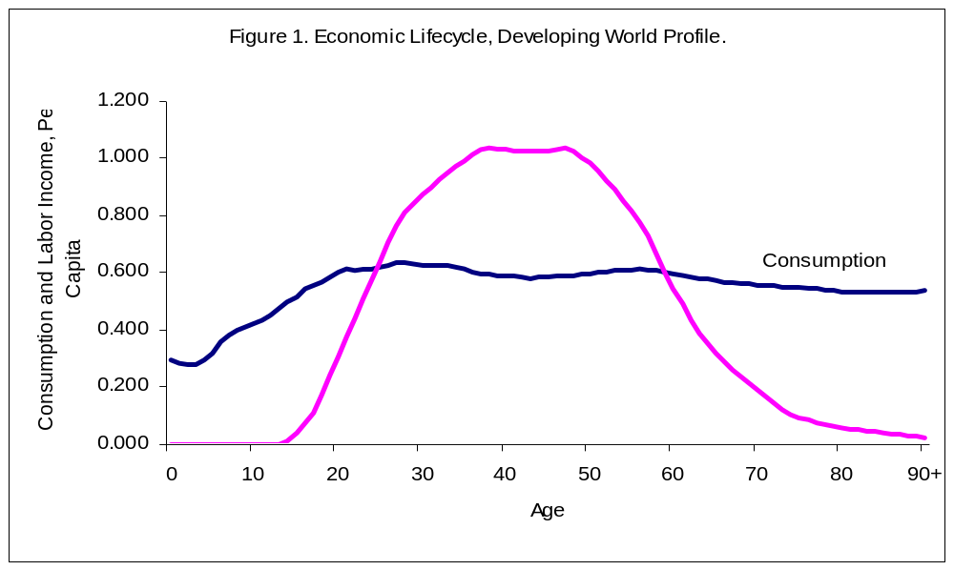

To fully appreciate the influences of population age-structure on the economy one must take a long view. The demographic transition and its accompanying changes in age structure occur over a period of several centuries. No country has yet completed the demographic transition and historical records that predate the transition are available only in a few instances. A few of the least developed countries have begun their demographic transitions only recently. By using United Nations population estimates and long-range projections for one of these countries, the support ratio can be constructed for the entire demographic transition. The values in Figure 2 are based on population estimates and projections for Niger, the country with the highest total fertility rate in the world in 2000, and the age profiles of consumption and labor productivity in Figure 1.
The demographic transition follows the classic pattern. In Years 0-5, life expectancy at birth for both sexes combined is only 36.2 years, increasing gradually to 44.3 years for Years 50-05, to 61.4 years in Years 95-100 and eventually reaching almost 90 in Year 350. The TFR increases slightly from 7.7 births per woman in Years 0-5 to peak at 8.2 births per woman from Years 25-40. The medium scenario employed here assumes that the TFR will decline gradually to reach 3.6 births per woman in Years 95-100 and replacement level, just over two births per woman, in Year 130 and thereafter.
The early part of the demographic transition is delineated by a rising share of the child population and a decline in the support ratio. During the second part of the transition, called the “demographic window”, the support ratio is increasing as the population is increasingly concentrated in the working ages. During the third part of the transition, the support ratio declines as the population becomes increasingly concentrated at older, low productivity ages. The length of these phases and the magnitudes of the change vary depending on the particular details of the demographic transition and the economic lifecycle, but every country in the world has or will in all likelihood experience the demographic window followed by population aging. The macroeconomic implications of these demographic changes is the matter to which we now turn.

Figure 2. The Demographic Transition and the Economic Support Ratio (the first 200 years).

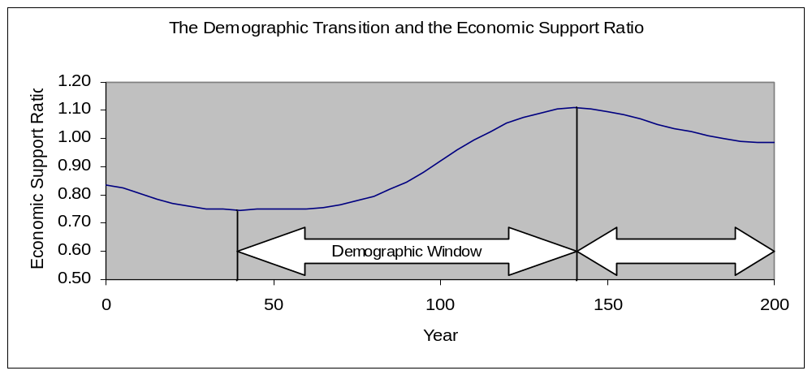

Demographic Dividends and Economic Growth
Economic growth is often measured by growth in income per capita. A preferable measure is growth in income per effective consumer, because this measure takes into account the population age distribution and the differing levels of consumption by age. Similarly, one can define income per effective worker. In a closed economy, income per effective worker reflects many factors including the level of technology, human capital, physical capital, the strength of political and economic institutions, and natural resources. In an open economy, income per effective worker is also influenced by income earned on assets invested abroad.
From these concepts a useful identity follows:

The first dividend is here defined as the growth rate of the support ratio (the middle term in this equation). It is positive, contributing to more rapid economic growth, during the period referred to as the “demographic window” in Figure 2. It is positive when the number of effective workers grows more rapidly than the number of effective consumers. In recent decades fertility decline in many countries in Asia and Latin America has led to slower growth in the number of children. Meanwhile, the working-age populations have continued to grow, raising the support ratio and yielding the first demographic dividend. Each one percentage point increase in the support ratio yields an equivalent increase in income per effective consumer. In Figure 1, the support ratio increased by 47%, from 0.75 to 1.1, between year 40 and 140. Thus, given the particular values used to construct Figure 1, the first dividend produced an increase in income per effective consumer of 47%.
As the transition proceeds, reduced fertility will eventually cause the working-age population to grow more slowly, so the first dividend will decline in importance. Growth in the elderly population will accelerate for decades to come due to falling mortality and high fertility in the distant past. Then effective number of consumers will grow more rapidly than the effective number of producers and the first demographic dividend will turn negative. After the 60 years of aging shown in Figure 2, about one-third of the first dividend has been lost. Further population aging not shown in the figure will lead to additional declines in income per effective consumer. Depending on many uncertain factors, the first dividend may disappear entirely by the end of the demographic transition.
Whether the favorable effects of age structure are limited entirely to the demographic window depends on how the first dividend is used. One possibility is that the additional income is entirely consumed, including by taking more leisure through earlier retirement or later labor force entry. If so, the effects of age structure will be entirely transitory. A second possibility, however, is that some or all of the first dividend is invested in human or physical capital or in stronger institutions that will lead to permanently higher economic growth. This will lead to additional growth in income per effective consumer, the third term in the simple growth equation presented above. Thus, depending on the choices made by individuals and the policies pursued by governments, the first dividend may give rise to a second dividend that persists well after the demographic window has closed.
The prospects for a second demographic dividend are relatively promising because population aging leads to an increase in the demand for wealth needed to maintain consumption levels at older ages for several reasons. First, old people, having accumulated during their working years, hold more wealth on average than younger adults. An increase in the proportion of old people therefore causes an increase in wealth per capita in the population. Second, in addition to this purely mechanical effect, the anticipation of longer life leads individuals to save more and accumulate more wealth over their life times, reinforcing this effect. Third, with lower fertility individuals allocate a larger share of their life time earnings to their own consumption, including in old age, again leading them to save more and accumulate more wealth over their working lives. For all these reasons, wealth per capita rises during the demographic transition. This increase in wealth per capita, and the increase in income and consumption to which it gives rise, creates a possibility for a second demographic dividend.
Why a possibility rather than a certainty? Wealth in this context is a broad concept encompassing all net claims on future output. Such claims can be based on ownership of an asset such as a physical property, stock certificates, or bonds or other promissory notes, all of which yield returns and can be sold at a later date. But wealth can also take the form of an expectation that one will receive a net transfer in the future, either from one’s adult children or from a public program. A net transfer is the difference between the transfers one expects to make, such as payroll taxes, and the transfers one expects to receive, such as public pension benefits. The present value of expected future net transfers, weighted by survival probabilities, is transfer wealth. From the point of view of the individual who must fund retirement, transfer wealth substitutes for financial or physical wealth. If one expects to be supported in old age by ones adult children, then the need to save and accumulate assets is correspondingly reduced. However, from the point of view of the macro economy, transfer wealth and assets are completely different. Assets generate income in the aggregate economy through the returns they earn (interest, dividends, profits, flows of services) and if invested domestically will also raise the wage rate. Transfer wealth, however, has no such effect, and simply redistributes existing income flows from one age group to another.
Although population aging over the transition has a wealth-enhancing effect, it matters greatly whether the additional wealth is held as assets or as transfer wealth. And the importance of transfer wealth in turn depends on the extent to which anticipated retirement needs are expected to be met through family support or through unfunded public pension systems.
In previous work we have used two approaches to modeling and calculating the size of the second dividend: one based on optimizing behavior by individuals in independent cohorts, and the other based on the continuation of sharing patterns across ages, reflecting the interdependence of cohorts. The standard life cycle model assumes that each individual and, hence, each cohort follows a separate optimal trajectory of consumption over their entire lives, with the height of the profile determined by their lifetime earnings and by their expected longevity. This can be generalized to take into account the consumption needs of the cohort’s children and the public and private supports systems which may substitute for asset accumulation. With this setup, saving rates rise during the period of the first dividend (so consumption is lower than otherwise), and then fall back to lower levels as the population ages (Lee et al, 2000). The ratio of wealth per worker, however, increases substantially and remains high. Unlike the first dividend, which is transitory, the second dividend leads to a permanent change. This effect is stronger when provision for retirement through familial transfers or public pensions is weaker (Lee et al, 2003). In the absence of such transfers, the capital/labor ratio permanently doubles or triples.
The second approach assumes that the shape of consumption by age is unchanging over time. This unchanging shape is maintained by sharing across different ages through the family and through public sector programs, and it reflects the interdependency and altruistic linkage of generations in contrast to the individual optimization of the standard lifecycle approach. Like the first approach, this one indicates that saving rates will rise and that the ratio of wealth to labor or income will rise (Mason and Lee, 2006). While the timing and magnitude of the changes are a little different, the qualitative conclusions are similar. Furthermore, in both approaches the second dividend is diminished when transfers to the elderly are larger and future changes in support systems will therefore influence the size of the second dividend. Possible changes in support systems are discussed later.
In the absence of large-scale transfer systems population aging leads to increased assets per person. In a closed economy, these additional assets will be invested in the domestic economy, where it will generate both a flow of asset income (dividends, interest payments, profits) and raise the productivity and earnings of domestic labor, raising GDP through both channels. It also will reduce interest rates and profit rates. In an open economy some of the increased assets will be invested abroad, in which case it will generate asset income flows but not alter the productivity of labor domestically. In this case it will raise labor productivity and wages in the foreign country, and reduce interest rates and profit rates there. In the open economy scenario, an aging global population will eventually lead everywhere to increasing assets, higher wages, and lower interest rates and profit rates. The industrial nations have aged earlier and more deeply than the rest of the world, and their old age dependency ratios will likely undergo a further doubling, so increasing flows of capital from them to the rest of the world can be anticipated.

III. Economic Lifecycle: Methods and Estimates
Irrespective of the conceptual approach used to model the economic effects of population aging, the economic lifecycle is central. Economic research is often based on simple representations of the lifecycle rather than actual estimates. Here we present cross sectional estimates of the economic lifecycle for a number of developing and developed countries and the common methodology used to construct those estimates. The economic lifecycle is summarized by age profiles of average consumption and labor income.

Consumption
Consumption consists of both private and public consumption. Age patterns of private consumption have been much more extensively analyzed, but public consumption is important to developing a full picture of the lifecycle of consumption.

Private Consumption
Consumer expenditure surveys provide information on private consumption expenditures for households. Most surveys do not report expenditures for individuals, but a variety of methods have been developed to allocate household spending to individual members of the household. Most of this research has focused on estimating the costs of children. Much less is known about consumption by the elderly. In societies where the elderly live independently from their adult children, estimates of consumption by the elderly can be obtained more or less directly from household expenditure data. In the many countries where the elderly live with their adult children, consumption by adults cannot be directly observed.
The methods that have been developed for allocating household consumption to children are not very reliable and consequently the estimates presented here rely on relatively simple methods. Private consumption of education and health are estimated separately from all other private consumption using regression methods that rely on information about utilization of services. Private spending on education, for example, is allocated to individuals based on their reported enrollment status and estimates of per student spending by age. Similar methods are used to estimate age profiles of private health consumption. In this case, information about utilization of in-patient and out-patient services can often be used to obtain plausible estimates.
Other household consumption is allocated to individuals using an ad hoc allocation rule. The allocation rule is based on an extensive review of the literature and follows the advice of Deaton (1997) that an ad hoc approach to child costs is probably the preferred approach, given the problems associated with other methods (Lee, Lee and Mason 2007 forthcoming). Deaton suggests that children age 0-4 be 0.4 of an adult and the children age 5-14 be 0.5 and children 15 and older be 1. We employ a more continuous, but similar equivalence scale, which is equal to 1 for adults aged 20 or older, declines linearly from unity at age 20 to 0.4 at age 4, and remains constant at younger ages.
Using these methods, we estimate consumption for each individual in each household in the sample. We average across all the individuals in the survey of a given age to construct age schedules of private expenditures on education, on health, and on other goods and services. Often, expenditures are underreported in surveys, so some further adjustment of the age profiles is desirable to make them consistent with reliable national level control totals for total private expenditures on health, on education, and on the balance of total private consumption. National Income and Product Accounts (NIPA) provide suitable control data. In this way, the profiles can be made consistent with NIPA, in general, and private and government final consumption expenditure, in particular.

Public Consumption
Public consumption consists of final goods and services that are produced by general government or purchased by the government and provided to households or individuals either free or at a nominal cost. Some goods and services are individual in nature and, in principle, the persons consuming them and their age group can be identified. Examples would be education and personal health services. Some forms of public consumption are collective services that accrue to the community at large rather than to particular individuals. Examples would be national defense, public diplomacy, and public sanitation programs.
In principle, we allocate individual public consumption to age groups based on the intended beneficiary of the program. This information is generally not available from household surveys, but often can be estimated from administrative data compiled by public agencies. Education expenditures provide a good example of the approach we employ. For most countries, enrollment data by age and school level are available. Per student costs can be calculated by school level using public expenditure data classified by school level. These data can be combined to estimate consumption of public education by age assuming that spending within each school level is independent of the age of the student.
More generally public consumption estimates are based on the actual costs incurred for services to individuals, if this information is available. If not, estimates are based on program usage information. For example, health care costs may be constructed using age-specific data on in-patient and out-patient utilization and per capita costs for in-patient and out-patient care. Collective public consumption and individual public consumption for which age-profiles cannot be estimated are allocated to age groups in proportion to population share. The detail with which the public consumption profiles are estimated varies from country to country. At a minimum, age-specific estimates for health and education have been constructed.
Public consumption age profiles are also adjusted to conform to National Income and Product Account estimates. Expenditures on health care that are reimbursed through national health insurance programs are classified as public consumption of health care.

Labor Income
Estimating labor income is relatively straight-forward and relies on survey data that reports the income of individuals. In principle, labor income should include the full return to work effort. Thus, it would include current earnings, the value of fringe benefits, and the share of entrepreneurial income or self-employment income that is a return to work effort. Entrepreneurial income is often not reported in a manner that allows for decomposition into returns to labor versus returns to assets. Thus, we assign a pre-defined age invariant portion of individual entrepreneurial income as a return to labor. The labor income of an individual is then the sum of these individual components of compensation. Again, labor income is adjusted to insure consistency with National Income and Product Accounts.

Economic Lifecycle Estimates
Estimates of the economic lifecycle – the per capita age profiles of consumption and production – for the developing world are presented above in Figure 1. The profiles are based on estimates for four developing economies: Costa Rica in 2004, Indonesia in 1996, Taiwan in 1977, and Thailand in 1996. The estimated profiles are all based on nationally representative surveys of household income and expenditure and have been adjusted to match National Income and Product Account totals using the procedures described above.
The “Developing Country Profile” is estimated by taking the simple average over the four countries of the age-specific normalized value. Although these countries’ profiles differ in some important respect, they are broadly similar. This can be seen from Figure 3, which charts the mean, minimum, and maximum value at each age for the consumption and the production profile. The consumption profiles for children are very similar in the four economies, but there is more variation in the consumption profiles of adults. The maximum value for those 20 and older is on average higher by 8 percent of the labor income of a prime age adult. The minimum value for those 20 and older is lower than the average value by 10 percent of the labor income of a prime age adult.

Figure 3. Developing Economy Profiles of Per Capita Consumption and Production (normalized on per capita labor income 30-49).
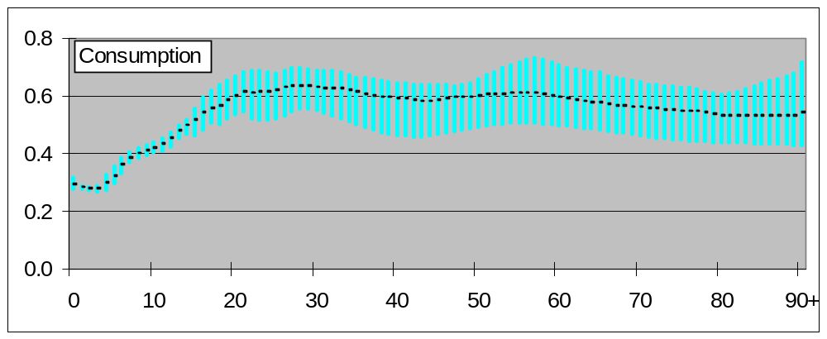
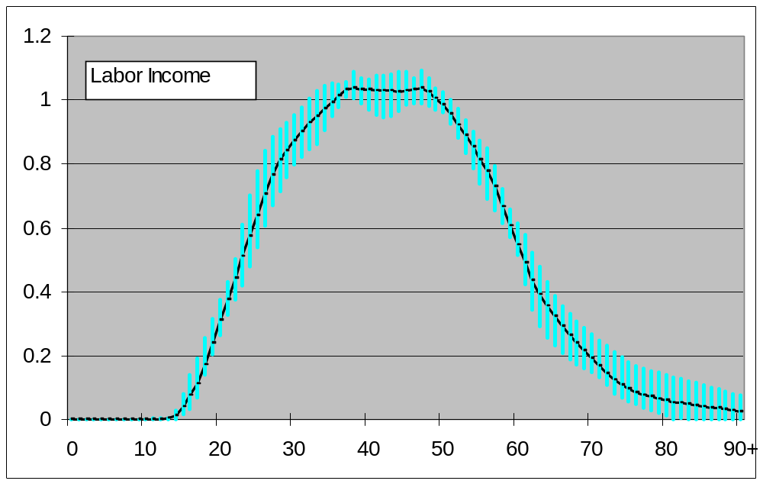 The labor income profiles are somewhat more tightly concentrated around the mean profile. For those 20 and older, the maximum value is on average higher than the average value by 7 percent of the labor income of prime age adults, whereas the minimum value is on average lower than the mean value by 6 percent of the labor income of a prime age adult.
Estimates of the economic lifecycle for two industrialized countries, Japan and the United States are presented in Figure 4. Again the per capita consumption and labor income age-profiles have been normalized by dividing by the simple average of per capita labor income for the 30-49-year-old age group. The labor income profiles are broadly similar. The Japanese profile rises more steeply and peaks at an older age than the US profile. This reflects the greater return to seniority characteristic of Japan’s labor market. The Japanese profile also declines more steeply that the US profile.
The Japanese and US labor income profiles are also quite similar to the developing country labor income profile. A few benchmarks drive this point home. Labor income reaches 0.5 at age 23 for the developing country profile and age 24 for both Japan and the US. Labor income reaches 0.75 a little late in Japan – at age 31 – as compared with age 27 in the developing country profile and age 28 in the US. The similarities are even more strike at older ages. Labor income declines to 0.5 at age 61 for the developing country profile, age 63 for Japan, and age 62 for the US. Labor income reaches 0.2 at age 69 for the developing profile and the US and age 68 for Japan.

The Japanese and US consumption profiles are very different from each other and from the developing country profile. Japanese consumption by children is very high, because of high levels of spending on education, followed by the US, and then the developing country profile. The most significant differences, however, are in the consumption profiles at older ages. For all three profiles consumption at age 25 is about 60 percent of the labor income of a prime-age adult. The developing country consumption profile is relatively flat, but declines gradually at older ages. The Japanese profile is more variable. Older Japanese consume substantially more than do adults in their 30s and early 40s. The increase in consumption with age in the US is quite remarkable. Whereas a productive 25-year-old consumes 60 percent of the total production of a prime-age adult, an 85-year-old who produces nothing consumes 100 percent of the total production of a prime age adult. An important difference between the three profiles is health care spending. In the US, spending on health care accounts for the rise in consumption at older ages. In Japan, the elderly also spend more on health care than younger adults, but health care spending is a much smaller share of total consumption in Japan and, hence, has less influence on the overall shape of the consumption profile (Ogawa, Mason, Maliki et al. 2007 forthcoming).
Descriptive accounts of consumption and earning by age are useful in many ways, but cannot in themselves tell us what will happen when a population age distribution changes. It may be clear that changing population age distribution would lead to an economic surplus or deficit if the age profiles were to remain unchanged, and therefore that some adjustment is to be expected, but the nature of the adjustment is unknown. Perhaps the shapes of the age profiles will remain the same, while their relative levels will change. Or perhaps the shapes of the age profiles will change, reflecting changing labor supply at older or younger ages, or changes in life cycle saving at some ages.
However, if the shapes of the age profiles are similar across a number of countries with different population age distributions and different levels of economic development, then that is evidence that the age shapes are likely to remain the same during periods of economic and demographic change, and therefore that the relative levels of consumption and production must adjust when population age distribution changes. In fact, this is what we have found. Per capita GDP varies by a factor of seven across the four countries whose profiles are summarized in Figure 3, and the proportion aged 65 and over in the population varies by a factor of two. Nonetheless there is relatively little variation in the age shapes of the consumption and labor earnings profiles across these disparate Third World countries. When we compare the age profiles for two industrial nations, the US and Japan, we see both similarities and differences, but the age profile of consumption for the US does stand out as discussed.

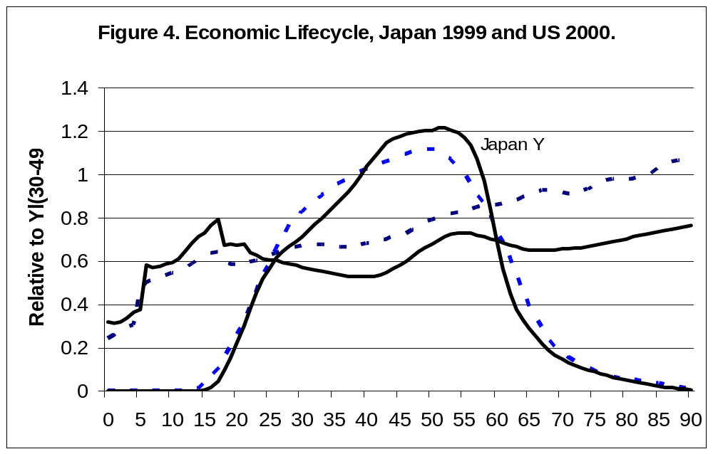

IV. Simulating Demographic Dividends
Descriptive accounts cannot tell us what will happen when the relative numbers of young, old, and working-aged people change. That requires assumptions about how people respond to change. One common assumption is that people maximize their utility subject to certain economic and social constraints, and that this maximization in a changing economic and demographic context leads to predictable changes in their consumption, transfer, and savings behavior. But it is well known that people are not always self-seeking rational maximizers, and that institutions and public policies also influence their behavior. Indeed, altruistic bonds lead people to share their good and ill fortune to some degree through both private, often familial channels and through public programs. We will describe a simulation approach based on the assumption that these patterns of sharing and intergenerational transfers remain in some respects unchanged.

Two approaches to simulating demographic dividends are briefly described in Section II. The second approach is described in more detail here and used to simulate the consequences of changing age structure (Mason and Lee 2007 forthcoming).

Lifecycle Wealth, Assets, and Population
Aggregate lifecycle wealth is the wealth that adults must hold, as a group, in year t to achieve a given path of consumption and labor income over the remainder of their collective existence. W(t), the lifecycle wealth of all adults in year t, is equal to the present value of the consumption less the present value of the labor income of those adults over the remainder of their lives. Let PV[] be the present value operator. Then,
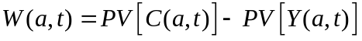,
where C(a,t) and Y(a,t) are vectors of current and future consumption and current and future labor income, respectively, for the cohort of age a in year t. Summing 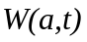 across all adult ages in year t yields aggregate lifecycle wealth, W(t).
By assumption labor income at each age depends on the effective number of producers in that age group, 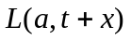, and their productivity as measured by output per effective producer which we call the productivity index and denote 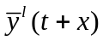.
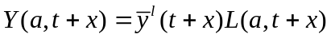
In a closed economy, the level of productivity is endogenous, influenced by capital deepening induced by population aging among other factors. The analysis presented here, however, is limited to the small open-economy case in which the level of productivity rises over time at a constant rate as a consequence of exogenous technological innovation. Thus, labor productivity depends only on its level in year t and productivity growth factor that changes at a constant rate, i.e., 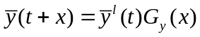.
In a similar fashion, consumption at each age depends on an index of consumption, 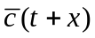, and the equivalent number of consumers at that age, 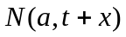:
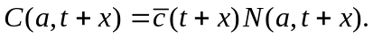
This representation of consumption is an essential feature of the behavioral model in that it reflects the assumption that the cross-sectional age profile of consumption is unchanging over time.
Lifecycle wealth, 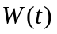, consists of two important components. The first component of lifecycle wealth is child transfer wealth, the obligation of year t adults to support children, calculated as the present value of all transfers to children in current and future periods by year t adults. Note that child transfer wealth is negative.
What determines child transfer wealth? In part, it depends on the difference between what children consume and what children produce in the current and in future periods. In the simulations production and consumption are determined in the same manner for children as for adults. The shape of the age profiles of production and consumption ( and 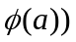 are held constant for all ages including children. The shifts of the profiles over time are governed by the shifts in the production and consumption indexes discussed above.
The cost of children to year t adults also depends on their share of the costs of children in future periods. By assumption all of the current costs of children are born exclusively by year t adults, i.e., children do not support children. Year t adults are responsible only for a portion of the cost of children in subsequent years, because some portion of the costs of children is shifted to persons who become adults after year t.
The share of child costs borne by year t adults depends on a host of factors, including the extent to which child costs are born by families as opposed to taxpayers, the system of taxation that is used to finance public transfers to children, and the extent to which parents, grandparents, and other family members finance familial transfers to children. The model distinguishes two ways in which child costs are financed: familial transfers and public transfers. Adult parents are assumed to bear the cost of familial transfers. Public transfers are financed through a proportional tax on labor income. The relative mix of these two mechanisms is an exogenously determined policy variable which would be strongly affected by policies with respect to privatization of public education or health care.
The second component of lifecycle wealth is lifecycle pension wealth – the wealth that year t adults will use to fund consumption in excess of labor income during their retirement. Lifecycle pension wealth is equal to lifecycle wealth less child transfer wealth. Lifecycle pension wealth is the present value of current and future consumption by year t adults and their dependent children less the present value of current and future production by year t adults and their dependent children. By dependent children we mean the children for whom year t adults bear economic responsibility.
Lifecycle pension wealth can be held in two forms, as assets (A) and as pension transfer wealth (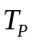), i.e.,
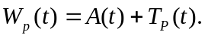
Pension transfer wealth is the present value of net transfers to year t adults in future periods. These net transfers will come from those who are not adults in year t, but who will become adults in future periods. The transfers include public transfers, such as net transfers provided through public pension programs and national health insurance, and familial transfers from future adult children to their aging parents. The relative size of pension transfer wealth is captured by 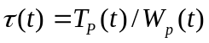. In the approach we consider below, we assume that the share of lifecycle pension wealth that is held as transfer wealth is exogenously given and a key policy variable.

The Macroeconomic Framework
The relationship between the trajectory of consumption and lifecycle pension wealth and assets is apparent from inspecting equation in the appendix. If the consumption trajectory is higher, because elements in the vector of growth rates 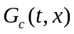 are higher, lifecycle pension wealth in the current period and current assets must be higher. However, if aggregate consumption is higher, saving must be lower, and the trajectory of assets must be lower. The feasible consumption trajectory is the one for which lifecycle accounting and macroeconomic accounting lead to the same assets in each period.

The solution will depend on whether the economy is open or closed. Here we assume that the economy is open and, hence, the rate of return to capital, 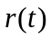, is exogenous. Thus, the aggregate flow constraint is governed by:
The rate of interest in each period is not affected by changes within the economy being analyzed, but it is influenced by the effect of global aging on interest rates. This is calculated by using the model to simulate the accumulation of capital in the global economy and the consequent reduction in global interest rates.
Backward recursion can be used to find an exact closed form solution to this model (Mason and Lee 2006). We assume that the population achieves stability and that the model reaches steady state at some point in the distant future, . Under those conditions, the consumption index will grow at the same rate as labor productivity. We can solve directly for the consumption index and assets in year and all years thereafter. Next we solve for consumption in year 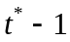 given consumption in all subsequent periods, equation , and the lifecycle model that governs the demand for assets by consumers. We work backwards to the present or historical periods.
For all simulations presented below we assume that two-thirds of child costs are met through familial transfers and one-third through public transfers, figures broadly consistent with results reported in Mason, Lee et al. (forthcoming). For the discount rate we use a risk-free rate of return of 3%. For the depreciation rate we use 3% (Mankiw, Romer and Weil 1992) and for the international real rate of return on assets we use 6% (Barro and Sala-i-Martin 1995) declining linearly to a steady-state rate of interest of 4.42% in 2300. We assume that productivity growth is 1.5% per year. Two exogenous policies towards transfer programs are considered. In the baseline simulations, transfer wealth and pension wealth each constitute 50% of transfer wealth. In an alternative set of simulations, transfer wealth constitutes 65% of pension wealth and assets 35%. Population estimates and projections are based on United Nations Population Division (2004; 2005). Three consumption and production age-profiles are employed – the developing country profile, the Japan 1999 profile, and the US 2000 profiles, the details of which are provided in the preceding section.

Assets and Dividends over the Demographic Transition
Changes in age structure and the accompanying swings in the economic support ratio are inherent features of the demographic transition experienced in the past in industrialized countries and more recently in the developing world. Important characteristics of the transition vary, e.g., the timing of the onset of mortality decline, the delay between mortality and fertility decline, the speed with which fertility and mortality decline occur. But the broadest features in which we are interested are general to the demographic transition. Thus, we use the generic demographic transition employed to construct the support ratio in Figure 1 to simulate how changes in age structure over the demographic transition influence the macroeconomy. Key results are charted in Figure 5.
Early in the demographic transition the support ratio declines reaching its lowest level in Year 50 because high fertility and declining infant mortality produces a population with many young dependents. The support ratio does not begin to rise until around Year 70, but then it rises steeply, by about 50%, during the next 70 years. During this phase, the first dividend phase, the direct effect of an increase in the support ratio, as shown in equation , is to increase consumption per equivalent consumer by 50%.
The transitory nature of the first dividend is quite clear. The support ratio drops from its peak in Year 140, at first rapidly and then more gradually. At the end of the transition the support ratio is well below the peak, about 10 percent above the Year 0 support ratio. The first dividend has turned negative and is adversely influencing per capita consumption during this phase of the demographic transition.
In the absence of the second demographic dividend, the income index (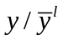) and the consumption index (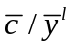) would track the support ratio exactly. The two indexes measure the extent to which income and consumption per equivalent consumer rise relative to income and consumption per equivalent consumer if only productivity changes induced by technological innovation are occurring. Income and consumption deviate from the support ratio because consumers vary the shares of their income that they devote to consumption and saving, and, as a result, assets and asset income vary.
Early in the transition, consumption and income decline by about the same amount as the support ratio. From Year 60 to Year 120, the consumption index is lower than the support ratio by roughly 5 percentage points and, thus, capital is being accumulated and income is growing more rapidly than the support ratio. After Year 60 the consumption index is growing at more or less the same rate as the support ratio. Just as the first dividend is coming to an end, the effects of the second dividend become increasingly apparent. Even though the support ratio begins to decline, consumption and income continues to increase relative to labor productivity. Income and consumption does begin to fall after about 150 years, but they remain above the support ratio peak for over 150 years (not shown). In steady-state (not shown) the consumption peak is about 18% above the level produced by the first dividend alone. The reason higher consumption can be sustained is that consumers have accumulated more assets. By doing so, they have converted a transitory dividend into a permanent one.
The annual growth effects of the dividends are modest, but important. The peak rate of growth for the support ratio is 0.8% per year in Years 95-100. Between Year 80 and Year 115, the support ratio increases by 0.5% per year or more. The consumption index grows at an annual rate peaking at about 1.0% per year for Year 115-120 and exceeding 0.5% per year between 80 and 130. The income index growth peaks at 1.2% per year between Years 95 and 100 and grows in excess of 0.5% per year for 55 years from Year 70 to Year 125. During this fifty-five year period, the only other source of economic growth is technological progress of 1.5% per year. Hence, the two demographic dividends combined contribute 25% or more of the economic growth experienced.
The second demographic dividend, measured in growth terms, is the difference between the rate of growth of the income index or the consumption index and the rate of growth of the support ratio. Growth of the income index consistently exceeds growth of the support ratio beginning in Year 65. The second dividend, measured in this ways, contributes 0.3% per year in additional growth between Year 75 and Year 130. The growth of the consumption index does not consistently exceed the growth rate of the support ratio until Year 85. The delay reflects the higher rates of saving and lower rates of consumption required in order to realize the second demographic dividend. The consumption index grows more rapidly than the support ratio until Year 200, but the second dividend, measured in this way, exceeds 0.1% per year between Year 95 and Year 170 and it exceeds 0.25% between Year 105 and 145.
Wealth variables are shown in the third panel of Figure 5. A key point is that the demand for pension wealth is very weak in the early stages of the demographic transition. First, most adults are young and they have not yet accumulated much pension wealth irrespective of their expectations about retirement. Second, those who are currently working, particularly those who have been working sufficiently long to have accumulated pension wealth, have little incentive to do so, because they anticipate a relatively short duration of retirement. Third, the costs of childrearing are very high. Because the population is dominated by such a large number of children, and the support ratio is correspondingly low, consumption during retirement is low. Moreover, the support ratio will continue to be low for decades. Hence, anticipated consumption during retirement is low. This leads to an even lower demand for retirement wealth. Pension wealth is barely discernible only in Year 70 and later.
Of particular importance in the early part of the demographic transition is the decline in fertility and its implications for child costs. The child transfer wealth values presented here are the present values of future childrearing costs to year t adults. Between Year 0 and Year 75, the childrearing debt is very high – equal to six to seven times annual labor income. The childrearing debt declines for two reasons. First, fertility drops more rapidly than child mortality and, hence, the surviving number of children decline. Second, the age distribution of adults begins to shift towards older ages so that adults, as a group, have completed a larger portion of their childrearing. There is a countervailing effect, however, because consumption per child rises relative to labor income as the number of children declines. The process is largely completed after 100 years. At that point childrearing debt stabilizes at about 3 times annual labor income.
Pension wealth and assets rise very substantially over the transition. In Year 50 there is a negligible demand for pension wealth as explained above. By Year 200, pension wealth has reached nearly 8 times annual labor income and assets have reached nearly 5 times annual labor income, as compared with a value of about 4 for current-day US.
The impact of this enormous increase in assets is muted in the simulation results presented here because the economy is small and open. The effect of a four-fold increase in the ratio of capital to labor income, experienced between Year 100 and Year 150 for example, would be to double output per worker assuming a standard Cobb-Douglas production function. This would produce an effect on consumption substantially higher

Figure 5. A Generic Demographic Transition and its Macroeconomic Consequences

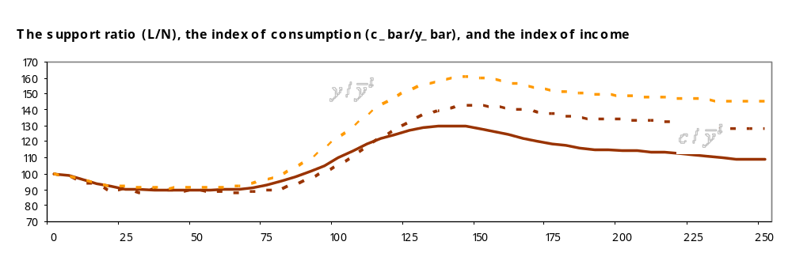
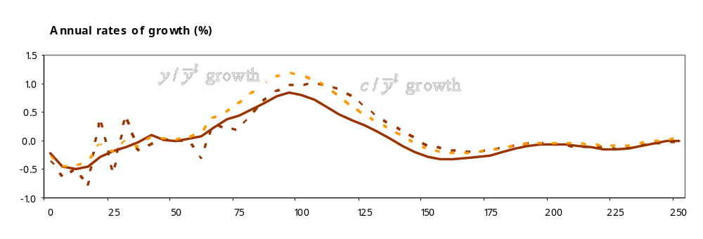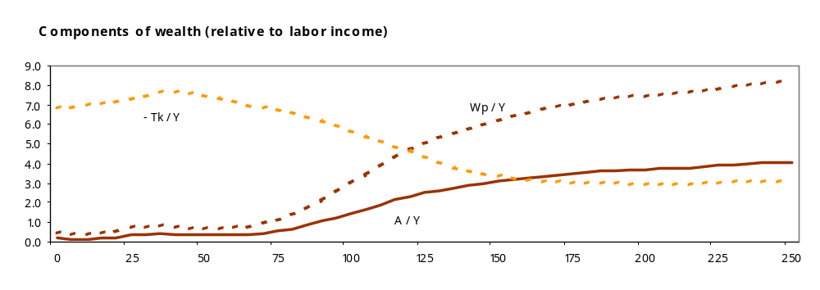
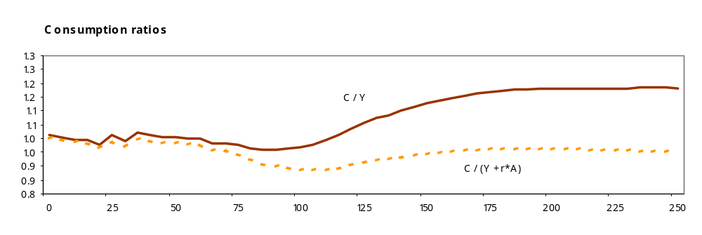
in a closed economy. Of course, even if the world consists entirely of open economies, the rise of assets will produce increases in wages and output.
The final baseline results we present are for the aggregate consumption rate. Consumption as a fraction of labor income and consumption as a fraction of net national income (Y+rA) are charted in final panel of Figure 5. Consumption as a fraction of labor income is of interest because of the key role it plays in equation 1. Consumption rises about 30 percent relative to labor income between Year 105-110 and Year 200-205. This is the cumulative effect of the second dividend.
The ratio of consumption to national income is of interest because its complement is saving as a fraction of national income. We see clear evidence of the saving boom often attributed to demographic effects in the literature – the saving rate rises from close to zero at the beginning of the simulation to peak at about 15 percent of national income. Thereafter, the saving rate declines to a steady state rate of about 6% of national income. An important point is that the decline in saving does not produce a decline in assets. The lower level of saving is sufficient to maintain assets at the high level shown in the third panel of Figure 5.

Four Developing Countries: Brazil, China, India, and Nigeria
The simulation analysis presented in this section examines four large developing countries, Brazil, China, India, and Nigeria, each with their own distinctive demographic experiences. The simulations employ the developing country economic lifecycle presented above and a constant of 0.5 – a relatively strong degree of reliance on asset accumulation to fund old age consumption. Other than the economic lifecycle, the demographic data, and the value of , the same assumptions are used in all simulations reported here. Hence, there are many important characteristics of individual countries – educational systems, financial systems, culture, geography, and so on – that are not incorporated into the simulations. Nor do these simulations incorporate the actual policies towards old-age support that are being pursued in individual countries. The objective here is very specific – to assess how demographic changes in these countries would affect macroeconomic performance given a particular set of policies.
We do not describe the demographic transitions of the four developing countries in any detail. Brazil and China are relatively far along in their demographic transitions with life expectancy at birth for 2000-05 in excess of 70 years of age and relatively low fertility rates – 2.35 in Brazil and 1.7 in China. During the same period India’s life expectancy was in the low 60s and its TFR was about 3 births per woman. Nigeria is at a much earlier point in the transition with a life expectancy in the 40s and a TFR of nearly 6 births per woman (United Nations Population Division 2005). One additional feature of note is the remarkable speed of China’s fertility transition. Its TFR dropped from 6 births per woman in 1965-70 to under 2 births per woman twenty-five years later.
If these four developing countries rely on asset accumulation to finance half of old age support as assumed, assets will grow substantially between 1950 and 2100. The simulated ratio of assets to labor income was less than 1 in 1950 in each country. By 2100 the wealth/labor income ratio varies from a low of 3.2 in Nigeria to a high of 4.2 in Brazil (Figure 6). The progression is relatively steady in India and Brazil, although the simulated capital accumulation in India lags that of Brazil by several decades at the current time and by even more in the future. The effect of Nigeria’s delayed demographic transition is very apparent. For several decades starting around 1960, demographic change drives assets to lower levels. As we will see momentarily, the support ratio deteriorates during this period depressing income, consumption, and consequently lifecycle wealth and assets. The support ratio hits bottom in 2000 and then begins to increase. Only then do we begin to see any significant increase in assets. However, the most important take-away message from the Nigerian simulation is how early the increasing demand for assets and the second dividend arise. An increased demand for assets for old age support begins when Nigeria’s population is at its youngest! Preparing for aging that will come in the future is what leads to a second demographic dividend.
The China case is interesting because its demographic transition has been so compressed. In the 1950s, the demand for assets for old-age support was essentially nil. Between 1960 and 1975, the demand for lifecycle assets increased dramatically, much more rapidly than in the other developing countries, although similar to the changes for Japan (=0.5).

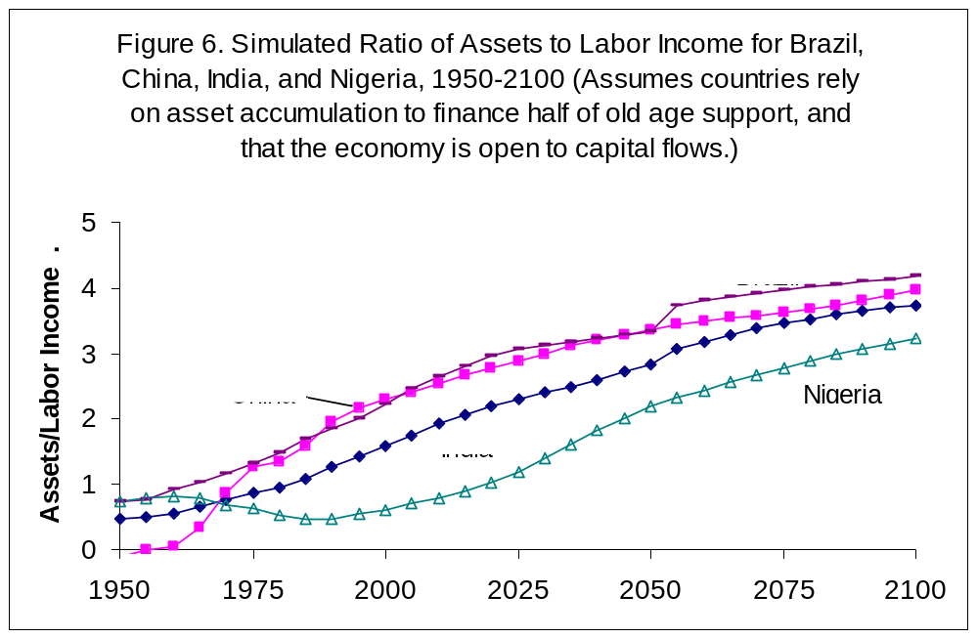

The effects of age structure on economic growth are measured using three series in Figure 7. The support ratio (L/N) measures the first dividend. In the absence of any change in saving behavior and any technological innovation, income and consumption per capita would rise and fall by the same percentage as the support ratio. If there is also a second dividend due to asset accumulation then both income and consumption per equivalent consumer will also rise due to asset income and, in a closed economy, due to increased labor earnings. These additional effects are shown by the income index () and consumption index. The income index is income per equivalent consumer relative to labor income per equivalent consumer (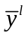). The consumption index (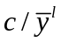) is consumption per equivalent consumer relative to labor income per equivalent consumer. The ratio tells us the gains in consumption per equivalent consumer beyond those due to technological innovation – the only factor influencing labor income in the open economy model.

Figure 7. Simulated Demographic Dividends in Four Developing Countries: Brazil, China, India, and Nigeria, 1950-2100 (assuming countries rely on asset accumulation to finance half of old age support, and that the economy is open to capital flows).
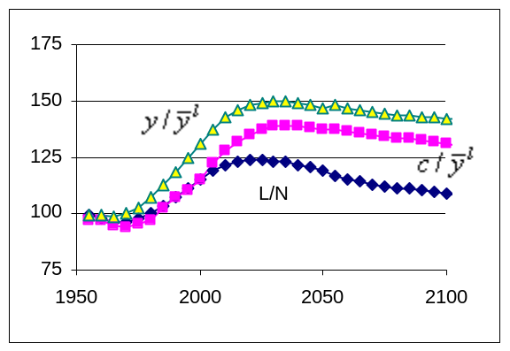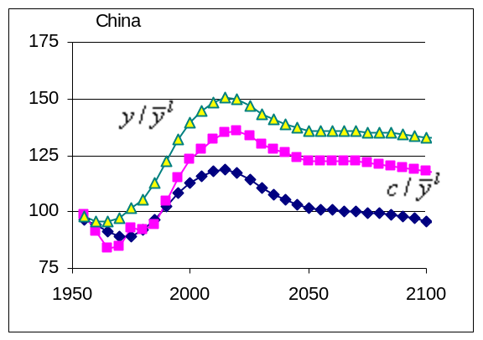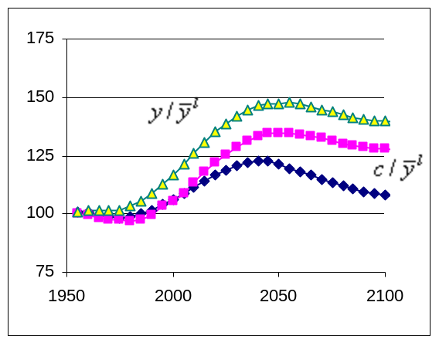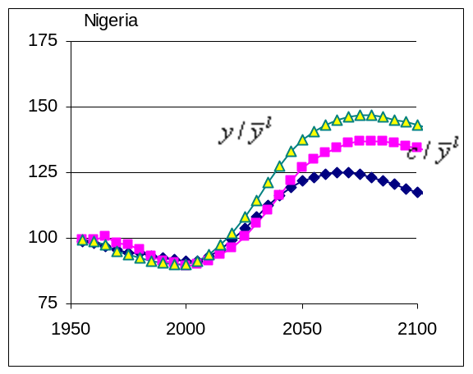

The consumption index and the income index are alternative ways of measuring the full effect of age structure on economic growth. Each of the series is normalized on its value for 1950. For example, a value of 125 for the support ratio would indicate that the support ratio is 25% above its 1950 level. In the absence of a second dividend, the three series would be identical. The magnitude of the second dividend is assessed by comparing the percentage increase in consumption and income to the percentage gain in the support ratio.
In the 1950s and 1960s the support ratio was relatively stable (at a low level) in Brazil and India and declining in China and in Nigeria where it continued to deteriorate for the rest of the 20th Century. The support ratio began to increase in 1970 in Brazil and China, 1975 in India, and 2000 in Nigeria. The projected duration of the dividend period is shortest in China, only 45 years, and longest in Nigeria at 70 years. The subsequent decline in the support ratio is especially precipitous in China because of its low fertility.
Figure 7 indicates that in each country income per equivalent consumer rises by about 50 percent relative to 1950. The peak is achieved in China in 2015, Brazil in 2030, India in 2055, and in Nigeria in 2075. Thereafter, income per equivalent consumer begins to decline gradually, but more rapidly in China. The importance of the second dividend is quite evident in Figure 7. Income and consumption both rise more rapidly than the support ratio and they remain at a much higher level than the support ratio as population aging becomes more important.
The measured size of the first and second dividends depends very much on the particular time period being considered. One approach is to compare the dividends during the demographic window, i.e., the period during which the support ratio is increasing (Table 1). During this period the first dividend is having its maximum positive effect on income per effective consumer. The largest annual effect is in China where the first dividend raises growth in income per equivalent consumer by 0.63 percent per year for a relatively short demographic window of 45 years. The second dividend adds an additional 0.28 percent per year of growth bringing the total dividend to 0.91 percent per year. The total effect is to raise income per equivalent consumer by 54% between 1970 and 2015. The annual effects in China are somewhat larger than in the other countries. The total gain is greatest in Nigeria.

Table 1. Simulated Effects of Age Structure on Income per Equivalent Consumer During the Dividend Period, assuming countries rely on asset accumulation to finance half of old age support, and that the economy is open to capital flows.
 |  |  | Annual Gains (percent) |  |  | Total  Gain  (%)
 | Dividend  period | Duration | First  Dividend | Second  dividend | Total  dividend | Total  Gain  (%)
Brazil | 1970-2025 | 55 | 0.46 | 0.23 | 0.69 | 49.3
China | 1970-2015 | 45 | 0.63 | 0.28 | 0.91 | 54.1
India | 1975-2040 | 65 | 0.34 | 0.22 | 0.56 | 43.8
Nigeria | 2000-2070 | 70 | 0.45 | 0.24 | 0.69 | 62.3

The significance of the second dividend is more apparent when we include the post-dividend period in the analysis, since that period includes population aging and deteriorating support ratios. Calculations of the first, second, and total dividend 30 years and 60 years after the dividend period are reported in Table 2. For example, the periods considered for Brazil are 1970-2055 and 1970-2085 rather than 1970-2025 as in Table 1. The first dividend is dissipating when we move beyond the dividend period, but the second dividend is not. The gain from the second dividend is as great after 30 years or after 60 years as it was at the end of the dividend period. Income per equivalent consumer is “permanently” higher by twenty-five to thirty-percent due to the second dividend.

Table 2. Simulated Effects of Age Structure on Income per Equivalent Consumer During the Dividend Period +30 and +60 years, assuming countries rely on asset accumulation to finance half of old age support, and that the economy is open to capital flows.
 | Dividend period + 30 years |  |  | Dividend period + 60 years
 | First  dividend | Second  dividend | Total  dividend | First  dividend | Second  Dividend | Total  Dividend
Brazil | 21.7 | 26.4 | 48.1 | 15.4 | 27.9 | 43.4
China | 15.8 | 24.5 | 40.3 | 11.8 | 26.8 | 38.6
India | 16.9 | 25.3 | 42.3 | 10.2 | 27.1 | 37.3
Nigeria | 28.9 | 29.7 | 58.6 | 23.7 | 30.9 | 54.7

Industrialized Countries: Japan and the United States
For Japan and the United States the demographic window has just closed. The support ratio has reached its peak in both countries and begun to decline. Up until 2050 the rate of decline is expected to be more rapid in Japan than in the United States, but more rapid in the US after 2050. The rates of decline over the entire 21st Century are surprisingly similar. Japan has an older population than does the US and by conventional demographic measures Japan will be aging more rapidly during this century. However, the economic support ratios also incorporate differences in the economic lifecycles between the two countries. As shown above, the gap between consumption and labor income for the elderly is larger in the US than in Japan. Thus, from an economic perspective the rates of aging are similar for the two countries. The annual rate of decline in the support ratio in Japan is -0.28% per year and in the US is -0.24% per year between 2000 and 2100.
The demographic changes leading up to 2000 were very different in Japan and the US, however. Japan experienced a very brief baby boom after the end of World War II, but fertility declined quite rapidly thereafter. The result was a relatively pronounced dividend period, although one that was much smaller than in other East Asian countries which had much higher fertility rates than Japan in 1950. In contrast, the driving demographic change in the US prior to 2000 was the baby boom which produced a drop in the support ratio during the 1950s and 1960s followed by recovery during the next two decades. By 2000, the support ratio in the US was essentially identical to the level prevailing in 1950.
In the absence of a second dividend and given the level of technology, per capita income would track the support ratio exactly. In Japan, the result would have been an increase in per capita income in excess of 25% followed by a decline of essentially equal magnitude. In the US, the decline in the support ratio would depress per capita income by about 25%.
Two sets of simulations for Japan and the US have been prepared using different assumptions about the emphasis on capital accumulation versus transfer systems for meeting retirement needs. One set of simulations is based on the assumption that fifty percent of lifecycle pension wealth is derived from assets and fifty percent from public or familial transfers as assumed in the simulations presented above. The second set of simulations is based on the assumption that only thirty-five percent of lifecycle pension wealth is derived from assets and the remaining sixty-five percent from public or familial transfers.
The simulated paths of assets for the two scenarios are shown in Figure 8. Given a modest saving policy, Japan and the US have very similar paths. Assets grow at a relatively modest pace throughout the simulation. The ratios of assets to labor income increase from between 1.3 in Japan and 1.5 in the US in 1950 to over 2.0 in both countries by 1975 and about 2.5 in 2000. Assets continue to grow relative to labor income during the next 100 years reaching 3.5 in the US and 3.3 in Japan in 2200.
Asset growth is much more rapid, especially in Japan, when 50 percent of pension needs are met through asset accumulation. Japan’s accumulation is very dramatic between 1950 and 1975 as the ratio of assets to labor income increases from 1.3 in 1950 to 4.1 in 1975. By 2000 Japan’s asset ratio reaches 5.2 and rises to 6.5 in 2100. In the US, assets are much higher than in Japan in 1950 and US assets grow more slowly than do Japan’s for a time. But eventually, the US asset ratio passes the asset ratio for Japan. The key point holds for both countries: Population aging produces an increase in the demand for assets that may be quite substantial depending on the policy towards old age support systems.

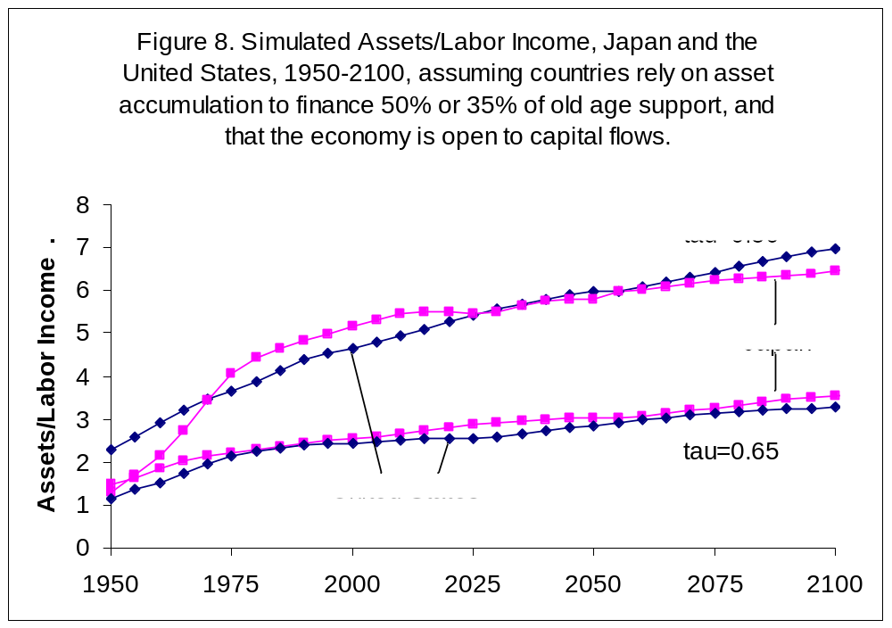

An increase in assets leads to more rapid growth in consumption and income per equivalent consumer (Figures 9 and 10). As explained above and defined in the appendix, the income and consumption indexes are based on the changes due to age structure with the effects of technological innovation controlled. They measure the combined effects of the first and the second dividend relative to the age structure of 1950. In Japan the combined effect of the dividends was to push income and consumption per equivalent consumer higher by 70 percent between 1950 and 2000. The first dividend alone would have produced a 30% increase with the second dividend raising consumption and income an additional 40%. During the 21st Century, the support ratio, consumption per equivalent consumer, and income per equivalent consumer all decline at approximately the same rate. The combined effect of age structure, the first and second dividend combined, is to raise income and consumption as compared with the very young age structure of 1950. But as compared with the favorable conditions of 2000, changes in age structure reduce consumption and income by about 20%. The post-1950 first dividend is projected to dissipate entirely by 2040 when the support ratio returns to the 1950 level.

Figure 9. Simulated Macroeconomic Effects of Demographic Change in Japan and the United States, 1950-2100: High-Saving Scenario (assuming countries rely on asset accumulation to finance 50% of old age support, and that the economy is open to capital flows).
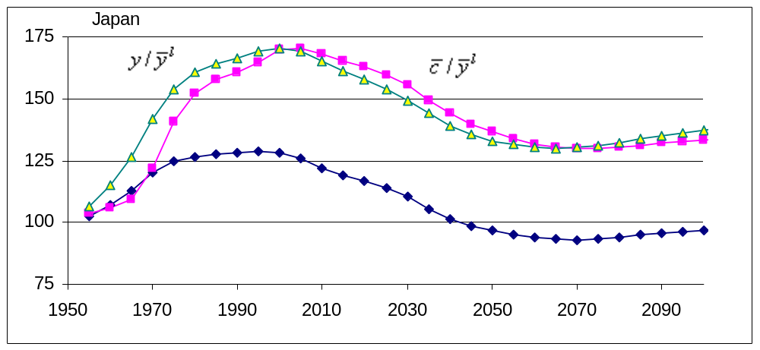
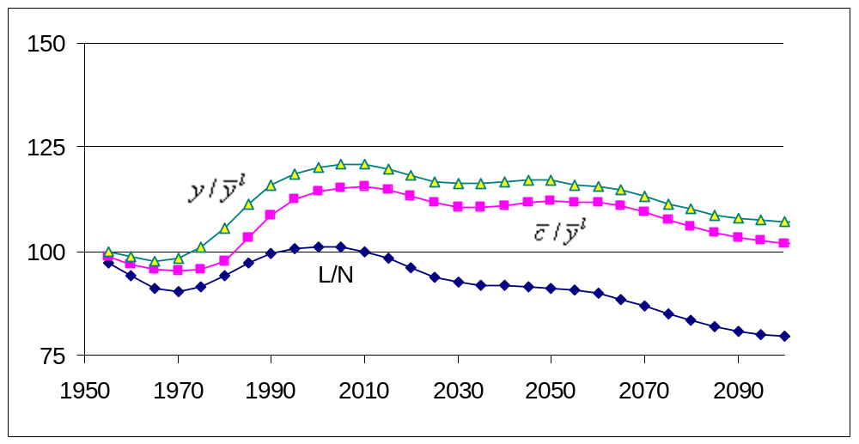

The second dividend persists, however, with consumption and income per equivalent consumer about 40% higher than the support ratio in 2100. It is worth emphasizing that the values plotted in these figures do not include the effect of technological gains. If they were included income and consumption would increase throughout the simulation. The charts only show the effects of demography.

In a number of important ways, the US simulations differ from the Japan simulation and other simulations presented above. The US experienced a mini-demographic window between 1970 and 2000 during which the support ratio increased by about 10%. A very substantial and prolonged dividend period occurred earlier in the US when fertility rates dropped from high levels to low levels in the late 19th and early 20th Centuries (Mason 2007 forthcoming). In any event, by 2000 the US support ratio recovered from the depressed level attributable to the US baby boom. Thereafter the effects of population aging are dominant leading to a decline in the support ratio similar in magnitude to the decline anticipated for Japan. By 2100, the support ratio will have declined by almost 25 percent as compared with 2000. Income and consumption per equivalent consumer will decline by a little less than 25 percent. By 2100 the second dividend will be raising income and consumption per equivalent adult by close to 30 percent as compared with the effect of the first dividend alone.
The importance of considering the effects of age structure on consumption as well as income is very apparent from the simulation. In Japan, for example, consumption per equivalent adult does not increase as rapidly as income per equivalent adult or even as rapidly as the support ratio in the 1950s and 1960s in Figure 9. During these two decades Japan’s population reduced their consumption and sacrificed their living standards. Doing so allowed them to accumulate assets more rapidly, leading to more rapid growth in income and consumption during the 1970s and subsequent decades.
The implications of pursuing a policy that emphasizes transfer wealth over asset accumulation is clear when we compare the paths of income and consumption in the low-saving scenario in Figure 10 with the paths of income and consumption in the high-saving scenario. Consumption and income per equivalent consumer peaked in 2000 at about 45% above the 1950 levels (Figure 10) as compared with a 70% gain under the high saving simulation (Figure 9). Over the longer term, income and consumption indexes are about 20% greater than the support ratio under the low saving scenario (Figure 10) as compare with a 40% gain in the high-saving simulation (Figure 9). Comparing the US simulations in Figures 9 and 10 demonstrates, as well, that relying on asset accumulation more and transfer programs less to fund old-age consumption has a strong favorable effects on economic growth during the first dividend period and on the long-run sustainable levels of consumption and income.

Figure 10. Simulated Macroeconomic Effects of Demographic Change in Japan and the United States, 1950-2100: Low-Saving Scenario, (assuming countries rely on asset accumulation to finance 35% of old age support, and that the economy is open to capital flows).
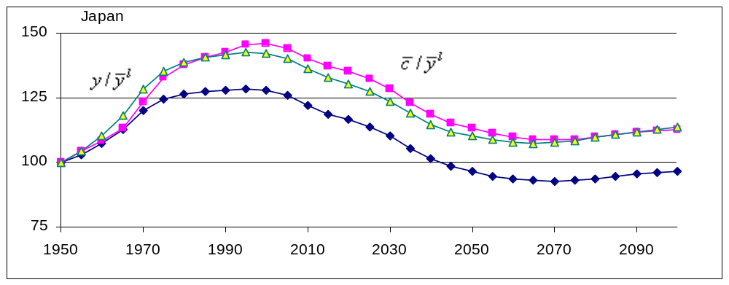
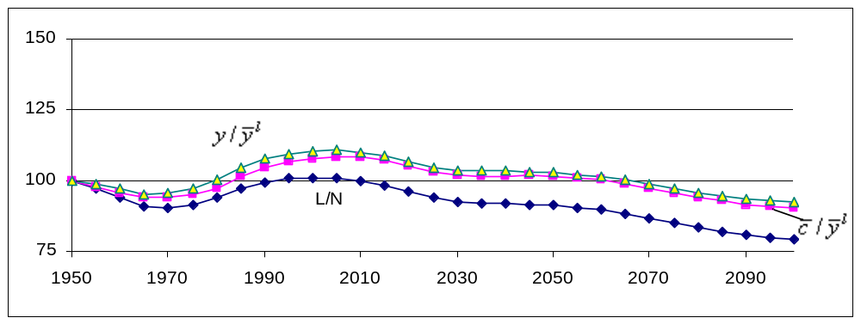
Note: All variables expressed relative to value in 1950.

Comparing with recent research on saving and investment
At first glance the conclusion that population aging may lead to a permanent increase in assets or capital per capita seems to contradict the commonly expressed view that population aging will lead to a decline in saving and investment rates. Two recent studies raise questions about the connection between saving and population aging (Deaton and Paxson 2000; Kinugasa and Mason 2007 forthcoming), but Higgins and Williamson (Higgins 1994; Higgins and Williamson 1997; Williamson and Higgins 2001), Borsch-Supan (2005) and Kelley and Schmidt (1996) conclude that saving and investment rates will decline as populations age.
There is nothing inconsistent, however, with the conclusion that saving rates will decline and that assets per worker will increase. There are two reasons why this can occur. First, some portion of saving goes towards capital deepening, i.e., an increase in capital or assets per person. Higher rates of saving will produce more rapid capital deepening. The simulated changes shown above, particularly in countries with rapid changes in age structure like China and Japan, are marked by rapid capital deepening and, hence, elevated saving rates. Once the deepening process slows or is completed, saving rates decline while assets do not. Second, some portion of saving goes towards capital widening. Over the demographic transition, the rate of population growth slows as does the growth in GDP and aggregate labor income. Consequently, less saving is devoted to capital widening and, consequently, lower saving rates are required to maintain the capital-labor ratio or the capital-income ratio.

Support Systems and Policy
In virtually all societies, children live with their parents and are raised by them, with the children’s consumption, education, and health care (all of which will be classified here as consumption) funded out of their parents’ production. To be sure, children may partially defray their costs through work in the home, the field, or the labor market. At the other end of the age spectrum, in many countries the elderly live with one of their adult children, and consume largely out of their children’s income. The elderly may continue to be productive, both within the home and outside. Some elderly also make transfers to their children and grandchildren, perhaps helping to fund education or the purchase of property, and many leave bequests when they die to family members. This is the well-known family support system.
In most countries, these private transfers are accompanied by public ones. Most countries provide some public education for children, with the costs born by adult taxpayers. Most countries also provide publicly funded health care to some degree, which is also a transfer. Nursing home care for the elderly is another program of this sort. Education, health care and long term care are all “in-kind” transfers, meaning that receiving the transfer and consuming it are one and the same, unlike a cash transfer. Many countries also have public pension programs which pay cash benefits to retirees. Public pension programs can be funded, in the sense that the program holds assets equal in value to the present value of its net obligations. They can also be unfunded, in the sense that current benefits are paid for out of current tax revenues, with the program holding only minimal assets. Unfunded pensions are transfers from the working age population to the elderly recipients. Funded pensions are simply government organized programs of saving and capital accumulation. As public transfer systems for old age support grow in size and coverage, they may increasingly substitute for and displace familial transfers, or even lead to a reversal of flows within the family as the elderly pass some of their pension benefits on to their children.
These public and familial transfer systems are supplemented by savings and the accumulation of assets over a worker’s life time, perhaps augmented by the transfer of assets from elderly parents during their lives or as bequests when they die. In this way, adults may arrive at old age with assets which help finance their consumption in retirement. Funded pension programs, whether organized by the public sector or by employers, institutionalize this sort of asset accumulation.
Patterns of provision for the consumption of elderly and children differ from country to country, but there are some general trends. Industrial nations mostly have relatively generous public pension systems covering most of their elderly, and these are almost entirely unfunded, or “pay-as-you-go”. Many Latin American countries have public pension systems with quite broad coverage. Some of these are in the process of conversion from unfunded to funded status, most famously Chile, but there are others as well. Even Chile, although it is in transition to a fully privatized system, still has a carry-over of unfunded obligations and so is currently a mix of funded and unfunded systems. Most of the rest of the world relies primarily on familial support for the elderly, although in many countries there is limited coverage of the population by public or private pensions.
Information on other forms of private transfers is more limited. However, it is clear that private expenditures on education are particularly high in many East Asian countries, where they may rival public expenditures. In many industrial nations, however, private educational expenditures are relatively low (Lee et al, 2005). Private expenditures on health care also vary widely.
Figure11 contrasts the provision for old age consumption in four countries in a recent year: Japan, Taiwan, Thailand and the United States. The differences are striking. For example, in Thailand public transfers account for only 3% of elder’s consumption, while in Japan they account for 65%, the US 37%, and Taiwan 26%. With low public transfers, Thailand has relatively high familial transfers at 31%, but not as high as Taiwan at 40%. The US and Japan have low family support at 7% and 3%. It is important to keep in mind that families in these countries are providing important support of other sorts, such as care time, advice, and management, but these will not show up in standard accounts.

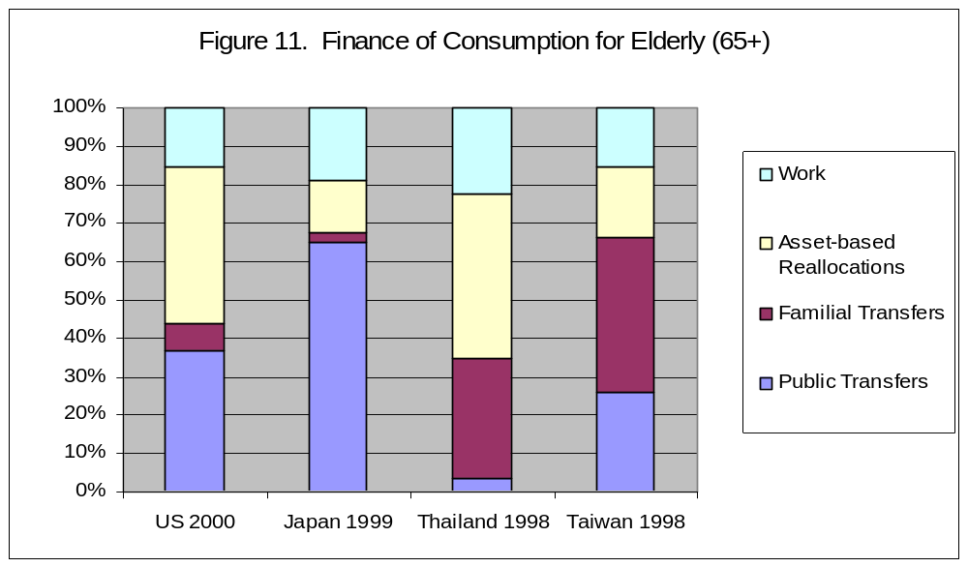Sources: Japan (Ogawa and Matsukura 2005); Thailand (Chawla 2006); Taiwan and US (Mason, Lee, Tung et al. forthcoming).

There is very likely substitution between public and private transfers, yet their sum also varies across the countries: in Taiwan total transfers fund 66% of old age consumption and in Japan 68%. The share is far less in the US at 44% and in Thailand at 35%. The balance is made up by asset income and by labor income. Labor income varies across these countries less than the other components, and is always between 15% and 22%. Asset income varies substantially. Thailand, with the lowest transfer income, has the highest asset income share at 43%. The US is similar at 41%. Surprisingly, Japan and Taiwan, both countries that have had very high savings rates in recent decades, have low asset income shares of only 13% and 18%.
Under the assumption that these patterns persist indefinitely into the future, the implication would be that population aging would yield a higher second dividend in Thailand and the US, with their low share of total transfers and high share of asset income, than in Taiwan and Japan. The higher the share of transfers and the lower the share of asset income, the more population aging will impose costs on workers rather than raising asset income and possibly labor productivity through domestic capital accumulation. However, this will only be true to the extent that the situation as shown in Figure11 does not change in years to come.
Current sources of support for the elderly reflect decisions made many years earlier, and these may be different than the decisions of current workers. Current workers may, for example, expect much less support than their parents are receiving, consistent with the observation that the percentage of elderly living with their children is in decline in many countries, and consistent with surveys indicating that young people are less likely to expect to receive familial support in old age themselves. Fertility rates in S. Korea are among the lowest in the world. It seems highly likely that S. Korea is in the midst of a transition from strong familial support for the elderly to increasing self-reliance through asset accumulation. But it is also possible that S. Korea may opt for a relatively strong public support system of some sort. Likewise in many Developed Countries there are calls for reform of unfunded public pension systems, including conversion to funded systems following Chile’s example. There is also rapid growth in public spending on health care and long term care for the elderly, and these trends may lead to an increasing role for public transfers.
Decisions made now by individuals and policy makers will shape the old age support system of the future, and the economic consequences of population aging will depend in part on these decisions. Public and private transfer systems have many advantages, but they also have costs. The institutional changes and policy decisions made about support systems in the coming decades will matter as much as population aging for the macroeconomy.

References
Barro, R. J. and X. Sala-i-Martin (1995). Economic growth. New York; London and Montreal, McGraw-Hill.
Bloom, D. E., D. Canning and J. Sevilla (2002). The Demographic Dividend: A New Perspective on the Economic Consequences of Population Change. Santa Monica, CA, RAND.
Bloom, D. E. and J. G. Williamson (1998). "Demographic Transitions and Economic Miracles in Emerging Asia." World Bank Economic Review 12(3): 419-56.
Axel Borsch-Supan (2005) “The Impact of Global Aging on Labor, Product and Capital Markets”, unpublished manuscript, version of March 22.
Chawla, A. (2006). "National Transfer Account Estimates for Thailand." mimeo.
Deaton, A. and C. H. Paxson (2000). Growth, Demographic Structure, and National Saving in Taiwan. Population and Economic Change in East Asia, A Supplement to Population and Development Review. R. Lee and C. Y. C. Chu. New York, Population Council. 26: 141-173.
Higgins, M. (1994). The demographic determinants of savings, investment and international capital flows. Department of Economics. Cambridge, MA, Harvard University.
Higgins, M. and J. G. Williamson (1997). "Age Structure Dynamics in Asia and Dependence on Foreign Capital." Population and Development Review 23(2): 261-93.
Kelley, A. C. and R. M. Schmidt (1996). "Saving, Dependency and Development." Journal of Population Economics 9(4): 365-86.
Kinugasa, T. and A. Mason (2007 forthcoming). "Why Nations Become Wealthy: The Effects of Adult Longevity on Saving." World Development 35(1): 1-23.
Lee, R. D., S.-H. Lee and A. Mason (2007 forthcoming). Charting the Economic Lifecycle. Population Aging, Human Capital Accumulation, and Productivity Growth, a supplement to Population and Development Review 33. A. Prskawetz, D. E. Bloom and W. Lutz. New York, Population Council.
Mankiw, G., D. Romer and D. Weil (1992). "A Contribution to the Empirics of Economic Growth." Quarterly Journal of Economics 107(2): 407-37.
Mason, A. (2001). Population Change and Economic Development in East Asia: Challenges Met, Opportunities Seized. Stanford, Stanford University Press.
Mason, A. (2005). Demographic Transition and Demographic Dividends in Developed and Developing Countries. United Nations Expert Group Meeting on Social and Economic Implications of Changing Population Age Structures, Mexico City.
Mason, A. (2007 forthcoming). Demographic Dividends: The Past, the Present, and the Future. Population Change, Labor Markets and Sustainable Growth: Towards a New Economic Paradigm. A. Mason and M. Yamaguchi, Elsevier Press.
Mason, A. and R. Lee (2006 forthcoming). "Reform and Support Systems for the Elderly in Developing Countries: Capturing the Second Demographic Dividend." GENUS LXII(2): 1-25.
Mason, A. and R. Lee (2007 forthcoming). Transfers, Capital, and Consumption over the Demographic Transition. Population Aging, Intergenerational Transfers and the Macroeconomy. R. Clark, A. Mason and N. Ogawa, Elgar Press.
Mason, A., R. Lee, A.-C. Tung, M. S. Lai and T. Miller (forthcoming). Population Aging and Intergenerational Transfers: Introducing Age into National Accounts. Developments in the Economics of Aging. D. Wise. Chicago, NBER and University of Chicago Press.
Ogawa, N., A. Mason, Maliki, R. Matsukura and K. Nemoto (2007 forthcoming). Population Aging and Health Care Spending in Japan:
Public and Private Sector Responses. Population Aging, Intergenerational Transfers and the Macroeconomy. R. Clark, A. Mason and N. Ogawa, Elgar Press.
Ogawa, N. and R. Matsukura (2005). The Role of Older Persons' Changing Health and Wealth in an Aging Society: The Case of Japan. UN Expert Group Meeting on Social and Economic Implications of Changing Population Age Structure, Mexico City.
United Nations Population Division (2004). World Population to 2300. New York, United Nations.
United Nations Population Division (2005). World Population Prospects: The 2004 Revision. New York, United Nations.
Williamson, J. G. and M. Higgins (2001). The Accumulation and Demography Connection in East Asia. Population Change and Economic Development in East Asia: Challenges Met, Opportunities Seized. A. Mason. Stanford, Stanford University Press: 123-54.

Appendix
With no loss of generality, the index of consumption is represented as 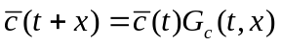, the product of the initial index of consumption and a growth factor. The consumption growth factor is endogenous. The rate at which the consumption profile can shift upward will depend on changes in the support ratio, the rate of technological innovation, asset accumulation, and interest rates to name a few key factors.
Combining equations , , and , lifecycle wealth of all year t adults in year t is:
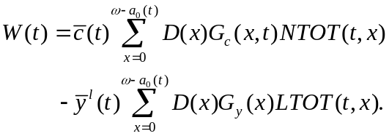
where 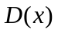 is the discount factor 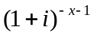, 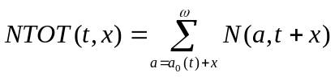 is the total number of year t adults alive in year t+x measured as effective consumers, and 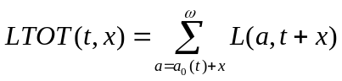 is the total number of year t adults alive in year t+x measured as effective producers.
Child transfer wealth is equal to:
where 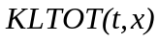 and 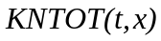 are the effective numbers of child producers and consumers, respectively, in year t+x for whom year t adults are financially responsible.
Noting that lifecycle wealth equals the sum of child transfer wealth and lifecycle pension wealth and combining results from equations and yields an expression for lifecycle pension wealth:
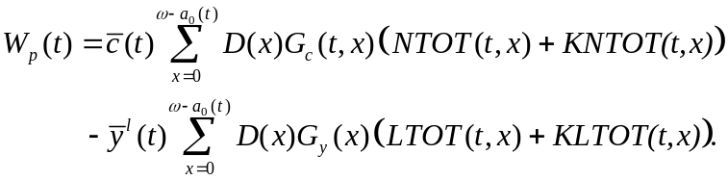
The value of assets held by adults at any point in time is given by:
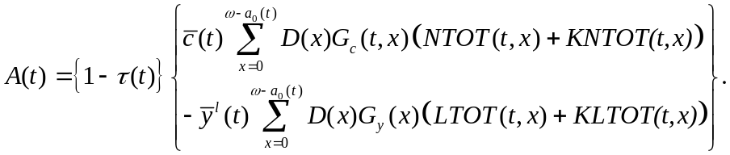

Consumption and income indexes
The shape of the labor income profile is fixed but shifts upward over time at the rate of technological progress, . Thus, income per equivalent consumer is equal to 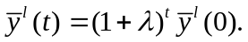 The trend in consumption per equivalent consumer controlling for the effect of technological innovation is equal to 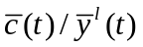. The income index is calculated in similar fashion. Income is computed as labor income plus income from assets. Income per equivalent consumer is calculated by dividing by the total number of consumer. Dividing income per equivalent consumer by 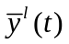 measures the trend in income controlling for technological progress. Both indexes are normalized on their value in 1950.

Developing the National Transfer Account System is a collaborative international effort supported by NIA, R01-AG025488 and NIA, R37-AG025247.
The estimates were constructed by Luis Rosero-Bixby (Costa Rica), Maliki (Indonesia); Mun-Sim Lai, Andrew Mason, and An-Chi Tung (Taiwan); and, Chawla Amonthep (Thailand).
The Japan estimates were constructed by a research team at Nihon University Population Research Institute led by Naohiro Ogawa and the US estimates by a team at the Center for the Economics and Demography of Aging led by Ronald Lee.
The appendix provides additional mathematical details.
We assume that assets are measured at the beginning of the period and that consumption and income accrue at the end of the period.
We assume that steady-state is achieved in 2300 which is the last year for which long-range population projections are available. Simulated values for 2000 to 2150 are nearly identical when we assume steady-state is reached in 2200.
The steady-state international rate of return is calculated using the same set of assumptions for the global economy and the global population distribution in 2300 weighted to reflect current differences in per capita income between the developing and developed countries. In the global calculations, however, the rate of return is endogenous. Details are available from the authors.
See appendix for more details.
The mild discontinuities at 2050 in Brazil and India reflect discontinuities in the underlying population projections employed. The population data up to 2050 are drawn from the most recently available UN Population Prospects, whereas the population data after 2050 are taken from the UN Population Division Long Range Projections.
In the standard Solow model saving rates are held constant and a decline in the population growth rate leads to a decline in the steady-state ratio of capital to income. Thus, saving rates exceed the level necessary to maintain the steady-state K/Y and capital deepening occurs. This could also occur in the simulation presented here with a slower pace of capital deepening.
Along a steady-state growth path, the consumption growth factor will increase at a constant rate, the same rate at which the productivity growth factor is increasing.

