Notes on the progress of NTA
China 2002
（Work Progress Report of 39th EWC Summer Seminar）
Ling Li, Qiulin Chen, Yu Jiang
I．Data Description
Data: Chinese Household Income Project (CHIP) data, year 2002. The survey is conducted by the China Social Science Academy every 7 years; So far, three waves of surveys have been conducted at 1988, 1995 and 2002 respectively. We apply the 2002 data.
The CHIP2002 survey is conducted at the rural and urban area separately, with 2 different questionnaires. The rural data contains 9200 households and 37762 individuals, while the urban data contains 6835 households and 20548 individuals. Statistical analysis shows that the sample is well reprehensive.
Both the urban and rural data contain information concerning (1) personal character, such as age, gender, relation to the house head, work status, education level, etc; (2) Individual income by item, including earnings, benefits, operating surplus. For the urban, transfer income and asset income are reported at individual level, while for the rural, transfer income and asset income are reported at the household level; (3) Saving and assets data at the household level, including the stock of assets, market value of durable goods；(4) Expenditure data at the household level, including education expenditure, training expenditure, healthcare expenditure and other expenditure. For the detail, please refer to the appendix for questionnaires.
II. Aggregate Control
1. Aggregate Data

For Aggregate data, the main resources are “National Accounts Statistics: Main Aggregates and Detailed Tables, 2005 (UNSNA 2005) from the UN, Government Finance Statistics Yearbook (GFS 2002 & 2006) from the IMF and China Statistical Yearbook from China National Bureau of Statistics.

2. Aggregate Control

In aggregate level, the National Transfer Account (NTA) is based on the National Account (NA, Combining Income Approach and Expenditure Approach). National Accounts for year 1995 and 2002 are both from National Accounts Statistics: Main Aggregates and Detailed Tables, 2005 (UNSNA 2005), which is consistent with China’s Statistics Yearbooks. But the numbers of expenditure account and income account are not equal due to the statistics discrepancy, so we just assume that the statistics discrepancy in production account is the consumption of capital in income account, which guarantees the e equivalence of Expenditure and Generation of GDP.

Table 1 National Account of China, 1995
Expenditure on the Gross Domestic Product |  |  | Generation of Domestic Production
Final Consumption Expenditure |  | 33635.0 | Compensation of Employees |  | 33660.0
General Government | 6690.5 |  | Operating Surplus (incl. mixed income) |  | 17040.3
Household | 26944.5 |  | Indirect Taxes on products and imports |  | 7777.8
Gross Capital Formation |  | 23877.0 | Subsidies |  | 0.0
Gross Fixed Capital Formation | 20300.5 |  | Consumption of Capital (Depreciation) |  | 32.4
Changes in Inventories | 3576.5
Net Export |  | 998.5
Exports of Goods and Services | 12295.5
Less: Imports of Goods and Services | 11297.0
Statistical Discrepancy |  | -32.4
 |  | 58510.5 |  |  | 58510.5

Table 2 National Transfer Account of China, 1995
Lifecycle Deficit |  | -7481.5 | Lifecycle Reallocation |  | -7481.5
Consumption |  | 28019.9 | Asset-based Reallocation |  | -7601.3
Private Consumption | 21329.4 |  | Net Private asset Income | 15409.9
Public Conumption | 6690.5 |  | Private Savings | -21165.6
Labor Income |  | 35501.4 | Net Public asset Income | 968.5
 |  |  | Public Savings | -2814.1
 |  |  | Net Transfers |  | 119.8
 |  |  | Net Private Transfers | 95.0
 |  |  | Net Public Transfers | 24.8
Note: Calculated by the authors

Table 3 National Account of China, 2002
Expenditure on the Gross Domestic Product |  |  | Generation of Domestic Production
Final Consumption Expenditure |  | 62798.5 | Compensation of Employees |  | 62524.3
General Government | 13916.9 |  | Operating Surplus (incl. mixed income) |  | 24813.6
Household | 48881.6 |  | Indirect Taxes on products and imports |  | 17834.2
Gross Capital Formation |  | 42304.9 | Subsidies |  | 0.0
Gross Fixed Capital Formation | 41918.3 |  | Consumption of Capital (Depreciation) |  | 2725.6
Changes in Inventories | 386.6
Net Export |  | 2794.2
Exports of Goods and Services | 30243.8
Less: Imports of Goods and Services | 27449.6
Statistical Discrepancy |  | -2725.6
 |  | 107897.6 |  |  | 107897.6

Table 4 National Transfer Account of China, 2002
Lifecycle Deficit |  | -16160.8 | Lifecycle Reallocation |  | -16160.8
Consumption |  | 52294.4 | Asset-based Reallocation |  | -17235.9
Private Consumption | 38377.5 |  | Net Private asset Income | 24611.1
Public Conumption | 13916.9 |  | Private Savings | -34608.9
Labor Income |  | 68455.2 | Net Public asset Income | 365.6
 |  |  | Public Savings | -7603.7
 |  |  | Net Transfers |  | 1075.1
 |  |  | Net Private Transfers | 1072.2
 |  |  | Net Public Transfers | 2.9
Note: Calculated by the authors

Some of the detailed information is from other sources and have to be adjusted to the SNA. For example, the final household consumption (private consumption) is distributed into health, education and other consummations by the proportion of counterparts in household expenditure from household survey, while the government final consumption (public consumption) is distributed into the same three items by the proportion of government outlays in total government expenditure from GFS.

The consumption, labor income and asset income in NA is adjusted to NTA by arranging the indirect taxes on consumption, labor income and asset income back to them. The previous methodology (method 1) to calculate the taxes sources is based on the proportion of taxes revenues taxed on consumption, labor income and asset income. We adopt Andy Mason’s methodology to calculate tax sources in this workshop (June, 2008), which is based either on the proportion of government revenue from GFS (method 2) or on the proportion of government outflow from SNA (method 3). Theoretically, all government revenue, the resource of government outlays is collected by the government from consumption, labor and asset income. The difference between results of the later two methods is mainly due to GFS has less information about structure of indirect tax revenue, while we have detailed tax revenue structure to separate the indirect tax in SNA. For example, the proportion of taxes taxed on labor income is 28.59% by method 2 or 31.10% by method 3 in 2002.

Table 5 Proportion of Indirect Tax Sources
Year: 2002 | Taxed on Labor Income | Taxed on Asset Income | Taxed on Consumptions
Method 1 | 12.70% | 7.23% | 80.07%
Method 2 | 28.59% | 12.51% | 58.90%
Method 3 | 31.10% | 17.83% | 51.07%
Note: Calculated by the authors

In NA, the household operation surplus including household mixed income is reported, while in NTA, private operating surplus only includes the operation surplus of household, enterprises and NPISH. Note that household operating surplus means imputed rent for self-owned housing. We assume the proportion of household operating surplus and mixed income in NA is same as the proportion of imputed rent and self-employee income from the household survey. Noted that there is no information imputed rent in rural survey while there are imputed market values of housing in both rural and urban survey, so we assume the rural households has same rent rate as the urban to calculate imputed rent of rural household. After the adjustment (we call it method 1), Self-employment Labor Income seems unreasonable comparing to other countries since it has a much lower proportion of labor income. For example, the proportion is only 1.35% in 2002. So we add one more step (we call it method 2), i.e. separating the adjusted labor income into Compensation to Employees and Self-employment Labor Income by the proportion of counterpart in household survey. For example, it is 69.5% and .30.5% accordingly.

Year: 2002 | Method 1 | Method 2
Labor Income | 68455.2 | 68455.2
Compensation to Employees | 67531.3 | 47550.9
Self-employment Labor Income | 923.9 | 20904.3

Using the methodology of NTA project, we generate China’s NTA based on the NA, but it seems China is a special case in the NTA project group. We have lifecycle surplus, but not lifecycle deficit, which means our Labor income is higher than our consumption in the NTA, both 1995 and 2002. By definitions, consumption expenditure in NTA equals final consumption expenditure in NT minus indirect taxes taxed on consumption, and labor income in NTA equals compensation to employee in NA plus calculated self employment labor income and indirect taxes taxed on labor income. In China’s NA, consumption expenditure is almost equals compensation to employee, so it’s obviously we will have lifecycle surplus while not deficit. It may due to two reasons. One is the higher saving rate in China comparing to other countries, so the consumption expenditure is lower. Another one may be lower operating surplus comparing to compensation to employees, so we have lower asset income. But this may be a statistical mistake. Maybe the farmer’s income from agriculture is all calculated as compensation to employee while it includes the mixed income actually.

III. Estimation of the Age Profiles 2002
In this part we brief the main methodology and the estimation result of the age profiles. The implications will be discussed and compared with the year 1995 in the next section.
1. Data merge
As the survey is conducted separately by urban and rural, we merge the urban data with the rural data at the individual level. The steps are:
(1) For both the urban and rural data, we allocate those data which are reported at the household level to the individual level according to the NTA rules. For the urban, those variables include: private consumption, self-employed income, inter-household private transfer inflow, inter-household private transfer outflow.
(2) Append the urban and the rural data, with the rural value multiplied by a factorλ, which equals
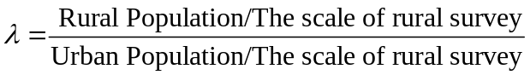
(3) Construct the age-profile under the aggregate control.

2. Consumption
(1) Private consumption
The private consumption on the education, health and other goods and services are reported at the household level. We allocate the private consumptions on health and education to the individual by iteration method. The result is similar with that by the regression method. Private other consumption is allocated by the scale method.
The result are shown in Graph 1
(2) Public consumption
For public education expenditure, we distribute the total education expenditure by the budgetary expenditure of school at different level. Estimate the student number at different level by age (using the enrollment at different level by age from the census data at 2000).
The public healthcare expenditure is distributed in proportion to the health care service utilization rate at each age. In China, government healthcare expenditure is subsidized directly to hospitals, so we assume those who go to hospitals receive the government subsidy in proportion to their utilization of the healthcare service. As generally speaking, the more the patient spent, the more labor force, equipment or medicine he or she consumes.
Other public consumption is allocated per capita.
The results are shown in Graph 2.
Graph 1&2 Consumption
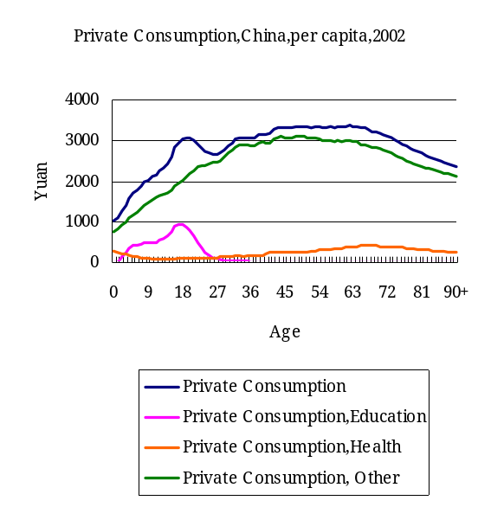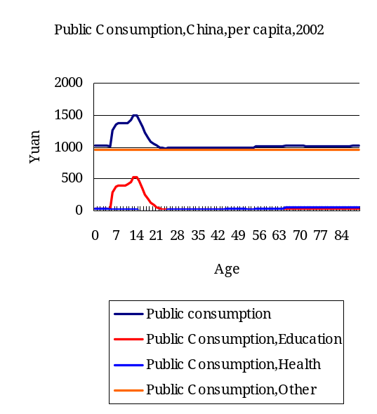
3. Labor Income
The wage and benefits (that means labor income from the formal sector) are reported at the individual level.
The self-employed income is calculated form 2/3 of household operating surplus (mixed income).
The result are shown in Graph 3
Graph 3 Labor Income
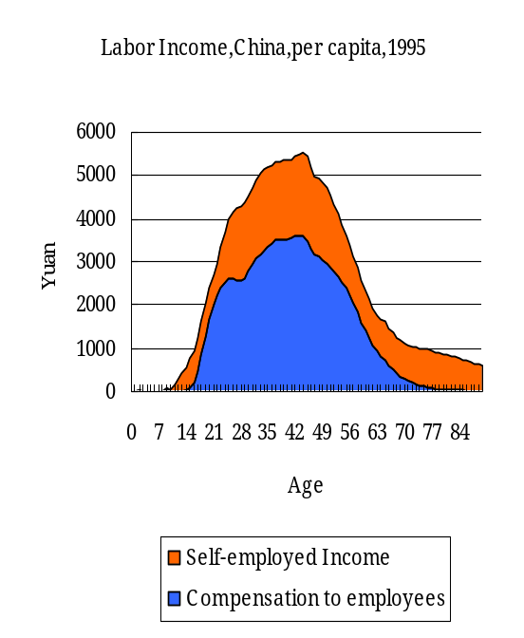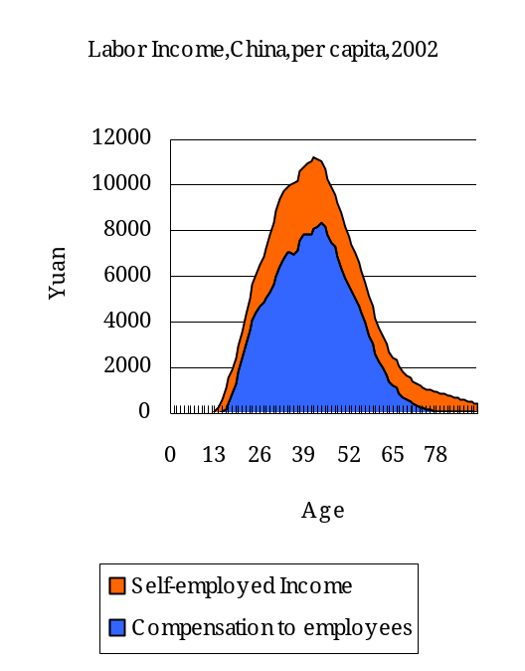
Compared with 1995, in 2002 the
4. Lifecycle Deficit
From the labor income and consumption, we can get the lifecycle deficit. This is shown in Graph 4.
Graph 4 Lifecycle deficits, China, per capita, 2002
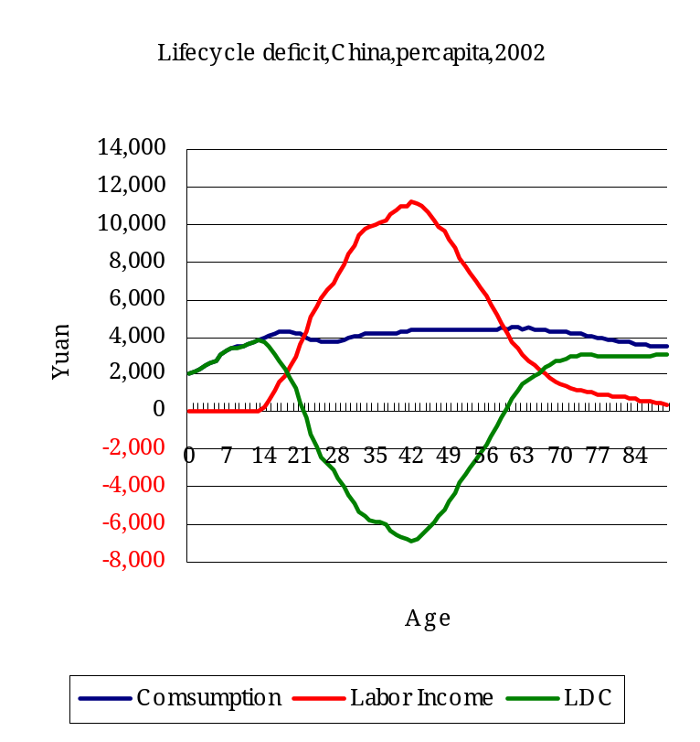
5. Asset-based Reallocation
We define asset-based reallocation as 1/3 of mixed income plus other asset income.

6. Public transfers
In the urban survey public transfers inflow is reported at the individual level, we simply apply it. In the rural survey public transfers inflow is reported at the household level, we assign the household public transfer to the household head. In the urban the outflow is reported at the individual level, while in the rural it is reported at the household level, we assigned them to the household head.
The following table summarizes the contents of public transfer incomes.
Table 6 Contents of public transfer
 | Public transfer inflow | Public transfer outflow
1995 urban | Pensions, social relief benefits, insurance benefit of unemployment, Survey income | Income tax, social insurance premium
1995 rural | Pensions, Survey income, Relief payment, Subsidies | Tax and fee
2002 urban | Pensions, social relief benefits, insurance benefit of unemployment, Fee for dismiss, Draw from the public housing funds, Survey income | Income tax, social insurance premium
2002 rural | Pensions, Survey income, Relief payment, (Government’s) Subsidies for the aged | Tax, social insurance premium, Expenditure on medical insurance, Expenditure on pension

Graph 5 Public Transfer
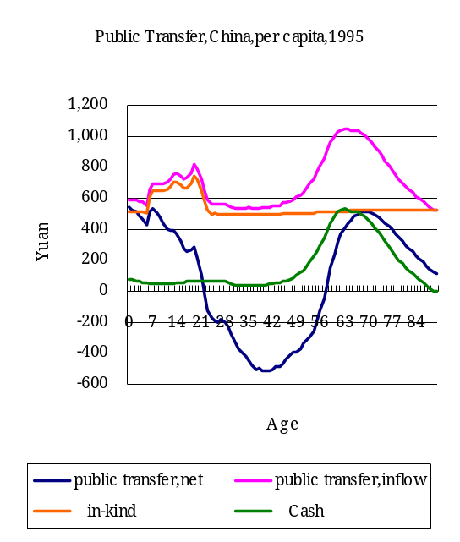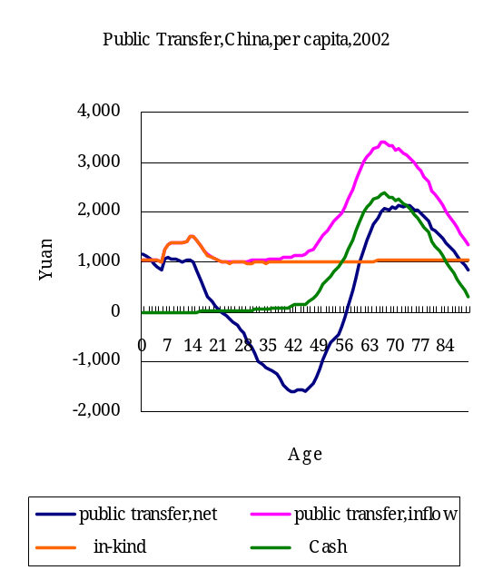
In China the public transfer system is in the progress of construction. So far the main public transfer system is the public pension system (focus on the employees), and the relief system, unemployment insurance and the low-income relief have quite limited scale, so the profile shows a high peak at the old age.

7. Private transfers: Inter-HH
In the urban, private transfers inflow is reported at the individual level, we assign them to the household head, and the private transfers outflow is reported at the household level. In the rural survey both private transfers inflow and outflow is reported at the household level. All of them are allocated to the household head.
The following table summarizes the contents of private transfer incomes.
Table 7 Contents of public transfer

 | Private transfer inflow | Private transfer outflow
1995 urban | Income form compensation, Alimony (for aged), Denotation（including present, Fee from the relative and friend who regularly eat in | Alimony outlay, Education cost for children, gifts
1995 rural | Presenter income from relatives and friends, Alimony, Child support payment | Gifts expenditure, Alimony expenditure
2002 urban | Income form compensation, Insurance benefit (minus social insurance benefit), Alimony (for aged), Denotation（including present, Fee from the relative and friend who regularly eat in, Other transfer income | Denotation, Buying lottery, Alimony outlay, Education cost for children living in other city, Expenditure on insurance as non-deposit, gifts
2002 rural | Income brought back or remitted by household members who lived and worked outside of the household, Presenter income from relatives and friends, Alimony, Child support payment, Present in wedding and mourning, | Gifts (including cash and goods) to relatives, Gifts (including cash and goods) to friends or neighbors, Gifts (including cash and goods) to village/township cadres, Alimony

Graph 6 Private Transfer, Inter Household

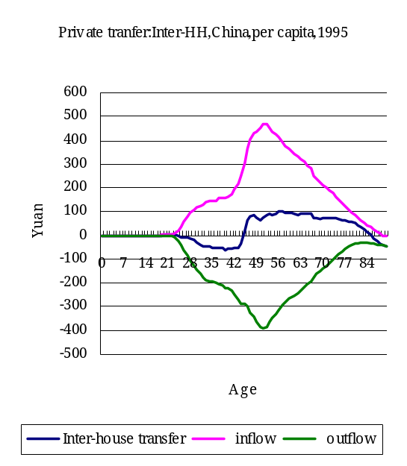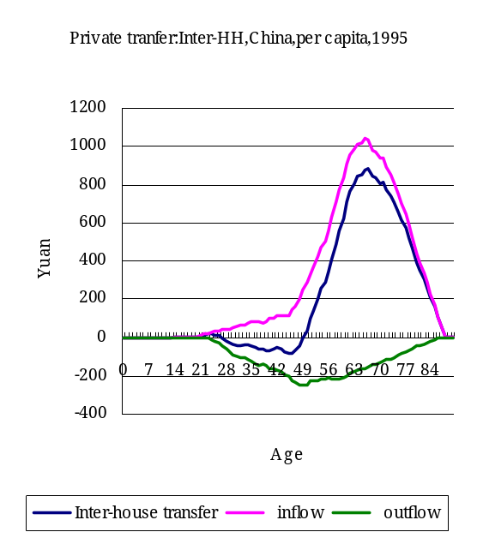
We conclude from the 2002 profile that the major part of the inter-household transfer is focus to the aged who live separately with their children.
8. Intra-HH transfer
We derive the Intra Household transfer profiles from the individual consumptions and disposable income. The disposable income is defined as labor income + public cash transfer inflow + private inter-HH transfer – public transfer outflow – private transfer outflow.

Graph 7 Private Transfer, Intra Household
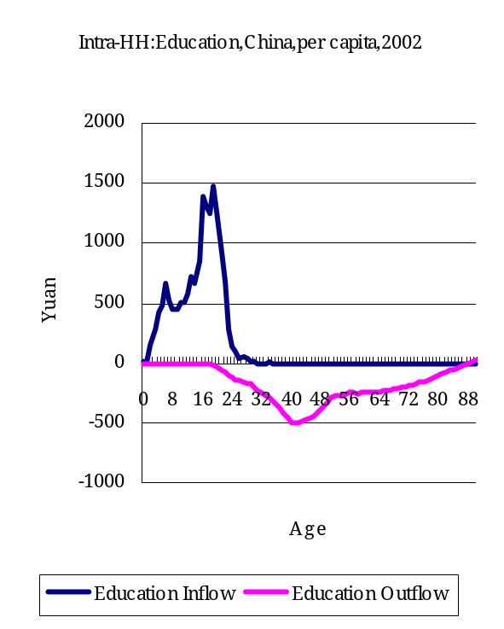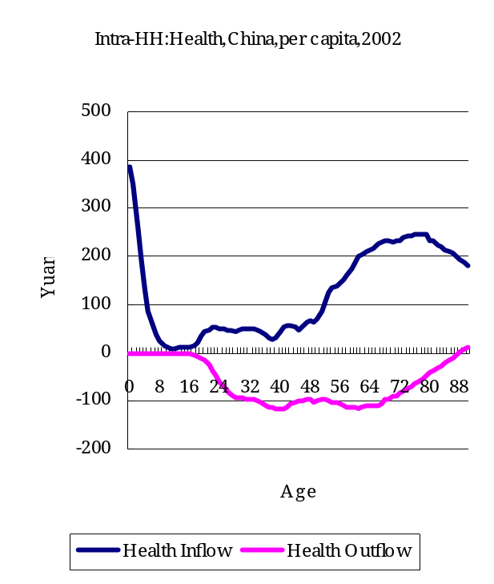
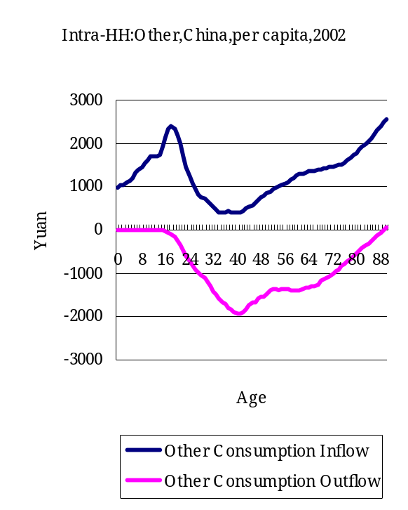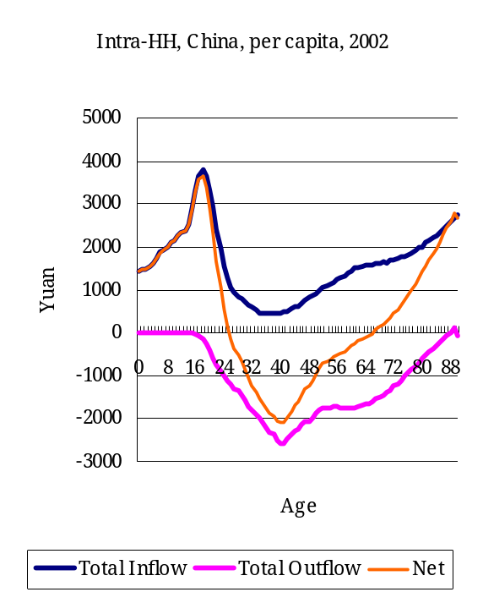

IV Comparison of 1995 and 2002
In this part, we will discuss the implication of the profiles on year 2002 and compare it with the 1995 profiles.
In this part, all age profiles are normalized by the average labor income for the age 30-49 as the denominator.
1. Consumption
Graph 8 shows the consumption profiles. We can conclude from the graphs:
(1) The relative scale of the public and private education keeps almost stable from 1995 to 2002, while the peaks move. The peak of the public education moves to the younger age while the private education moves to the older age. This result is perfectly consistent with China’s education policy adjustment. Since 1990s, Chinese government subsidized more resources to the primary education rather than advanced education. And public universities began to charge tuition from the middle 1990s.
(2) The public health expenditure reduced while the private health expenditure increased simultaneously. This reflects that during 1995 to 2002 the government healthcare expenditure decreased and the out of pocket expenditure increased.
The shape difference of the private healthcare consumption for the old age maybe attributed to the method difference. In 2002 it is reported by individual while in 1995 the private health consumption is reported at the household level and allocated to the individuals.
Graph 8: Consumption comparison
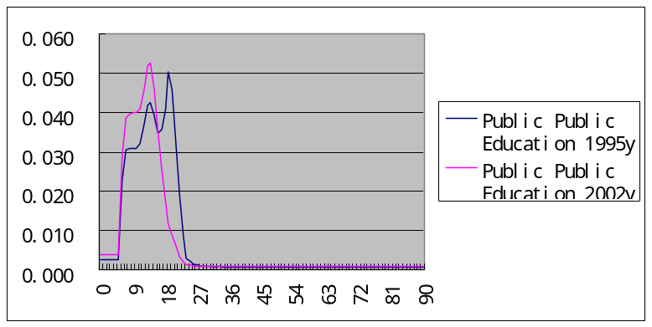
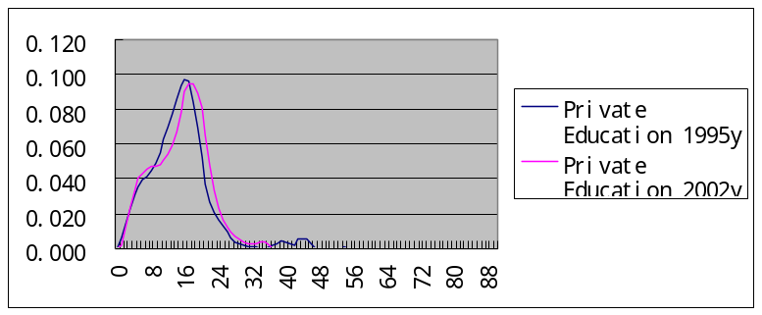
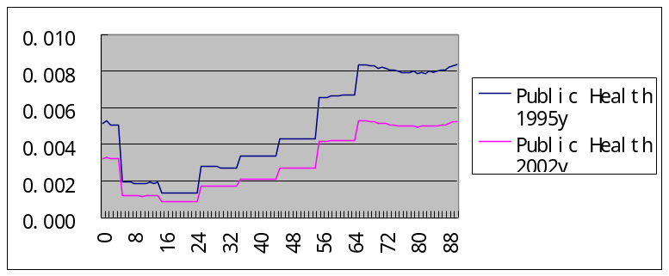
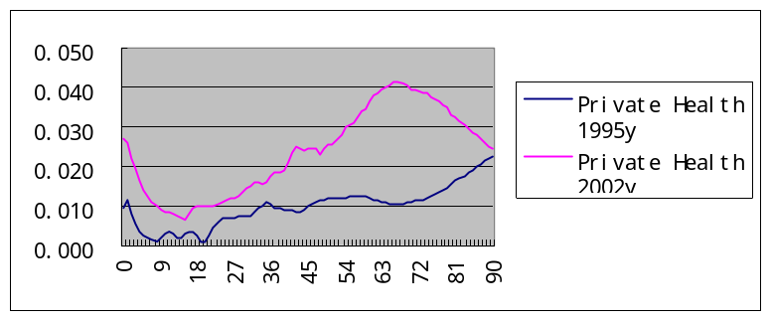

2. Labor Income
Graph 9 shows the labor income profiles. We can conclude from the graphs:
(1) The proportion of the compensation increased while that of the self-employed income decreased. This is consistent with the growth of the former sector, which is accompanied by the economic growth.
(2) The profile of self-employed income is flatter than the compensation to employees, that is to say, the self-employed income is distributed more averagely across the middle and old ages, while the compensation to employees are more concentrated. The reason is that in the rural area, self-employed income account for the majority of the labor income, and the year for the peasants to do agriculture work is much longer than in the formal sector.

Graph 9: Comparisons of Labor Income
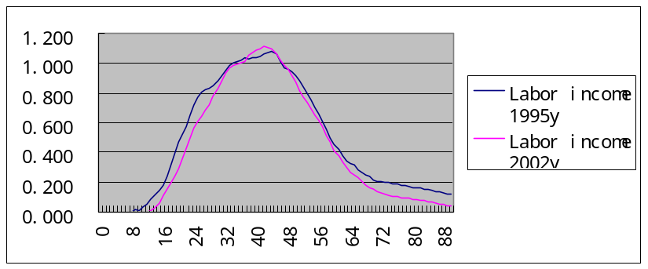
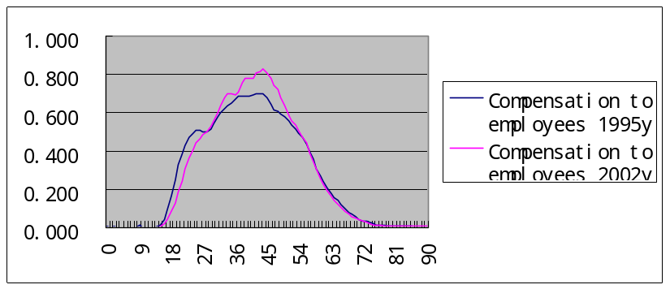
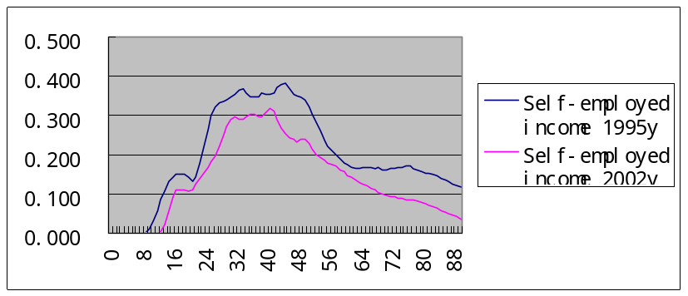

3. Public transfer
We have mentioned that the public (cash) transfer system in China is mainly composed of the public pension system. The scale of the public pension system has grown rapidly from 1995 to 2002, so that graph 10 shows the higher peak of 2002 than that of 1995. In China the retirement and pension system for the government agencies and public institutions was originally funded directly by government finance. Ever since 1990s, some localities in China began to probe the procedures of reforming the retirement system in such institutions to raise the retirement pension funds through the social pool program. By the end of 2003, some 11.99 million employees and 2.58 million retirees had participated in such pilot projects.
And, the location of the peak is older in 2002 than that in 1995, which reveals the trend of population aging.

Graph 10: Comparisons of Public Transfer
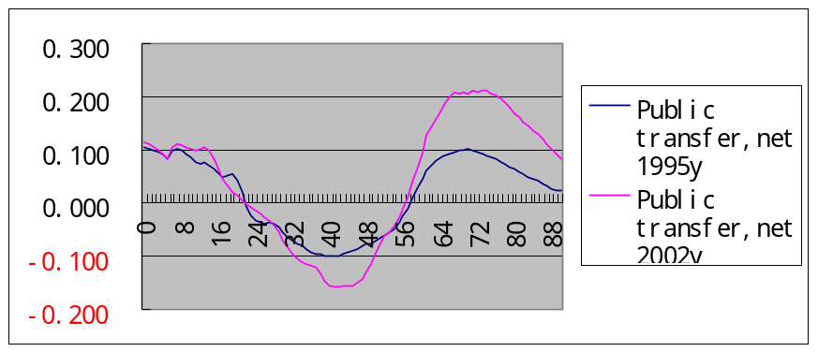
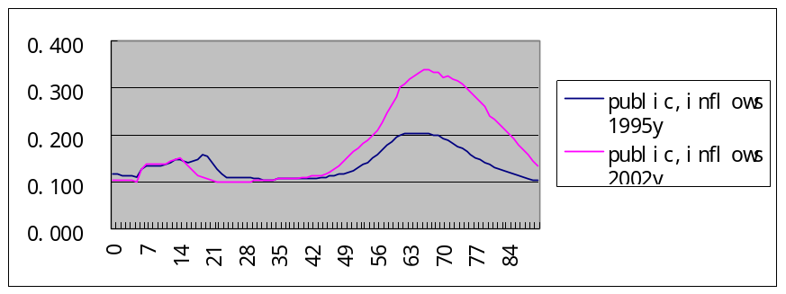
4. Private transfer: Inter-HH
The shapes of private inter-household inflows changed a lot from 1995 to 2002, shifting to the old age. It may be explained by the fact that more aged people choose to live separately with their children or receive more cash transfers from their children.
Graph 10: Comparisons of Private Transfer: Inter Household
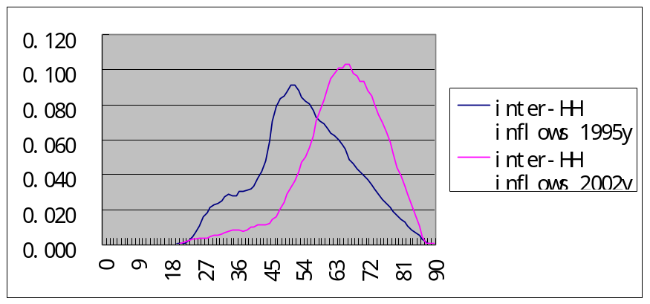
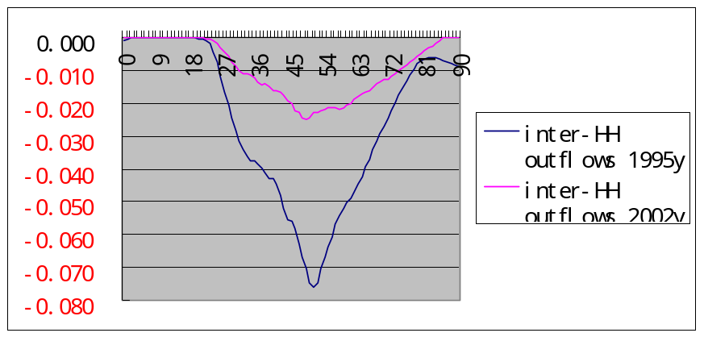
5. Private transfer: Intra-HH
Graph 11 shows the comparisons of the age profile of the Intra household transfer. We conclude that the intra-household transfer to the children’s education and to the health of the aged increased. These are consistent with the rapid growing expenditure of the education and healthcare. The price of the increase in education and health inflow is that the inflow of other consumption decreased. The overall effect is that more recourse is allocated to the children rather than to the aged.

Graph 11: Comparisons of Private Transfer: Intra Household
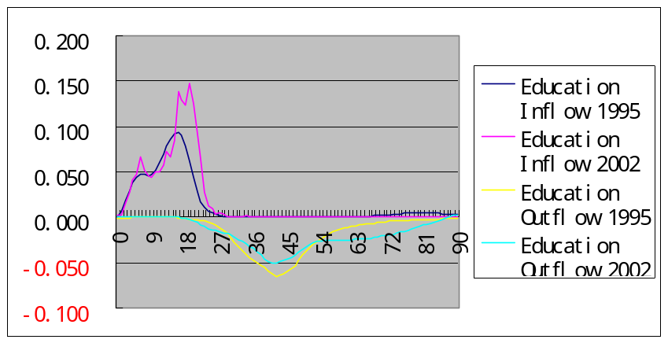
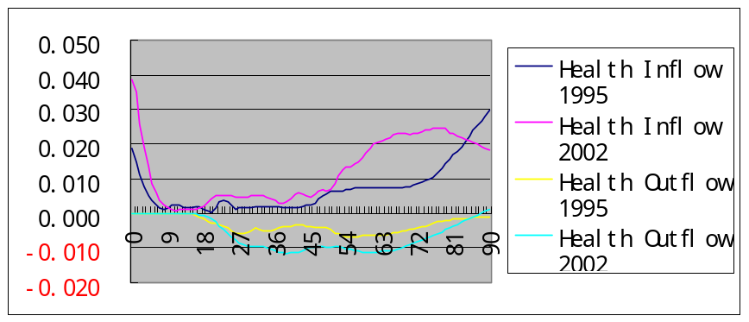
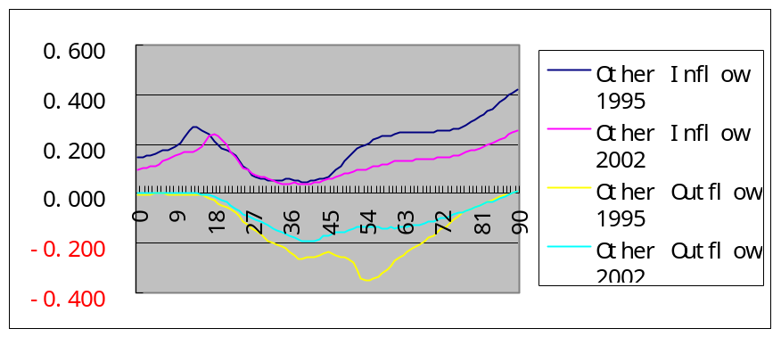
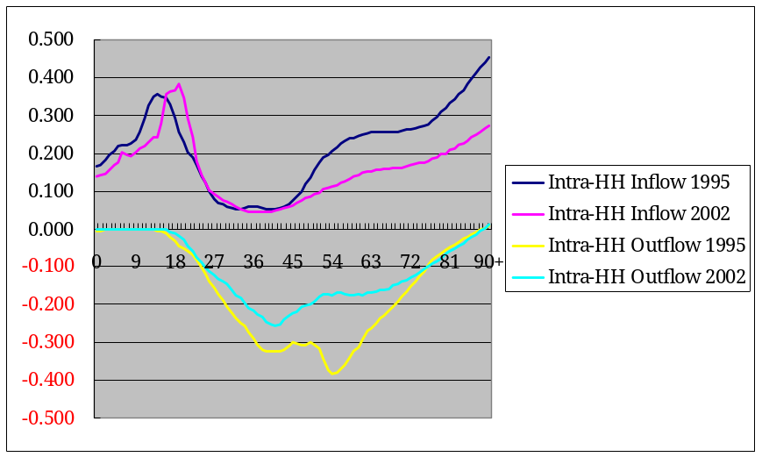
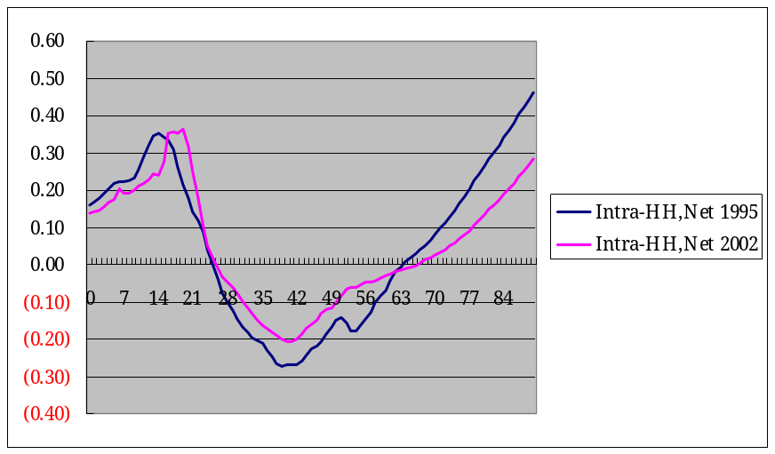
Some findings from the National Aged Population Survey (NAPS, conducted for the year 2002) are helpful in explaining the results above. See appendix 1.

6. Component of Lifecycle Deficit
Graph 12: Structure of Lifecycle Deficit: 1995 and 2002
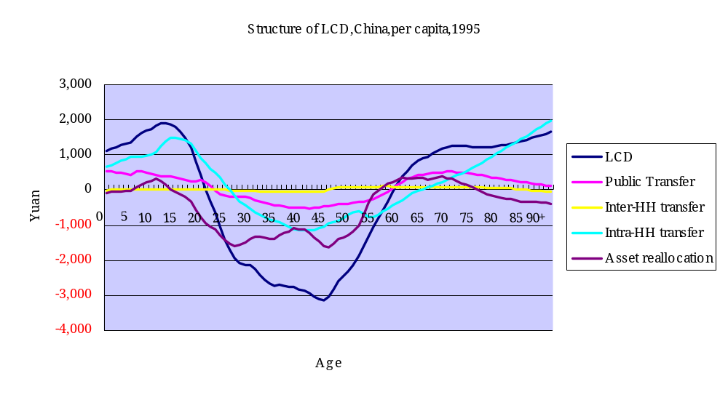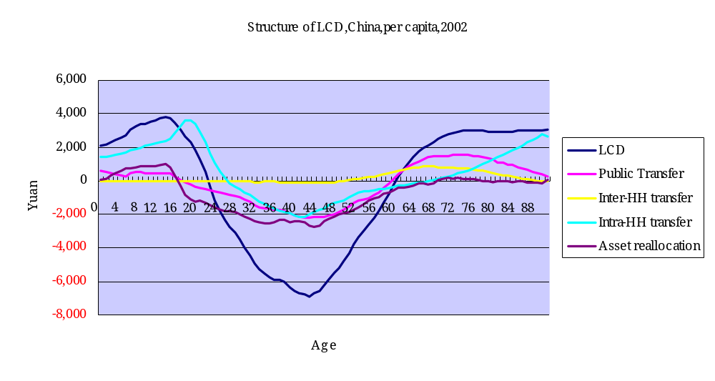
From the profiles of the lifecycle deficits, we summarize in table 8 the cutting ages of the lifecycle deficit.

Table 8 the Structure of the Lifecycle Deficit
(Assets Reallocation as residual)

 | 1995 |  |  | 2002
 | Cutting Ages |  | Duration | Cutting Ages |  | Duration
Lifecycle Deficit | 20 | 58 | 38 | 21 | 59 | 38
Public Transfer | 22 | 58 | 36 | 17 | 59 | 42
Private Transfer | 25 | 62 | 37 | 26 | 57 | 31
- Inter Household |  |  |  | 27 | 50 | 23
- Intra Household | 25 | 63 | 38 | 26 | 67 | 41
Residual (Asset reallocation) | 13 | 55 | 42 | 16 | 68 | 52

The duration of lifecycle deficit keeps at 38 years in 1995 and 2002, with one year older in 2002 (from 21 to 59) than 1995(from 20 to 58).
The beginning age of public transfer has decreased from 22 in 1995 to 17 years old in 2002. This shows the decrease of the public expenditure to the advanced education and the expanding of the public pensions.
From 1995 to 2002, the ending age of the public transfer has decreased from 62 to 57, which shows the aged population began to receive net private transfer at a younger age. However, the intra-HH transfer ends at 63 and 67 years old, much older than the inter-HH transfer. This is consistent with our hypothesis above. Those aged people who lived separately with their children will receive recourses from their children through inter-HH transfer, while those who lived together with their children (and their grand-children) will transfer net resources to their children and grand-children, until very old age (67 years old). Maybe it is the result of their choice of living arrangement: people would be like to live together with their old parents if they can receive resources from their parents. Refer to the Appendix for more information about the living arrangement.

7. Old-age Reallocation System
According to the NTA table, we derive the old-age reallocation system. The triangle graph is shown at graph. In order to compare the supporting systems of aged people at different ages, we show the old-age supporting system for the aged people above 60, 65 and 70 years old separately.
China is located next to the southern edge of the triangle. In 1995, the asset reallocation, public transfer and private transfer account for 11.7, 37.1 and 51.2 separately. And in 2002, the proportions are 0.7, 51.7 and 47.6. The increase of public transfer and decrease of private transfer have been explained above.
Graph 13 Old-age Reallocation System, China 1995 and 2002.
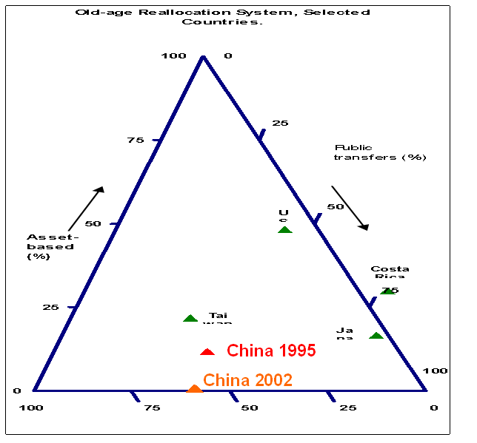
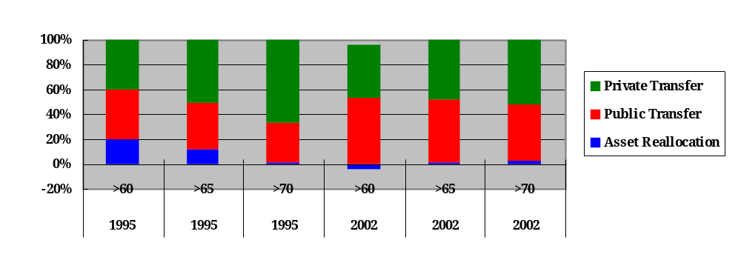
 | >60 | >65 | >70 | >60 | >65 | >70
Asset Reallocation | 19.9 | 11.7 | 0.7 | -4.3 | 0.7 | 2.7
Public Transfer | 40.2 | 37.1 | 32.4 | 56.0 | 51.7 | 45.8
Private Transfer | 39.9 | 51.2 | 66.9 | 44.3 | 47.6 | 51.5

Appendix 1 Living Arrangement of the Aged and Private Transfer
Table 1 shows the distribution of co-residence arrangement for the China’s elderly population aged 65 above.
Table1 Living Arrangement of the elderly (%)
 | 2002 | 2005 | 2002rural | 2002urban | 2005rural | 2005urban
with offspring | 64.46 | 64.06 | 57.99 | 58.03 | 59.14 | 57.04
with spouse only | 15.69 | 17.9 | 24.36 | 24.42 | 23.18 | 23.2
alone | 13.45 | 13.41 | 14.64 | 11.71 | 15.39 | 12.78
in a nursing house | 4.61 | 2.7 | 1.22 | 3.82 | 1.22 | 4.5
with others | 1.79 | 1.94 | 1.79 | 2.02 | 1.07 | 2.48
Sample Size | 100 | 100 | 100 | 100 | 100 | 100
Source: calculated from NAPS data.
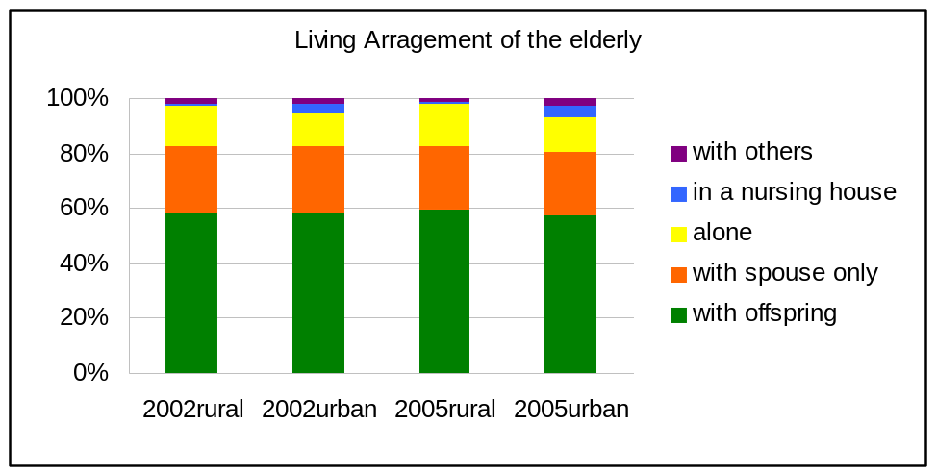
The majority of elderly Chinese lives in the same household as their offspring (59.14% in the rural and 57.04% in the urban), while only 1.22% and 4.5% elderly lived in the nursing home. It has been an article of faith in China that the family should pay respect to and care for its elderly members. Our estimation also reveals that family support plays the key role in supporting the elderly.
However, recently some new evidence suggests that family and household structures have been changing greatly in China (Zeng, 2000). Lower mortality is improving the survival of family members and thus contributing to the chance of co-residence, but lower fertility is reducing the number of potential relatives for the elderly person to live with.
The inequality between rural areas and urban areas in China has been discussed extensively in literature by economists, demographers and policy-makers. In studying the well-being and living arrangements of the elderly in China, it is also of importance and interest to consider the elderly in rural and urban China separately. People often take it for granted that the rural elderly are more likely to live with offspring while the urban elderly are more likely to live independently. But the data from the survey are inconsistent with this surmise. The percentage of living with offspring does not very significantly between rural and urban elderly; however, the changes in the percentage of living with offspring are of opposite direction in rural and urban areas.
Judging from the living arrangement, we may infer that the intra-household transfer should be the main channel of supporting the elderly. Currently, we have no nation-wide census on the family support to the elderly.
The surveyed elderly are asked to report their main source of financial support. Table 2 summarizes the result.
Table 2 Main source of financial support of the elderly, 2002
 | urban | rural | Total
Pension | 37.8% | 5.5% | 19.9%
spouse | 2.4% | 1.9% | 2.1%
child(ren) | 43.8% | 69.0% | 57.8%
grandchild(ren) | 3.9% | 6.0% | 5.0%
other relative(s) | 0.4% | 0.7% | 0.6%
local government or community | 5.8% | 4.2% | 4.9%
work by self | 3.9% | 11.3% | 8.0%
others | 2.1% | 1.3% | 1.7%
Clearly, we can see that no matter in urban or rural area, family support from children is the main sources of the financial support of the elderly. Note that 37.8% of the elderly in the rural area depends on pension as the main financial source while only 5.5% of rural elderly depends mainly on pension, which reveals that the coverage of pensions is low and has big gap between the urban and the rural.
Another important phenomenon is that 11.3% of the elderly in the rural area aged 65 and above still make living themselves. This is consistent with our estimation of the age-labor income profile of the rural area, which curve has a relatively smooth “peak”.
Moreover, 26.3% of rural elderly and 18.2% of urban elderly do not get adequate financial support to cover their living cost, a high proportion. Interesting, the distribution of the type of financial support within this group is similar to that of the whole sample.
The scale of family support
The NAPS data reports the cash and in-kind transfers form the children and grandchildren as well as the transfer from the elderly to the children and grandchildren.
We can see that in the urban area, annual transfers from the children and grandchildren is 2383.7 Yuan, accounting for 33.2% of per capita consumption level this year. While in the rural area, the children and grandchildren contribute 1613.3 Yuan to the elderly, accounting for 73.8% of the per capita consumption level. Considering the consumption equivalence scale of the elderly, we may infer that in the rural area, the transfer from the children is enough for the elderly to meet basic living needs.
We also investigate the transfers from the elderly to the children and grandchildren, which is 544 Yuan in the urban and 184.4 Yuan in the rural, much less than the inflows.
Table3 Annual transfer from the children and grandchildren, 2002
 | Transfers to the elderly |  | Transfers from the elderly
 | urban | rural | urban | rural
The son | 1200.8 | 904.2 | 208.7 | 56.3
The daughter | 932.9 | 507.0 | 130.1 | 69.4
The grandchildren | 250.0 | 202.1 | 205.2 | 58.7
Total (1) | 2383.7 | 1613.3 | 544 | 184.4
Consumption level(2) | 7182 | 2185
(1)/(2) | 33.2% | 73.8%
Another question is, at what ages do the elderly get more transfers from the children? We draw the age profiles of the inflow and outflow from/to the children (Figure 4). The curve shows that there are no significant differences between different age groups in getting transfer from the children. Concerning the outflow, the curve is downward after 80 years old, which is easy to explain.

