Draft: Preliminary and incomplete
Do not cite or distribute further

Asset-based Reallocations:
Concepts and Estimates for Selected Countries

Andrew Mason
University of Hawaii at Manoa and
Population and Health Studies, East-West Center
amason@hawaii.edu

Naohiro Ogawa
Population Research Institute, Nihon University

Amonthep Chawla
Population and Health Studies, East-West Center, and
Population Research Institute, Nihon University

Rikiya Matsukura
Population Research Institute, Nihon University

Presented at the Sixth National Transfer Account Workshop, January 9-10, 2008. Research for this paper was funded by the National Institutes of Health NIA R01 AG025488 grant to Mason and grants from MEXT.ACADEMIC FRONTIER (2006-2010) and UNFPA (RAS5P203) to NUPRI in Japan. We are grateful to Ronald Lee and the country research teams in the NTA project for the use of their data.

I. Introduction
Two economic mechanisms respond to the deficits and surpluses that characterize the economic lifecycle: transfers and asset-based reallocations. Willis (1988) and Lee (1994) provide comprehensive models for exploring the economic implications of the use of these two mechanisms building on the work of Samuelson (1958), Diamond (1965) and others. Asset-based reallocations can take different forms and serve different purposes, but the role most emphasized in the literature is to meet the lifecycle deficit associated with old age. This role of asset-based reallocations is central to the conventional lifecycle model (Modigliani and Brumberg 1954). Workers save some portion of their labor income and begin to accumulate assets. The assets grow as additional labor income and the return to assets are saved. In retirement, individuals can support their consumption using asset income and by dis-saving or equivalently by purchasing annuities. Lifecycle saving is important because it meets the needs of retirees, but also because it influences aggregate capital accumulation, productivity, and economic growth.

Population aging and the demand for lifecycle saving are closely associated. Increases in life expectancy along with earlier retirement are leading to a longer duration of retirement and a larger lifecycle deficit at old ages. Low fertility may reinforce this shift if the decline in child dependency leads to higher consumption at old age. Moreover, changes in population age structure may have a large effect as the proportion of older and, hence, wealthier individuals increases (Lee, Mason et al. 2001; Mason and Lee 2007).

The importance of lifecycle saving may vary widely from country to country, because, among other reasons, transfers offer a substitute for lifecycle saving. Public PAYGO pension programs, for example, may crowd out lifecycle saving and reduce rates of capital accumulation (Feldstein 1974; Kotlikoff and Summers 1981; Feldstein 1998; Feldstein and Samwick 2001; Krueger and Kubler 2002). Family transfers to the elderly may have the same effect although this possibility has not been studied extensively (Lee, Mason et al. 2003).

Asset-based reallocations may play other important lifecycle roles than those envisioned in the conventional lifecycle model. An obvious example is the use of credit by young adults to pay for school or other needs beyond their current income. The evidence presented below, although preliminary, indicates that asset-based reallocations are playing a role that has received little attention in the literature – to fund transfers to children and to the elderly.

Asset-based reallocations may be a consequence of motives unrelated to lifecycle saving. Saving may be a consequence of shorter run smoothing (Carroll and Summers 1991; Carroll 1992). Saving may be motivated by the bequest motive rather than lifecycle motives (Kotlikoff and Summers 1981; Kotlikoff 1988; Modigliani 1988). If so, the saving profile could be very different from that envisioned by the lifecycle model and changes in fertility, life expectancy, age structure, and other factors could have very different effects on aggregate saving and capital accumulation.

This paper has several objectives. The first is to provide a conceptual foundation for understanding asset-based reallocations. Prior to the construction of National Transfer Accounts, asset-based reallocations have been analyzed to a relatively limited extent (perhaps not at all). Economic theory has emphasized saving rates rather than asset income or asset-based reallocations. A further complication is that conceptual models often describe lifecycle patterns for a cohort whereas the data analyzed in this paper are cross-sectional.

Second, we provide a brief overview of the methodology employed to construct NTA estimates of asset income, saving, and asset-based reallocations. The purpose is to provide a broad rather than a comprehensive understanding of the methods. A full explanation of the methodology is available in Mason, Lee et al. (forthcoming) on the NTA website: www.ntaccounts.org. We also discuss key assumptions and their implications.

Third, we present estimates of asset-based reallocations. For a larger group of countries, we present and discuss estimates of the broadest measure of asset-based flows that combine public and private as well as asset income and saving. Although these estimates do not provide any details about the components of asset-based reallocations, they none the less provide useful clues about the roles of asset-based reallocations in a broad cross-section of countries.

Fourth, we present detailed estimates of asset income, saving, and asset-based reallocations for the private sector for a small group of countries for which estimates are currently available.

The final section of the paper employs new methods to estimate intra-household transfers that are related to asset-based reallocations. The purpose is to gain some insights into how the saving behavior of the household is related to other co-resident children and adults who may be contributing to or impeding household saving.
The key findings are as follows:

Asset-based reallocations fund a substantial share of the old age lifecycle deficit in almost every country. Of the eight countries for which we present estimates, asset-based reallocations are almost equal to the lifecycle deficit in the Philippines and Mexico, two-thirds of the deficit in Thailand and the US, and one-third in Taiwan, Japan, and Chile. Only in Finland are asset-based reallocations very small for the elderly.

We find no evidence than, on average, resources for old age are not being generated by dis-saving. The elderly continue to save. Assets are very important for the elderly, however, because they rely on asset income to support their consumption.

The elderly do not appear to be relying more on asset-based reallocations as compared with transfers in countries with historically high saving rates, e.g., Japan and Taiwan. There is an extensive literature on Japanese saving rates, the importance of bequests versus lifecycle saving, etc (Horioka 1990; Horioka 1991; Horioka 2006). But a possible explanation is as follows. Contemporary elderly in these countries had very low wages over their working years as compared with more recently born cohorts. Thus, their accumulated wealth is relatively low as compared with current standards of living. Transfers to the elderly, public in Japan and familial in Taiwan, have become an important vehicle for maintaining intergenerational equity.

One of the fundamental features of the conventional lifecycle model does not appear to hold in many countries. Young adults are not saving out of labor income on average. They are saving but almost always less than they are earning in asset income.

Assets are used to a limited extent to fund consumption by young adults in a number of countries for which we have estimates. Young adults are accumulating debt in Japan, Taiwan, and Mexico at some young ages. In the US, young adults are borrowing to a much greater extent.

One of the most striking results discussed below is that asset income is being used to fund transfers to children. This is particularly true of high fertility countries, but also true of some countries with relatively low fertility but high consumption per child. Rather than saving some portion of labor income, as postulated in the conventional lifecycle model, working-age adults are relying on asset income to support their children and, to a lesser extent, elderly parents. Working adults are saving during their working years, but the estimates suggest that a substantial portion of their assets are inheritances and other capital transfers received at a relatively young age. The evidence about this is indirect, however. Moreover, further analysis of the sensitivity of these results to the assumptions on which NTA estimates are based is needed.

II. Theory and Conceptual Issues

A. Lifecycle Saving Model

In the conventional lifecycle model saving is an economic mechanism for reallocating resources from the working ages to the retirement ages. Individuals accumulate assets during their working years and support consumption after retirement relying on asset income and dis-saving. Individuals can successfully deplete their wealth at the time of death by relying on annuities (or by knowing the age at which they will die).

For an individual or a cohort the shape of the lifetime consumption path is governed by tastes, interest rates, and in some models by household composition and per capita income growth. The level of the consumption path is determined by the lifetime budget constraint which is determined in turn by lifetime earnings, net public transfers, and in some cases by net private transfers.

The lifecycle model has relatively strong implications for the age profiles of asset-based reallocations, asset income, and saving. Consider first the simplest and most unrealistic case represented by a 3 period OLG model. Children (Generation 1) and Retirees (Generation 3) consume but have no labor income. Workers (Generation 2) have labor income. All individuals live for 3 periods. The consumption of children is funded entirely by transfers from parents. We will call this the low child cost case. The consumption of retirees is funded through lifecycle saving. The economy is in steady state equilibrium, is dynamically efficient, but not golden rule. Hence, total consumption exceeds total labor income.

One possible set of per capita NT Flows is shown in Figure 1. Panel A shows consumption and labor income by age; panel B shows the lifecycle deficit and surplus by age; panel C shows transfers, and panel D asset-based reallocations. The asset-based reallocations are of interest here. The simple lifecycle model implies that during the working years asset-based reallocations are negative; asset income is positive; and, hence, saving is positive and exceeds asset income. During the retirement years, asset-based reallocations equal asset income plus dis-saving equal consumption.

NTA estimates can be employed to illustrate how the lifecycle saving model is affected by a more realistic treatment of the economic lifecycle and transfer systems. This is accomplished here with some very important simplifying assumptions. The population is closed to immigration; age-specific mortality and fertility rates are constant; and, hence, the population is stable with a constant age structure and population growth rate. Labor productivity is growing at a constant rate and interest rates are constant. Both parameters are exogenously determined. Labor income varies by age. Individuals accumulate assets in the form of costless annuities and, hence, there are neither accidental nor intentional bequests. The lifecycle deficit of children is financed entirely by transfers from adults. The effect of population aging on adult transfer programs is accommodated by increasing taxes and reducing benefits by equal amounts. The shape of the cross-sectional age profile of consumption is fixed but its level is endogenously determined by the lifetime budget constraint. Transfers to children are also endogenously determined because they are equal to the difference between their consumption and their labor income.

The baseline parameters of the model are as follows. Survival rates are based on recent estimates for the U.S., the population growth rate is set to 0.5 percent per year. The interest rate and discount rate are set to 6 percent; labor productivity growth is 1.5 percent per year; age profiles of labor income and consumption and transfer inflows and outflows are based on Taiwan 1998 estimates (Mason, Lee et al. forthcoming). A detailed description of the model is available on the NTA website: www.ntaccounts.org.

The cross-sectional aggregate lifecycle profile is shown in Figure 2. Important features of the flows highlighted for the OLG profiles are also present in this more realistic representation of the lifecycle model. First, during a major portion of the working years (mid-twenties to age 50) asset-based reallocations are negative (saving exceeds asset income). During retirement asset-based reallocations are positive, as the elderly rely on asset income and dis-saving. The age profile of asset income (and assets) peaks at about age 60.

An interesting feature of this more realistic rendering of lifecycle saving is the relatively young age at which asset-based reallocations turn positive – age 50. In the simulation people are earning more than they consume until age 58, but because of downward transfers to children they are beginning to rely on asset-based reallocations to supplement other income sources throughout their 50s. This outcome is quite different than the conventional wisdom that the period immediately prior to retirement is particularly well-suited to saving toward retirement because childrearing is complete and labor income is at its peak. The financial responsibilities for childrearing continue into the fifties, however. In Taiwan, for example, the mean age of childbearing is close to 30 and children continue to receive transfers until they are in their early- to mid-twenties. Child costs are particularly high for older children. Moreover, individuals in their 50s may be bearing some of the cost of grandchildren. Finally, labor income in Taiwan peaked in the mid-forties (in the 1998 cross-section). All things considered the thirties and forties were conducive to retirement saving in Taiwan, not the fifties.

One of the important implications of the lifecycle model is that transfers to the elderly crowd out saving. This is true for public transfers (Feldstein 1974; Kotlikoff 1979) or for private transfers (Lee, Mason et al. 2003). Furthermore we know that large transfers to the elderly are a feature of the reallocation system for every country that has constructed estimates. In industrial countries and Latin American countries public transfers dominate, while in Asian countries with the exception of Japan familial transfers dominate.

In Figure 3 we allow for net transfers from workers to the elderly. The shape of the age profile is determined by the shapes of the outflows and inflows for adult transfers in Taiwan in 1998. The level of transfers has been adjusted as explained above to accommodate changes in age structure. Given the steady-state age structure implied by the demographic assumptions, twenty-three percent of the population is over the age of 60. This is substantially more than is the case in Taiwan in 1998. Thus, per capita transfer inflows to the elderly are about 5 percent less than the value in 1998.

Net transfer inflows for the elderly are quite large and meet a major portion of the retirement needs of the elderly. Asset-based inflows for the elderly are correspondingly small. Those between the ages of 65 and 85 are relying to a small extent on asset income and dis-saving to support their retirement. After age 85, the small amounts of assets held by the elderly are entirely depleted and the elderly rely exclusively on transfers.

Asset-based inflows are most important to those who are in their forties. This is a surprising result given that this is the very age range during which labor income is at its peak. The inflows are not a consequence of high consumption by those in their 40s, however, but a consequence of the transfer burden faced by those in their 40s who are making substantial transfers both to children and to the elderly.

We cannot overemphasize that these profiles are calculated under very strong assumptions and that there are many reasons why the patterns in Taiwan deviate from these simulations. In the following sections we discuss two potentially important issues, but there are many factors that may influence the cross-sectional profiles. Taiwan is in the midst of its demographic transition so that its age structure is changing, older generations had more children than younger generations, and the parents of older generations died at a younger age than will those of younger generations. Taiwan has experienced very rapid but variable economic growth. For three decades wages grew much more rapidly than assumed in the simulation, while in recent years the economy has been quite stagnant. The support systems are changing very rapidly. Public transfer programs are being expanded and family support systems are contracting. Taiwan was still under the influence of the Asian financial crisis in 1998 although not to the extent of many other Asian countries.

Even in the face of all of these complexities, certain features of the lifecycle model should characterize the cross-sectional flows. We would expect negative asset-based reallocations during some substantial part of the working years and positive asset-based reallocations during the retirement years with the magnitudes of these flows depending on the extent to which members of any age group is relying on or expects to rely on assets rather than transfers to fund their retirement. We would also expect to see dis-saving at older ages.

B. Bequests

A longstanding debate among economists is the extent to which saving is motivated by the lifecycle motive or by a bequest motive. Whether or not the elderly dis-save is often used as important evidence. Dis-saving is taken as an indication of lifecycle saving and the absence of dis-saving is taken as an indication of a bequest motive. Offering further evidence on this issue is not of prime interest here, although the age patterns of asset-based reallocations may provide useful information about this issue.

Providing bequests and meeting lifecycle objectives are not mutually exclusive objectives. Workers may accumulate wealth, rely on asset income during their retirement years, and make a bequest at the end of their lives. Or workers may not save at all for their retirement but depend on an inheritance to fund old-age consumption. In principle, they could rely on the asset income generated by the inheritance to fund their retirement and maintain the estate for their heirs or dis-save the inheritance.

A key macroeconomic issue is whether there is a continuing or persistent estate demand for wealth in addition to a lifecycle demand for wealth. In a steady state world, the ratio of wealth to income is constant. If the economy is in golden rule growth, asset income is just sufficient, if saved, to maintain W/Y. In other dynamically efficient cases, i.e., non-golden rule growth, a portion of asset income is consumed. Thus, estates can be passed from one generation to the next with some portion saved and some portion used to fund the old-age lifecycle deficit.

Bequests and other asset transfers are not measured in the National Transfer Flow Account. In the future we hope to construct asset transfer accounts that would include bequests, dowry, and other capital transfers. At this point, however, we can only explore how age patterns of saving and asset income are related to bequests and other capital transfers.

An example of NT flows for an economy in which bequests dominate is illustrated using the 3 period OLG model employed above (Figure 4). In this example, the costs of children are high and the entire working-age surplus is transferred to children. None is saved nor transferred to the elderly. Generation 3 receives bequests at the beginning of the period at the death of the preceding generation. Old-age consumption is funded entirely from asset-based reallocations. There are no asset-based outflows during the working years, neither saving nor asset income. There are substantial asset-based inflows during the retirement years. Saving by the elderly must be positive if aggregate income is growing. The excess of asset income over saving funds retirement.

C. Downward Asset-based Reallocations

Asset-based reallocations can also be used directly or indirectly to reallocate resources in a downward direction – from older to younger ages. Among all asset classes only credit can be used directly for downward reallocations. Young adults can generate inflows by accumulating debt – using credit cards, taking out student loans, etc. In this case asset-based reallocations will be positive at young ages to the extent that borrowing exceeds interest payments and negative for creditors, at older ages, for whom lending exceeds interest income. The use of credit by young adults and children is limited because of constraints on indebtedness and because children cannot enter into contracts.

Assets can play an indirect role in downward flows by funding transfers. Three possibilities can be distinguished. The first is that lifecycle saving can be used in conjunction with downward transfers. Figure 3 illustrates such a case. Lifecycle saving creates an upward flow – an asset-based outflow for young adults and an inflow for older adults. The inflows are not consumed by middle-aged adults, but they are transferred to children. The underlying lifecycle driver in this example, Taiwan, is high private educational costs for children. Viewed in isolation, the asset-based reallocations are upward. Used in conjunction with transfers, the ultimate effect is a downward reallocation. Tax-advantaged college saving plans in the US is an institutionalized example of this possibility. A similar arrangement would involve transfers to grandchildren from grandparents funded from assets accumulated during their working years.

The other two possibilities involve bequests or other capital transfers. One possibility is that grandchildren receive transfers from their grandparents using asset-based reallocations generated from inherited wealth. The asset-based flows shown in Figure 5 are similar to those shown in Figure 4. In the illustration here (Figure 5), consumption by children is very high and the child deficit exceeds the lifecycle surplus. Asset-based reallocations are used to fund generation skipping transfers from the elderly, resulting in a reduced level of consumption for the elderly and greater consumption for their grandchildren.

The final possibility involves capital transfers to Generation 2 used by that generation to fund the high level of consumption by children. The lifecycle surplus of Generation 2 is insufficient to fund consumption by children, but asset-based reallocations can be used to fund additional transfers to children. In the 3 generation OLG case, Generation 2 cannot accumulate assets because its consumption and net transfers exceed its labor income. Hence, Generation 2 must have been the beneficiary of capital transfers. One possibility is generation-skipping bequests. The other possibility is that Generation 2 receives inter vivos capital transfers at the beginning of the period (Figure 6). There are many examples of these kinds of capital transfers. Parents may make capital transfers to their children at the time of adulthood, marriage, first birth, or at other times. Dowry or bride price may be a common mechanism although the recipient of these transfers may be the parents of one of the marital partners. Parents may also give children a house or provide large cash gifts to assist with the purchase of a house.

These cases are all sustainable in a steady state world, but of course they are extremes. The asset-based reallocations will be some combination of these possibilities, but in addition they will reflect many dynamic influences and short-term effects.

D. Other considerations
The discussion of asset-based reallocations above is based on highly stylized models and strong assumptions that will not hold in practice. The observed cross-sectional patterns of asset income, saving, and asset-based reallocations will reflect many additional forces.

Economic growth. Countries vary substantially in their historical rates of economic growth with obvious implications for the intergenerational distribution of income and possibly saving behavior. Some East Asia economies experienced real per capita income growth of around 6% per annum for two to three decades. With wages almost doubling every decade, the lifetime earnings of cohorts who are currently in the labor force will greatly exceed the lifetime earnings of cohorts who are currently retired.

If saving rates were independent of the rate of economic growth, more recently born cohorts will have substantially higher assets and asset income controlling for age than earlier born cohorts. Under some models of saving, however, economic growth has a strong positive effect on saving. If these models are correct, the cross-sectional profile of assets and asset income will be less sensitive to the rate of growth.

Demographic change. Cohorts vary in their demographic circumstances. Lower fertility and longer life expectancy may induce younger cohorts to shift a larger share of their lifetime consumption to older ages. If lifecycle saving is used to support higher consumption in older ages, we would expect the asset-based outflows of young cohorts to be greater during the worker years (in absolute value) and expected asset-based inflows to be greater at old ages than was the case for older cohorts. The extent to which low fertility leads to this outcome would depend on the quality-quantity tradeoff which may be very substantial (Lee and Mason forthcoming).

Changing support systems. Political change in transition economies, e.g., China and Hungary, and pension and health finance reform may influence the extent to which successive cohorts rely on asset-based reallocations for old age support. In many East Asian countries, the elderly are much more likely to live independently of their adult children than in the past. Expectations among young adults about the extent to which they can rely on their children for old-age support have declined dramatically in Japan and no doubt other countries (Ogawa and Retherford 1993).

Time effects. Asset-based reallocations in individual year will reflect financial crises, recessions, wars, natural disasters, and other year-to-year fluctuations.

III. Comparative Analysis of Asset-based Reallocations
This section of the paper first provides a brief description of asset-based reallocations in National Transfer Accounts. Full detail is available on the website (www.ntaccounts.org). Next we consider total asset-based reallocations which are available for countries that have calculated the economic lifecycle and public and private transfers. The final part of this section considers private asset-based reallocations in more detail for the relatively few countries for which these estimates are currently available. As additional estimates become available a more extensive analysis will be possible.

NTA Concepts and Definitions

The National Transfer Flow Account is governed by the flow identity:

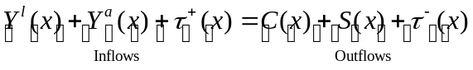

where 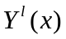 is labor income, 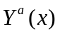 is asset income, 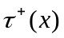 and 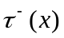 transfer inflows and outflows, 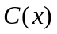 is consumption, and 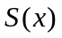 is saving and x is age. Rearranging terms yields:

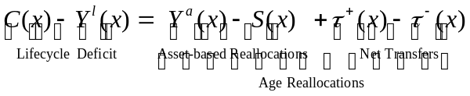

The lifecycle deficit must equal age reallocations consisting of asset-based reallocations and transfers. Asset-based reallocations are equal to asset income less saving. The flow identity holds for both aggregate and per capita values. Separate estimates are constructed for public and private flows.

Asset income consists of returns to capital and property income. The aggregate values are based on National Income Account data. Capital income consists of the operating surplus of corporations, a share of mixed income that is attributed to capital (with the counterpart attributed to labor), and the rental value of owner-occupied housing. All capital income is net of depreciation. Property income includes interest, dividends, rent, and other components that typically are small and vary from country to country.

Public asset income consists of the net asset income of government and includes the government’s operating surplus if any and income from financial assets owned by the government including financial assets in public pension funds and the interest expense associated with public debt (a negative value). The operating surplus of public enterprise is classified as private income. Distributions by those firms to the public sector, however, are private property income outflows and public property income inflows.

Private asset income consists of the net income of households, financial and non-financial corporations, and NPISHs. All asset income including the retained earnings of corporations is assigned to individuals (single-year age groups).

Public asset income and public saving are allocated to individuals using the age profile of general taxes. Interest payments on national debt, for example, are asset income outflows (interest) from those age groups that paid taxes used to make interest payments. More generally, the allocations of public asset income and public saving are based on a counterfactual. Public asset income, if negative, is allocated to the individuals who paid higher taxes as a consequence; if positive, the income is allocated to individuals who otherwise would have paid more taxes to support public programs. Public saving or dis-saving is allocated to individuals who actually paid the taxes in the case of saving and to those who otherwise would have been required to pay more taxes in the case of dis-saving.

Unlike other NTA variables, private asset-based reallocations are not allocated to multiple household members. We assume that assets are collectively owned and that asset income and saving are fundamentally household flows. Furthermore, we assume that the household head is the custodian of these assets. Thus, all asset income flows to and from the head and all saving and dis-saving is attributed to the household head.

Uncertainty about individual saving behavior clouds the interpretation of saving and asset income. Per capita assets at older ages may not decline or decline more slowly because seniors with few or no assets are absorbed into the households of their children. Young adults may be accumulating assets within the households of their parents, but this only becomes evident when they establish a separate household. The headship designation may be assigned to one member, e.g., the highest earner, while assets are owned by another, often older, household member. The implications of this assumption are examined to some extent below, but without a full resolution.

Private asset income is assigned using age profiles of asset income from nationally representative income and expenditure household surveys. The household’s property income profile is used to allocate the operating surplus of corporations and most property income: dividends, interest, rent, etc. The household profile of imputed rent from owner occupied housing is used to allocate the operating surplus of households, which is also imputed rent from owner-occupied housing as reported in NIPA. The household profile of mixed income is used to allocate capital’s share of mixed income. The age profile of interest expense is used to allocate interest outflows from households.

Private saving, 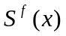, is the balancing item in NTA and calculated as:

where 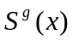 is public saving, 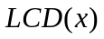is the lifecycle deficit, 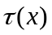 is net transfers (public and private combined), and other terms are defined above. Public saving and private saving accumulated over age are equal to net public saving and net private saving, respectively.

The details of the methods used to allocate asset-based reallocations by age are described in www.ntaccounts.org.

Asset-based Reallocations

Considering the age reallocation system at the broadest level may lead to some potentially useful insights about asset-based reallocations. It follows from the flow constraint that the lifecycle deficit can be funded from only two sources – transfers and asset-based reallocations. Estimates of these three age profiles for Japan 2004 (Figure 7) illustrate some features of the estimates that are discussed in more detail below (Ogawa, Mason et al. 2008).

First, consider the elderly. The lifecycle deficit increased sharply in Japan between the ages of 60 and 65 and more gradually, thereafter. Transfers and asset-based reallocations were both very important to the elderly, but their share varied substantially with age. Asset-based reallocations were very important for the young elderly, but transfers were not. The old elderly relied heavily on transfers and not so much on asset-based reallocations.

<Figure 7 about here>

Next consider children. Asset-based reallocations did not directly fund any of the lifecycle deficit of children. This reflects the reality that children have no surplus to save and they cannot accumulate debt. Hence, their lifecycle deficit is funded entirely through transfers.

Finally, consider working-age adults. Asset-based reallocations are positive throughout the lifecycle surplus ages. Asset income exceeds saving at all ages. Asset-based reallocations, either asset income or the accumulation of debt, are funding net transfers that exceed the lifecycle surplus at all ages. This pattern is inconsistent with the classic lifecycle profile – negative asset based reallocations for working age adults – as discussed above. In the next section we consider asset-based reallocations at older ages and in the following section we turn to asset-based reallocations for prime age adults.

Asset-based reallocations in old-age

In every country for which we have constructed estimates, the lifecycle deficit, i.e., the gap between consumption and labor income, at old ages is substantial. To fund the deficit, the elderly must rely on three important economic mechanisms: asset-based reallocations, public transfers, and private transfers. The relative importance of these mechanisms varies considerably from country to country and with the age of the elderly in question.

The ternary graph or triangle graph is a useful way of representing the respective shares of asset-based reallocations, public transfers, and private transfers (Figure 8). The share of asset-based reallocations is given by the height above the horizontal axis, the share of familial transfers by the distance from the right-hand axis, and the share of public transfers by the distance form the left-hand axis. A country that relied exclusively on only one sources would fall on one of the points of the triangle. The Philippines, for example, falls almost on the apex of the triangle indicating that on average the lifecycle deficit is funded entirely by asset-based reallocations. Countries may lie outside the triangle – to the left of the left-axis if the elderly make net public transfers to younger generations and to the right of the right-hand axis if the elderly make net private transfers to younger generations. A country in which asset-based reallocations were negative (net outflows) for the elderly would be located below the horizontal. To this point we have not found such a case.

<Figure 8 about here>

A striking feature of the reallocation systems is the strong regional pattern in transfer systems. The elderly in developing Asian countries, i.e., Asia excluding Japan, rely very little on public transfer systems. Elsewhere – in Latin America and in the industrialized countries (Japan, US, Europe) – the elderly rely little on familial transfers. In many cases the elderly are making net familial transfers to younger generations. Within these two groups, countries differ greatly in the extent to which the elderly rely on asset-based reallocations or transfers.

Asset-based reallocations vary strongly with age. This is an interesting feature of the reallocation system in its own right, but also important because average measures of asset-based reallocations are sensitive to the age composition of the population. Per capita asset-based reallocations normalized on per capita labor income of those 30-49 are charted for Asian countries including Japan in Figure 9. Some questions remain about the values for South Korea because of the difficulty of estimating asset-based reallocations associated with owner-occupied dwellings. China is also a very unusual case. Asset-based reallocations are essentially zero there. This may be an accurate reflection of China’s status as a transition economy. Until recently private ownership was illegal and elderly Chinese had no opportunity to accumulate wealth during their working years. The situation is similar, although less extreme, in Hungary, another transition country.

In the other four Asian countries, the importance of asset-based reallocations drops very substantially with age. One possible explanation for this pattern is that it is an age effect, i.e., that as cohorts age in these countries they rely less on asset-based reallocations and more on familial transfers. In a world of pure lifecycle saving with costless annuities one would not expect such a pattern. But if annuities are costly, the elderly might rely on their families to protect themselves against longevity risk. If so, transfers would rise and asset-based reallocations would decline as age increased. There may be other age effects that could explain this pattern.

<Figure 9 about here>

Another possibility is that the cross-sectional age pattern reflects cohort effects and, in particular, cohort differences in assets. Suppose, as a first approximation, that workers saved a constant percentage of their earnings until they reached age 65 and, thereafter, saved nothing else. Consumption would equal transfers plus asset income with saving zero. Under these conditions the age profile of assets and asset income would decline at the rate of growth of wages. The average rate of decline in percent obtained by regressing the natural logarithm of asset-based reallocations on age (65 – 90+) is shown on Figure 9. The values range from 1.2 percent for the Philippines to 5.1 percent for Taiwan and 6.7 percent for Japan. The slopes are very roughly consistent with the rates of growth of these economies over substantial portions of the post-World War II era. Given this interpretation we would also expect asset-based reallocations to be less important in a high growth economy than in a low growth economy – as we find to be the case in Asia. This simple idea abstracts from several very important considerations. One is that East Asian economies grew very rapidly because saving rates were very high. The rate of return to capital may vary across these economies, etc.

There are other potentially important reasons why we might observe cohort effects. First, life expectancy has increased quite rapidly in these economies and, hence, the demand for assets should be higher in later born (younger) cohorts. Second, family support systems are eroding in Asia. Hence, later born cohorts may anticipate less support from their children and save more.

The industrialized countries are shown in Figure 10. The upper age bracket for Hungary is 70+. The age profiles for Finland and the US slope in an upward direction. We shall see about other countries as estimates become available. The very low values for Hungary reflect its status as a transition economy as noted above. The importance of asset-based reallocations in the other three industrialized countries shown here mirrors the importance of public transfer programs for the elderly which are very generous in Finland, less so in Japan, and least so in the US.

<Figure 10>

Latin American economies – only two so far. Wait to comment until there are more.

<Figure 11>

Asset-based reallocations for prime age adults
The lifecycle framework outlined above emphasizes the magnitude of the child deficit. If it exceeds the lifecycle surplus, adults are devoting their entire surplus to transfers leaving nothing to prime the saving pump. In Figure 12 we compare the child deficit to the lifecycle surplus in a group of countries for which estimates are available. In the West, except for the US, and East Asia, except for Taiwan, the lifecycle surplus equals or exceeds the lifecycle deficit. But note that the gap is small in East Asia except for China. In Latin America and Southeast Asia, the child deficit is substantially greater than the lifecycle surplus.

<Figure 12. Lifecycle Surplus versus the Child Deficit.>

Three groups of countries are considered in turn. The first group consists of countries with relatively high asset-based inflows to working-age adults (Figure 13). This includes relatively high fertility countries, Mexico and the Philippines, where transfers to children are substantial. Also included is Taiwan with low fertility but high spending per child combined with relatively high transfers to the elderly. Asset-based reallocations rise rapidly as the number of children and childrearing costs increase.

<Figure 13>

Figure 14 presents countries with moderate asset-based inflows to working-age adults. In the US we see significant inflows among very young adults. After a short period of decline asset-based reallocations rise gradually until age 55 and then sharply between the ages of 55 and 64. The age profiles of Thailand and Japan are similar (except at the youngest ages) increasing moderately until the mid-fifties and then sharply until age 65. The profiles are consistent with using asset-based reallocations to fund transfers to children and then retirement at the end of the work-span. The pattern in Finland is distinctive – very high in the twenties and declining gradually throughout most of the prime adult ages.

<Figure 14>

In only two countries do we find significant age spans during which asset-based reallocations are negative: China and South Korea (Figure 15). In China the outflows are very substantial. For those in their 30s and 40s, outflows exceed 20 percent of the average labor income of a prime age adult. China is quite a unique case with extremely rapid growth and a very high saving rate. South Korea estimates are still being finalized and these may change.

<Figure 15>

Private Asset-based Reallocations
Complete private asset-based flows are available for only a five economies: Japan, Mexico, the Philippines, Taiwan, and the US. Private asset income profiles are available for four additional countries: Chile, Hungary, South Korea, Uruguay. This limits the extent to which we can generalize, but the experiences of these economies are interesting in their own rights.

Private asset-based reallocations are positive at virtually every age for the five economies (Figure 16). For prime age adults private asset-based reallocations are funding transfers while for older adults they are funding consumption. With the exception of a few young adult ages in Taiwan, private saving does not exceed private asset income at any age. Even in the Taiwan case, saving exceeds asset income by a small margin.

<Figure 16. Private asset-based reallocations, per capita, normalized>

For the two most economically advanced countries, Japan and the United States, asset-based reallocations are heavily concentrated at older ages. In Japan private asset-based reallocations playing a diminished role for the very old Japanese, but in the US private asset-based reallocations are more important for the very old.

The private AR age profiles for the Philippines and Mexico are similar to each other. They rise with age fairly rapidly to a high plateau where for the most part they remain. In these countries then private asset-based reallocations do not play an especially important role at old age as compared with adults in their middle ages.

The age profile for Taiwan is similar to the age profile for Japan for those 60 and older. The profile peaks in the late 60s and then declines steadily with age. Private asset-based reallocations are much smaller in Taiwan than in Japan. Private inflows are very high among adults 35-55 as compared with older adults in Taiwan. For Taiwan private asset-based reallocations are funding transfers to children and to some extent to the elderly to a much greater extent than they are directly funding the consumption of the elderly.

The substantial private asset-based inflows are directly at odds with the conventional lifecycle saving model in which labor income is being saved to fund retirement. There is some saving at the working ages, but out of asset income not labor income. Labor income and some asset income are devoted to consumption and to transfers. The amounts are very substantial in the Philippines, Mexico, and Taiwan and more modest in Japan and the US.

The private asset-based reallocations patterns are very similar to the total asset-based reallocations presented above. For these five economies the simple correlation between the two series varies from 0.984 in Japan to in excess of 0.999 in the Philippines, Taiwan, and the US.

Variation in the private AR profile reflects variation in its two components asset income and saving. Asset income is charted in two different ways: normalized on mean labor income of adults 30-49 in Figure 17 and the ratio of asset income for age x to labor income for age x in Figure 18. Note that Figure 18 charts values only to age 70.

Asset income is very small for those younger than 20 in every country. In every country asset income rises with age beginning at around age 20 in Mexico, the Philippines, and Taiwan to as late as around age 30 in Japan and the US. The “speed” with which asset income rises varies considerably – quite rapidly in Mexico, the Philippines, and Taiwan and much more slowly in the US and Japan. The slope is much steeper for both the absolute values of asset income (Figure 17) and as a share of labor income (Figure 18).

<Figure 17. Private asset income, per capita, normalized on mean labor income 30-49>

<Figure 18. Private asset income relative to labor income by age, selected countries>

There are a variety of potential explanations for the differences in the slopes during what might be termed the asset accumulation period. Cohorts in countries with greater slopes might be accumulating wealth more rapidly because either they have higher saving rates at young ages or they are receiving capital transfers (bequests or inter vivos) at greater rates at young ages. The cross-sectional labor income profile has an effect, but Figure 18 controls for this possibility and the inter-country differences persist. Differences in the rate of productivity would have an effect. If productivity growth is low, the cross-sectional profile should be steeper. No doubt other explanations are possible.

In every country the age profile of asset income (Figure 17) reaches a peak and then declines. The peaks are reached very early in Taiwan, Uruguay, Hungary, and South Korea and relatively late in the Philippines, Mexico, Chile, the US, and Japan. In some cases, there may be idiosyncratic explanations. The rate at which asset income declines also varies substantially from country to country. The most rapid rates of decline are found in South Korea, Taiwan, and Japan. The slowest decline is found in Mexico, Chile, and the Philippines. The US situation is a bit difficult to judge because the CES survey from which asset income is estimated uses an upper age bracket of 80+.

A possible explanation of the decline in asset income is that asset income profiles capture age effects associated with retirement as postulated by the lifecycle model. If so, age profiles of asset income would be closely tied to the age profile of labor income. In labor income peaked at a young age then asset income would peak at a young age. If is true that labor income peaks late in Japan and the US and early in Taiwan and South Korea.

The rate of decline will depend on saving rates later in life – a higher saving rate will lead to a slower decline (or an increase in asset income). If earlier retirement were associated with a longer duration of retirement then asset income might decline more gradually in countries with earlier peaks, but this does not appear to be the case. We return to variation in saving rates across countries below.

The age profiles may reflect inter vivos capital transfers. If older individuals transfer their assets to their children to a greater extent then asset income will be correspondingly depressed at older ages.

Cohort effects are probably very important in some countries. Because the East Asian economies have grown so rapidly, the lifetime earnings and consequently assets at each age will be much higher for more recently born cohorts (younger adults in the cross-section). Cohorts born more recently have longer life expectancies, longer duration of retirement, and hence may be saving at higher rates. Political change may have a similar effect. In Hungary, for example, accumulation of wealth was impossible for many of today’s elderly and, hence, they have relatively few assets and low asset income.

There are very substantial differences in the level of private saving in the five countries that are somewhat unexpected (Figure 19). The Philippines has the highest age profile of private saving followed by Taiwan and Mexico depending on the age. The age profiles are generally lower in Japan and especially the US. Note that aggregate saving rates were much lower in 2004 in both countries than in the past. Aggregate saving depends on both the age profiles and the age distribution of the populations in question. Mexico and the Philippines have younger age distributions.

<Figure 19. Private saving, per capita, normalized>

With the exception of Taiwan saving rates are very low for those under the age of 35. In Japan, Mexico, and the US saving rates are mostly negative during the 20s. In the US saving rates do not begin to turn up until the early 40s. In the US, Taiwan, and Japan the highest saving rates are observed for those in the fifties. There is a pronounced secondary peak in Japan and Taiwan for those in their 70s – the source of which requires further exploration. In the US, saving rates decline steadily with age and turn negative for those 90+.

Saving rates at older ages in Mexico and the Philippines are quite different. They essentially remain at the high plateau reached more or less at age 65. The very high rates of saving at old ages in these two countries track the very high levels of asset income. The elderly have very high levels of asset income about 60 percent of which is saved in the Philippines and about 40 percent of which is saved in Mexico. Comparing the five countries in Figure 20, saving as a proportion of asset income declines steadily with age only in the US. In the other countries the saving rate is relatively flat as a percentage of asset income – higher in the Philippines and Taiwan and lower in Mexico and Japan.

<Figure 20. Saving as a proportion of asset income>

The most striking feature of the profiles is the disconnect between the age profiles of asset income and saving. At young ages asset income is rising steadily with age and quite sharply in Mexico, the Philippines, and Taiwan. But of the five countries, saving rates at young ages are relatively high only in Taiwan. Possibly saving rates were higher in earlier years and have dropped precipitously. If not, the rise in asset income (and assets) with age can only be explained by substantial asset transfers either bequests or inter vivos asset transfers.

The disconnect extends to older ages as well. Asset income (and presumably assets) decline with age in every country, but the elderly are not dis-saving. Capital transfers could be playing a role here; thus, assets may be declining because they are being bequeathed or transferred to younger generations. Cohort effects may also play a very important role so that the accumulated wealth of early birth cohorts may be much lower than the accumulated wealth of later born cohorts at each age. Given the very high rates of economic growth in Taiwan and Japan this seems to be a potentially important issue in these countries.

There are other possible explanations of course. Perhaps the rate of return on assets varies with age as individuals select more conservative portfolios as they age. Perhaps saving rates have changed radically in these countries so that age profiles of asset income reflect age profiles of saving rates that were very different than the ones currently observed.

Private Asset-based Reallocations and Related Transfers

Asset-based reallocations are heavily conditioned by household level characteristics in addition to those of the household head. Asset-based inflows occur when the combined consumption of household members exceeds the combined labor income plus net cash transfers of household members. Asset-based outflows characterize households in which the consumption of all members combined is exceeded by labor income plus net cash transfers. By convention asset-based reallocations are assigned to the household head in NTA. The indirect role of other members can be traced to some extent, however, using intra-household transfers funded by asset-based reallocations.

Estimates of the funding source of intra-household transfers are based on a simple model of how the household allocates resource internally. The governing principle is that household members share resources without reference to family relationships or age. Rather those who have resources in excess of their needs provide resources to those who have needs in excess of their resources.

Asset-based transfers arise in two ways. First, in households with asset-based outflows the labor income plus net transfers (including intra-household transfers required to fund the consumption of other members of the household) will exceed consumption for one or more household members. The surplus of any non-head member is transferred to the household head and saved. These transfers, called saving transfers, create an outflow from the age group of the members with a surplus and an inflow to the age group of the head of the saving household. Second, in households with asset-based inflows, consumption will exceed the labor income plus net transfers of one or more household members. This gives rise to transfers from the head to household members funded by asset-income or dis-saving by the household head.

Asset-based transfers are charted for Japan 2004 in Figure 21. Saving transfers flow from young adults, mostly those in their 20s and 30s, to adults who are 50 and older. This pattern would be expected in extended households with earners in two generations. Transfers funded from asset income and dis-saving are combined in Figure 21 – their age profiles are similar to each other. Asset-income and dis-saving are funding transfers to children, young adults, and those 80 and older from adults who range from roughly 40 to 80 years old.

Combined asset-based transfers for Japan are also shown in Figure 21. There are large per capita inflows to children especially those in their late teens (for whom education costs are very high) and for those in their 80s who are receiving transfers from their adult children. The asset-based transfer inflow for those in their late-50s and early 60s are transfers inflows of saving to household heads from adult children.

<Figure 21. Asset-based Transfers, Private, Per Capita, Japan 2004>

One interpretation of asset-based transfers is that they are indirect asset-based reallocations. Children, for example, do not dis-save themselves, but their consumption may lead to dis-saving on the part of their parents (as is well known by anyone with a child attending university). In Figure 22 we compare direct asset-based reallocations with direct and indirect asset-based reallocations, i.e., asset-based reallocations plus asset-based transfers. For Japan, direct plus indirect asset-based reallocations are substantial for children especially those in their late teens. For elderly Japanese the two series are very similar except for those in their 80s, where the direct and indirect asset-based reallocations are somewhat larger than the direct. For adults 25-50 years of age, direct plus indirect asset-based reallocations are very close to zero or slightly negative. The direct asset-based inflows estimated for these ages are entirely a consequence of net asset-based transfers to dependent household members, primarily children. Note, however, that only asset income is being saved, i.e., direct plus indirect asset-based reallocations are essentially zero.

<Figure 22. Direct and Indirect Asset-based Reallocations, Private, Per Capita, Japan 2004>

The importance of asset-based transfers can be assessed by comparing them to other sources of support for children and the elderly. In Figure 23, age reallocations for children are classified as public transfers, private transfers less asset-based transfers, and direct and indirect asset-based reallocations. Direct and indirect asset-based reallocations combined play a role at all ages. They are certainly less important than other sources of support but far from inconsequential.

<Figure 23. Age reallocations, per capita values, Japan 2004.>

Private asset-based transfers to the elderly are relatively unimportant in Japan, but it should be kept in mind that private transfers from all funding sources are unimportant in Japan. As compared with the conventional decomposition of the support system for the elderly, direct and indirect asset-based reallocations are a bit more important and transfers excluding asset-based transfers are a bit less important among the very old (Figure 24). Among those under the age of 80, asset-based transfers are very modest and have no discernible effect.

<Figure 24. Old-age reallocation systems, Japan 2004.>

IV. Conclusions
The key results in this paper are summarized in the introduction and some of the important limitations are discussed throughout the paper. Hence, these will not be reviewed in any detail here, but three “findings” seem particularly interesting to us.

The first is that asset-based reallocations are a very important source of support for the elderly in almost every country we have examined. We did not, however, anticipate in which countries the elderly are most reliant on asset-based reallocations. The countries with high saving rates, at the moment or historically, do not rank high. Nor do the countries with the most developed financial markets. Rather elderly in the Philippines, Thailand, and Mexico rely the most on asset-based reallocations.

The second finding is that in virtually no country are working-age adults saving on average out of labor income. One of the key features of the lifecycle saving model doesn’t seem to hold except perhaps in China. It is important to keep in mind that NTA estimates are aggregate or per capita values. Many individuals and even the typical (or median) individual may be saving out of labor income, but we find this not to be the case on average or in the aggregate.

The third finding is the important role that asset-based reallocations play in funding transfers to children. The lifecycle surplus for all adults combined is substantially less than the lifecycle deficit for all children combined in high fertility countries. Thus, adults must be relying on asset-based reallocations to fund transfer to children. Even in some low fertility Asian countries, spending per child is so high that asset-based reallocations are funding transfers to children.

These three findings warrant further scrutiny and investigation.

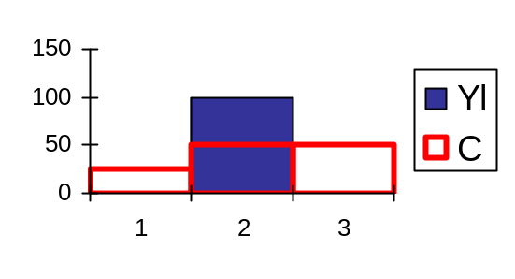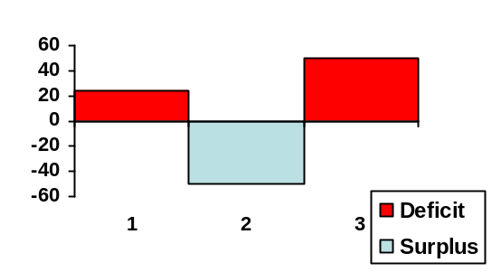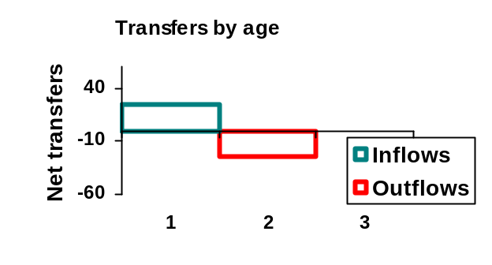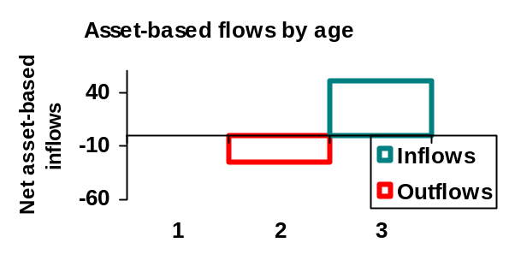
Consumption and
labor income by age
Lifecycle deficit by age

Figure 1. NT Flows for a 3 Generation OLG Model in Steady State. Low Childrearing Costs. Lifecycle Saving Funds Retirement.

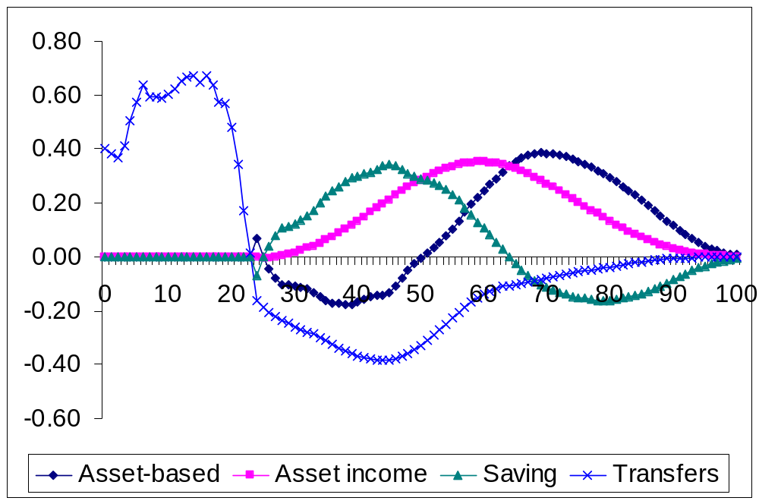
Figure 2. Asset-based reallocations for the lifecycle model, downward transfers to children, no upward transfers, economic lifecycle and transfer estimates based on NTA for Taiwan 1998.
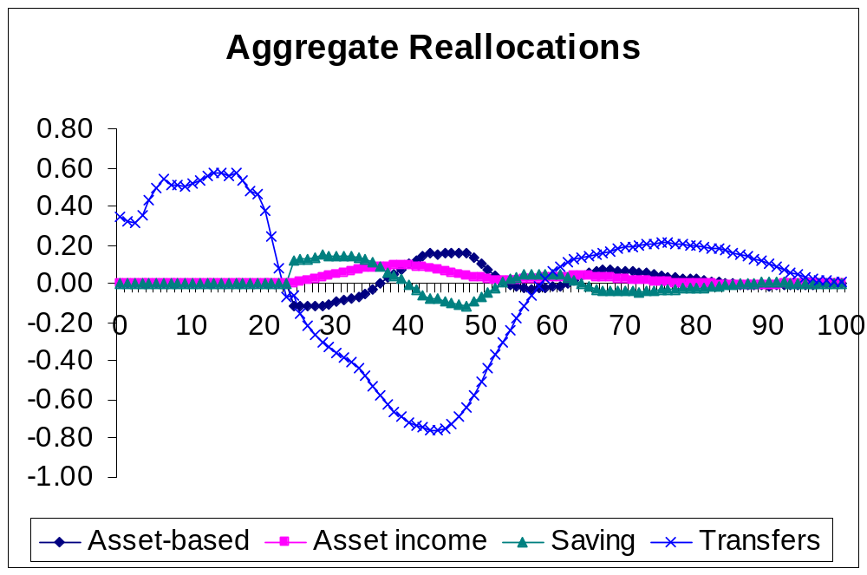
Figure 3. Asset-based reallocations for the lifecycle model, downward and upward transfers allowed, economic lifecycle and transfer estimates based on NTA for Taiwan 1998.
Consumption and
labor income by age
Lifecycle deficit by age
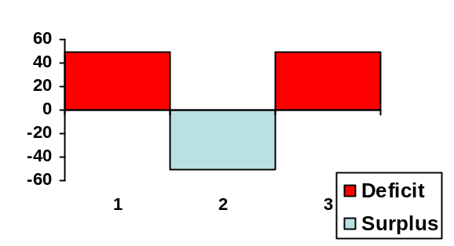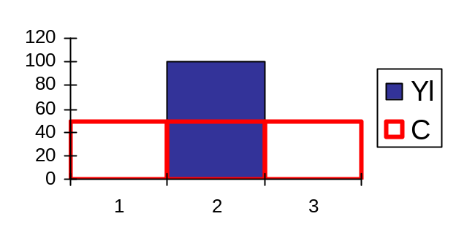

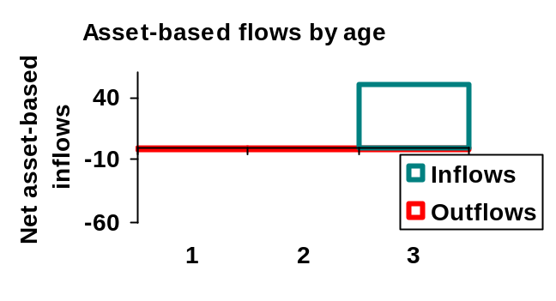
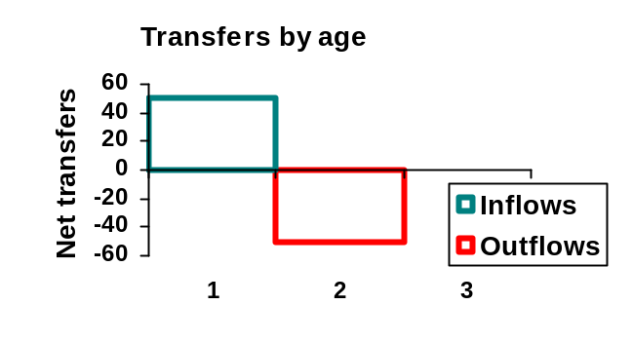

Figure 4. NT Flows for a 3 Generation OLG Model in Steady State. High Childrearing Costs. Asset Income from Bequests Fund Retirement.

Consumption and
labor income by age
Lifecycle deficit by age
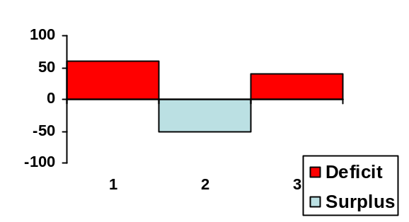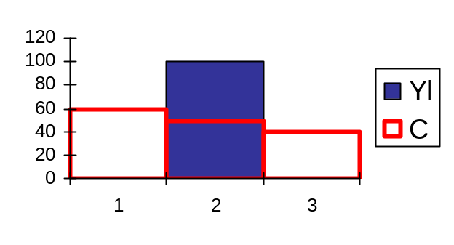

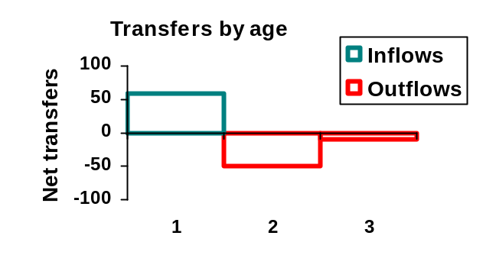

Figure 5. NT Flows for a 3 Generation OLG Model in Steady State. Very High Childrearing Costs. Asset Income from Bequests Fund Retirement and Indirectly Some Child Costs.

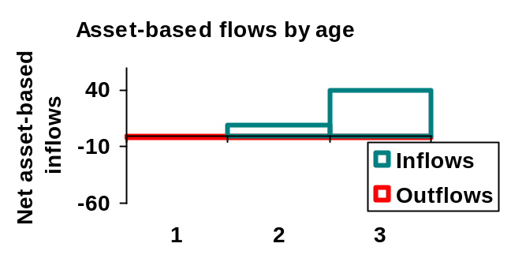
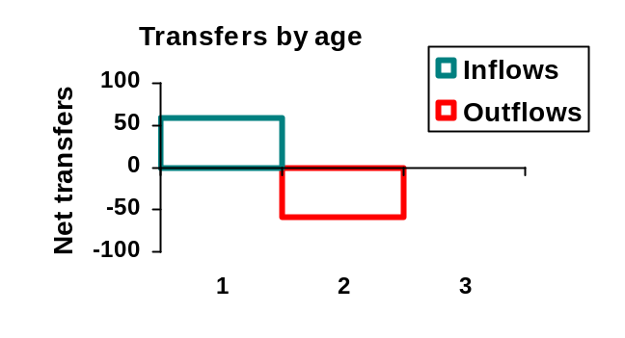

Figure 6. NT Flows for a 3 Generation OLG Model in Steady State. Very High Childrearing Costs. Asset Income from Capital Transfers to Generation 2 Fund Retirement and Indirectly Some Child Costs.

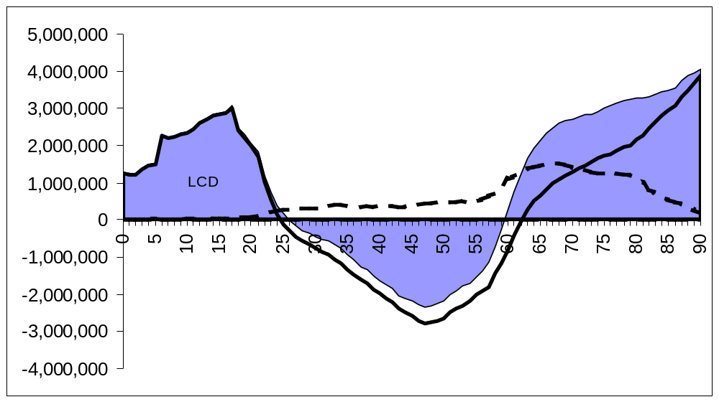

Figure 7. Lifecycle deficit, net transfers, and asset-based reallocations (yen), annual per capita flow, Japan, 2004.

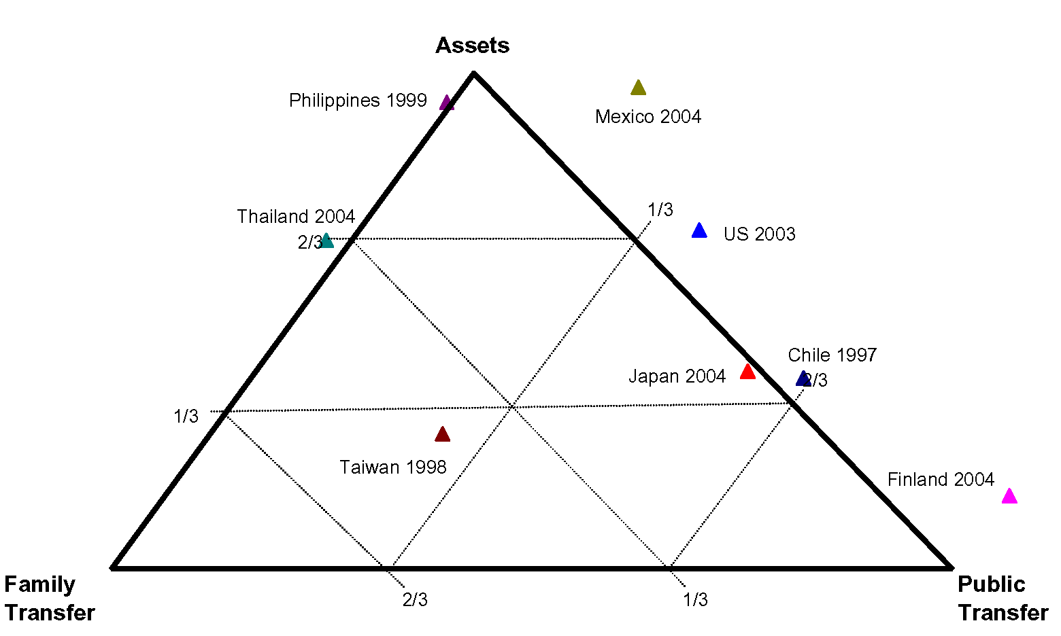

Figure 8. Familial Transfers, Public Transfers, and Asset-based Reallocations as a Share of the Lifecycle Deficit, Individuals Sixty-five and Older, Selected Countries.
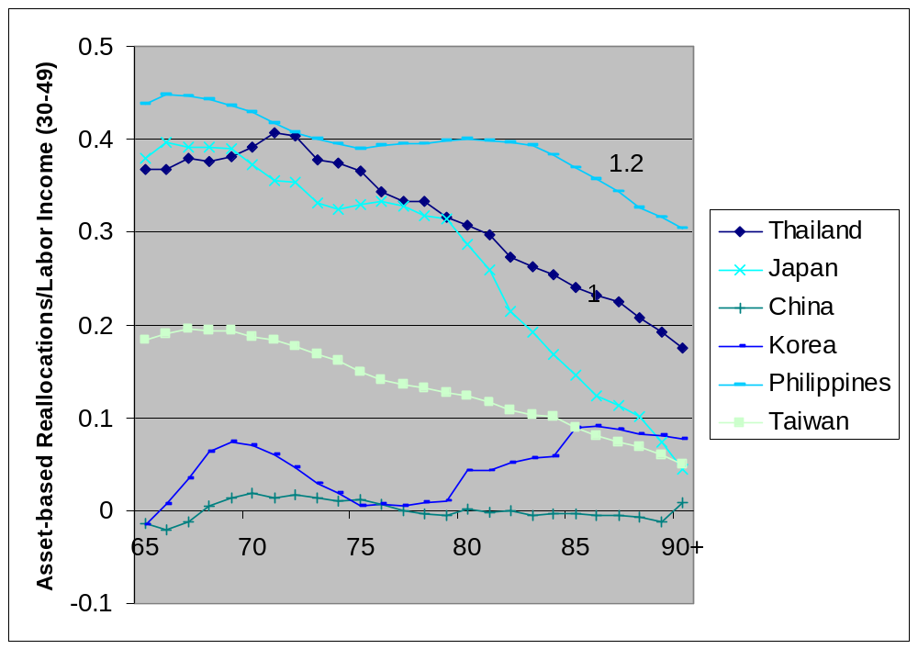

Figure 9. Per Capita Asset-based Reallocations by Age (65 and older), Normalized on Average Per Capita Labor Income of Individuals 30-49, Selected Asian Countries. This will be updated as more countries become available and estimates are revised.
Source: AR Calculations.xls
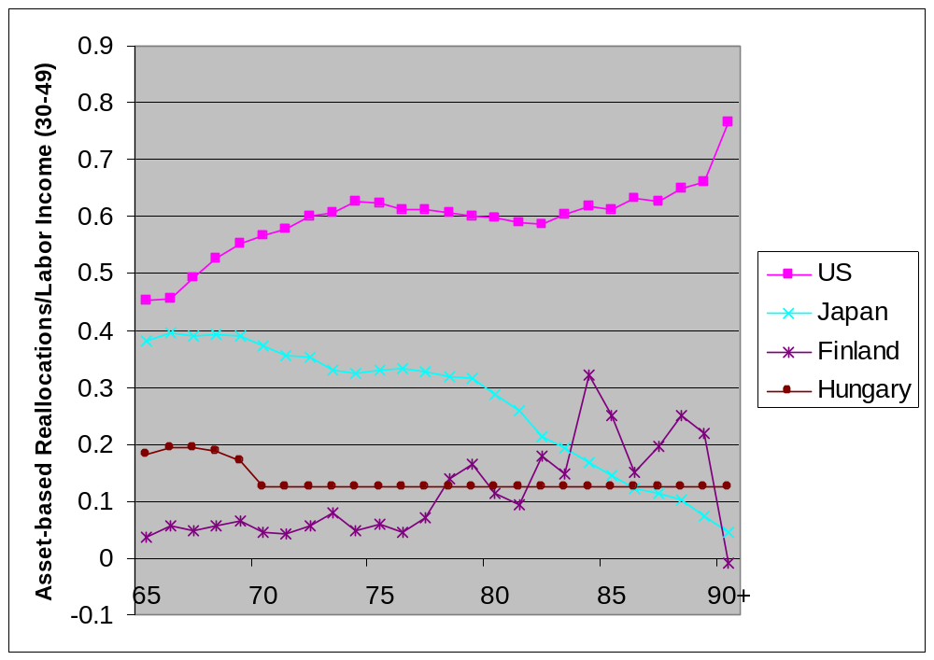

Figure 10. Per Capita Asset-based Reallocations by Age (65 and older), Normalized on Average Per Capita Labor Income of Individuals 30-49, Selected Industrialized Countries. This will be updated as more countries become available and estimates are revised.
Source: AR Calculations.xls
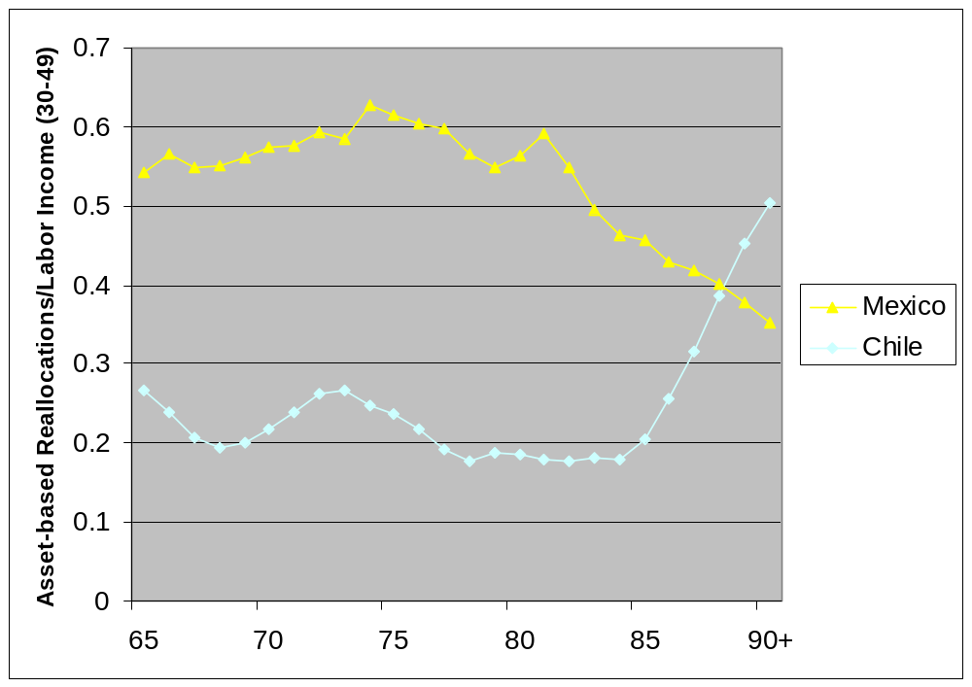

Figure 11. Per Capita Asset-based Reallocations by Age (65 and older), Normalized on Average Per Capita Labor Income of Individuals 30-49, Selected Latin American Countries. This will be updated as more countries become available and estimates are revised. Source: AR Calculations.xls

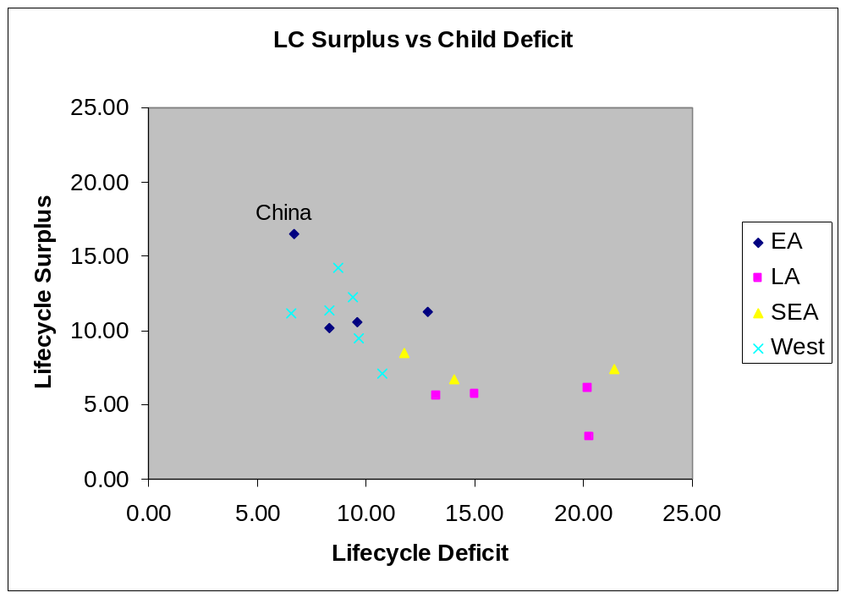
Figure 12. Aggregate Lifecycle Surplus versus the Aggregate Child Deficit, Available Countries. All values normalized on aggregate labor income from 30-49 (divided by 30). Cumulated across ages for which LCD is negative and for which LCD is positive.

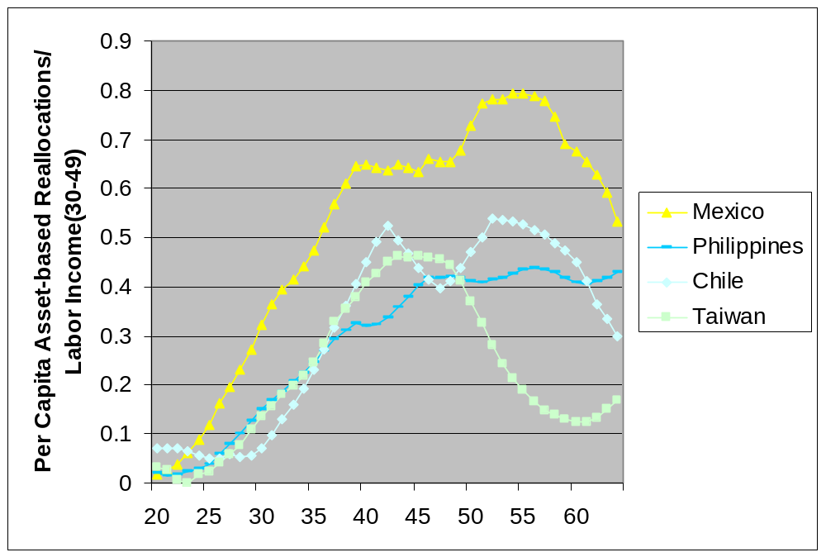
Figure 13. Asset-based reallocations, individuals 20-64, per capita values normalized on average per capita labor income of individuals in the 30-49 age group, high inflow countries.
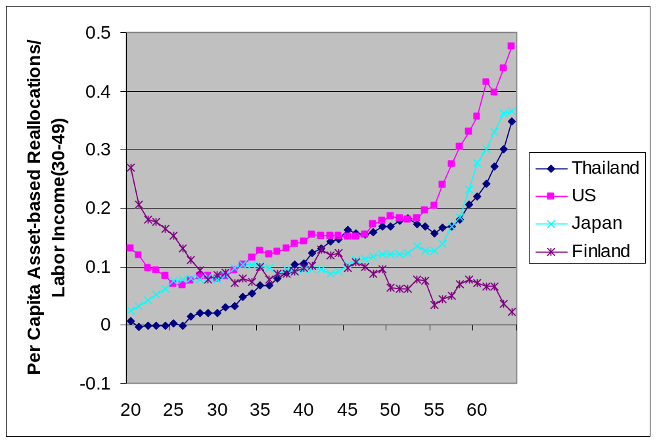
Figure 14. Asset-based reallocations, individuals 20-64, per capita values normalized on average per capita labor income of individuals in the 30-49 age group, moderate inflow countries.
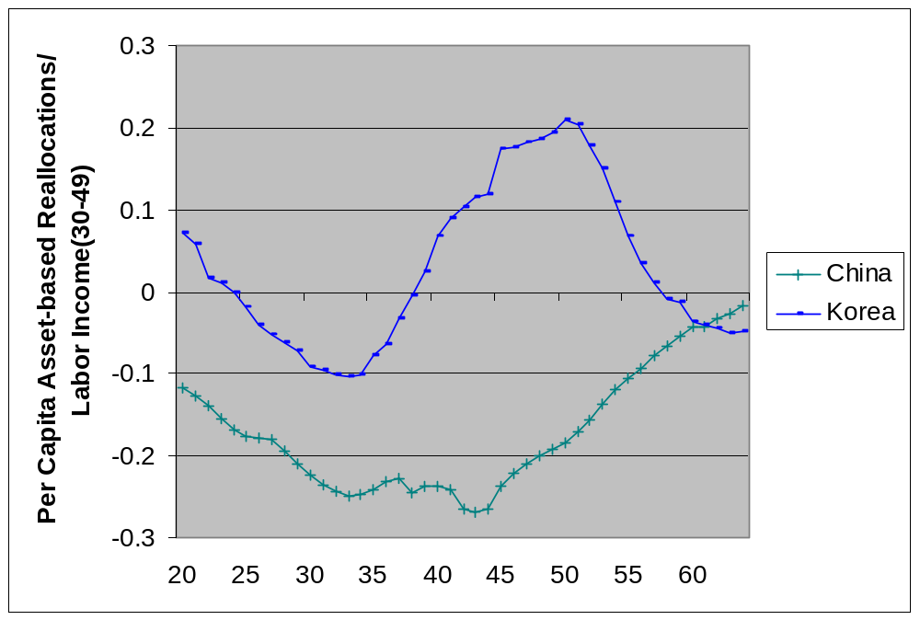
Figure 15. Asset-based reallocations, individuals 20-64, per capita values normalized on average per capita labor income of individuals in the 30-49 age group, outflow countries.
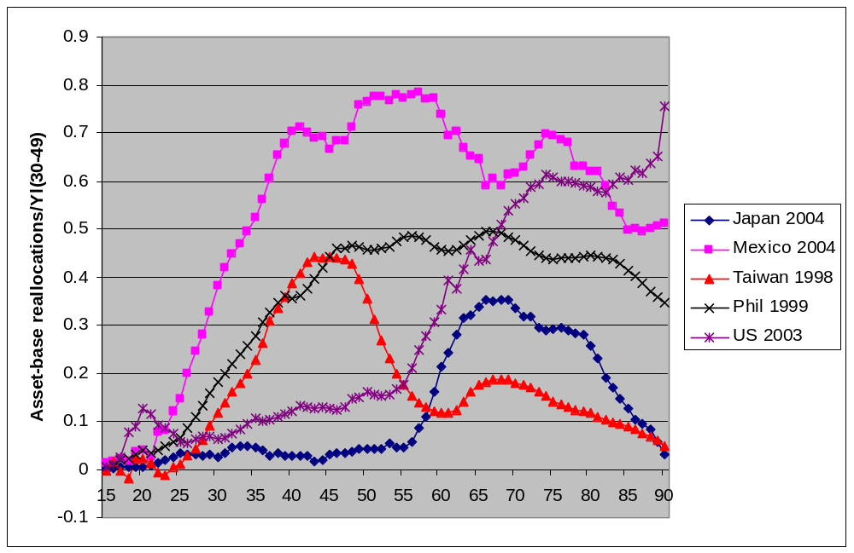 Figure 16. Private asset-based reallocations, per capita values normalized on average per capita labor income for individuals 30-49, selected countries.

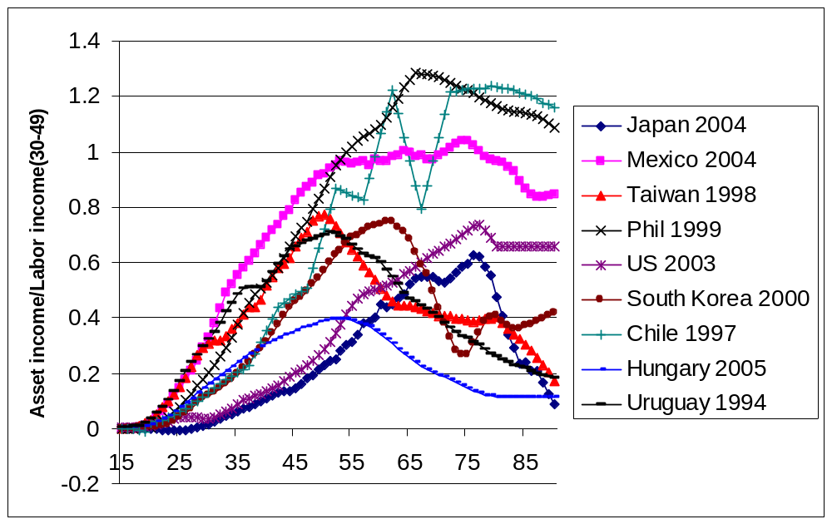 Figure 17. Private asset income, per capita values normalized on average per capita labor income for individuals 30-49, selected countries.

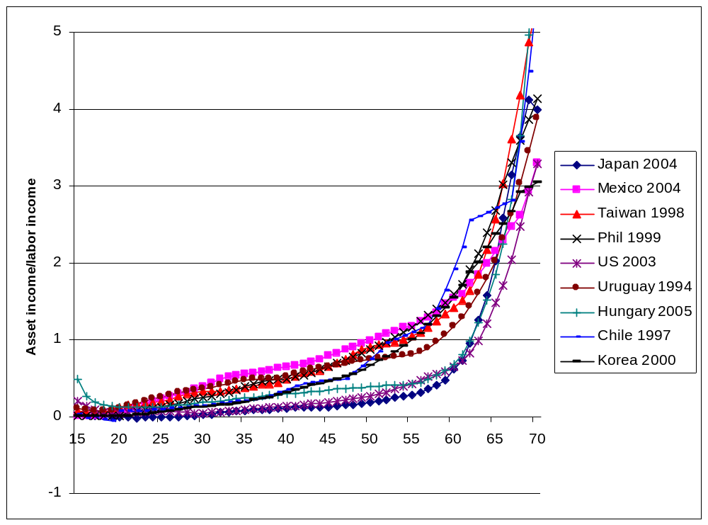
Figure 18. Asset income relative to labor income by age, selected countries.
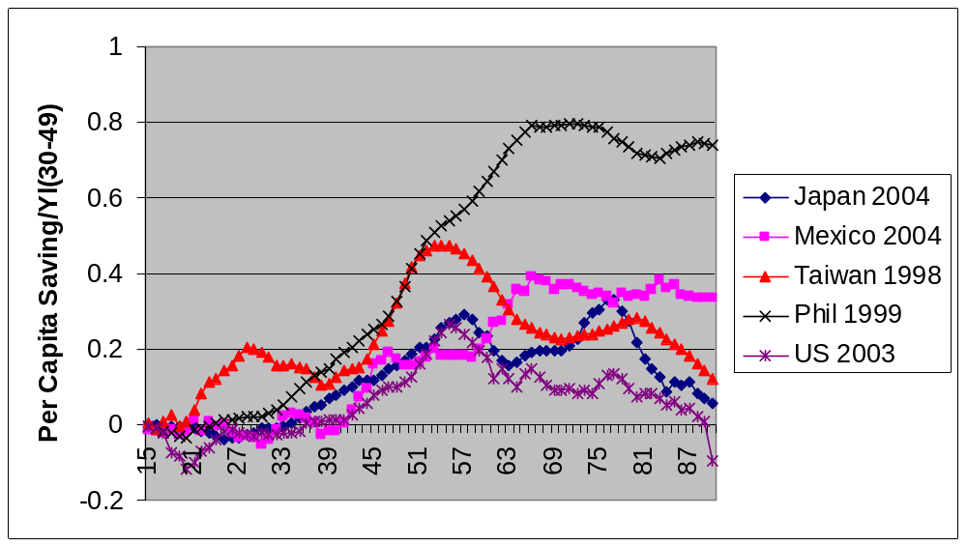Figure 19. Private saving, per capita values normalized on average per capita labor income for individuals 30-49, selected countries.
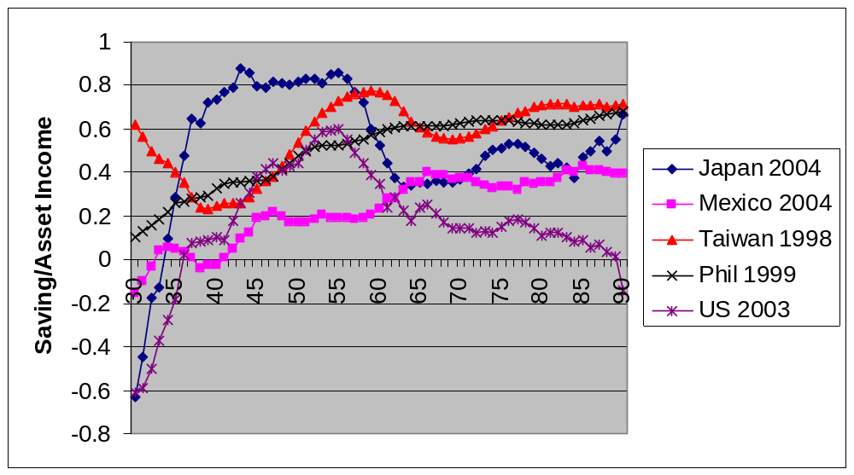
Figure 20. Private saving as a proportion of private asset income, selected countries.

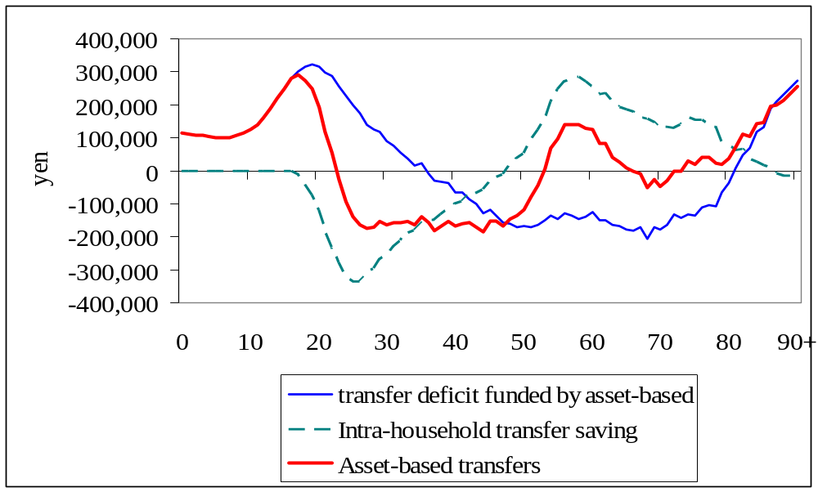

Figure 21. Asset-based transfers, per capita values, Japan 2004.

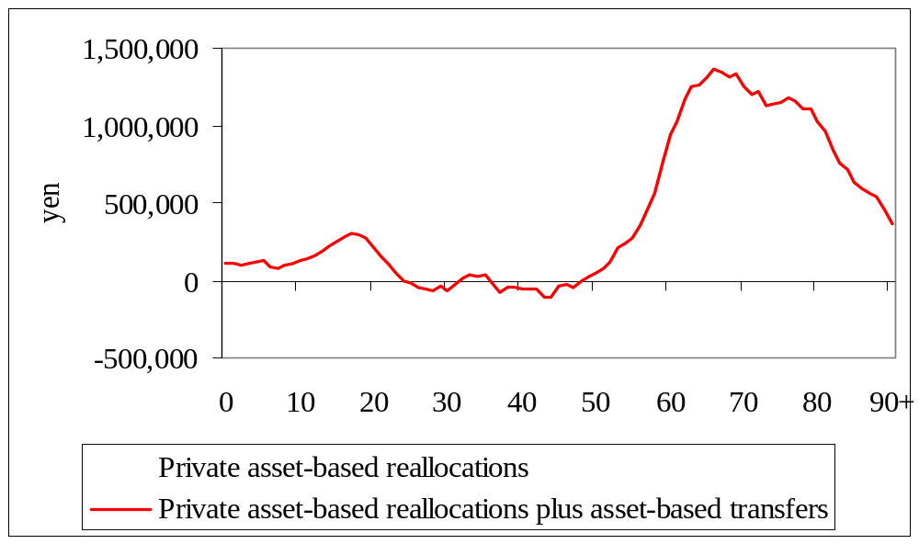

Figure 22. Direct and indirect private asset-based reallocations, per capita, Japan, 2004.

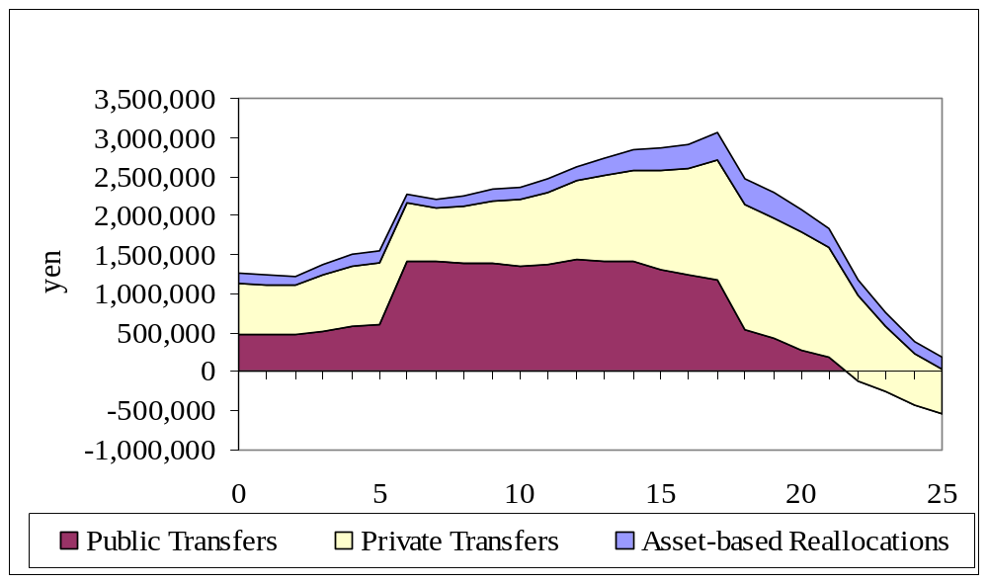

Figure 23. Age reallocations, per capita values, Japan 2004.
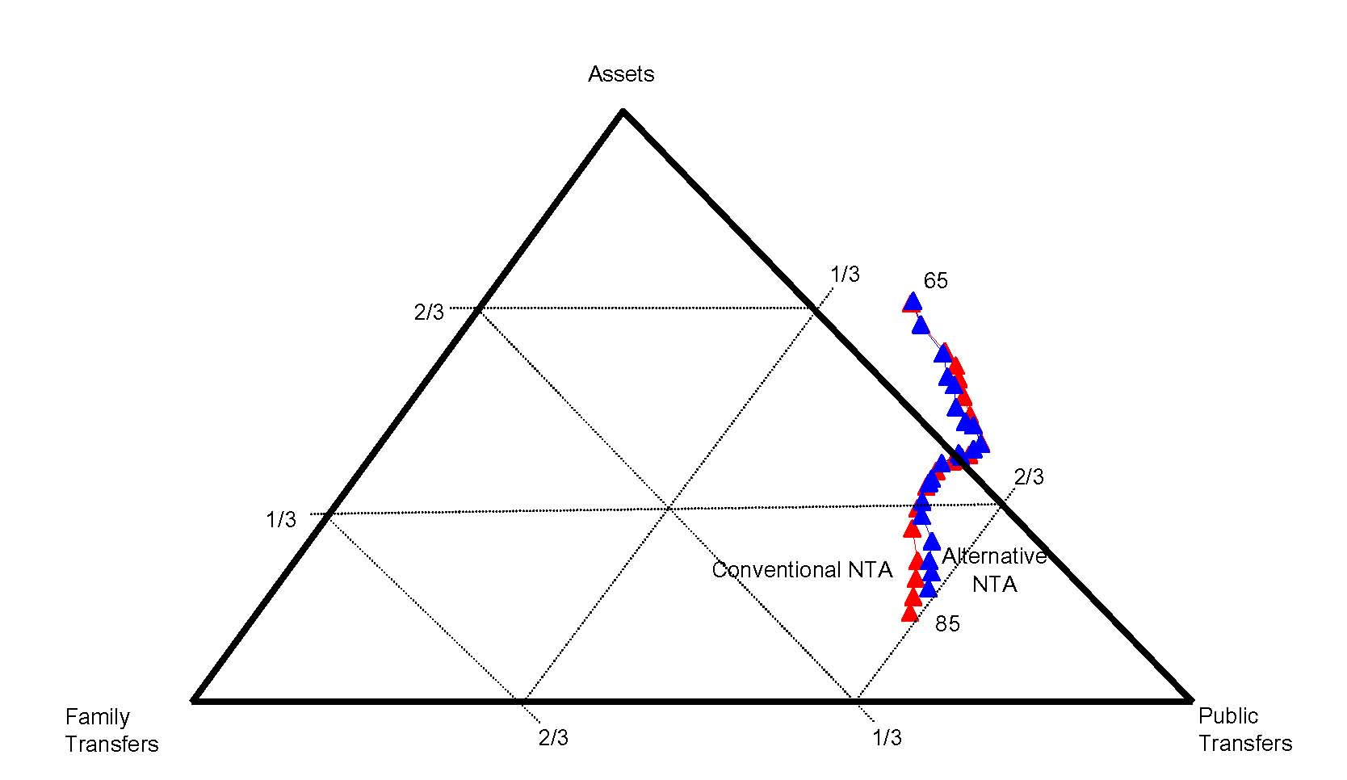
Figure 24. Old-age reallocation system, Japan, 2004.

REFERENCES

Carroll, C. D. (1992). "The Buffer-Stock Theory of Saving: Some Macroeconomic Evidence." Brookings Papers on Economic Activity CXII(1): 1-56.
Carroll, C. D. and L. H. Summers (1991). Consumption growth parallels income growth: Some new evidence. National Saving and Economic Performance: A National Bureau of Economic Research Project Report. B. D. Bernheim and J. B. Shoven. Chicago, University of Chicago Press: 305-343.
Diamond, P. (1965). "National Debt in a Neoclassical Growth Model." American Economic Review 55: 1126-50.
Feldstein, M. (1974). "Social Security, Induced Retirement, and Aggregate Capital Accumulation." Journal of Political Economy 82(5): 905-26.
Feldstein, M. and A. Samwick (2001). "Potential Paths of Social Security Reform." NBER Working Papers 8592.
Feldstein, M. e. (1998). Privatizing social security. Chicago and London, University of Chicago Press.
Horioka, C. Y. (1990). "Why is Japan's Household Saving Rate So High? A Literature Survey." Journal of the Japanese and International Economy 4(1): 49-92.
Horioka, C. Y. (1991). "The Determinants of Japan's Saving Rate: The Impact of the Age Structure of the Population and Other Factors." Economic Studies Quarterly 42(3): 237-53.
Horioka, C. Y. (2006). "The Dissaving of the Aged Revisited: The Case of Japan." NBER Working Paper W12351(July).
Kotlikoff, L. J. (1979). "Testing the Theory of Social Security and Life Cycle Accumulation." American Economic Review 69(June): 396-410.
Kotlikoff, L. J. (1988). "Intergenerational Transfers and Savings." Journal of Economic Perspectives 2(2): 41-58.
Kotlikoff, L. J. and L. H. Summers (1981). "The Role of Intergenerational Transfers in Aggregate Capital Accumulation." Journal of Political Economy 89(4): 706-32.
Krueger, D. and F. Kubler (2002). "Pareto Improving Social Security Reform When Financial Markets are Incomplete!?" NBER Working Papers 9410.
Lee, R. and A. Mason (forthcoming). "Low Fertility, Human Capital, and Macroeconomics." European Journal on Population.
Lee, R., A. Mason, et al. (2003). "From Transfers to Individual Responsibility: Implications for Savings and Capital Accumulation in Taiwan and the United States." Scandinavian Journal of Economics 105(3): 339-357.
Lee, R. D. (1994). The Formal Demography of Population Aging, Transfers, and the Economic Life Cycle. Demography of Aging. L. G. Martin and S. H. Preston. Washington, D.C., National Academy Press: 8-49.
Lee, R. D., A. Mason, et al. (2001). Saving, Wealth, and the Demographic Transition in East Asia. Population Change and Economic Development in East Asia: Challenges Met, Opportunities Seized. A. Mason. Stanford, Stanford University Press: 155-184.
Mason, A. and R. Lee (2007). Transfers, Capital, and Consumption over the Demographic Transition. Population Aging, Intergenerational Transfers and the Macroeconomy. R. Clark, N. Ogawa and A. Mason, Elgar Press.
Mason, A., R. Lee, et al. (forthcoming). Population Aging and Intergenerational Transfers: Introducing Age into National Accounts. Developments in the Economics of Aging. D. Wise. Chicago, NBER and University of Chicago Press.
Modigliani, F. (1988). "The Role of Intergenerational Transfers and Life Cycle Saving in the Accumulation of Wealth." Journal of Economic Perspectives 2(2): 15-40.
Modigliani, F. and R. Brumberg (1954). Utility Analysis and the Consumption Function: An Interpretation of Cross-Section Data. Post-Keynesian Economics. K. K. Kurihara. New Brunswick, N.J., Rutgers University Press.
Ogawa, N., A. Mason, et al. (2008). Japan's Unprecedented Aging and Changing Intergenerational Transfers. NBER-TCER-KDI conference on “The Demographic Transition in the Pacific Rim”. Seoul, Korea.
Ogawa, N. and R. D. Retherford (1993). "Care of the Elderly in Japan: Changing Norms and Expectations." Journal of Marriage and the Family 55(3): 585-97.
Samuelson, P. (1958). "An Exact Consumption Loan Model of Interest with or without the Social Contrivance of Money." Journal of Political Economy 66: 467-82.
Willis, R. J. (1988). Life cycles, institutions and population growth: A theory of the equilibrium interest rate in an overlapping-generations model. Economics of Changing Age Distributions in Developed Countries. R. D. Lee, W. B. Arthur and G. Rodgers. Oxford, Oxford University Press. 106-38.

Because labor income is growing the peak for the cohort profile is later than the peak in the cross-sectional profile.
Alternatively net credit outflows may be negative for the rest of the world.
Public transfers are becoming a more important source of support in higher income Asian countries. Both Korea and Taiwan have implemented large transfer programs, e.g., public pension programs and public health insurance systems, that are leading to an increase in net public transfers for the elderly.
Korea has an unusual system of housing finance.
For a few cases (Hungary and the US) asset income is non-negligible as compared with labor income at young ages as shown in Figure 18.
Asset income in the US is held constant for 80+. Asset-based reallocations are estimated to rise; hence saving rates must decline to accommodate this. If asset income is actually declining after 80+ following the trend and the pattern in other countries, saving rates would be lower in the US and might turn negative at a younger age.)
A more detailed description of the methods used for estimating intrahousehold transfers are available at www.ntaccounts.org.

